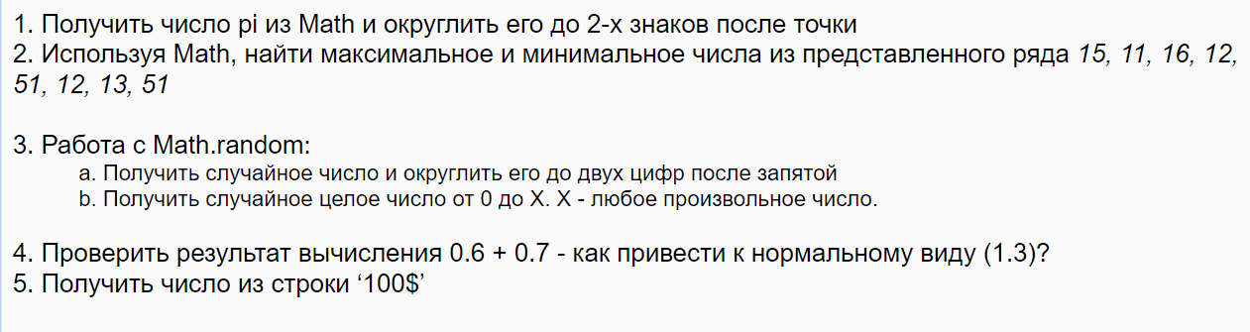

// first task

let value1 = +Math.PI.toFixed(2);

console.log(value1);

//second task

let value2Min = Math.min(15, 11, 16, 12, 51, 12, 13, 51);

let value2Max = Math.max(15, 11, 16, 12, 51, 12, 13, 51);

console.log(value2Min, value2Max);

//third task

let value3 = Math.random() \* 10; // part a

value3 = +value3.toFixed(2);

console.log(value3);

const X = 111;

let valueB = Math.random() \* X; //part b

valueB = +valueB.toFixed();

console.log(valueB);

//fourth task

let value4 = 0.6 + 0.7;

value4 = +value4.toFixed(1);

console.log(value4);

//fifth task

let value5 = '100$';

value5 = parseFloat(value5);

console.log(value5);