International Information Technology University JSC

Faculty of Information Technology

Department of Information Systems

**Laboratory work №1**

**«Software requirements specification development»**

**for discipline «Fundamentals of information systems»**

**Konopyanov Manap / Gabdykalikov Adilet**

**IITU Network**

**Almaty, 2022**

## 1 INTRODUCTION

### 1.1 Purpose

The goal of the project is to provide students of the International University of Information Technology with quick and easy access to the information of the university. Also, his goal is to create a site that combines the features of a social network and a forum where students can discuss various events, similar to the Reddit website.

### 1.2 Scope

The information system is a web application. Each student will have their own account linked to their university account. Through the web application, students will be able to create discussions in the style of Reddit threads, comment, rate, and trend them. In addition, the site will provide brief and useful information about the University, clubs.

### 1.3 Definitions

IITU – International Information Technology University.

## 2 GENERAL INFORMATION

### 2.1 Full name of IS and its abbreviation

Full name of the information system – “IITU Network”.

### 2.2 Information about developers and customers

Customer – “International Information Technology University”

Developers –

Konopyanov Manap,

Gabdykalikov Adilet

### 2.3 Project timelines

Started: 6 February of 2022.

Planned end date: …

### 2.4 Funding

The creation of the Information System is sponsored by the International University of Information Technology.

## 3 PURPOSE OF CREATING INFORMATION SYSTEM

### 3.1 Relevance

The relevance of the web application lies mainly in the fact that at the moment there are no analogues of the web application that allow you to create discussions among the students of the University. Another relevance is that there is no place where all the necessary information for the student would be collected.

### 3.2 Use

The web application will be used in the field of web development.

### 3.3 Ideology

The ideology of our application is that all the information present on the site will be written by the students themselves. Along with the fact that students will also be able to comment, discuss and evaluate, this provides reliable information and will be useful for applicants, first-year students.

### 3.4 Formulation of the problem

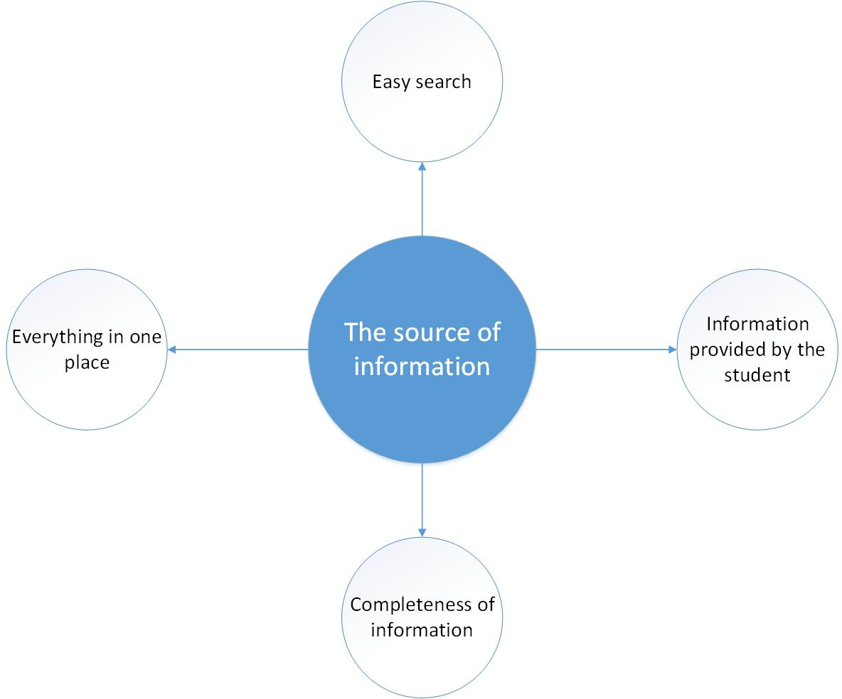

### 3.5 Formalization of the problem

#### 3.5.1 Easy search.

To solve the task, in the design development process, all the nuances and needs of the average user will be taken into account. That is, an intuitive and simple design will be developed, with navigation allowing you to quickly find the information you need.

#### 3.5.2 Everything in one place.

Due to the scatter of different information about the university, students are forced to look for information in different sources. The presented application will help you get scattered information from one place.

#### 3.5.3 Information provided by the student.

Solving this problem will give confidence in the reliability of the information, due to the fact that it is written by a student. A grading system will also be set up to prevent students from writing false information.

#### 3.5.4 Completeness of information.

The advantages of this item are that the information provided by the admins will be exhaustive and students will not have to clarify anything. If you still have clarifying questions, you can always contact the admins.

### 3.6 The goal

Development of an intuitive web application presenting a wealth of information about the student life of the International Information Technology University.

### 3.7 Objectives

To achieve this goal, we have set ourselves the following tasks:

* Analysis of student needs.
* Development of the logic of work and structure of the site.
* Website design development.
* Website development based on html, css and javascript programming, as well as databases.
* Testing the site and its individual functions.
* Correcting bugs, if any.

### 3.8 Advantages

* The ability to join discussions or create your own to solve any specific problems.

## 3.9 Disadvantages

* Large data stream loading the server

## 4 SOFTWARE REQUIREMENTS

### 4.1 Requirements for the structure and functioning of the IS

### 4.1. 1 Software technology used

Since a web application is being created**, front-end development technologies** and **database technology** are used to create this IS.

### 4.1.2 IS model

### 4.1.2.1 Selection of the model

When developing the application, the management model of IS will be used.

### 4.1.2.2 Justification of the model chosen

Since the web application itself is built on the management of something, it was considered necessary to choose the management model of the IS.

### 4.1.2.3 Construction of the general model

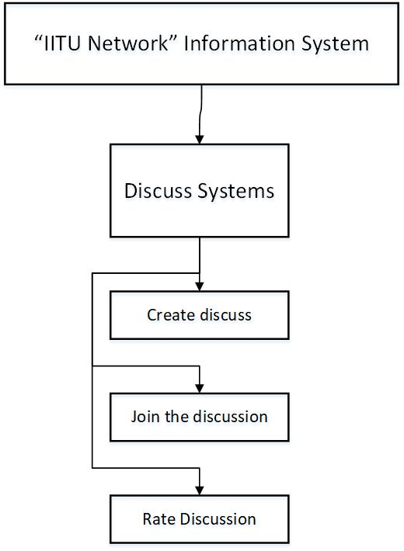

### 4.1.3 IS Architecture

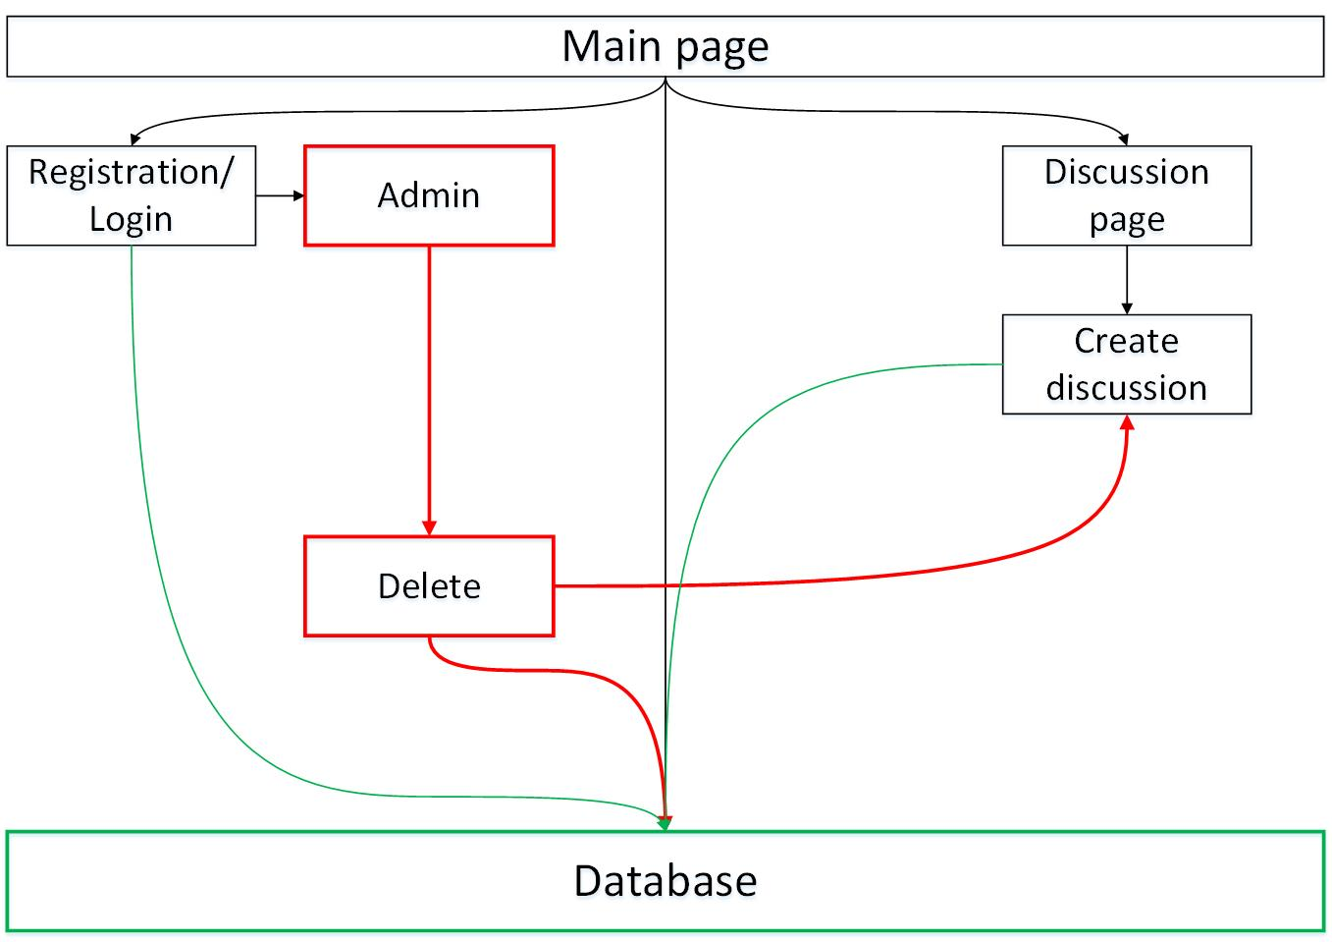

### 4.1.4 Information support requirements

Text volume. Basically 3000 characters, will also change, depending on the activity of the students.

Number of files 30.

### 4.1.5 Software requirements

The total amount of software in MB: 70.

### 4.1.6 Requirements to the construction of the algorithm

### 4.1.6.3 Requirements to the user data queries from the database

---------------------------------------------------------

### 4.1.6.4 Requirements to the source code/programming languages

The application will be developed in JavaScript language.

### 4.1.7 OS requirements

Any operating system can be used to use the application.

### 4.1.8. Construction of the algorithm

-----------------------------------------------------------------

### 4.2. Reliability requirements:

----------------------------------------------

### 4.2 Requirements to reliability:

---------------------------------------------

**4.4 Requirements for exploitation**

**4.4.1 Exploitation conditions**

**4.4.1.1 Climatic conditions of exploitation**

The application works in any climatic conditions.

**4.4.1.2 Requirements to employees qualification and number**

* Responsibility.
* Unselfishness.
* Basic knowledge of the site.

**4.4.2 Help manual development**

Help manual is developed in *.hlp format; it contains subject index, search by keyword, indication of the author.

**4.5 Technical requirements:**

**4.5.1 The recommended monitor resolution range at which software will be viewed is**

Recommended screen resolutions. (px)

|  |  |
| --- | --- |
| 1200 and higher | PC’s |
| 1200-992 | Laptops and PC’s |
| 992-600 | Tablets and mobile |
| 600 and less | mobile |

**4.5.2 The minimal monitor resolution range at which software will be viewed**

The minimal monitor resolution is 320 px.

**4.5.3 Recommended PC configuration**

2 GHz Processor, 1024MB RAM, 256MB Video Card, 120 GB HDD

**4.5.4 Minimal PC configuration**

1 GHz Processor, 512MB RAM, 100MB available HDD, 64 MB Video Card

**4.6. Non-Technical requirements to IS:**

**4.6.1 Adaptability**

The website is responsive and supports different device sizes: PC’s, laptops, tablets, mobiles.

**4.6.2 Intellectual development**

The information system will be constantly updated with new information and knowledge by creating and commenting on student discussions.

**4.6.3 Consistency**

No, the application does not work at the system level.

**4.6.4 Full functionality**

No.

**4.6.5 Integrity**

The information system does not require any additional modules, as it is a website.

**4.6.6 Quality**

**4.6.6.1 Functionality**

The ability of the software under certain conditions to solve the problem, users need. Determines what is done for what problems it solves.

Software functionality - the ability to perform a set of software functions:

- Defined in its external description;

- Satisfy given or implied user needs.

**4.6.6.2 Reliability**

Ability to maintain a certain performance under specified conditions.

Software Reliability - the ability of the software to perform certain functions smoothly under predetermined conditions for a predetermined period of time with sufficiently high probability.

Reliability of operation is characterized by a probability of the software product without failure for a specified period of time.

**4.6.6.3 Ease of application**

The ability of the software to be easy to learn and use, as well as attractive to users.

**4.6.6.4 Effectivity**

The ability of the software under the given conditions to provide the necessary performance in relation to the allocated resources to do so. You can define it, and as the ratio obtained by means of the software results to spent on a resource.

The effectiveness of the software - the ratio of the level of services provided by the user software product under specified conditions, to the volume of resources used.

**4.6.6.5 Maintainability**

Ease of all activities related to the support of the program.

Maintainability of software - software product characteristics that minimize efforts to amend it:

- To eliminate errors;

- For modification in accordance with the changing needs of users.

**4.6.6.6 Possibility to learn**

Indicator, reverse the efforts spent by the user to

learn how to work with the software.

**4.6.6.7 Modifiability**

Extensibility, structuring, modularity.

**4.6.6.8 Mobility**

Ability to continue to operate when moving from one environment to another, including organizational, hardware and software aspects of the environment, the ability of software and computer system as a whole continue to operate under its physical movement in space.

Mobility software - the software's ability to work on different hardware platforms or running different operating systems.

**4.6.6.9 Finiteness**

The inverse of the frequency of failures.

**4.6.10 Accuracy**

The ability to give the desired results (e.g., with a certain confidence interval)

**4.6.6.11 Autonomy**

Property that characterizes the ability of the PC to perform intended functions without help or support other software component

software.

**4.6.6.12 Stability**

The ability to maintain a given level of performance in case of failures and irregularities interaction with the environment.

**4.6.6.13 Security**

Ability to prevent unauthorized, ie without the person who is trying to carry it out, and do not allow access to data and applications.

**4.6.6.14 P-documentation**

The property is characterized by the presence, completeness, clarity, accessibility and visibility of the training, guidance and reference documents necessary for the application of the PC

**4.6.6.15 Informational content**

The property is characterized by the presence in the composition according to the information necessary and sufficient for understanding the purpose of the SS, the assumptions made, the existing limitations, the input data and the results of the individual components, as well as the current state of the program in the course of their operation.

**4.6.6.16 Sociability**

Property characterizing the degree to which the SS

facilitates the task description or the input data, and provides useful information issuing in the form and content that are easy to understand.

**4.6.6.17 Time efficiency**

The ability of the software to give the expected results, as well as provide for the transfer of necessary volume of data in the allotted time.

**4.6.6.18 The effectiveness of memory**

Measure characterizing the ability of the PC to carry out its functions under certain restrictions on memory usage.

**4.6.6.19 Efficiency devices**

The measure is cost-effective use of the devices of the machine for the task.

**4.6.6.20 C-documentation**

Properties that characterize in terms of availability documentation of the software requirements and the results of the different stages of development of the 10 software, including capabilities, limitations, and other features of the software, as well as their justification.

**4.6.6.21 Intelligibility**

Indicator, reverse the efforts spent by the user to accept a set of concepts, on which the software and their applicability to solve their problems.

**4.6.6.22 Structured**

The property that characterizes the program PS in terms of organization of related parts into a single unit in a certain way (e.g., according to the principles of structured programming).

**4.6.6.23 Readability**

Readability software - software product characteristics that:

- Minimize user effort in preparing the initial data, application software, and evaluation of the results

- Can cause positive emotions a specific user or implied.

Property characterizing the ease of perception of the text software programs (indentation, fragmentation, formative).

**4.6.6.24 Extensibility**

Property that characterizes the ability of the software to use more memory for data storage or expanding the functionality of the individual components.

**4.6.6.25 Modularity**

The property that characterizes the software organization in terms of its programs from discrete components such that a change in one of them has a minimal impact on other components.

**4.6.6.26 Regardless of the device**

Property characterizing the ability to work on a variety of hardware (different types, brands and models of computers).

**5 PSYCHOLOGICAL FEATURES**

**5.1.1 Aesthetic look**

**5.1.2 Choice of style**

**5.1.3 Color solution**

**5.2 Location of interface elements**

Graphically display will look like a form (window) and thus justify the location of each element on the form in terms of functionality and convenience.

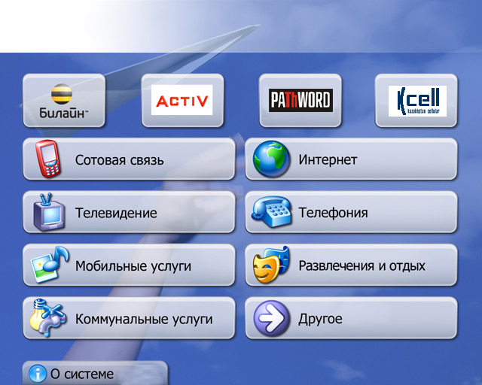

Figure 1.8 – The system interface ATM

**5.3 Ergonomics**

Friendliness, nice interface, “soft” messages about errors: “Welcome!”, “Are you sure, that you want exit?” are connected with ergonomics.

**5.4 Target audience**

**5.4.1 Age of users**

**5.4.2 Their mood, temperament, etc.**