SmartLife
Feature Walkthrough Report
An Expo / React Native app for student schedule, finance, and AI-assisted planning
English for Business Presentations — Project Presentation Preparation
Prepared for Week 9 (Video Pitch) and Week 10–11 (Live Presentation)
24 August – 11 September 2026

1. Project Overview
SmartLife is an Expo and React Native application built for students. It brings class schedules, personal notes, finance tracking, receipt OCR, notifications, Google Calendar synchronization, and an AI assistant together into a single mobile experience.
The project includes a complete application source, a shared Firebase backend (Authentication, Firestore, Storage, and Cloud Functions), security rules, Google Cloud Vision / iApp OCR integration, and two separate interfaces: a User app and an Admin app.

Main Features
- Firebase Email/Password and Google authentication
- Separate User and Admin applications with role-based access
- Day, week, month, and year schedule views
- Google Calendar two-way synchronization
- Notes and personal finance tracking
- Cloud Vision OCR for receipts and class schedules
- AI schedule extraction and an AI assistant
- AI Adaptive Scheduling — conflict checks, learned behavior patterns, explainable suggestions, and Undo
- Firebase Storage, Firestore, Cloud Functions, security rules, and indexes
- Thailand date and time formatting (Asia/Bangkok)

Technology Stack
- Expo SDK 57 and React Native, with TypeScript and Expo Router
- Firebase Authentication, Firestore, Storage, and Cloud Functions
- Google Cloud Vision API
- Google Calendar API and Google OAuth 2.0
- Gemini AI and iApp OCR, called through Firebase Secret Manager

2. User App — Feature Walkthrough
All screenshots below were captured from the real application running on an Android device (MuMu emulator) using “adb exec-out screencap -p”, against real data on the production project — not mock-ups or edited images.
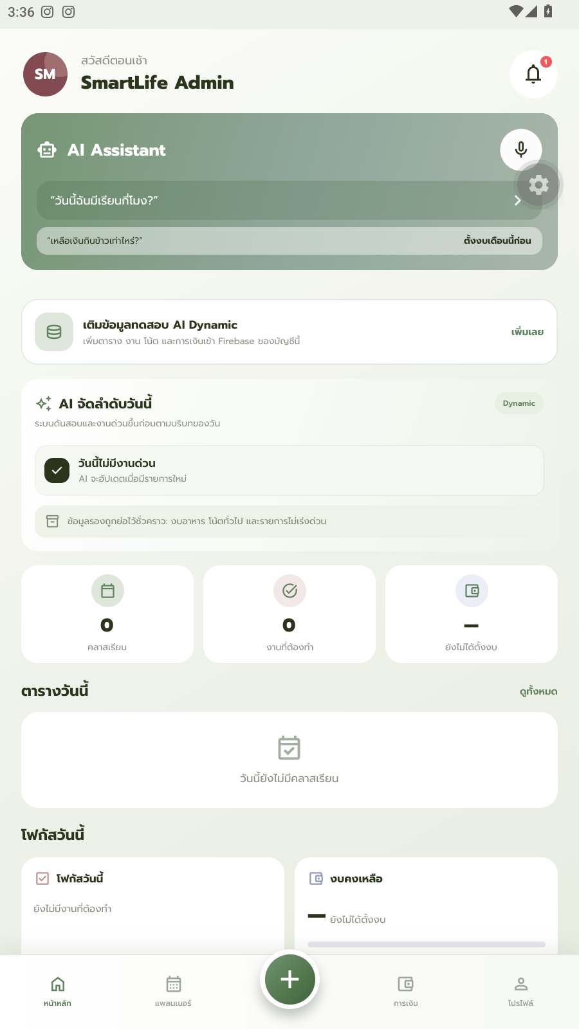  1. Dashboard  Home screen — today's summary, budget overview, and upcoming activities. | 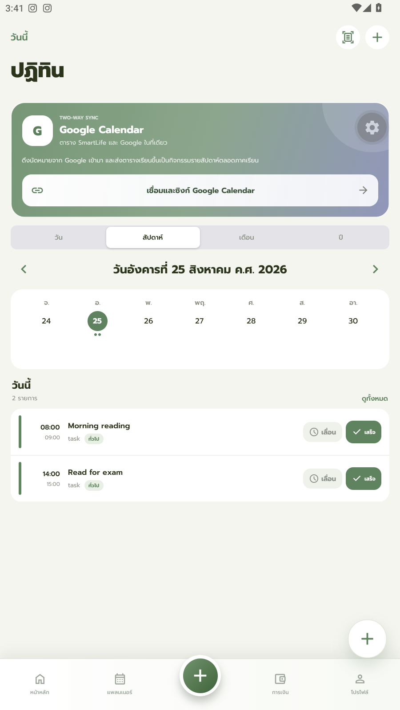  2. Calendar (Week view)  Weekly calendar with today's tasks and inline Postpone / Done actions on each row.
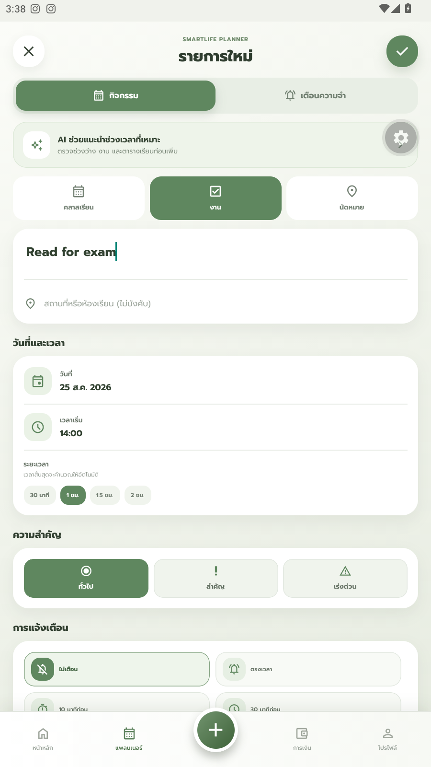  3. Create Task form  Task creation form — name, date, time, and a default 1-hour duration. | 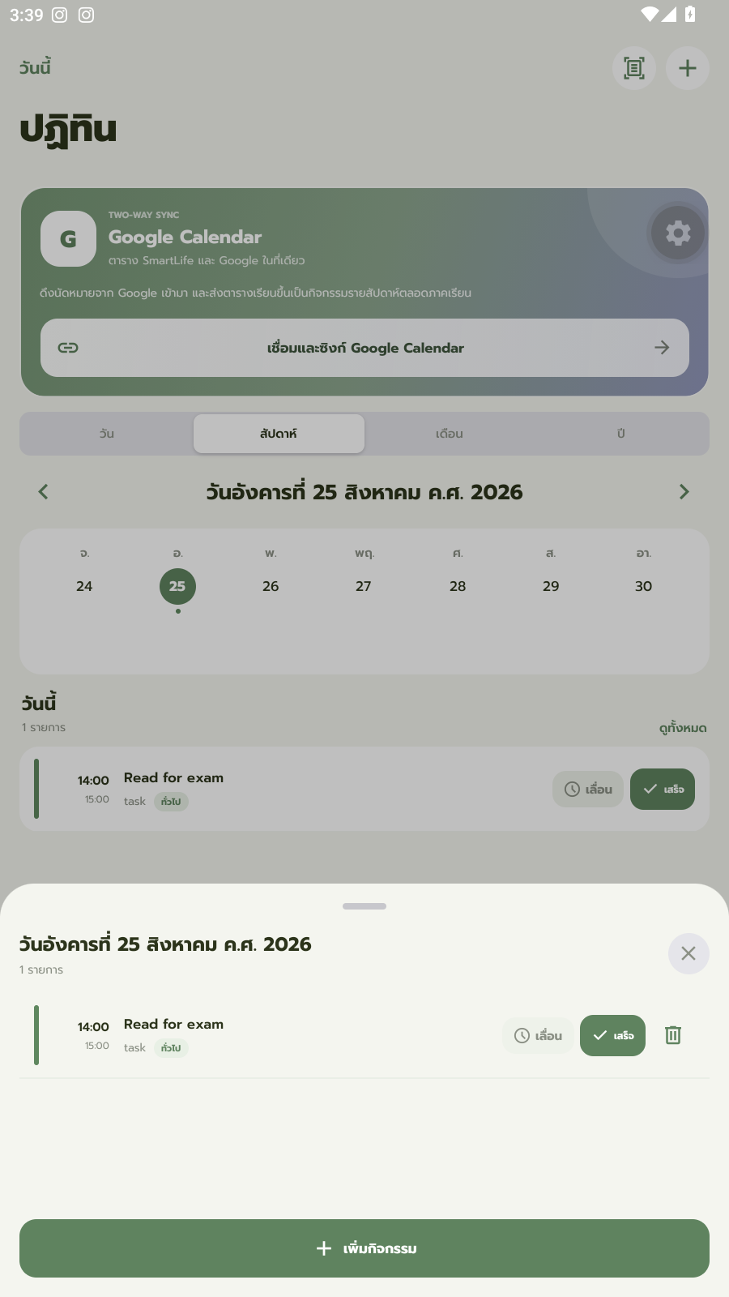  4. Task actions  Day-detail sheet with Postpone / Done / Delete actions for each task.
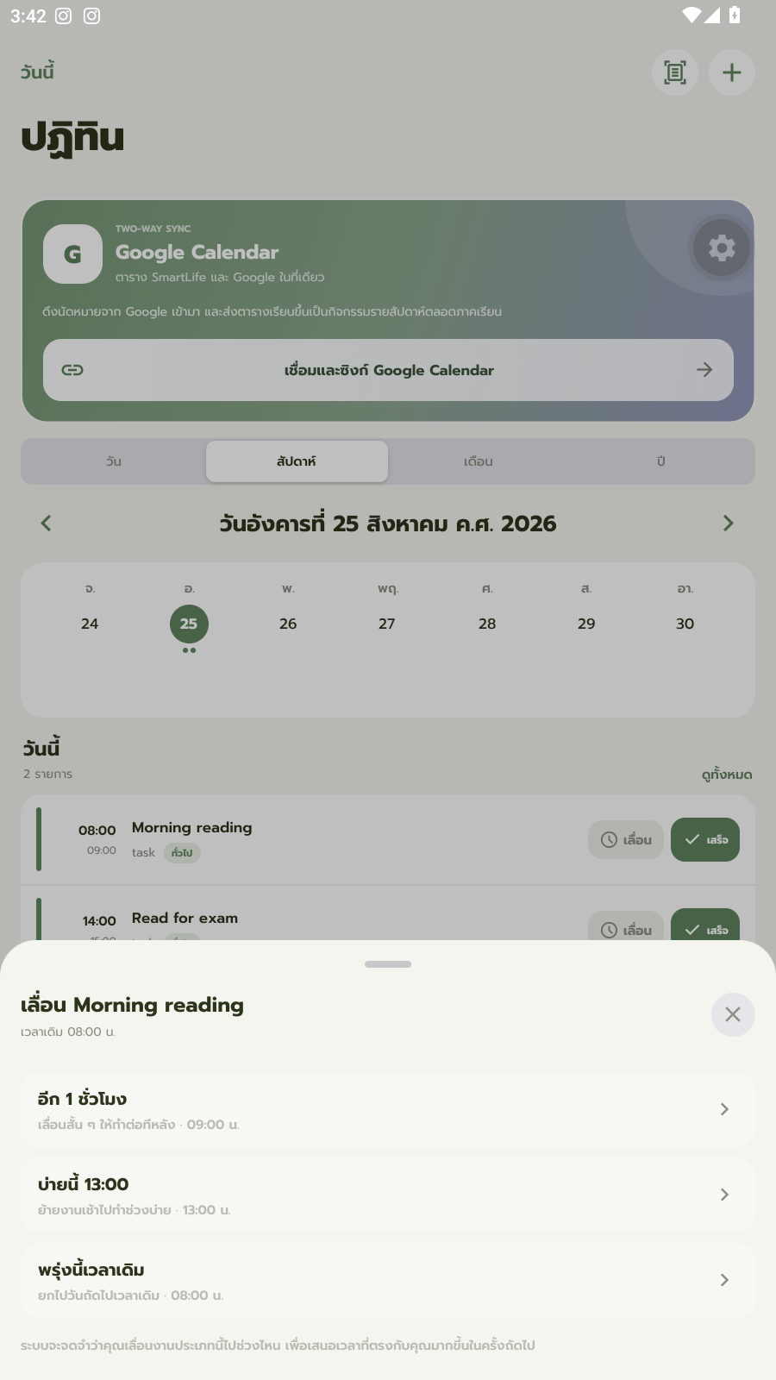  5. Postpone sheet  Reschedule options: +1 hour, this afternoon (13:00), or the same time tomorrow. | 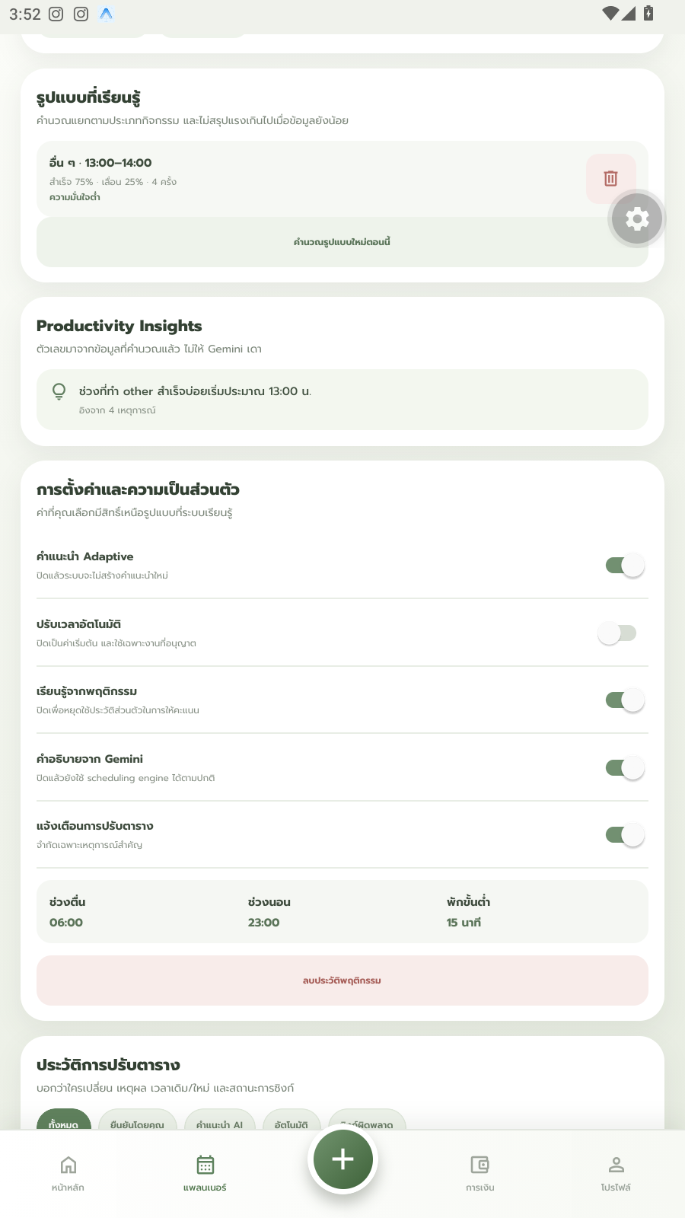  6. Adaptive scheduling — learned pattern  A real pattern the AI learned: “Other · 13:00-14:00 · 75% completed · 25% postponed · 4 occurrences,” with an insight based on 4 events.
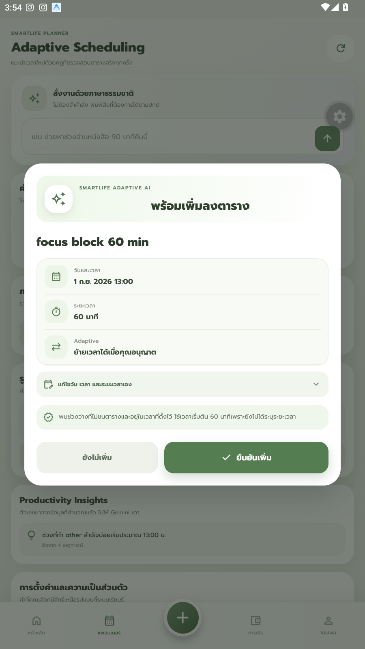  7a. Suggested time — learning ON  “Learn from behavior” switched ON → the system suggests Sep 1, 2026, 13:00, matching the learned pattern. | 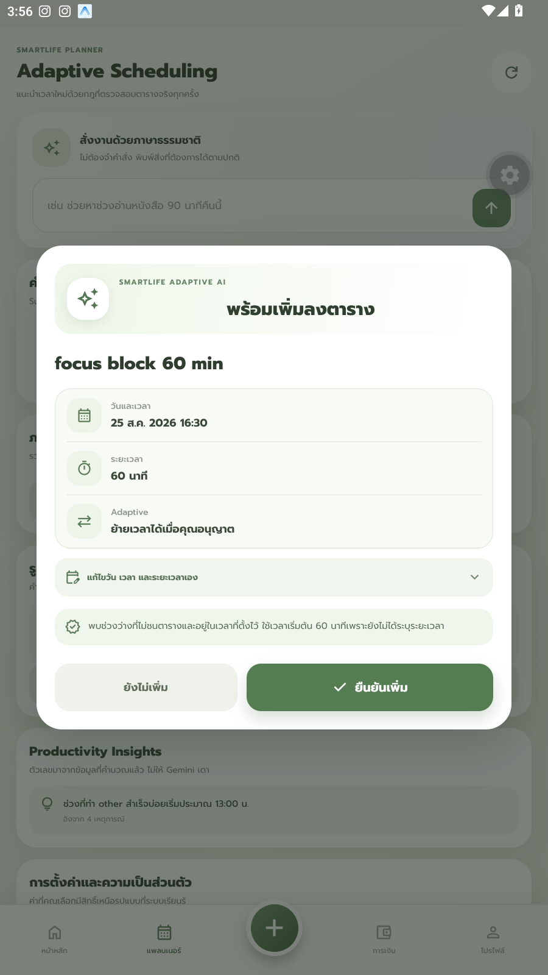  7b. Suggested time — learning OFF  Same request with learning switched OFF → the system falls back to the default suggestion, Aug 25, 2026, 16:30.
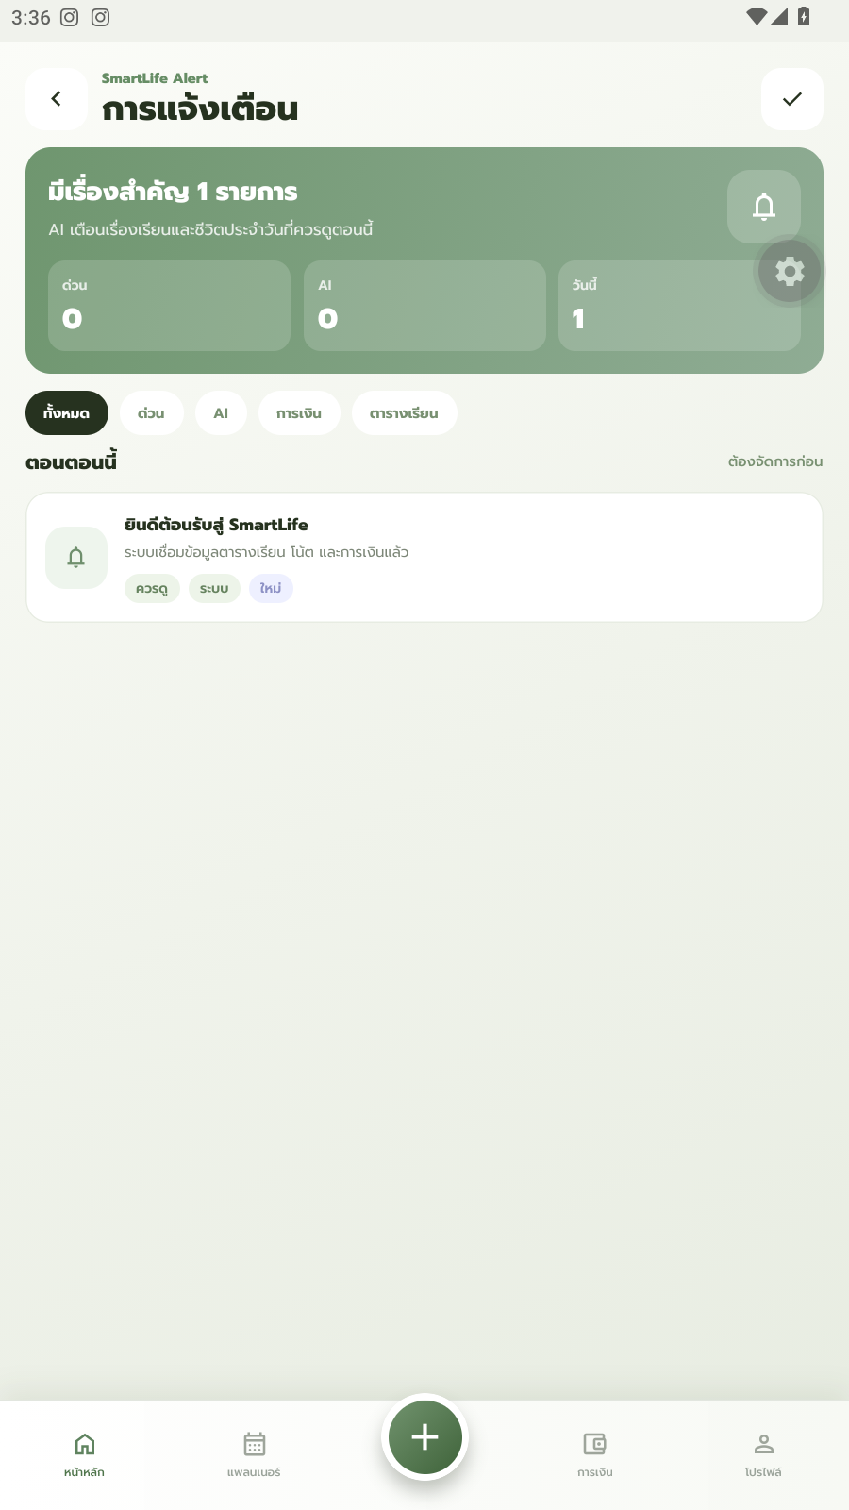  8. Notifications  Notification center for schedule, finance, and AI alerts. | 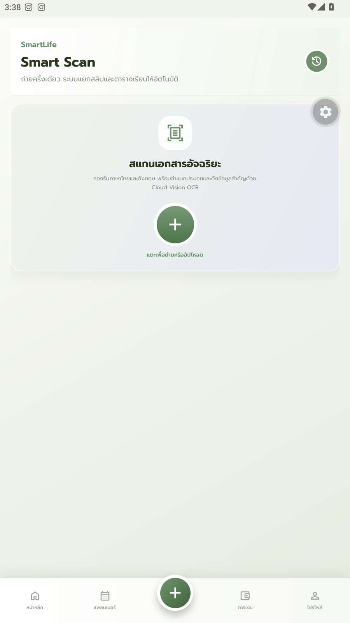  9. Smart Scan (receipt OCR)  Receipt-scanning screen using Cloud Vision / iApp OCR (empty state shown; no real receipt uploaded).
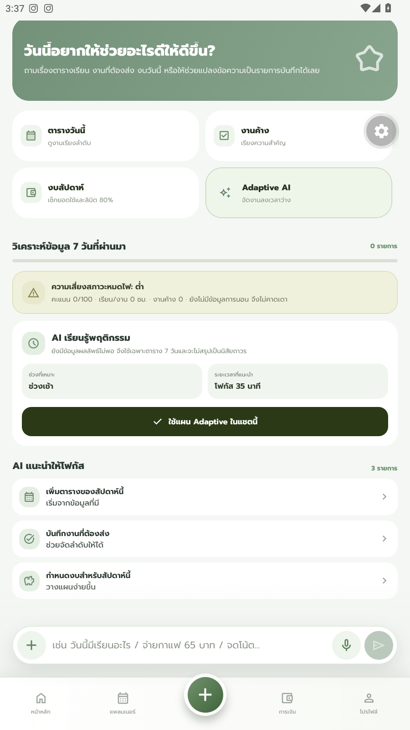
10. AI Assistant
Conversational AI assistant for schedule and finance questions.
Note: screenshots 7a and 7b use the exact same account, data, and request — the only difference is the “Learn from behavior” switch. The suggested time changes from 13:00 (matching the learned pattern) to the default 16:30, which is the clearest evidence that Adaptive Scheduling has a real, measurable effect.

3. Admin App — Feature Walkthrough
The Admin application gives project maintainers visibility into what the AI has learned and whether backend services are healthy.
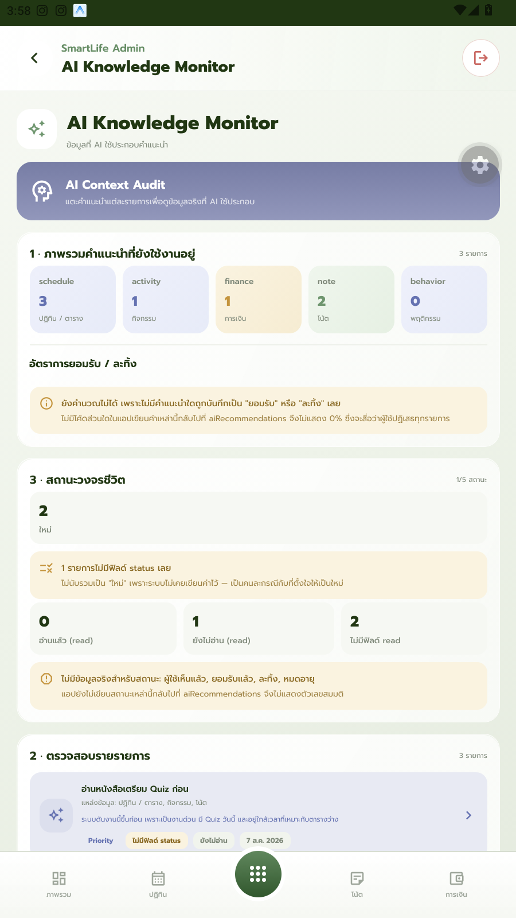  11a. Admin — AI Knowledge Monitor (summary)  Overview and lifecycle view of what the AI has learned across all users. | 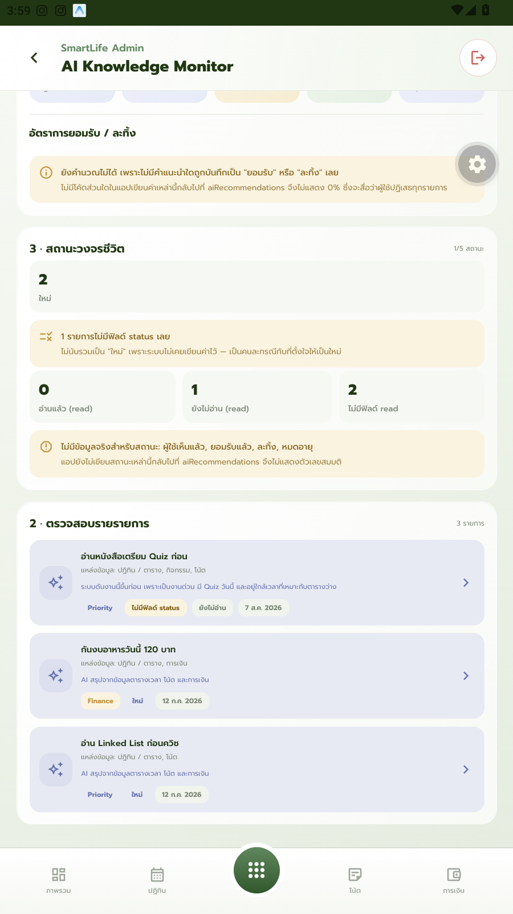  11b. Admin — AI Knowledge Monitor (per item)  Three individual learned items, each with the AI's own reasoning.
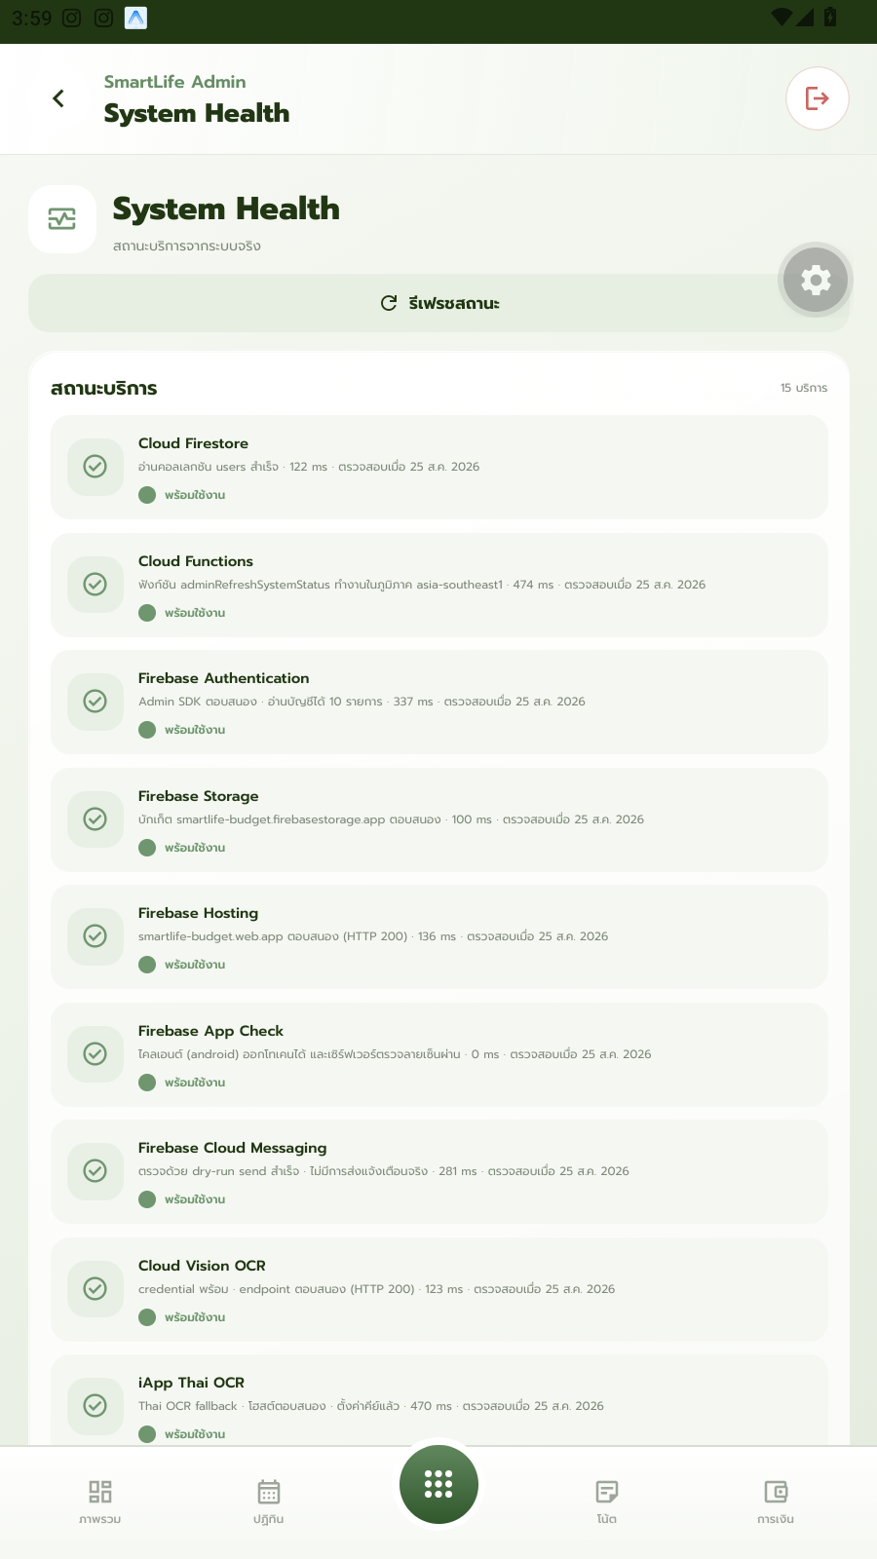  12. Admin — System Health  Live status for 15 backend services, all shown healthy. | 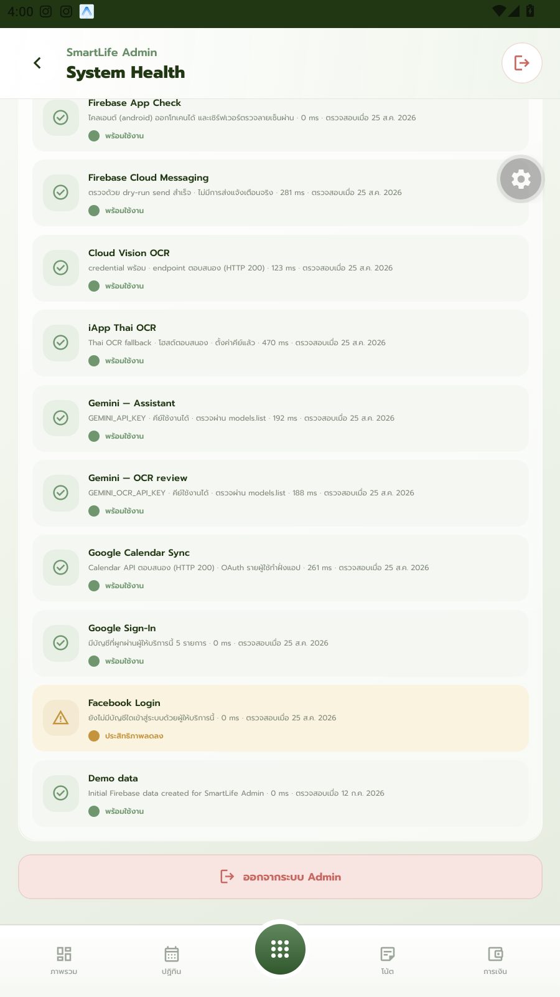  12b. Admin — Integrations detail  Integrations broken out individually: Gemini (Assistant), Gemini (OCR), and Facebook Login (shown degraded).

4. Next Steps
- Week 9 (24–28 Aug 2026): record a 7-minute pitch-style video presentation of this project and submit it on the SUT E-Learning system.
- Week 10 or 11 (31 Aug – 11 Sep 2026): present the same project live in English (7 minutes) followed by an 8-minute Q&A.
- Turn the project proposal into presentation slides, using the feature walkthrough in this report as supporting visuals.

