Report

- Purpose of the algorithm
- Artifacts classification
- Quantization threshold determination
- Spike detection
- Real life application

Given traces from one movie algorithm should classify them in 2 groups: those where neural activity is present and the other ones whit sole stimulation artifacts.
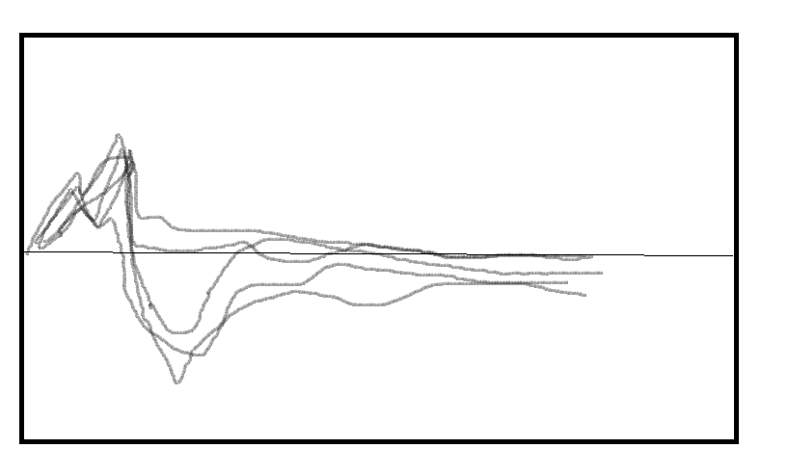
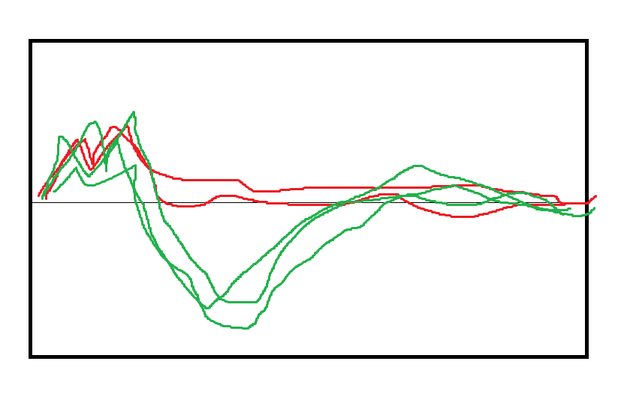

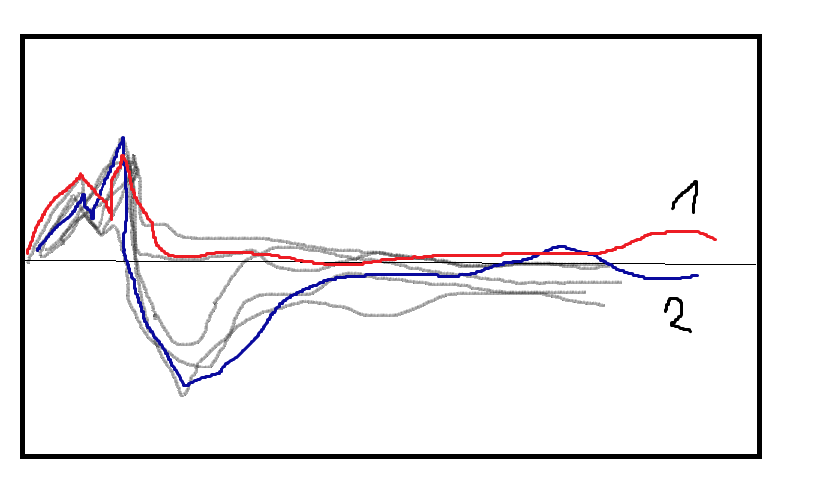
1. First step in the algorithm is determination whether given trace contains neural activity or not. To distinguish those situations we compare given trace against every other in the set by subtracting it.
Let's consider traces 1 and 2 marked in the picture below:
If we subtract trace 2 from trace 1 we will obtain a curve depicted on figure below:

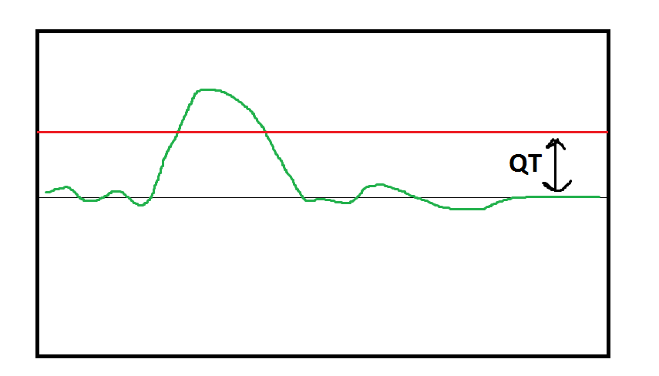
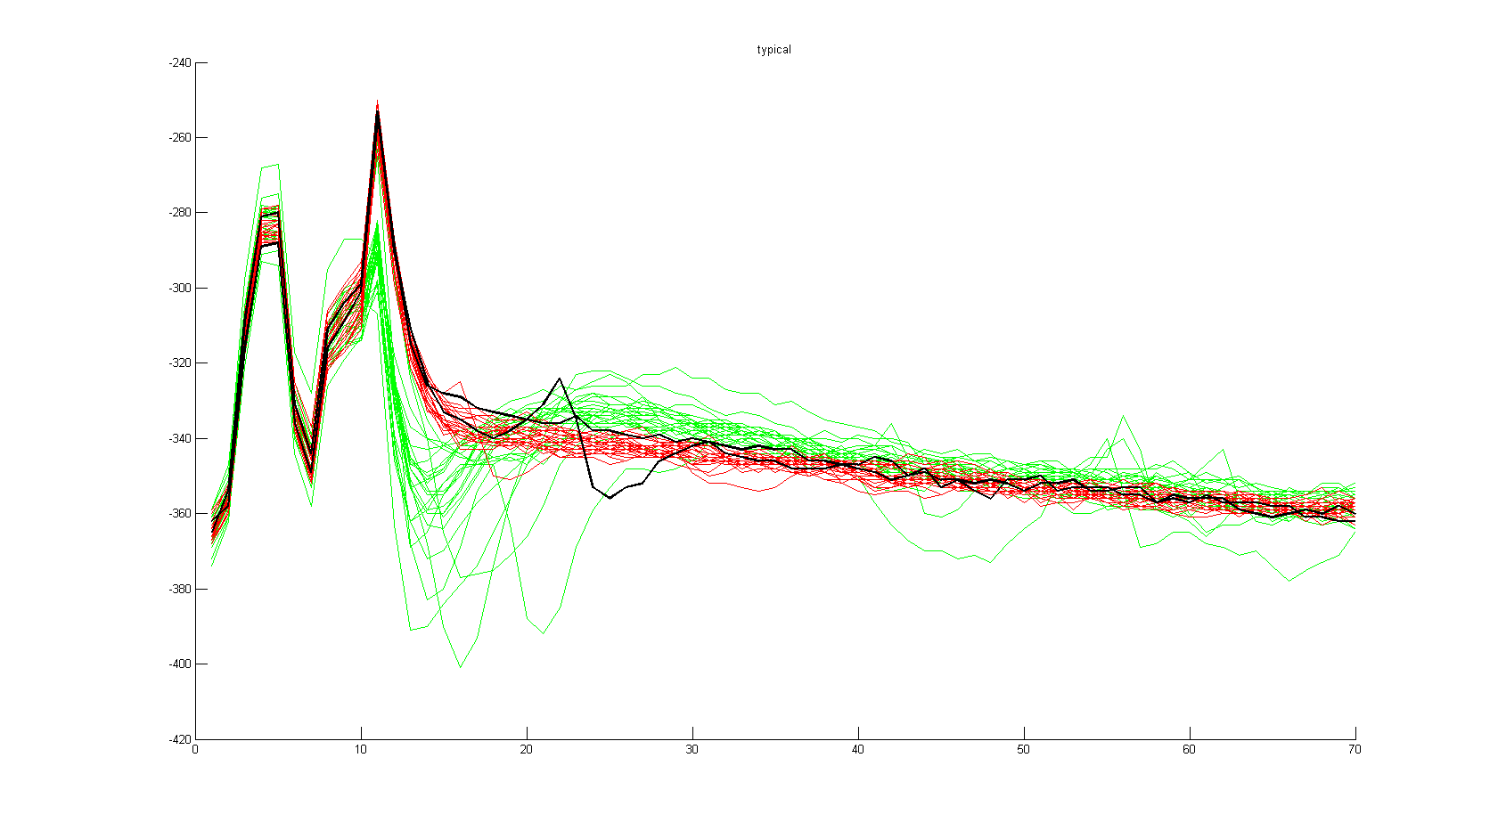
If Quantization Threshold(QT)is exceeded that means some other trace lies above considered one, therefore we infer that trace under investigation (here no. 2) most likely is not stimulation artifact, as we assume, that traces not containing neural spikes should lie above traces with neural activity (until hyperpolarization phase). To mitigate the influence of outliers one trace lying above given trace is not enough to exclude it from the set of artifacts. It needs at least 5 'votes', that is traces contaning more positive samples by margin of QT. Measures to ensure homogeneity in the set of proposed artifacts were taken. Two most differing traces are excluded when computing mean stimulation artifact (picture below, traces is black).

The value of QT is not known, and in principle it can vary from neuron to neuron, or even from one movie to another. We need to find the right value in each case. The procedure used to accomplish this aim is described in the next paragraph.

2. Determining value of QT

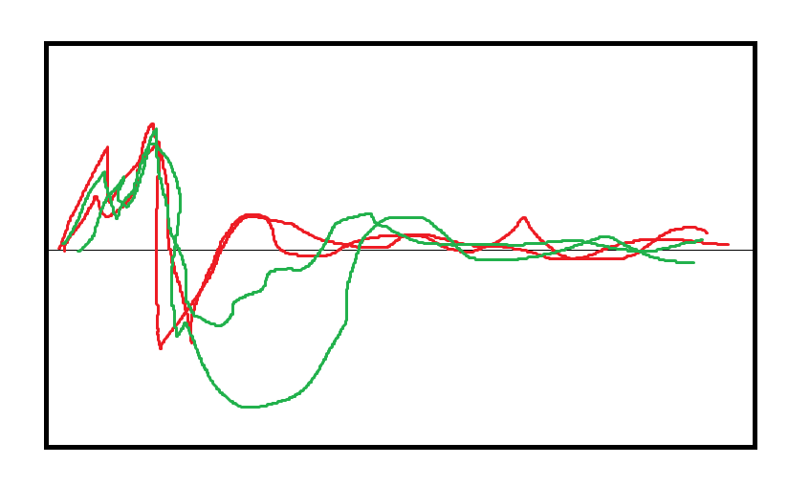
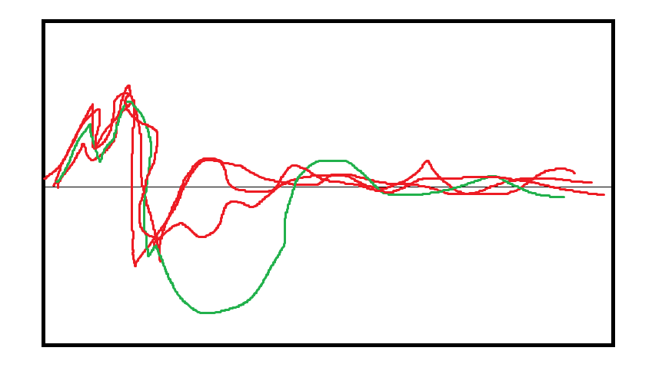
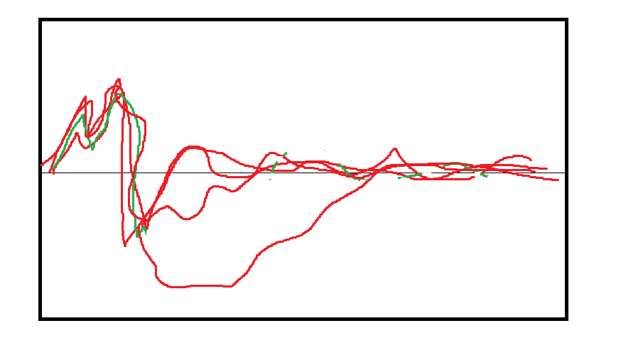
Let's consider a set of traces, and three different classifications of traces performed by described algorithm for different values of QT (red – declared artifacts, green – declared not artifacts)

Now let's take mean of traces marked as artifacts (in red)

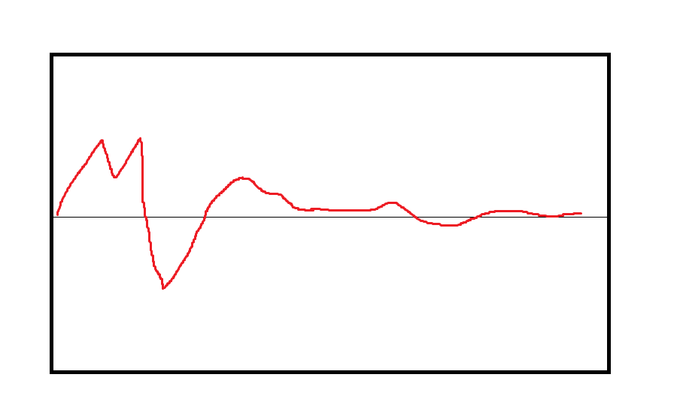
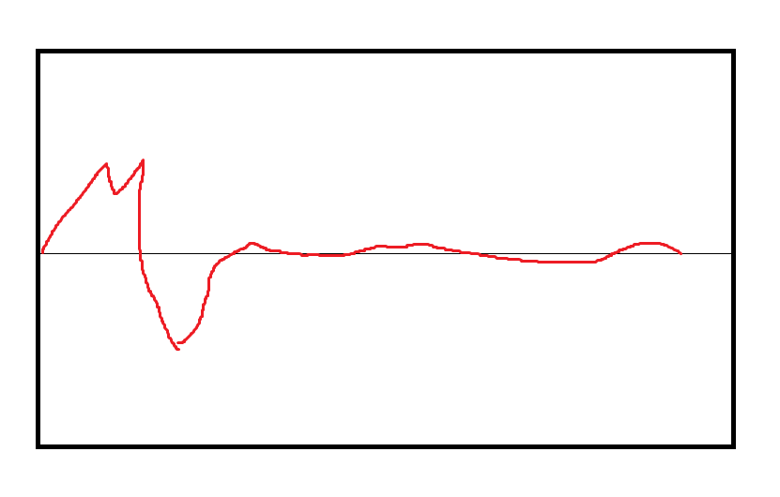
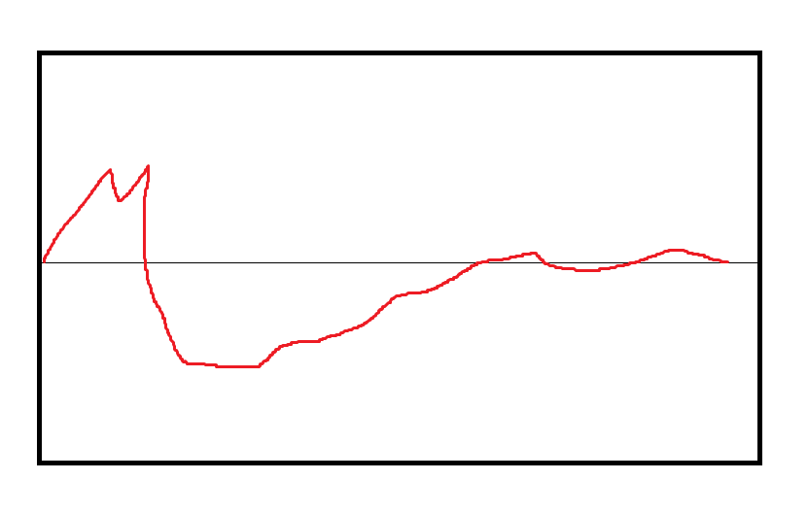

To find the proper QT we compare mean artifacts found for different values of QT. If the difference between two mean artifacts (defined as area between two curves vide picture) is negligible, then they are declared as belonging to the same 'stability island'.

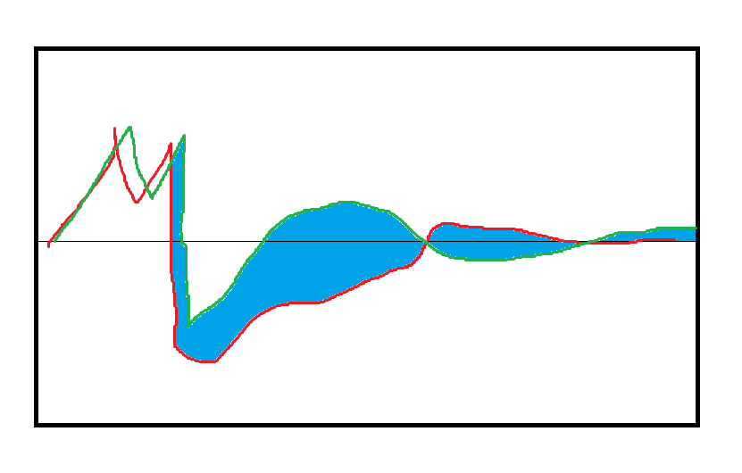
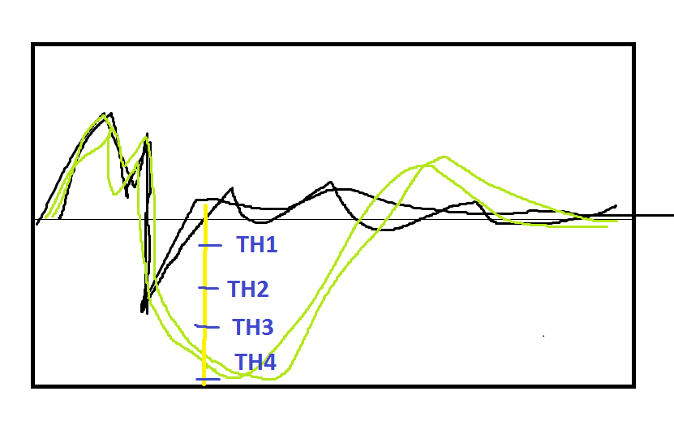
It means that traces classified as artifacts by two iterations of algorithm with different QTs are similar to each other. If the stability island spans through multiple thresholds, that means either we found cluster of similar traces lying above other ones (our operational definition of only-artifact traces) or there are no distinct groups of traces (0% and 100% stimulation efficiency . The purpose of defining stability island is graphically presented in picture.
Up until value of QT marked as TH4 the artifacts declared by each iteration of the algorithm will be the same (marked black), resulting in zero difference function. That leads to declaration of stability island consisting of 3 different QT values. From that we can deduce that probably there is a cluster of similar traces (sole artifacts) lying above other traces by at least the difference between the largest value of QT from stability island and the smallest one (TH3 – TH1 in given case). From threshold values in stability island set we choose one and perform classification using it as parameter to algorithm described in paragraph 2. As result we get traces declared 'only artifacts' and by computing mean waveform we obtain model of stimulation artifact. This allows us to proceed to the last phase of routine – spike detection.

3. Spike detection

With model waveform of stimulation artifact we can proceed to the final phase – spike detection. The black traces in picture were classified as bare artifacts.

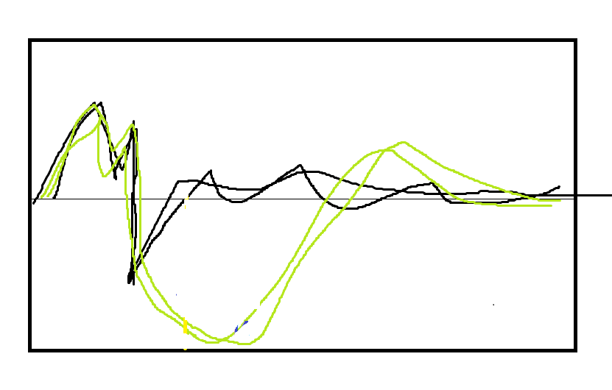

By subtracting the mean of black traces from all the other ones we get waveforms of such shape:
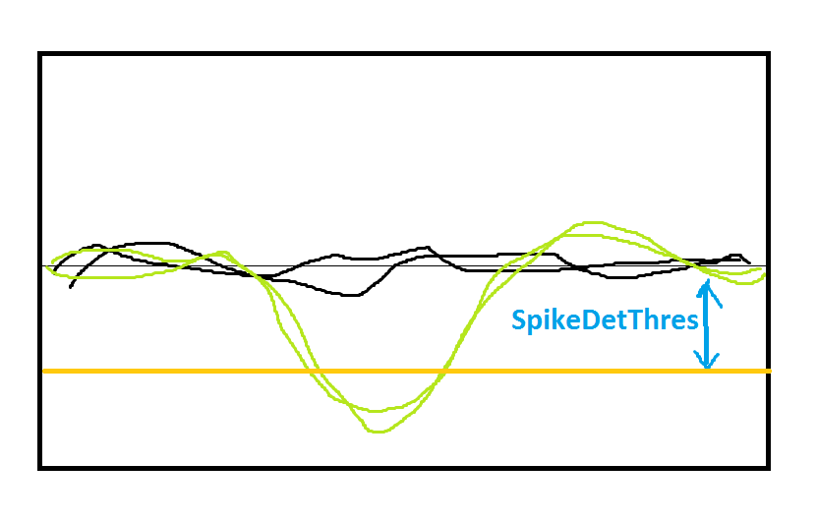

From that point spike detection is fairly easy – we just need to specify a value when exceeded triggers categorization of given trace as spike ( SpikeDetThres on picture). This value can be obtained as a percentage of amplitude retrieved from electrophysiological image of given neuron from light stimulation phase.

4. Proof of concept – real data

Classification of traces
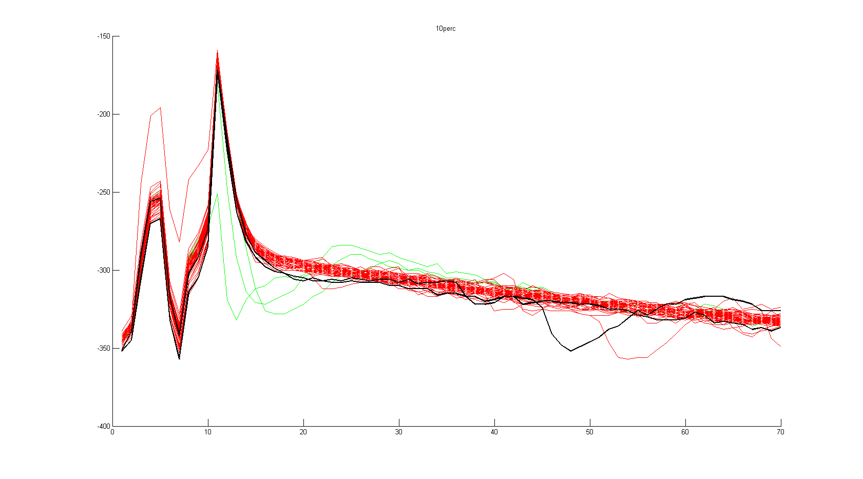

Choosing best movie:

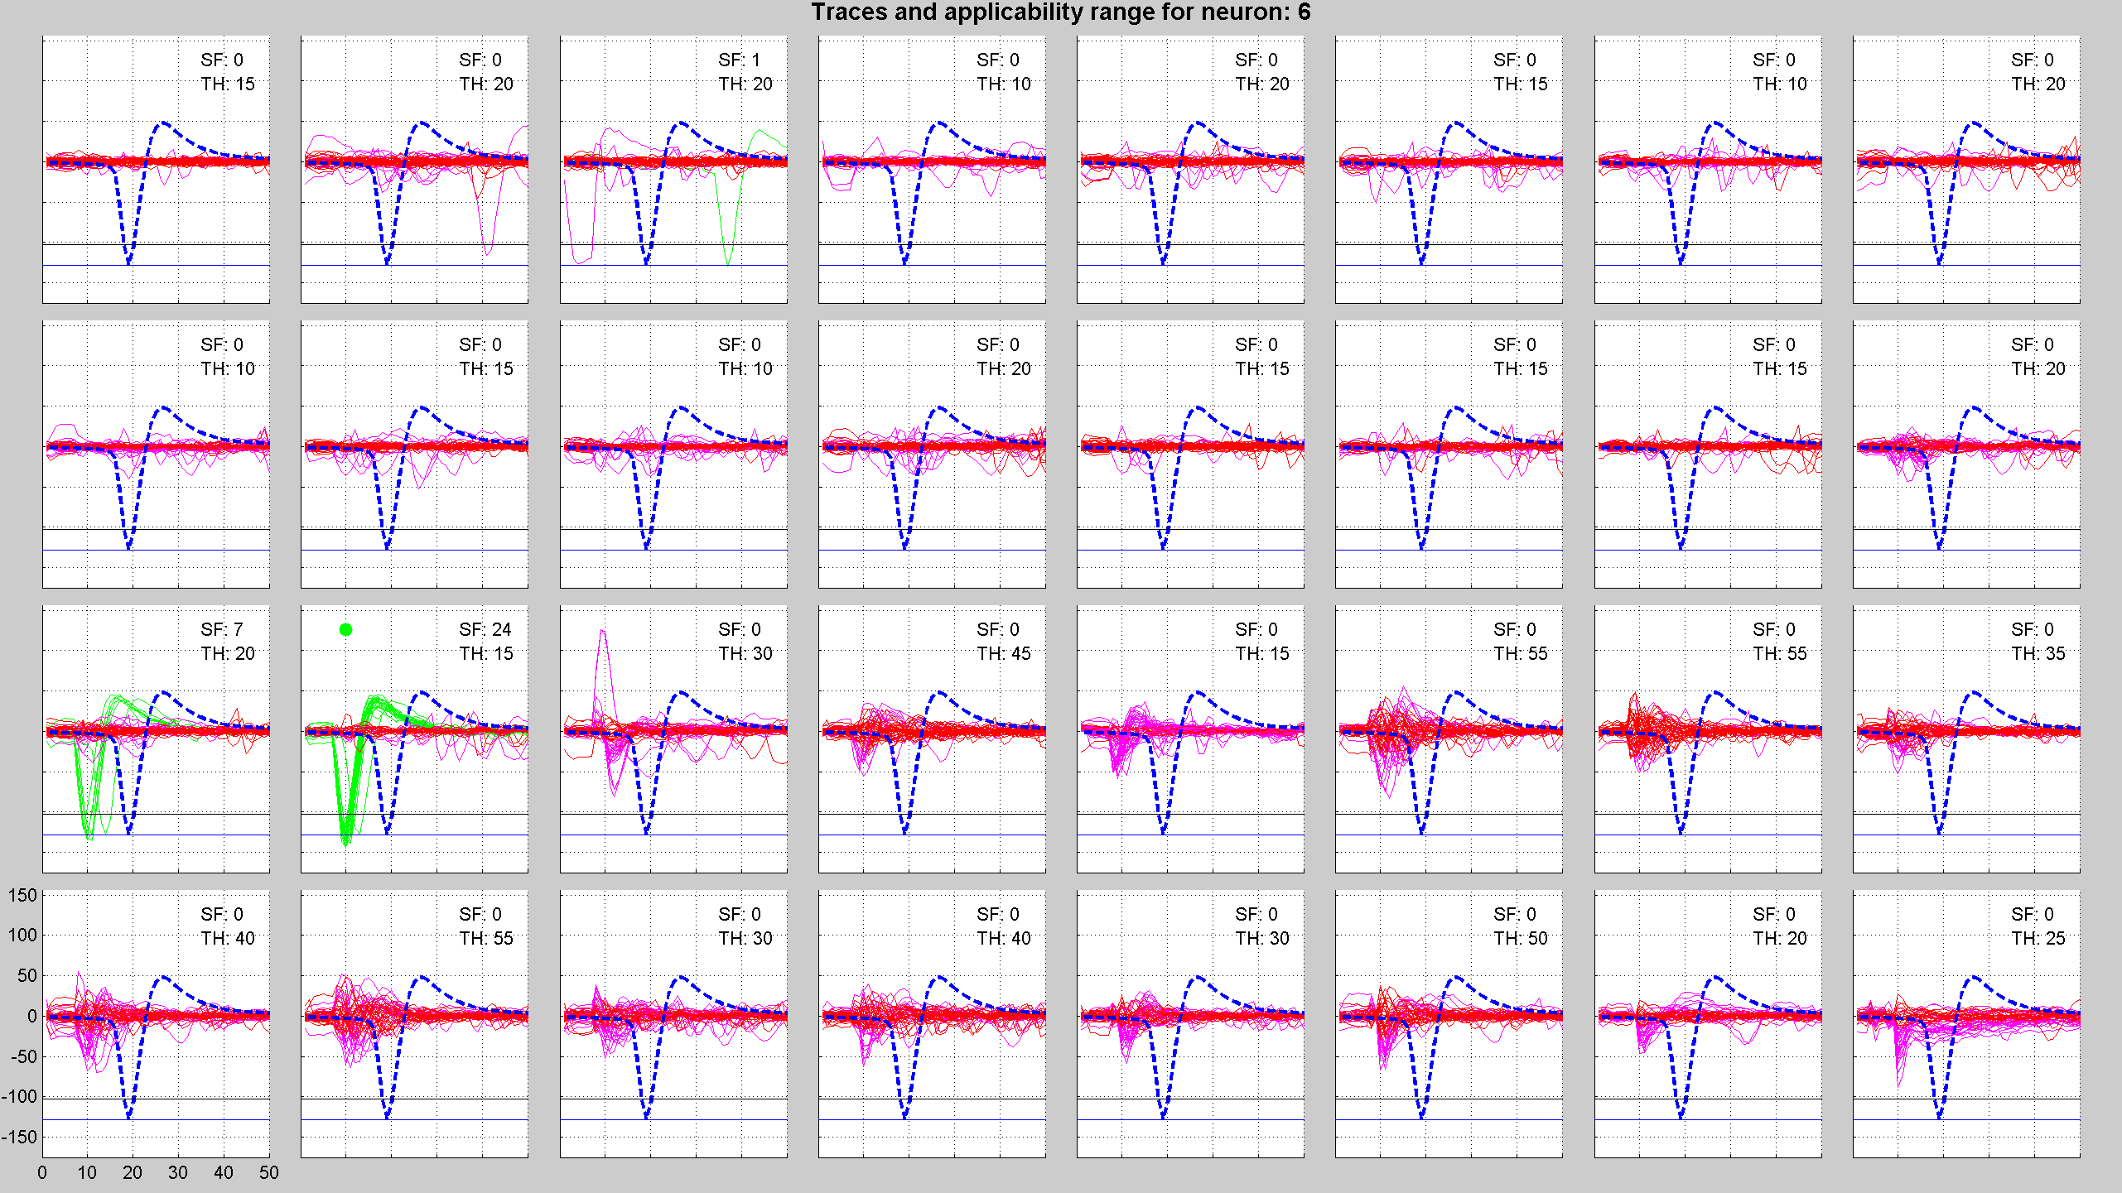
Choosing best stimulation electrode:

