INTRODUCTION

Conducting electrophysiological experiments with multielectrode arrays and dissected retinas produces lot of data. To extract meaningful information it has to be closely examined by scientists themselves. Firstly traces with and without neural responses have to be distinguished. After that best stimulation electrode has to be determined and optimal stimulation current needs to be identified. Our algorithm aims to automation of that process. It is modular by desing, that means every procedure designed to accomplish given step can be exchanged without affecting how other layers compute. The flow of computation consists of several levels: obtaining stimulation artifact model, spike detection, picking optimal current amplitude and lastly choosing best stimulation electrode. All steps with its inputs and outputs are presented in graphic 1.

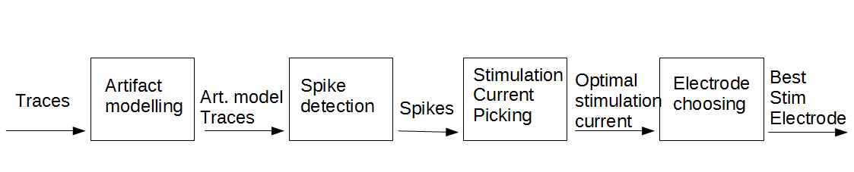Figure 1: Steps of the algorithm

During experiment two types of stimulation can be encountered: somatic (by electrodes placed in strict vicinity of target neuron) and axonal (by electrodes that happened to be over axon of given neuron). Those two categories of stimulation differ quite significantly when we look closer to their stimulation efficiency function, defined as percentage of trials with neural activation as function of stimulation current. While somatic stimulation is characterized by gradual gain in efficiency with larger current amplitudes, axonal stimulation might be described by some threshold current amplitude. In the latter case efficiency for amplitudes smaller than the borderline value oscillates round 0% and for the larger ones almost every electrical stimulus results in neuroal spike (vide figures 2 and 3 from Hottowy et al. (2012)). Our algorithm was designed and tuned on data with mainly somatic stimulation from retinas dissected from mice(presented in Methods section) . After that we performed tests on datasets gathered in experiments with monkey's retinas (reported on Results section).

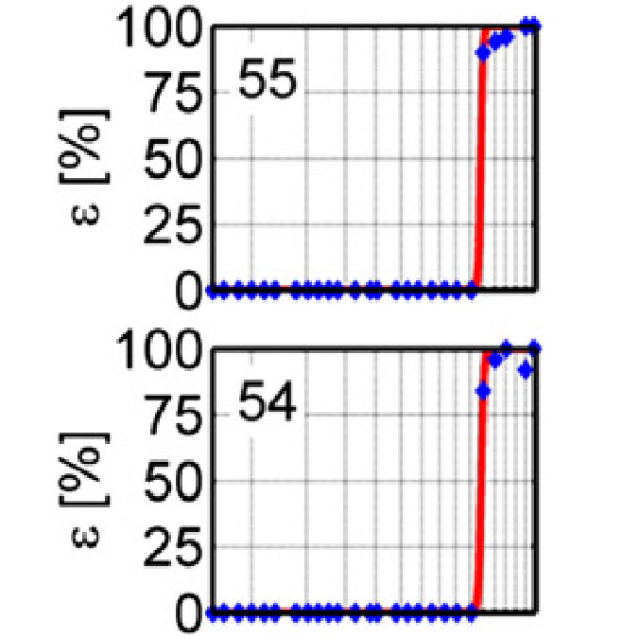Figure 3: Axonal Stimulation
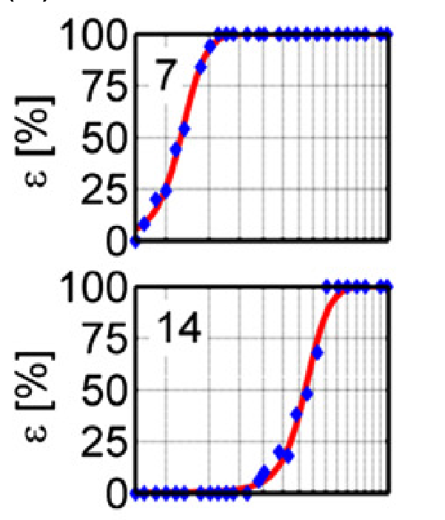Figure 2: Somatic stimulation.

METHODS

Stimulation Artifact Modelling

During the experiments neuron was usually stimulated 50 times with given current amplitude. As we do not know the shape of stimulation artifact a priori we need to extract its waveform from gathered data. First step is to determine whether given trace contains neural activity or not. Traces without such activity should be more positive compared to other ones until hyperpolarization phase. To distinguish those cases we compare given trace against every other in the set by subtracting it. Each other waveform is 'voting' whether investigated trace should be crossed out from artifact candidates. Let's consider traces 1, 2 and 3 marked on the figure 4.

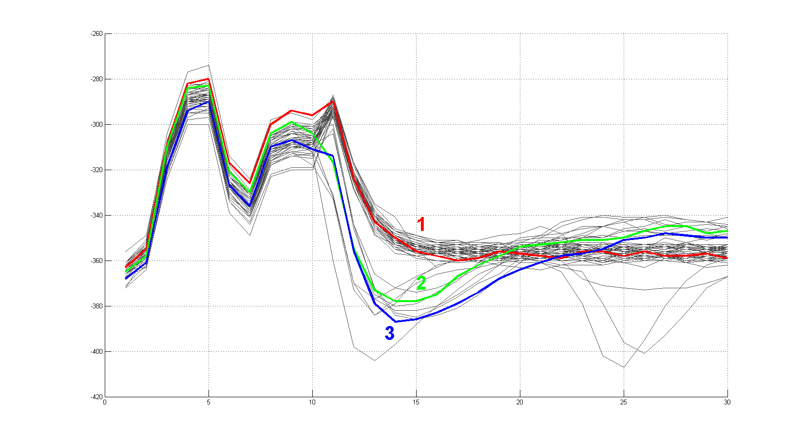Figure 4: 50 waveforms from one movie.
A value called Quantization Threshold(QT) is used to tell whether given waveform should be classified as stimulation artifact or it contains neural spike. When exceeded, it means some other trace lies above considered one. Let's consider waveforms 1 and 2 from figure 4 and arbitrarily set QT to value 20. If we subtract trace 2 from trace 1 we will obtain a curve depicted on figure below.

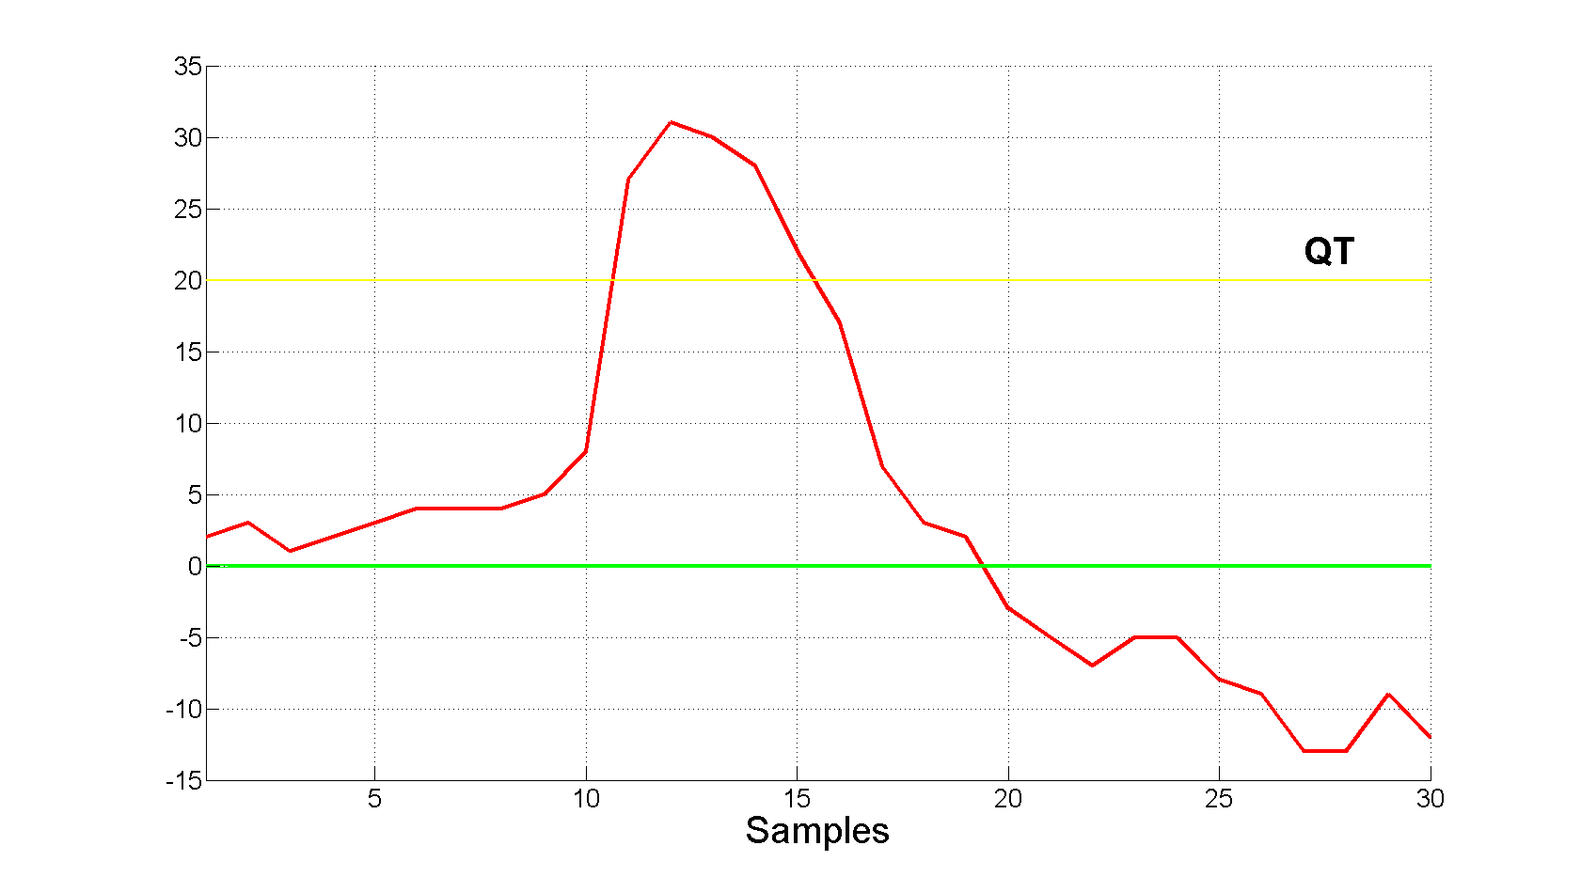Figure 5: Trace no. 2 subtracted from trace no. 1
The Quantization Threshold is indeed exceeded therefore trace number 2 gets one vote to cross it out from Artifact Candidates set.

Let us consider another set of waveforms resulting from stimulation with different amplitude (fig. 6). There is clearly one cluster of artifact-only traces (among which trace no. 3 is found), other one consisting of waveforms with neural stimulation and two problematic traces marked as 1 and 2.

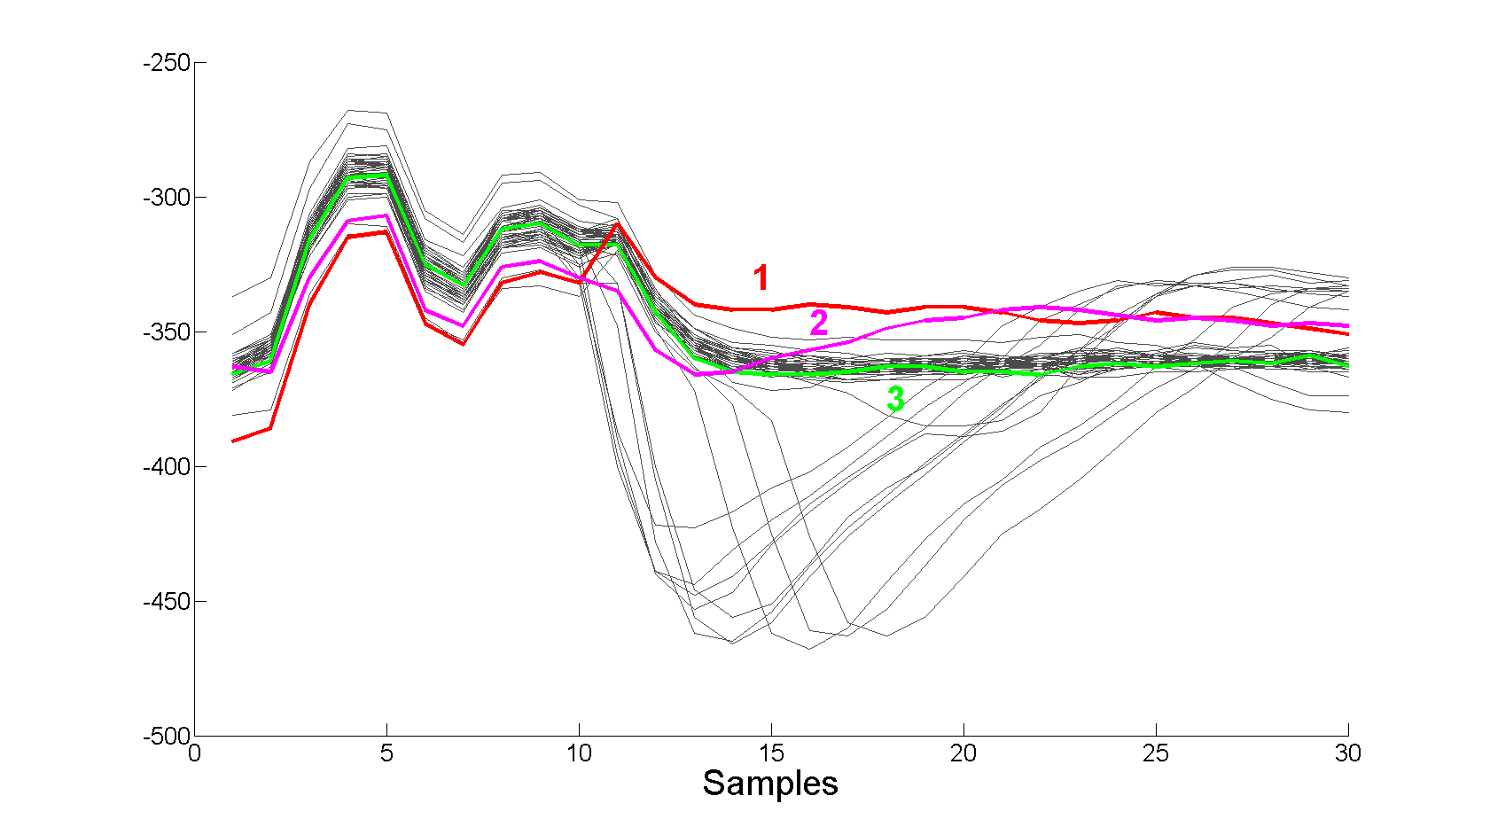Figure 6: Movie with outliers
If we perform test whether trace no. 3 is artifact we will get two negative answers from waveform no. 1 and 2 (breach of QT illustrated on figure 7). To mitigate the influence of outliers one trace lying above given waveform is not enough to exclude it from the set of artifacts. It needs at least 5 'votes', that is traces containing more positive samples by margin of QT.

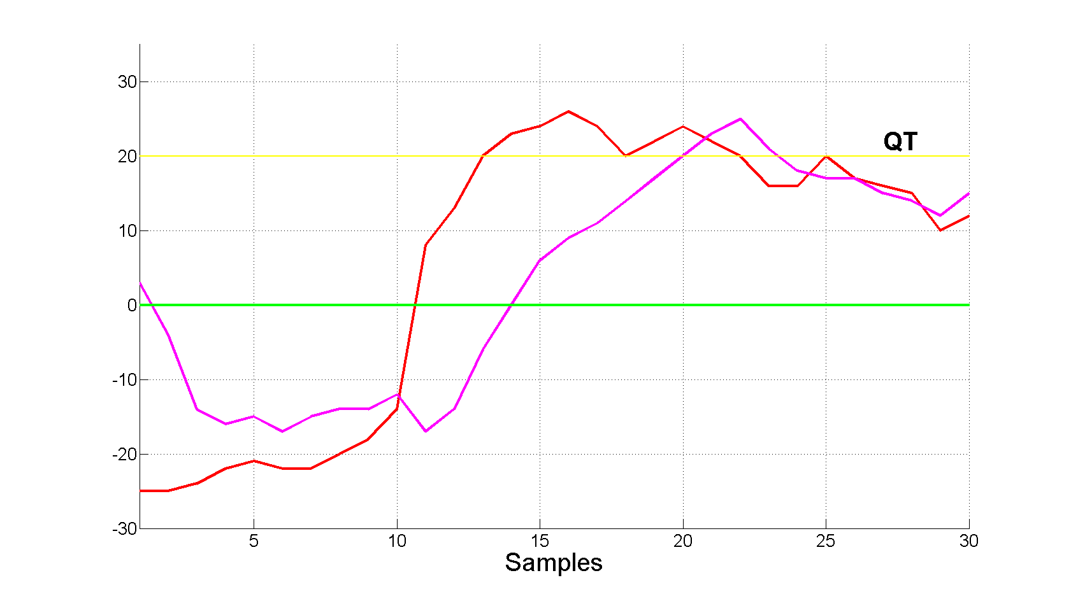Figure 7: Outliers subtracted

Classification performed by algorithm with QT set to 20 is presented on figure 8.

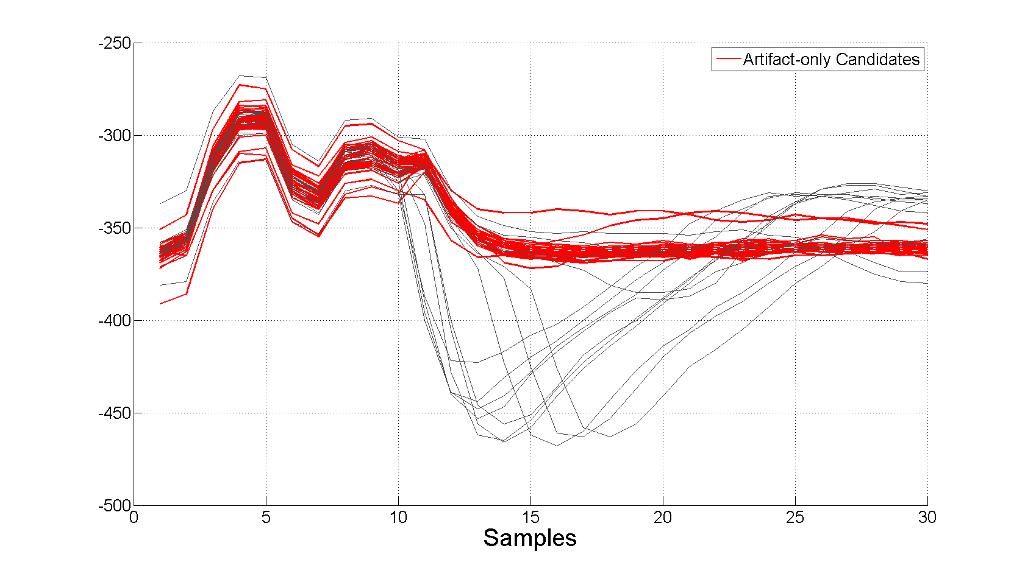Figure 8: Classification performed by algorithm
The two outliers are included in artifact-only candidates set, which we use to compute the model of stimulation artifact. It is not desired as they can greatly influence the model. To address that problem we define a dissimilarity function (eq. 1) and compute it's value for every artifact-only candidate. Two candidates with highest scores are crossed out.
Equation 1: Dissimilarity Function
where L is length in samples of trace, is i-th sample of trace andis mean artifact-only candidate.

Dropping two most differing waveforms results in more homogenous set which we use to estimate stimulation artifact model by computing its mean (fig. 9).

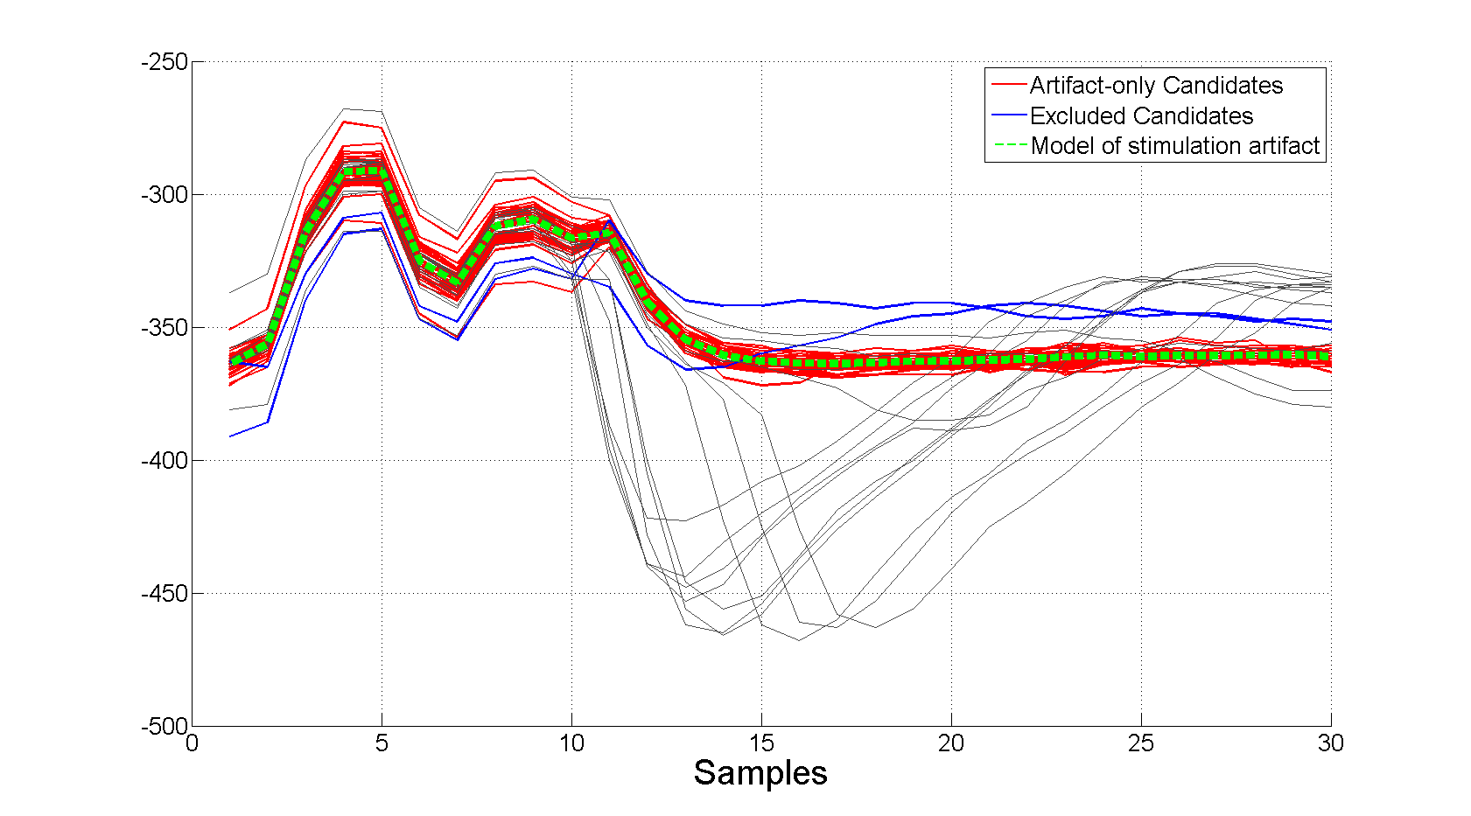Figure 9: Stimulation artifact model

The optimal value of QT is not known, and in principle can vary from neuron to neuron, or even from one movie to another. We need to find the right value in each case. The procedure used to accomplish this aim is described in the next paragraph.

2. Determining value of QT

541 m 11

To illustrate how the right value of QT is chosen let us look into data from stimulation with one current amplitude (fig. 10).

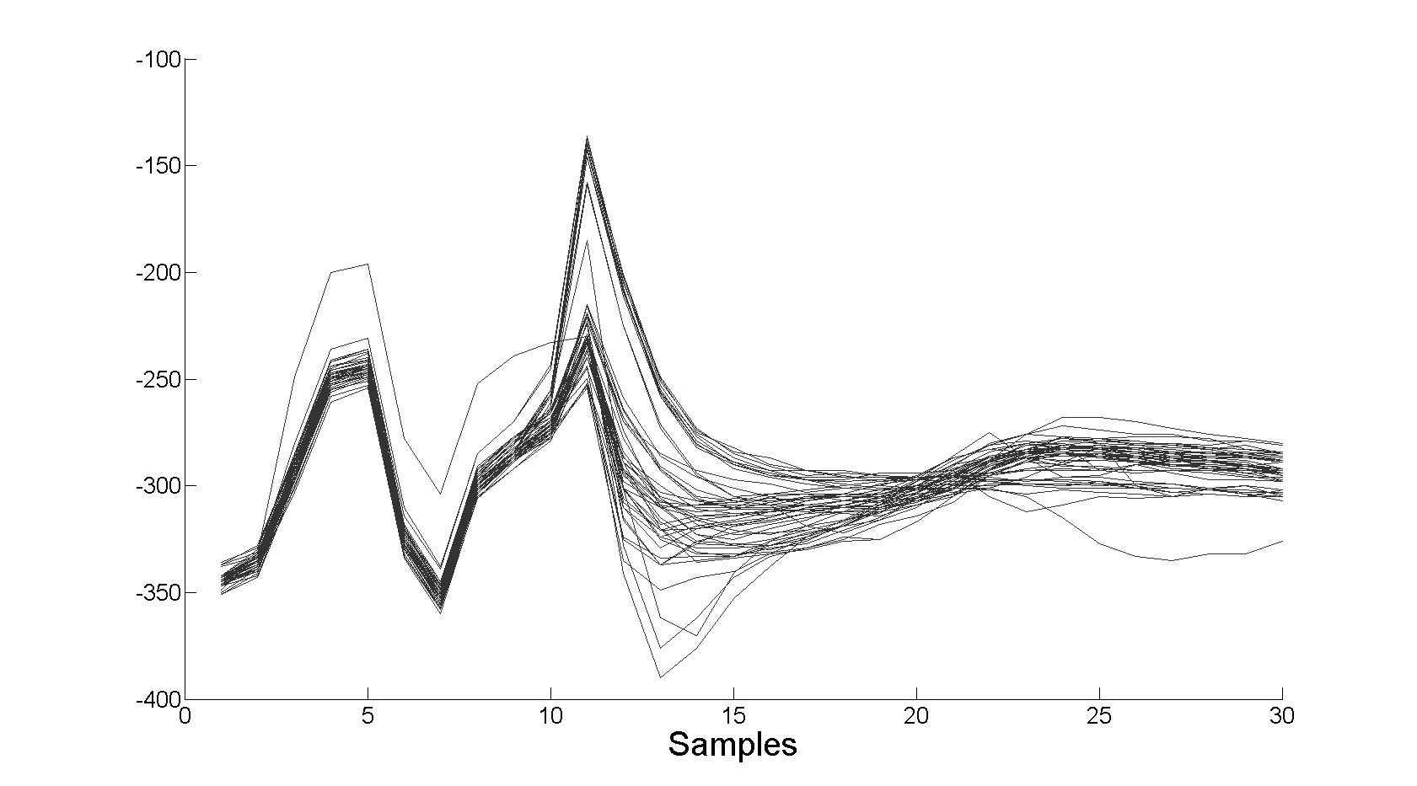Figure 10: Traces recorded during stimulation
Computation on aforementioned data set was conducted four times using algorithm described in previous section yielding four different classifications of Artifact Candidates. Each iteration of algorithm used different values of Quantization Threshold. The results are shown if figure 11. The green dashed line represents mean artifact computed from Candidate Artifacts (plotted in red).

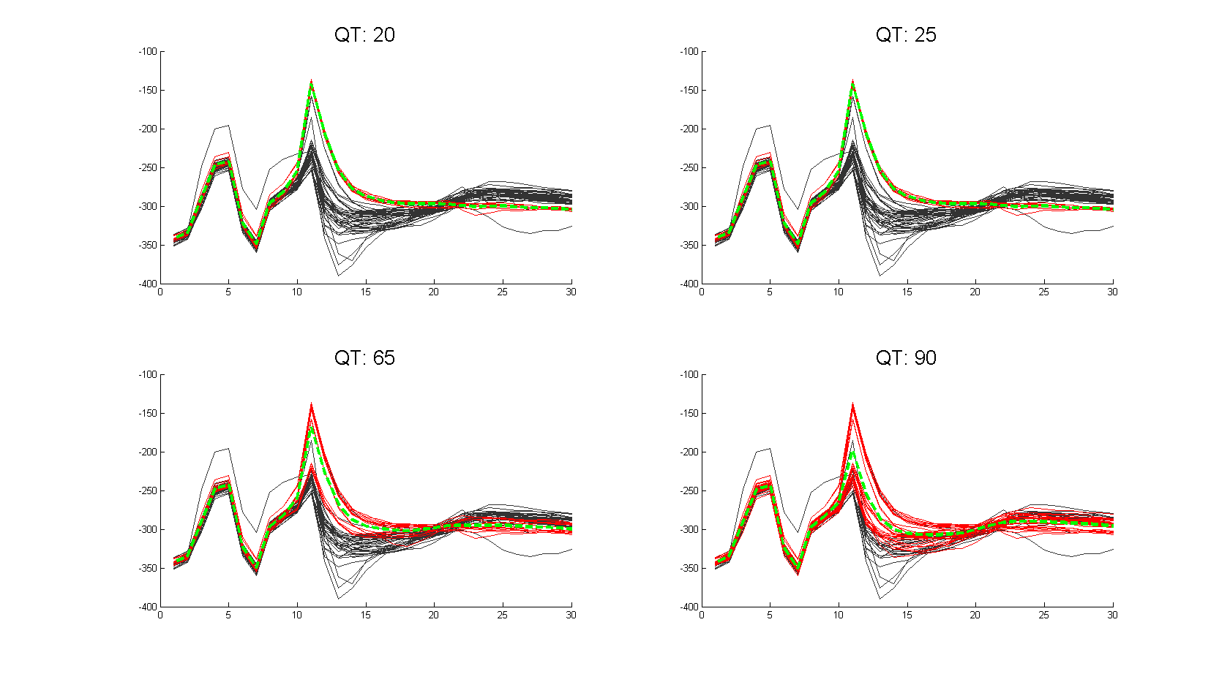Figure 11: Classification of candidate artifacts performed with different values of quantization threshold with mean artifact plotted in green.
Now we would like to know whether two classifications yield similar results. To do that let us plot two mean artifacts for threshold 20 and 90 from figure 11. As a measure of dissimilarity between two models of artifact we use area between curves representing them (fig 12).

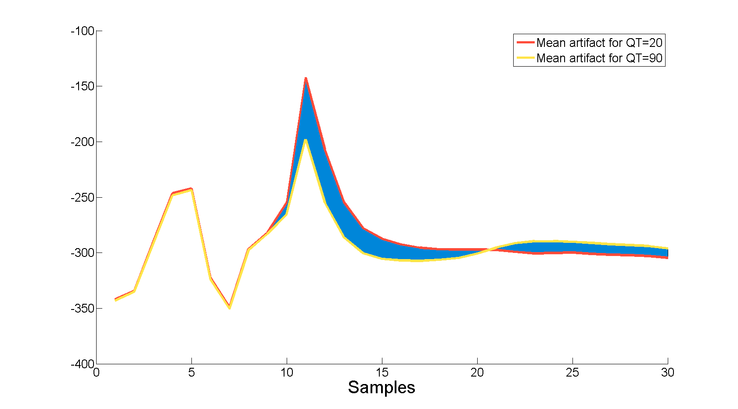Figure 12: Dissimilarity measure between two mean artifacts

Now let's take mean artifacts for different QTs (20, 25, 60, 90 represented in figure 11) and compute dissimilarity functions between them. The results are represented in figure 13. There are obviously 0s in diagonal as we compute dissimilarity function for one curve with itself. The smaller measure is the more similar are two artifact models computed for different QTs.

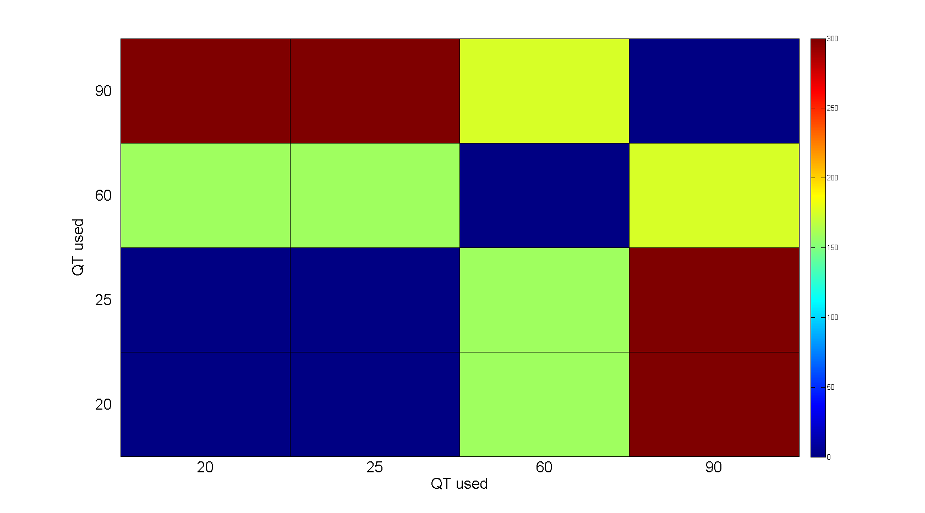Figure 13: Difference measure between artifact models computed for different values of QT
As can be seen (or not in that case) in fig 14 models of artifact computed for thresholds 20, 25 are exactly the same (that's why one curve is covered by another). They both differ a from mean artifact for QT = 60 and even more for that one computed with QT = 90, what is reflected in value of dissimilarity measure shown in colors in figure 13.

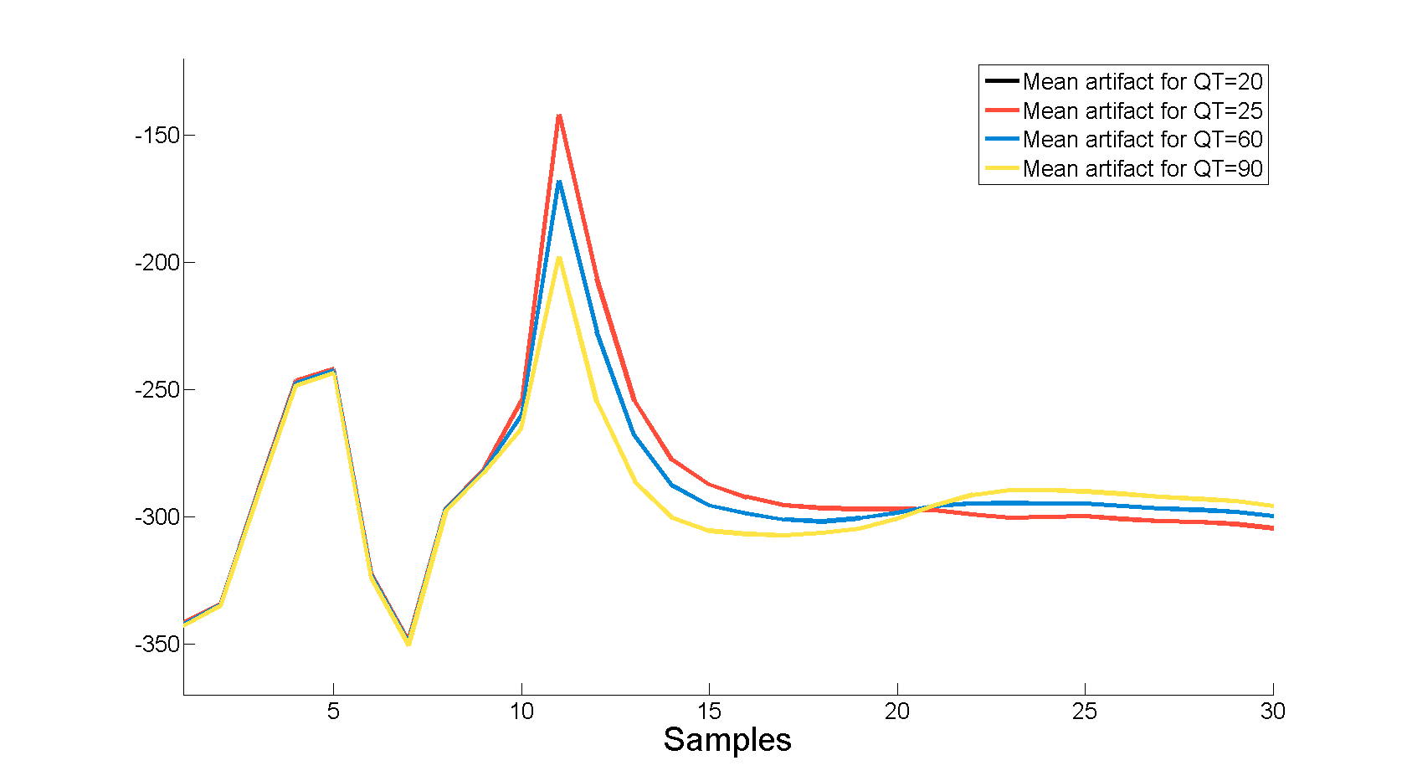Figure 14: Artifact models found for different values of QT

A blue square in the lower left corner of that illustration represents thresholds for which artifact model is very similar, which means despite changing QT artifact candidates chosen by the algorithm are quite the same every iteration. This is what we call a 'stability island', and we infer we found a cluster of similar waveforms lying above other traces which is our operational definition of artifact-only traces.

Now let's take a broader look to analysis performed on data described above. If figure 11 on right hand side there is matrix summarising dissimilarity function between model artifacts for every QT used. Top left graphic illustrates classification of traces to candidate artifact group, and in bottom left the same classification but for traces with mean artifact subtracted. Quantization Threshold for which the classification is performed is marked by the red rectangle in the bottom of subplot C.

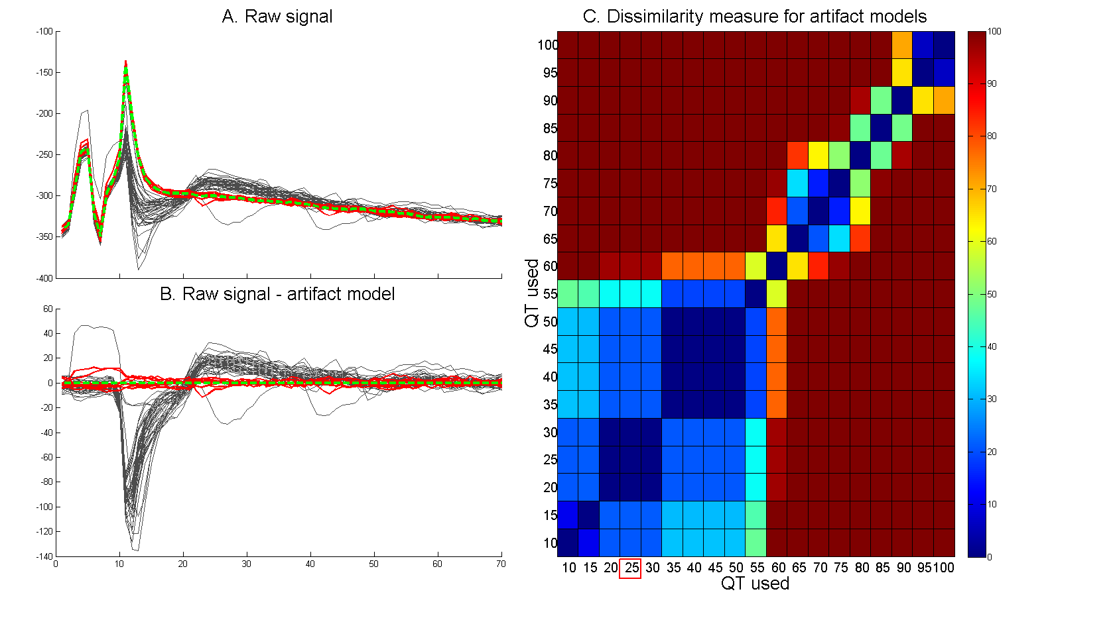Figure 15: Artifact model dissimilarity function for every QT and classification for threshold 25.
In graphic C of figure 15 we can notice two stability islands – one spanning through QT from 20 to 30 and the other one for thresholds 35 – 50. Classifications for QT from the first stability island can be found in figure 15, from the second in fig 16 and from region of high QTs in fig 17. Algorithm chooses Quantization Threshold from first stability island found consisting at least three thresholds.

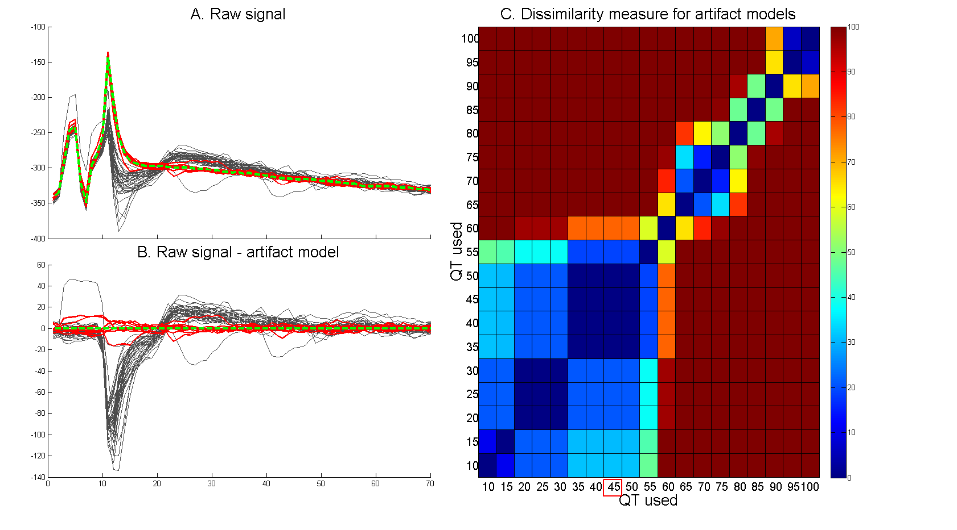Figure 16: Artifact model dissimilarity function for every QT and classification for threshold 45.

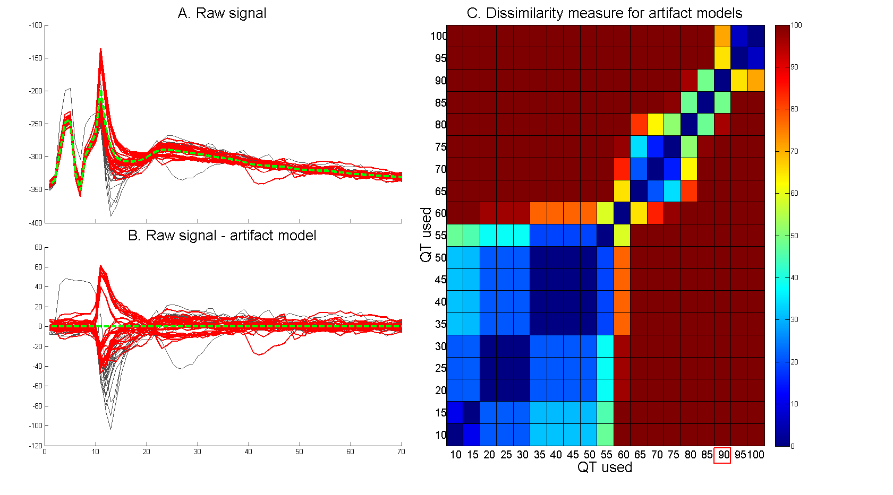Figure 17: Artifact model dissimilarity function for every QT and classification for threshold 90

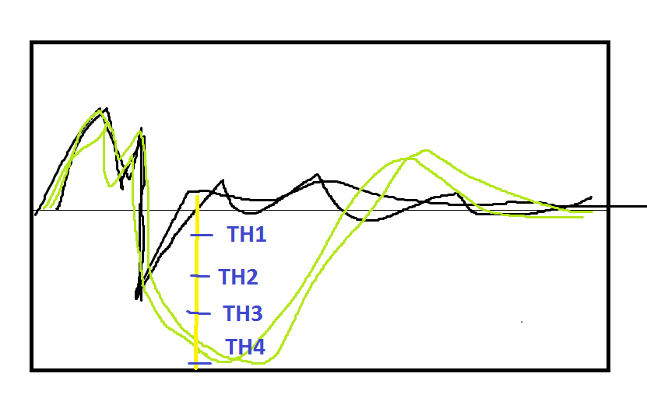
It means that traces classified as artifacts by two iterations of algorithm with different QTs are similar to each other. If the stability island spans through multiple thresholds, that means either we found cluster of similar traces lying above other ones () or there are no distinct groups of traces (0% and 100% stimulation efficiency . The purpose of defining stability island is graphically presented in picture.
Up until value of QT marked as TH4 the artifacts declared by each iteration of the algorithm will be the same (marked black), resulting in zero difference function. That leads to declaration of stability island consisting of 3 different QT values. From that we can deduce that probably there is a cluster of similar traces (sole artifacts) lying above other traces by at least the difference between the largest value of QT from stability island and the smallest one (TH3 – TH1 in given case). From threshold values in stability island set we choose one and perform classification using it as parameter to algorithm described in paragraph 2. As result we get traces declared 'only artifacts' and by computing mean waveform we obtain model of stimulation artifact. This allows us to proceed to the last phase of routine – spike detection.

3. Spike detection

With model waveform of stimulation artifact we can proceed to the final phase – spike detection. The black traces in picture were classified as bare artifacts.

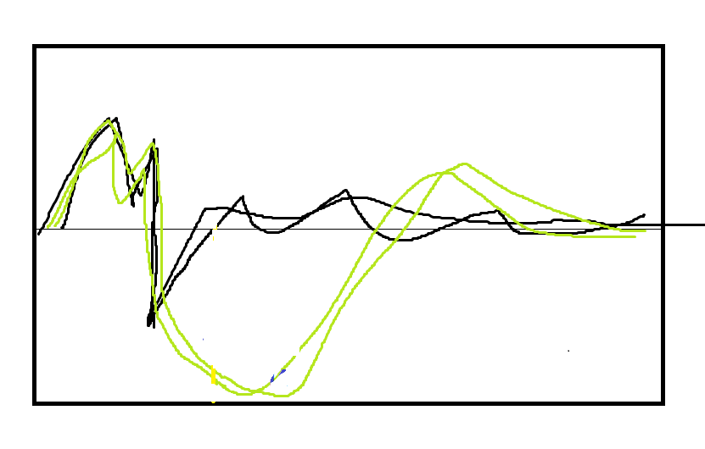

By subtracting the mean of black traces from all the other ones we get waveforms of such shape:
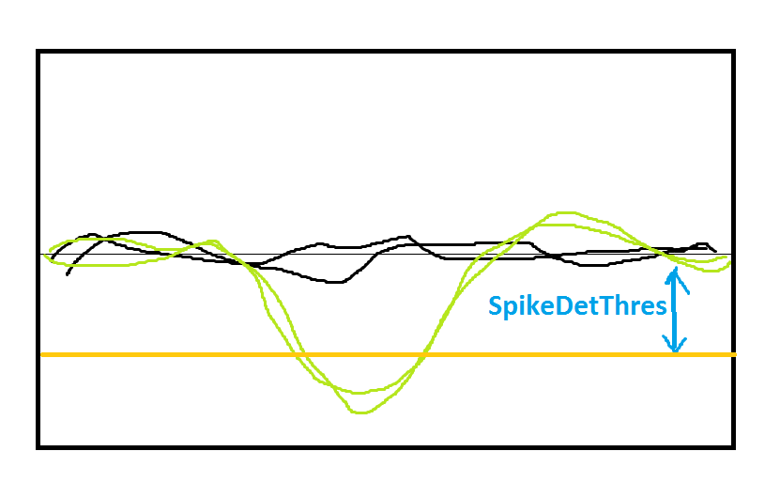

From that point spike detection is fairly easy – we just need to specify a value when exceeded triggers categorization of given trace as spike ( SpikeDetThres on picture). This value can be obtained as a percentage of amplitude retrieved from electrophysiological image of given neuron from light stimulation phase.

4. Proof of concept – real data

Classification of traces
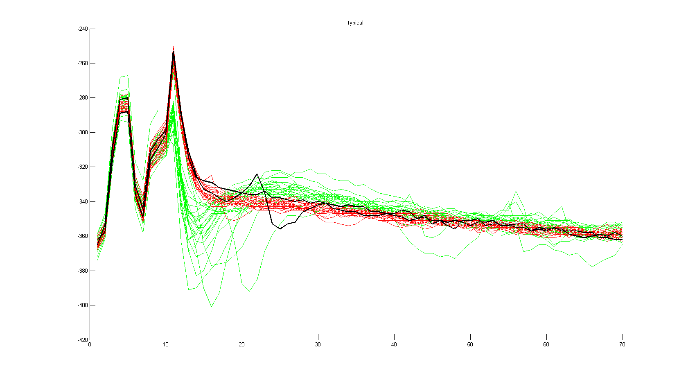
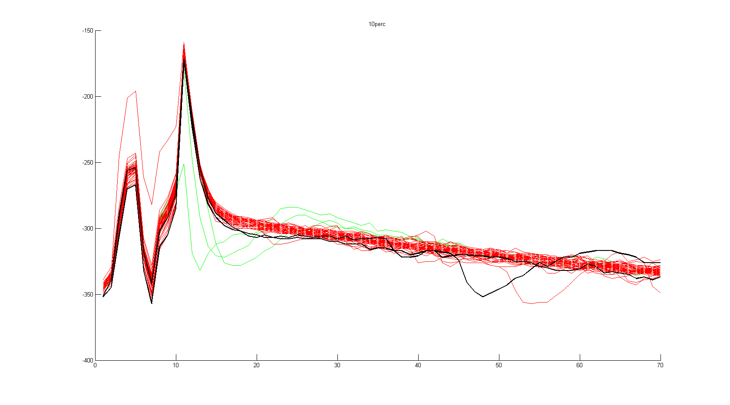

Choosing best movie:

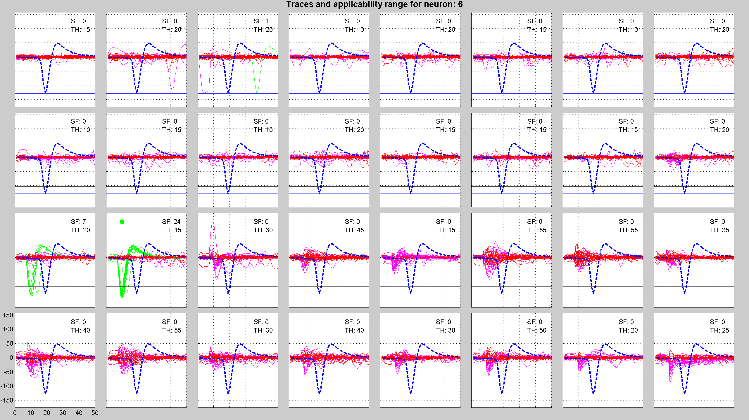
Choosing best stimulation electrode:

