INTRODUCTION

Conducting electrophysiological experiments with multielectrode arrays and dissected retinas produces lot of data. To extract meaningful information it has to be closely examined by scientists themselves. Firstly traces with and without neural responses have to be distinguished. After that best stimulation electrode has to be determined and optimal stimulation current needs to be identified. Our algorithm aims to automation of that process. It is modular by desing, that means every procedure designed to accomplish given step can be exchanged without affecting how other layers compute. The flow of computation consists of several levels: obtaining stimulation artifact model, spike detection, picking optimal current amplitude and lastly choosing best stimulation electrode. All steps with its inputs and outputs are presented in graphic 1.

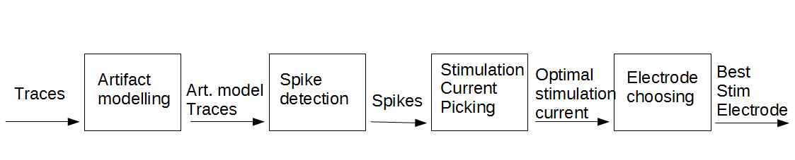Figure 1: Steps of the algorithm

During experiment two types of stimulation can be encountered: somatic (by electrodes placed in strict vicinity of target neuron) and axonal (by electrodes that happened to be over axon of given neuron). Those two categories of stimulation differ quite significantly when we look closer to their stimulation efficiency function, defined as percentage of trials with neural activation as function of stimulation current. While somatic stimulation is characterized by gradual gain in efficiency with larger current amplitudes, axonal stimulation might be described by some threshold current amplitude. In the latter case efficiency for amplitudes smaller than the borderline value oscillates round 0% and for the larger ones almost every electrical stimulus results in neuroal spike (vide figures 2 and 3 from Hottowy et al. (2012)). Our algorithm was designed and tuned on data with mainly somatic stimulation from retinas dissected from mice(presented in Methods section) . After that we performed tests on datasets gathered in experiments with monkey's retinas (reported on Results section).

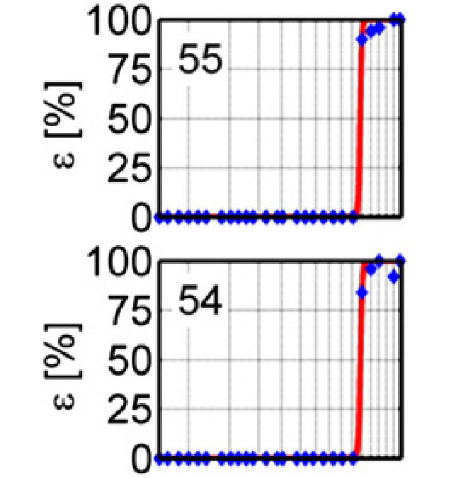Figure 3: Axonal Stimulation
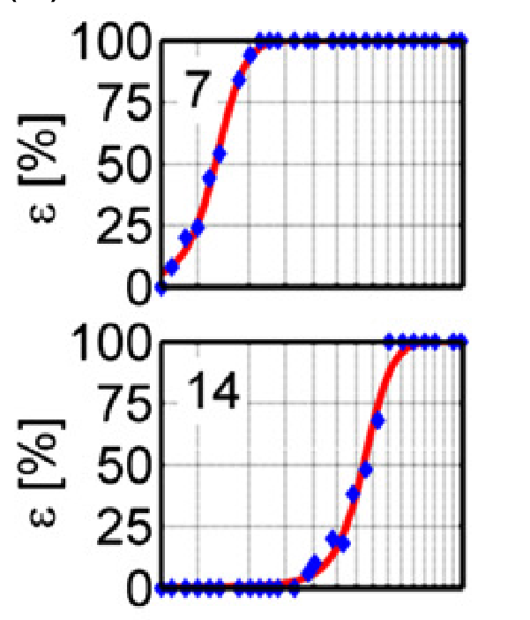Figure 2: Somatic stimulation.

METHODS

Stimulation Artifact Modelling

During the experiments neuron was usually stimulated 50 times with given current amplitude. As we do not know the shape of stimulation artifact a priori we need to extract its waveform from gathered data. First step is to determine whether given trace contains neural activity or not. Traces without such activity should be more positive compared to other ones until hyperpolarization phase. To distinguish those cases we compare given trace against every other in the set by subtracting it. Each other waveform is 'voting' whether investigated trace should be crossed out from artifact candidates. Let's consider traces 1, 2 and 3 marked on the figure 4.

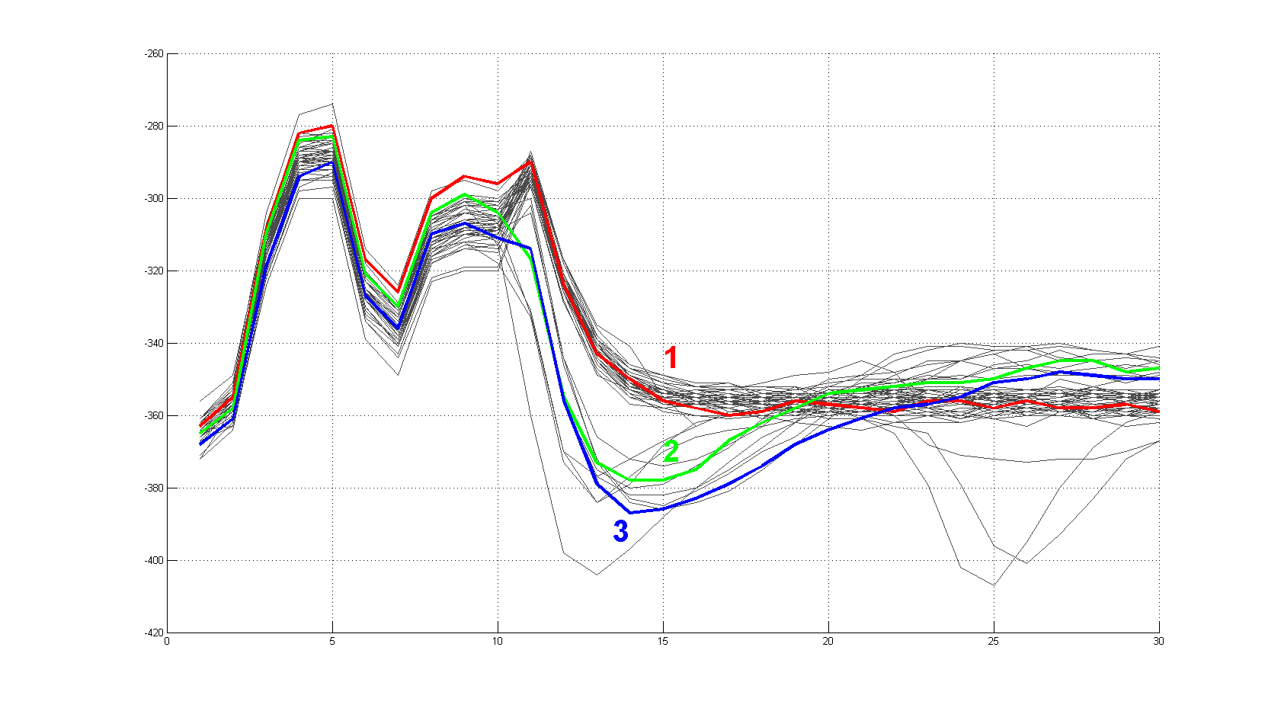Figure 4: 50 waveforms from one movie.
A value called Quantization Threshold(QT) is used to tell whether given waveform should be classified as stimulation artifact or it contains neural spike. When exceeded, it means some other trace lies above considered one. Let's consider waveforms 1 and 2 from figure 4 and arbitrarily set QT to value 20. If we subtract trace 2 from trace 1 we will obtain a curve depicted on figure below.

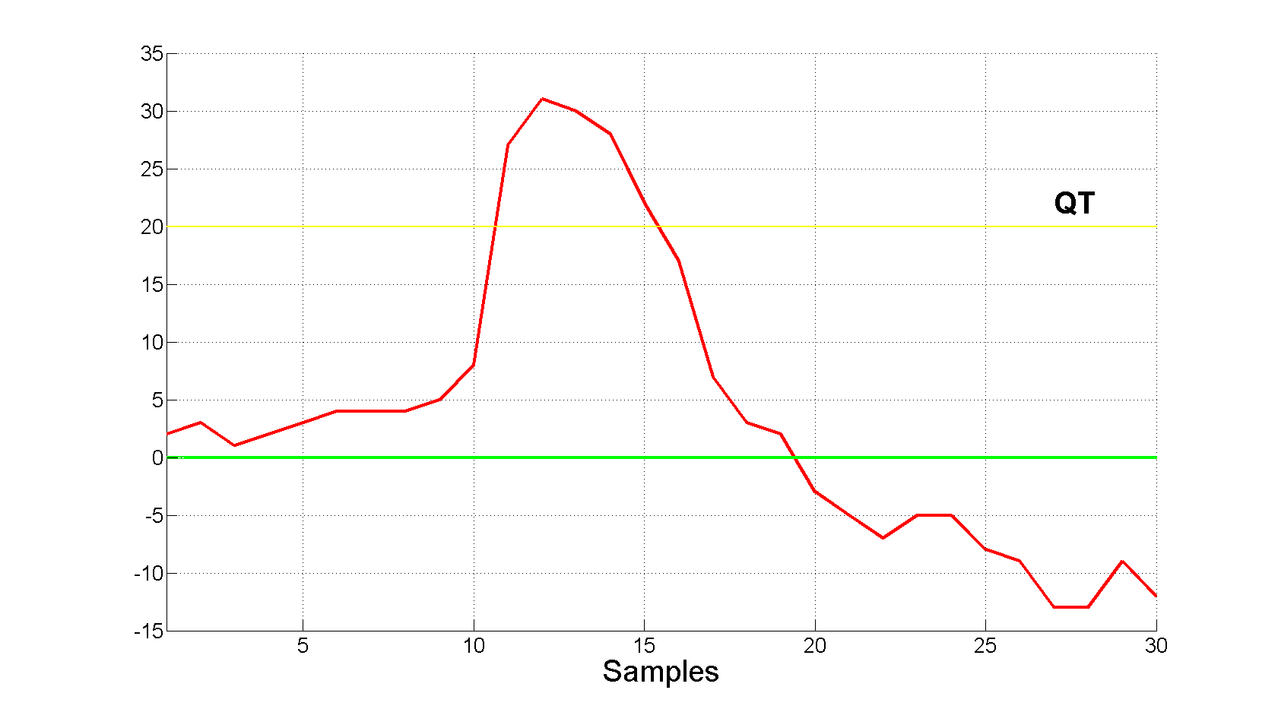Figure 5: Trace no. 2 subtracted from trace no. 1
The Quantization Threshold is indeed exceeded therefore trace number 2 gets one vote to cross it out from Artifact Candidates set.

Let us consider another set of waveforms resulting from stimulation with different amplitude (fig. 6). There is clearly one cluster of artifact-only traces (among which trace no. 3 is found), other one consisting of waveforms with neural stimulation and two problematic traces marked as 1 and 2.

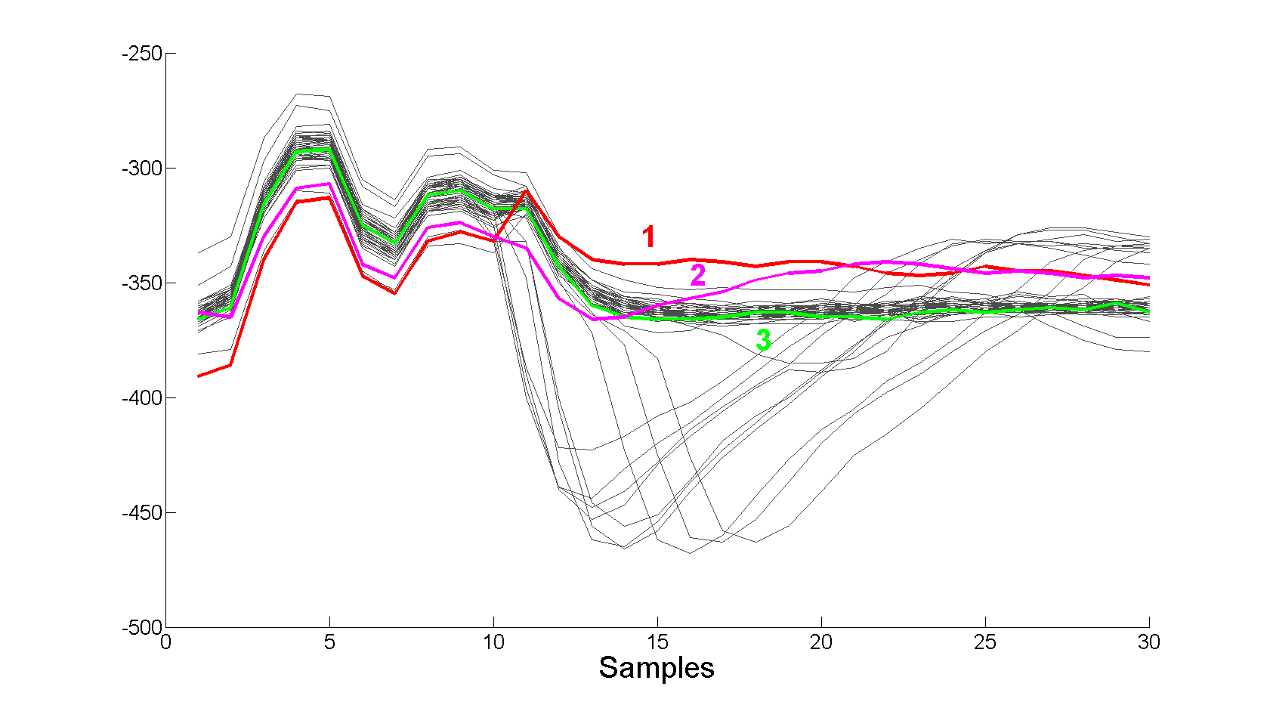Figure 6: Movie with outliers
If we perform test whether trace no. 3 is artifact we will get two negative answers from waveform no. 1 and 2 (breach of QT illustrated on figure 7). To mitigate the influence of outliers one trace lying above given waveform is not enough to exclude it from the set of artifacts. It needs at least 5 'votes', that is traces containing more positive samples by margin of QT.

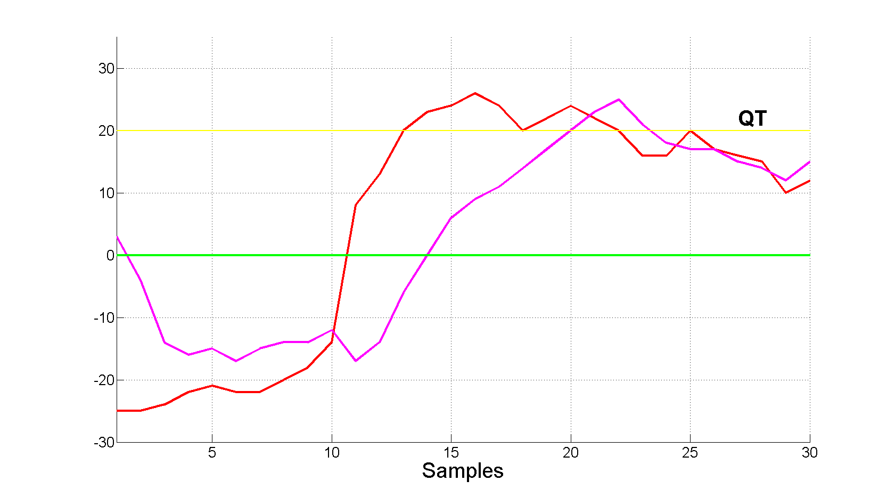Figure 7: Outliers subtracted

Classification performed by algorithm with QT set to 20 is presented on figure 8.

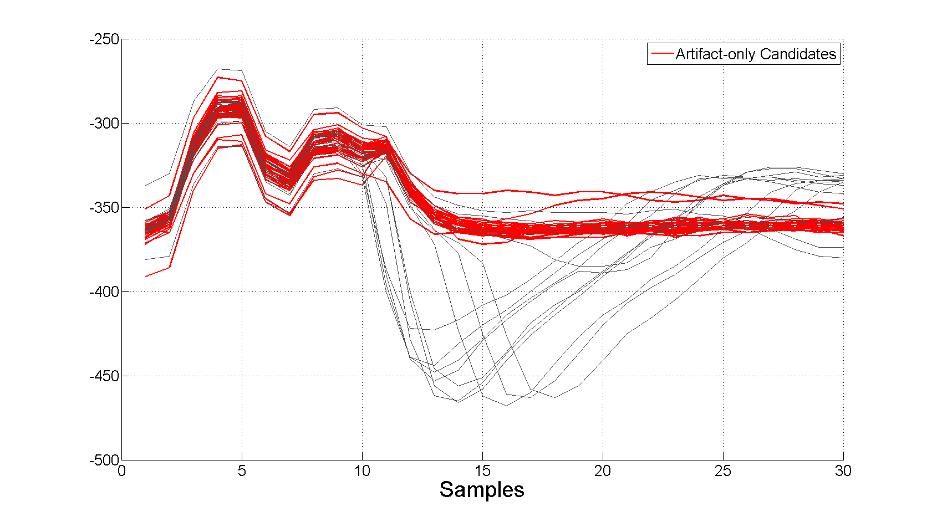Figure 8: Classification performed by algorithm
The two outliers are included in artifact-only candidates set, which we use to compute the model of stimulation artifact. It is not desired as they can greatly influence the model. To address that problem we define a dissimilarity function (eq. 1) and compute it's value for every artifact-only candidate. Two candidates with highest scores are crossed out.
Equation 1: Dissimilarity Function
where L is length in samples of trace, is i-th sample of trace andis mean artifact-only candidate.

Dropping two most differing waveforms results in more homogenous set which we use to estimate stimulation artifact model by computing its mean (fig. 9).

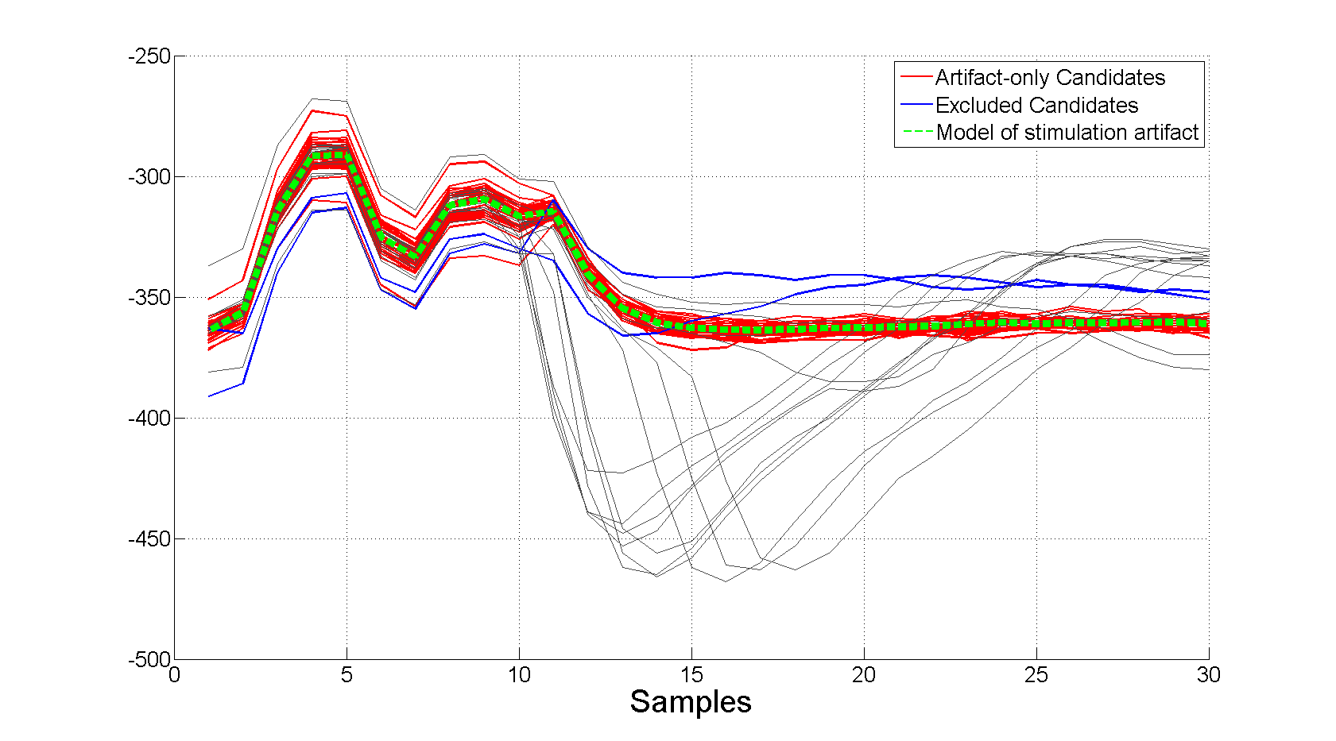Figure 9: Stimulation artifact model

The optimal value of QT is not known, and in principle can vary from neuron to neuron, or even from one movie to another. We need to find the right value in each case. The procedure used to accomplish this aim is described in the next paragraph.

