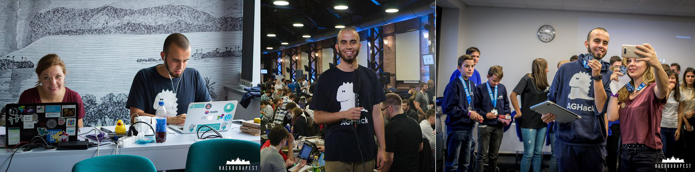

**Hey there!**

I’m Konrad and I’ve dedicated my whole career to working in and on the developer ecosystem. I used to work as a software engineer using tech like Python and Swift, developer community engineer but also hackathons organizer always utilising my project and program management skills as well as passion for creating software in all those jobs. Being super passionate about anything product engineering, data analysis and developer ecosystems, I’m always willing to engage in projects in those fields!

When it comes to my educational background, I have a Master’s degree from AGH University of Science and Technology where I studied Computer Science and Econometrics. My Bachelor’s degree thesis was about: Data Science using Python, while in my Master’s thesis I focused on implementing an application for pattern recognition in medical data using iOS.

I’m super passionate about innovation and bringing in my leadership and management skills in order to create more valuable and useful products. Always doing my best to spark creative and critical thinking in others to empower my team and company I work for as much as I can. Let’s work together to bring added value for everyone!

**Hope to collaborate with you soon!**

