Quality Assurance

STORE NAME
STORE NUMBER

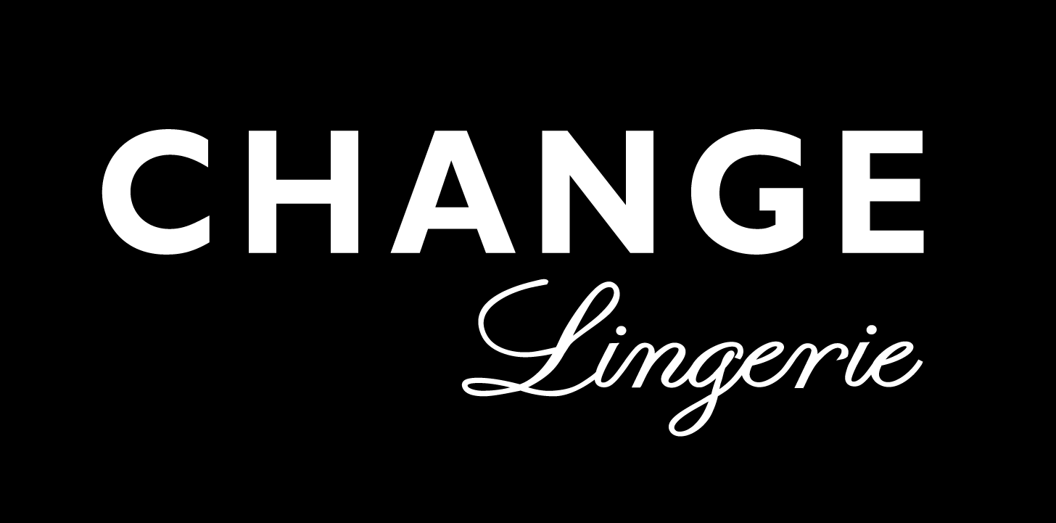

At

Change of Scandinavia A/S
Farum Gydevej 73 – 3520 Farum

Date: 10/11-2018

Topic: Solna, Stockholm

Adress:

Table of Contents

Introduction 3
The interior 4
General 5
Cash section 6
Dressing room 7
The facade 8
Documentation 9

Introduction

This directory is intended to facilitate the transfer by completing renovation.

Includes an appendix in the form of a drawing of the store, this drawing is used to count the number of furniture shown in this particular store and then compare with the delivered goods.

The directory is divided into 5 pages / items where each side has put a picture into. This picture has been applied to text to indicate which things should be checked and ticked for.

It is important to set all of the directory is checked carefully.

After going all 5 pages / items through acknowledged that at the back which approval of the delivered goods.

In the unlikely be a fault / defects noted this, and this is noted.

The interior

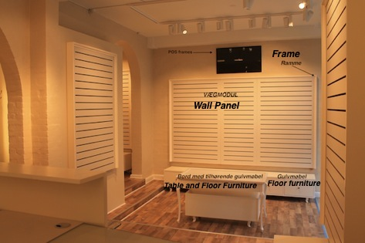

Topics  Description | Made  (X) | Not Done (X) | Not Rel.  (X) | Initials | To be completed by lack of export.
POS Frames
Wall panel
Frame
Floor Furniture
Table and
Floor Furniture
Light box
Shelves Big

General

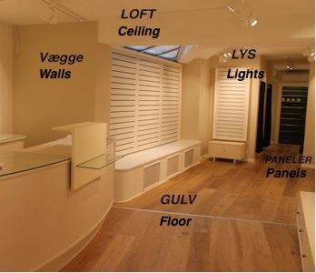

Topics  Description | Made  (X) | Not done (X) | Not Rel.  (X) | Initials | To be completed by lack of export.
Ceiling painted
Floor/ Gulv
Panels
Lights mounted
Walls painted
Alarmstands

Cash section

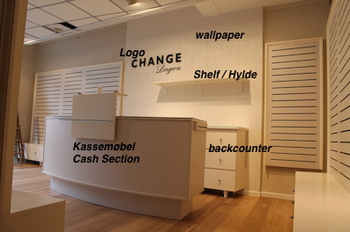

Topics  Description | Made  (X) | Not Done (X) | Not Rel.  (X) | Initials | To be completed by lack of export..
Wallpaper
Logo
Cash Section
Backcounter
Shelf

Dressing room

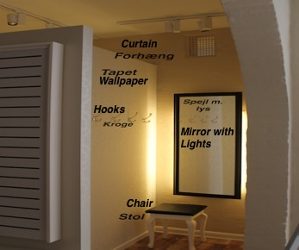

Topics  Descriptions | Made  (X) | Not Done  (X) | Not Rel.  (X) | Initials | To be completed by lack of export..
Wallpaper
Curtain
Hooks
Mirror with
Light
Carpet
Braguide
Frames

Topics  Description | Made  (X) | Not Done (X) | Not Rel.  (X) | Initials | To be completed by lack of export.
Bar & shelves

The Wardrope

The facade

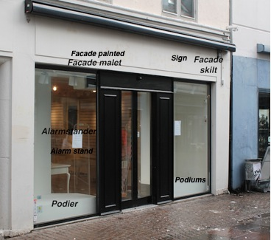

Topics  Description | Made  (X) | Not Done (X) | Not Rel.  (X) | Initials | To be completed by lack of export.
Facade painted
Facade sign
Alarm stand
customer counter
Podiums
TV screen
Lightbox
Glas facade
Rollershutter
Dibond

Documentation

Any deficiencies revealed by deposit noted below.
It agreed on the spot by the transfer around the end of deficiencies.

Is there occurred deviations from the standard of delivery, please indicate also the following

General comments on the delivery:
__________________________________________________________________________________ ________________________Electricians need to do light, POS, TV, mirror light_______________________________________________________________________________________________________________________________________
______________________________________________________________________________________________________________________________________________________________________________________________________________________________________________________

Deviations:
____lightbox
Frames for fitting room
1 wall frame above wall panels
__________________________________________________________________________________________________________________________________________________________________________________________________________________________________________________
______________________________________________________________________________________________________________________________________________________________________________________________________________________________________________________

Missing:
______________________________________________________________________________________________________________________________________________________________________________________________________________________________________________________
______________________________________________________________________________________________________________________________________________________________________________________________________________________________________________________

Date / - 14 Date / - 14

------------------------------------------- ---------------------------------------------
For receiving Store For transfer of store

Pictures

All Pictures are saved on

K:\_Retail - Department\_International\_Store Projects INTRANET\2018_05_01_Trianglen_NEW_SWE\Quality Assurance

