Use Case Descriptions

# 1. ACCOUNT MANAGEMENT

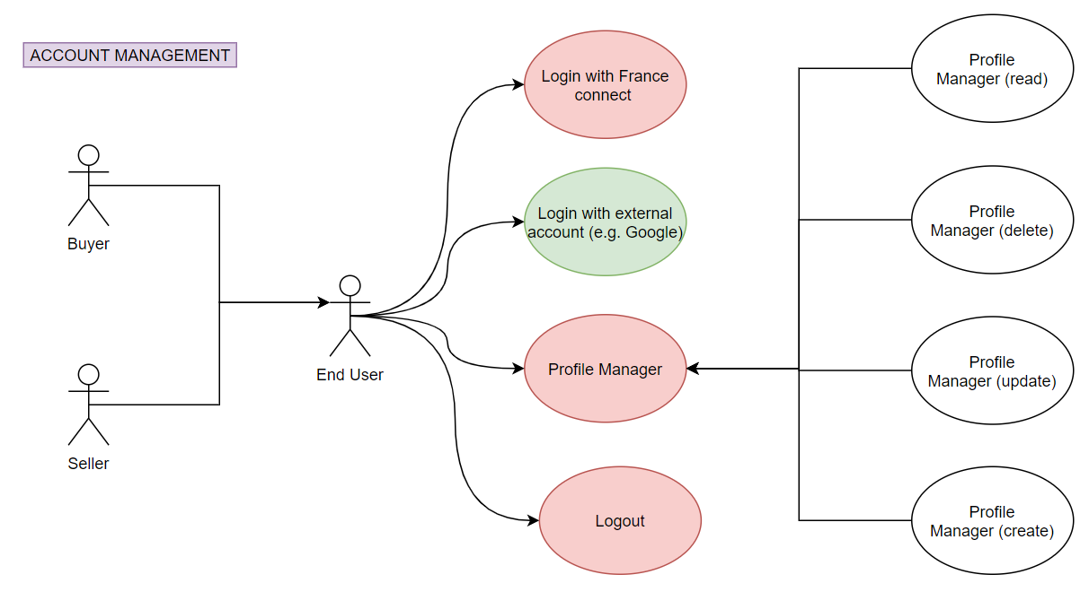

## 1.1. Login (MUST)

|  |  |
| --- | --- |
| **Id** | UC_000 |
| **Name** | Login |
| **Priority** | MUST |
| **Goal** | To login in Phygipay application using external account |
| **Constraints** | - |
| **Scenario** | To be able to use the Phygipay application, the user must be logged in. The user can choose to use an external account to login. For that we need to implement the login with external account functionality. |
| **Actors** | Seller or Buyer |
| **Pre-conditions** | The User is logged in |
| **Post-conditions** | User sees the home page |
| **Trigger Event** | User go to Login view |
| **Flow** | 1. User clicks on Login button 2. System redirect the login procedure on external login page 3. User types his/her username and password  4. User clicks on login button 5. System extracts user email from token 6. System checks if the given email already exist in the database and the user exists 7. System creates a new session for the user  8. System display the home page |
| **Alternative Flow** | 6a. System checks if the given email already exist in the database and the user does not exists. System creates new user profile in the database |

## 1.2. Logout (MUST)

|  |  |
| --- | --- |
| **Id** | UC_002 |
| **Name** | Logout |
| **Priority** | MUST |
| **Goal** | To exit the Phygipay application |
| **Constraints** | - |
| **Scenario** | The user needs to log out of the Phygipay application. For that we need to create a logout button. |
| **Actors** | Seller or Buyer |
| **Pre-conditions** | The User is logged in |
| **Post-conditions** | • The application is closed and is not displayed on the user's smartphone.  • No sessions are open on the system side |
| **Trigger Event** | User click Logout from the menu or is automaticaly logout after a given time of no reaction |
| **Flow** | 1. System closes the application  2. System removes user session |
| **Alternative Flow** | - |

## 1.3. Craete New User Account (MUST)

|  |  |
| --- | --- |
| **Id** | UC_003 |
| **Name** | Craete New User Account |
| **Priority** | MUST |
| **Goal** | - |
| **Constraints** | - |
| **Scenario** | - |
| **Actors** | - |
| **Pre-conditions** | The User do not exists in database |
| **Post-conditions** | - |
| **Trigger Event** | - |
| **Flow** | - |
| **Alternative Flow** | - |

## 1.4. See Profile Details (MUST)

|  |  |
| --- | --- |
| **Id** | UC_004 |
| **Name** | See Profile Details |
| **Priority** | MUST |
| **Goal** | To get information about private profile |
| **Constraints** | - |
| **Scenario** | The user needs to see all of his/her profile data. For that, we need to develop a display page. |
| **Actors** | Seller or Buyer |
| **Pre-conditions** | The User is logged in |
| **Post-conditions** | The private profile page with current data is shown |
| **Trigger Event** | User click Profile view |
| **Flow** | System sends profile data to user’s smartphone  User reads his/her following personal data:  name  surname  birth date  address |
| **Alternative Flow** | - |

## 1.5. Modify Profile Details (MUST)

|  |  |
| --- | --- |
| **Id** | UC_005 |
| **Name** | Modify Profile Details |
| **Priority** | MUST |
| **Goal** | To edit information about private profile |
| **Constraints** | - |
| **Scenario** | The user needs to modify his/her profile. For that, we need to develop an edit page to modify the profile. |
| **Actors** | Seller or Buyer |
| **Pre-conditions** | The User is logged in |
| **Post-conditions** | The private profile edited data are updated in database |
| **Trigger Event** | User click Edit button in Profile view |
| **Flow** | System sends profile data to user’s smartphone  User modifies his/her following personal data:  name  surname  birth date  Address  Our data User click on save button  System saves the new data in the database  System sends a message to confirm |
| **Alternative Flow** | - |

# 2. BANK ACCOUNT MANAGEMENT

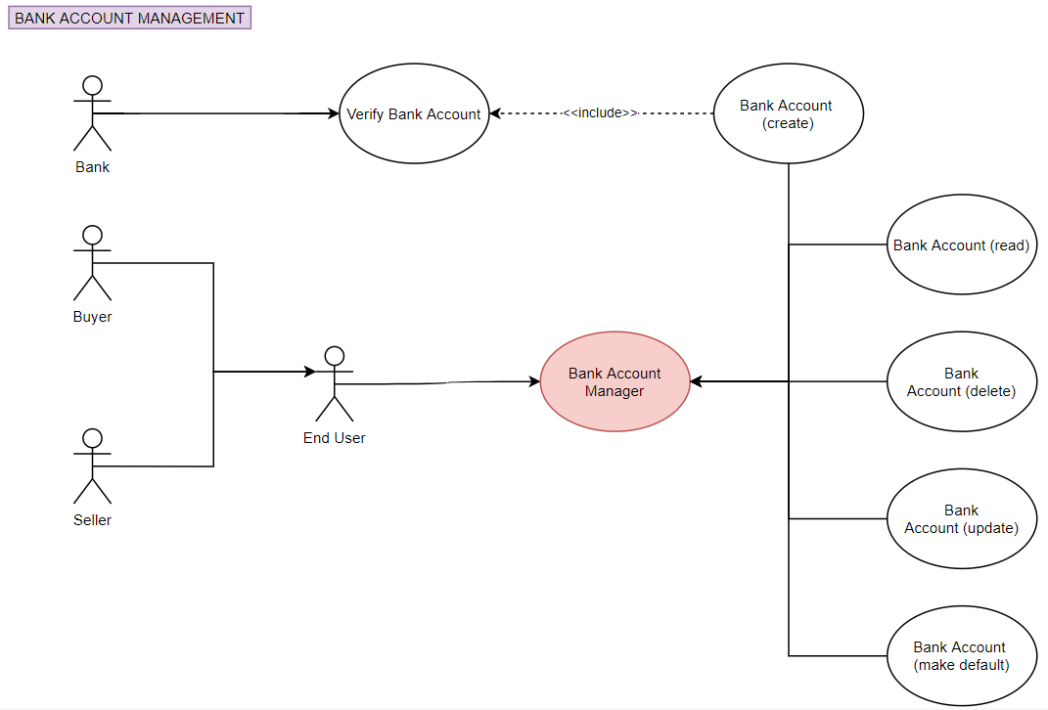

## 2.1. See List Of Banks (-)

|  |  |
| --- | --- |
| **Id** | UC_100 |
| **Name** | See List Of Banks |
| **Priority** | - |
| **Goal** | To show the users' list of banks |
| **Constraints** | - |
| **Scenario** | The user wants to see all the list of banks he/she has added. To do this we need to create a view with the list of banks |
| **Actors** | Buyer or Seller |
| **Pre-conditions** | The User is logged in |
| **Post-conditions** | User sees all banks added |
| **Trigger Event** | User click Banks view |
| **Flow** | System sends the list of banks to smartphone’s user  The user sees the page the list of banks view |
| **Alternative Flow** | - |

## 2.2. Add New Bank (-)

|  |  |
| --- | --- |
| **Id** | UC_101 |
| **Name** | Add New Bank |
| **Priority** | - |
| **Goal** | Assign new Bank to the user private account |
| **Constraints** | - |
| **Scenario** | To be able to pay using Phygipay application, the user must have saved at least a bank in Phygipay application.   The main functionality is to save bank information |
| **Actors** | Buyer or Seller |
| **Pre-conditions** | The User is logged in |
| **Post-conditions** | User sees new bank added success   All data are saved in the database |
| **Trigger Event** | User clicks on "add new bank" button |
| **Flow** | System redirects the login procedure on bank website  User types the following information:  Username  Password  Two-factor authentication (2FA)  System receives a bank token  System extracts bank information from token  System saves bank data in the database  System sends a success message notification on user’s smartphone  User sees the message of the new bank added successfully  User sees the bank account management page with the added bank |
| **Alternative Flow** | - |

## 2.3. Remove Bank (-)

|  |  |
| --- | --- |
| **Id** | UC_102 |
| **Name** | Remove Bank |
| **Priority** | - |
| **Goal** | To remove Bank from the user account |
| **Constraints** | - |
| **Scenario** | The user needs to delete his/her bank information from his/her profile. For that, we need to develop a delete button. |
| **Actors** | Buyer or Seller |
| **Pre-conditions** | The User is logged in User has at least one bank assigned |
| **Post-conditions** | Bank information is removed from the database |
| **Trigger Event** | User clicks on "delete" button |
| **Flow** | System removes bank information from the database  System sends a success message on user’s smartphone  User sees the message of the bank is removed successfully |
| **Alternative Flow** | - |

## 2.4. See List Of Bank Accounts (-)

|  |  |
| --- | --- |
| **Id** | UC_103 |
| **Name** | See List Of Bank Accounts |
| **Priority** | - |
| **Goal** | To show the user the list of bank accounts |
| **Constraints** | - |
| **Scenario** | The user wants to see all the list of bank account he/she has added. To do this we need to create a view with the list of bank accounts |
| **Actors** | Buyer or Seller |
| **Pre-conditions** | The User is logged in |
| **Post-conditions** | User see the list of bank accounts (it can be also empty) |
| **Trigger Event** | User choose one bank from the list |
| **Flow** | System sends the list of bank account to smartphone’s user  User sees the list of bank accounts view |
| **Alternative Flow** | - |

## 2.5. Add New Bank Account (-)

|  |  |
| --- | --- |
| **Id** | UC_104 |
| **Name** | Add New Bank Account |
| **Priority** | - |
| **Goal** | To link a new bank account to the user private account for the given bank |
| **Constraints** | - |
| **Scenario** | To be able to pay using Phygipay application, the user must have saved an account of his/her bank in the Phygipay application. For that we need to create bank account functionality.   The main functionality is to save user bank account information. |
| **Actors** | Buyer or Seller |
| **Pre-conditions** | The User is logged in |
| **Post-conditions** | User sees bank account added success  All data are saved in the database |
| **Trigger Event** | User clicks on "add new bank account" button |
| **Flow** | User types the following information:  Account owner (name and surname)  Bank name  IBAN  BIC  User clicks on create bank account button  System checks if the given information is valid  System saves bank account data in the database  System sends a success message on user’s smartphone  User sees the message of the new bank account added successfully |
| **Alternative Flow** | - |

## 2.6. Remove Bank Account (-)

|  |  |
| --- | --- |
| **Id** | UC_105 |
| **Name** | Remove Bank Account |
| **Priority** | - |
| **Goal** | To unlink a bank account from the user private account for the given bank |
| **Constraints** | - |
| **Scenario** | The user needs to delete his/her bank account. For that, we need to develop a delete button. |
| **Actors** | Buyer or Seller |
| **Pre-conditions** | The User is logged in User has at least on bank account assigned |
| **Post-conditions** | Bank account is removed from the list of user bank accounts list for the given bank |
| **Trigger Event** | User click Delete button |
| **Flow** | System removes bank account information from user profile and updated the database  System sends a success message to the user  User sees the message of the bank is removed successfully  System shows updated list of bank account |
| **Alternative Flow** | - |

## 2.7. See Bank Account Details (-)

|  |  |
| --- | --- |
| **Id** | UC_106 |
| **Name** | See Bank Account Details |
| **Priority** | - |
| **Goal** | To check his/her bank account data |
| **Constraints** | - |
| **Scenario** | The user needs to see all of his/her bank account data. For that, we need to develop a display page. |
| **Actors** | Buyer or Seller |
| **Pre-conditions** | The User is logged in |
| **Post-conditions** | User sees bank account information |
| **Trigger Event** | User selects the "bank account" view |
| **Flow** | User sees sensitive information (IBAN, BIC) hidden  User clicks on the button to show sensitive information  User reads:  Account owner (name and surname)  Bank name  IBAN  BIC  Balance |
| **Alternative Flow** | - |

## 2.8. Change Bank Account Name (-)

|  |  |
| --- | --- |
| **Id** | UC_107 |
| **Name** | Change Bank Account Name |
| **Priority** | - |
| **Goal** | To change the name of the bank account on application side |
| **Constraints** | - |
| **Scenario** | The user needs to modify his/her bank account data. For that, we need to develop an edit page to modify the bank account data. For now there is only 'name' field to edit |
| **Actors** | Buyer or Seller |
| **Pre-conditions** | The User is logged in User has at least on bank account assigned |
| **Post-conditions** | User has logged in Phygipay mobile application  System has the bank account data saved in the database |
| **Trigger Event** | User clicks Edit button |
| **Flow** | System sends bank account data to user’s smartphone  User modifies bank name User click on save button  System checks if the given information is valid  System saves the new data in the database  System sends a success message on user’s smartphone |
| **Alternative Flow** | - |

## 2.9. Set Default Bank Account (-)

|  |  |
| --- | --- |
| **Id** | UC_108 |
| **Name** | Set Default Bank Account |
| **Priority** | - |
| **Goal** | To set bank account as default |
| **Constraints** | - |
| **Scenario** | There is only one bank account set as default in order to perform transaction faster. User do not have to choose bank account on every transaction |
| **Actors** | Buyer or Seller |
| **Pre-conditions** | The User is logged in User has at least on bank account assigned |
| **Post-conditions** | User default bank is set in the database |
| **Trigger Event** | User clicks Set As Default button |
| **Flow** | System sends bank account data to user’s smartphone  User set bank as default User click on save button  System saves the new data in the database  System sends a success message on user’s smartphone |
| **Alternative Flow** | - |

# 3. TRANSACTION MANAGEMENT

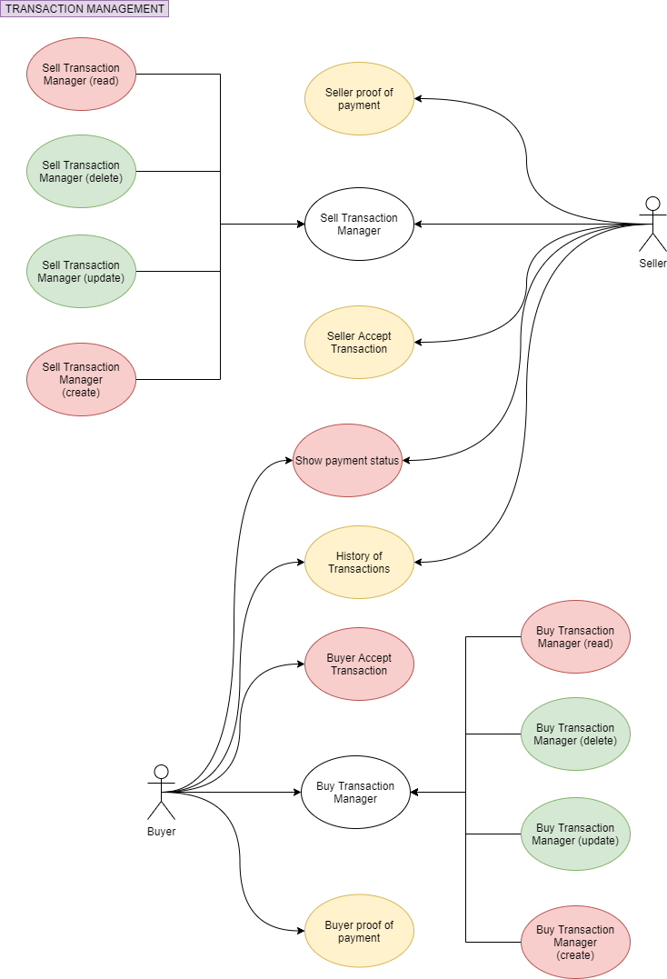

## 3.1. Seller Creates New Transaction (-)

|  |  |
| --- | --- |
| **Id** | UC_200 |
| **Name** | Seller Creates New Transaction |
| **Priority** | - |
| **Goal** | To create a new transaction |
| **Constraints** | - |
| **Scenario** | To be able to start a transaction with Phygipay application, the seller should create a new transaction by entering the price and description of the item to sell. The seller must be able to choose which bank account to have the payment.  The main functionalities are  create a new transaction  choose the bank account  QR code generation |
| **Actors** | Seller |
| **Pre-conditions** | The User is logged in |
| **Post-conditions** | System has the transaction  Seller sees the QR Code on his/her smartphone |
| **Trigger Event** | Seller selects the "sell transaction" view |
| **Flow** | Seller sees the following information:  Transaction Details fields to be filled:  Amount  Currency  Description  Bank account information:  Default bank account name and number  Switch account button that redirects to bank account management  Generate QR code button  Seller fills the amount and description. Preferred bank account is automatically chosen  Seller clicks on generate QR code button  System inserts the new transaction in the database  System generates QR code  System sends QR code to seller’s smartphone  Seller sees the QR Code |
| **Alternative Flow** | 2a. Seller fills the price and description. He/She chooses a different account |

## 3.2. Buyer Creates New Transaction (-)

|  |  |
| --- | --- |
| **Id** | UC_201 |
| **Name** | Buyer Creates New Transaction |
| **Priority** | - |
| **Goal** | - |
| **Constraints** | - |
| **Scenario** | - |
| **Actors** | Buyer |
| **Pre-conditions** | The User is logged in |
| **Post-conditions** | - |
| **Trigger Event** | - |
| **Flow** | - |
| **Alternative Flow** | - |

## 3.3. Seller Modify Transaction Details (-)

|  |  |
| --- | --- |
| **Id** | UC_202 |
| **Name** | Seller Modify Transaction Details |
| **Priority** | - |
| **Goal** | - |
| **Constraints** | - |
| **Scenario** | - |
| **Actors** | Seller |
| **Pre-conditions** | The User is logged in |
| **Post-conditions** | - |
| **Trigger Event** | - |
| **Flow** | - |
| **Alternative Flow** | - |

## 3.4. Buyer Modify Transaction Details (-)

|  |  |
| --- | --- |
| **Id** | UC_203 |
| **Name** | Buyer Modify Transaction Details |
| **Priority** | - |
| **Goal** | - |
| **Constraints** | - |
| **Scenario** | - |
| **Actors** | Buyer |
| **Pre-conditions** | The User is logged in |
| **Post-conditions** | - |
| **Trigger Event** | - |
| **Flow** | - |
| **Alternative Flow** | - |

## 3.5. Buyer See Transaction Details (-)

|  |  |
| --- | --- |
| **Id** | UC_204 |
| **Name** | Buyer See Transaction Details |
| **Priority** | - |
| **Goal** | To read the information about the new transaction created by seller |
| **Constraints** | - |
| **Scenario** | The buyer wants to buy the product and use the transaction data created by the seller. For that we must implement the QR code scan and read transaction data from the server. |
| **Actors** | Buyer |
| **Pre-conditions** | The User is logged in Seller has created the transaction |
| **Post-conditions** | Buyer sees transaction information on his/her smartphone |
| **Trigger Event** | Buyer click on " buy transaction" view |
| **Flow** | Buyer sees the following information  Total balance  Bank account information:  Default bank account name and number  Switch account button that redirects to bank account management  Scan QR code button  Buyer click on " scan QR code" button  The buyer scans the QR code from seller’s smartphone  System sends transaction information to buyer’s smartphone  The buyer checks the following information are correct:  Transaction description (item description, amount)  Buyer bank name  Balance before the transaction  Balance after the transaction  Seller name  Seller bank name |
| **Alternative Flow** | - |

## 3.6. Seller See Transaction Details (-)

|  |  |
| --- | --- |
| **Id** | UC_205 |
| **Name** | Seller See Transaction Details |
| **Priority** | - |
| **Goal** | - |
| **Constraints** | - |
| **Scenario** | - |
| **Actors** | Seller |
| **Pre-conditions** | The User is logged in |
| **Post-conditions** | - |
| **Trigger Event** | - |
| **Flow** | - |
| **Alternative Flow** | - |

## 3.7. Remove Transaction From The List (-)

|  |  |
| --- | --- |
| **Id** | UC_206 |
| **Name** | Remove Transaction From The List |
| **Priority** | - |
| **Goal** | - |
| **Constraints** | - |
| **Scenario** | - |
| **Actors** | Buyer or Seller |
| **Pre-conditions** | The User is logged in |
| **Post-conditions** | - |
| **Trigger Event** | - |
| **Flow** | - |
| **Alternative Flow** | - |

## 3.8. Buyer Accept transaction (-)

|  |  |
| --- | --- |
| **Id** | UC_207 |
| **Name** | Buyer Accept transaction |
| **Priority** | - |
| **Goal** | - |
| **Constraints** | - |
| **Scenario** | - |
| **Actors** | Buyer |
| **Pre-conditions** | The User is logged in |
| **Post-conditions** | - |
| **Trigger Event** | - |
| **Flow** | - |
| **Alternative Flow** | - |

## 3.9. Seller Accept transaction (-)

|  |  |
| --- | --- |
| **Id** | UC_208 |
| **Name** | Seller Accept transaction |
| **Priority** | - |
| **Goal** | - |
| **Constraints** | - |
| **Scenario** | - |
| **Actors** | Seller |
| **Pre-conditions** | The User is logged in |
| **Post-conditions** | - |
| **Trigger Event** | - |
| **Flow** | - |
| **Alternative Flow** | - |

## 3.10. Buyer Cancel Transaction (-)

|  |  |
| --- | --- |
| **Id** | UC_209 |
| **Name** | Buyer Cancel Transaction |
| **Priority** | - |
| **Goal** | - |
| **Constraints** | - |
| **Scenario** | - |
| **Actors** | Buyer |
| **Pre-conditions** | The User is logged in |
| **Post-conditions** | - |
| **Trigger Event** | - |
| **Flow** | - |
| **Alternative Flow** | - |

## 3.11. Seller Cancel Transaction (-)

|  |  |
| --- | --- |
| **Id** | UC_210 |
| **Name** | Seller Cancel Transaction |
| **Priority** | - |
| **Goal** | - |
| **Constraints** | - |
| **Scenario** | - |
| **Actors** | Seller |
| **Pre-conditions** | The User is logged in |
| **Post-conditions** | - |
| **Trigger Event** | - |
| **Flow** | - |
| **Alternative Flow** | - |

## 3.12. See The List of open transactions (-)

|  |  |
| --- | --- |
| **Id** | UC_211 |
| **Name** | See The List of open transactions |
| **Priority** | - |
| **Goal** | - |
| **Constraints** | - |
| **Scenario** | - |
| **Actors** | Buyer or Seller |
| **Pre-conditions** | The User is logged in |
| **Post-conditions** | - |
| **Trigger Event** | - |
| **Flow** | - |
| **Alternative Flow** | - |

## 3.13. Scan QR Code (-)

|  |  |
| --- | --- |
| **Id** | UC_212 |
| **Name** | Scan QR Code |
| **Priority** | - |
| **Goal** | - |
| **Constraints** | - |
| **Scenario** | - |
| **Actors** | Buyer |
| **Pre-conditions** | The User is logged in |
| **Post-conditions** | - |
| **Trigger Event** | - |
| **Flow** | - |
| **Alternative Flow** | - |

## 3.14. Generate QR Code (-)

|  |  |
| --- | --- |
| **Id** | UC_213 |
| **Name** | Generate QR Code |
| **Priority** | - |
| **Goal** | - |
| **Constraints** | - |
| **Scenario** | - |
| **Actors** | Seller |
| **Pre-conditions** | The User is logged in |
| **Post-conditions** | - |
| **Trigger Event** | - |
| **Flow** | - |
| **Alternative Flow** | - |

## 3.15. Create Transaction Automatically (-)

|  |  |
| --- | --- |
| **Id** | UC_214 |
| **Name** | Create Transaction Automatically |
| **Priority** | - |
| **Goal** | - |
| **Constraints** | - |
| **Scenario** | - |
| **Actors** | Seller |
| **Pre-conditions** | The User is logged in |
| **Post-conditions** | - |
| **Trigger Event** | - |
| **Flow** | - |
| **Alternative Flow** | - |

## 3.16. See Payment Status (-)

|  |  |
| --- | --- |
| **Id** | UC_215 |
| **Name** | See Payment Status |
| **Priority** | - |
| **Goal** | - |
| **Constraints** | - |
| **Scenario** | - |
| **Actors** | Buyer or Seller |
| **Pre-conditions** | The User is logged in |
| **Post-conditions** | - |
| **Trigger Event** | - |
| **Flow** | - |
| **Alternative Flow** | - |

## 3.17. Download Proof Of Payment (-)

|  |  |
| --- | --- |
| **Id** | UC_216 |
| **Name** | Download Proof Of Payment |
| **Priority** | - |
| **Goal** | To get the proof of payment PDF file for the given transaction |
| **Constraints** | - |
| **Scenario** | The buyer needs to have the proof of payment. For that we must ensure that the receipt he/she receives is validated by a trusted entity. |
| **Actors** | Buyer or Seller |
| **Pre-conditions** | The User is logged in System has completed the transaction successfully |
| **Post-conditions** | Buyer sees the PDF receipt. |
| **Trigger Event** | User selects the "history transaction" view |
| **Flow** | Buyer clicks on the latest transaction  System display the latest transaction details  Buyer clicks on download proof of payment button  System sends PDF receipt  User checks his/her receipt |
| **Alternative Flow** | 1a. Buyer filters transaction’s list |

# 4. SECURITY

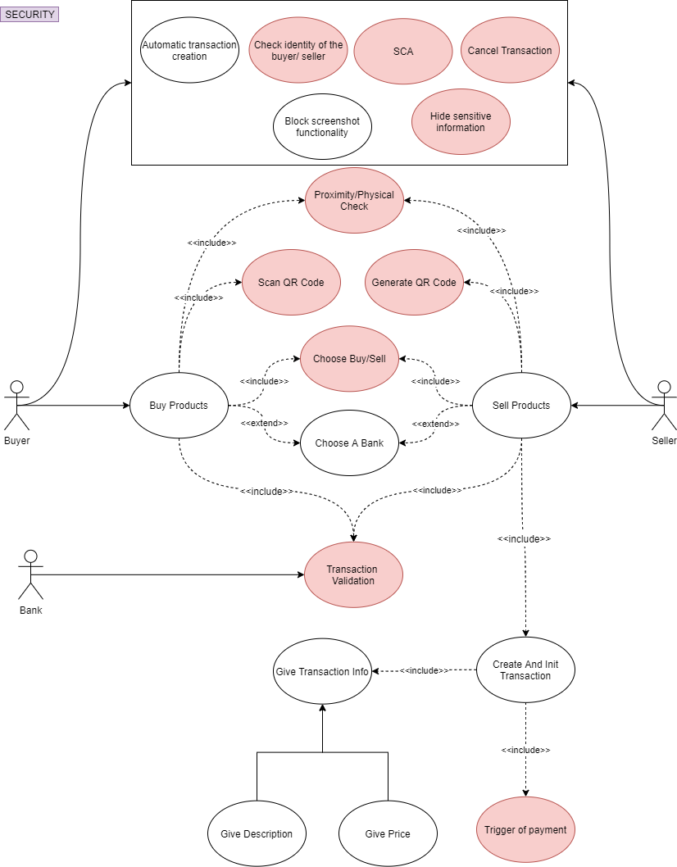

## 4.1. Check Proximity (-)

|  |  |
| --- | --- |
| **Id** | UC_300 |
| **Name** | Check Proximity |
| **Priority** | - |
| **Goal** | - |
| **Constraints** | - |
| **Scenario** | - |
| **Actors** | - |
| **Pre-conditions** | - |
| **Post-conditions** | - |
| **Trigger Event** | - |
| **Flow** | - |
| **Alternative Flow** | - |

## 4.2. SCA – Show bank SCA page (-)

|  |  |
| --- | --- |
| **Id** | UC_301 |
| **Name** | SCA – Show bank SCA page |
| **Priority** | - |
| **Goal** | - |
| **Constraints** | - |
| **Scenario** | - |
| **Actors** | - |
| **Pre-conditions** | - |
| **Post-conditions** | - |
| **Trigger Event** | - |
| **Flow** | - |
| **Alternative Flow** | - |

## 4.3. SCA – Redirect to Phygipay (-)

|  |  |
| --- | --- |
| **Id** | UC_302 |
| **Name** | SCA – Redirect to Phygipay |
| **Priority** | - |
| **Goal** | - |
| **Constraints** | - |
| **Scenario** | - |
| **Actors** | - |
| **Pre-conditions** | - |
| **Post-conditions** | - |
| **Trigger Event** | - |
| **Flow** | - |
| **Alternative Flow** | - |

## 4.4. Validate Transaction (-)

|  |  |
| --- | --- |
| **Id** | UC_303 |
| **Name** | Validate Transaction |
| **Priority** | - |
| **Goal** | - |
| **Constraints** | - |
| **Scenario** | - |
| **Actors** | - |
| **Pre-conditions** | - |
| **Post-conditions** | - |
| **Trigger Event** | - |
| **Flow** | - |
| **Alternative Flow** | - |

## 4.5. Block Screenshot Functionality (-)

|  |  |
| --- | --- |
| **Id** | UC_304 |
| **Name** | Block Screenshot Functionality |
| **Priority** | - |
| **Goal** | - |
| **Constraints** | - |
| **Scenario** | - |
| **Actors** | - |
| **Pre-conditions** | - |
| **Post-conditions** | - |
| **Trigger Event** | - |
| **Flow** | - |
| **Alternative Flow** | - |

## 4.6. Hide Sensitive Information (-)

|  |  |
| --- | --- |
| **Id** | UC_305 |
| **Name** | Hide Sensitive Information |
| **Priority** | - |
| **Goal** | - |
| **Constraints** | - |
| **Scenario** | - |
| **Actors** | - |
| **Pre-conditions** | - |
| **Post-conditions** | - |
| **Trigger Event** | - |
| **Flow** | - |
| **Alternative Flow** | - |

# 5. NOTIFICATION MANAGEMENT

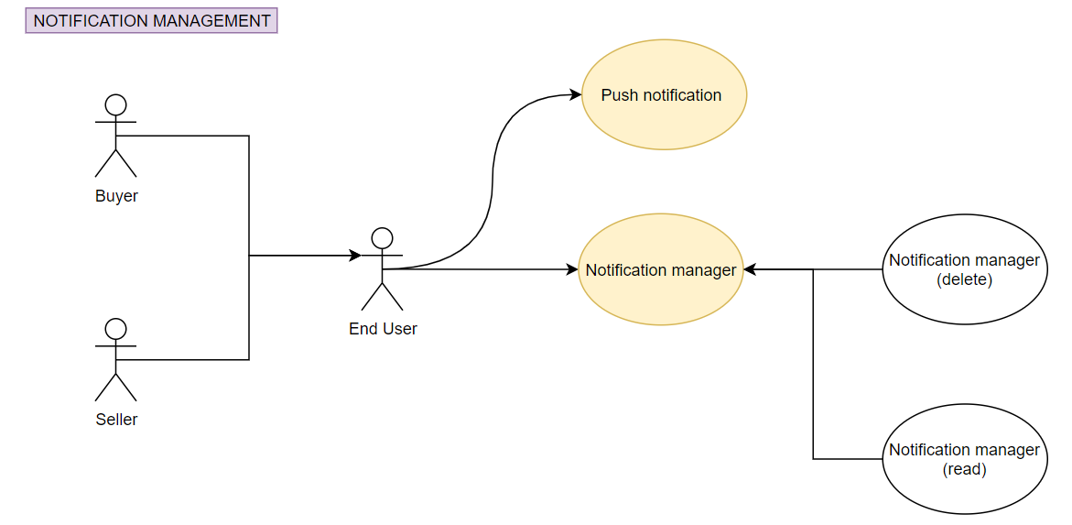

## 5.1. Notify User Outside Application (-)

|  |  |
| --- | --- |
| **Id** | UC_400 |
| **Name** | Notify User Outside Application |
| **Priority** | - |
| **Goal** | - |
| **Constraints** | - |
| **Scenario** | - |
| **Actors** | - |
| **Pre-conditions** | - |
| **Post-conditions** | - |
| **Trigger Event** | - |
| **Flow** | - |
| **Alternative Flow** | - |

## 5.2. See Notification (-)

|  |  |
| --- | --- |
| **Id** | UC_401 |
| **Name** | See Notification |
| **Priority** | - |
| **Goal** | - |
| **Constraints** | - |
| **Scenario** | - |
| **Actors** | - |
| **Pre-conditions** | - |
| **Post-conditions** | - |
| **Trigger Event** | - |
| **Flow** | - |
| **Alternative Flow** | - |

# 6. HELP

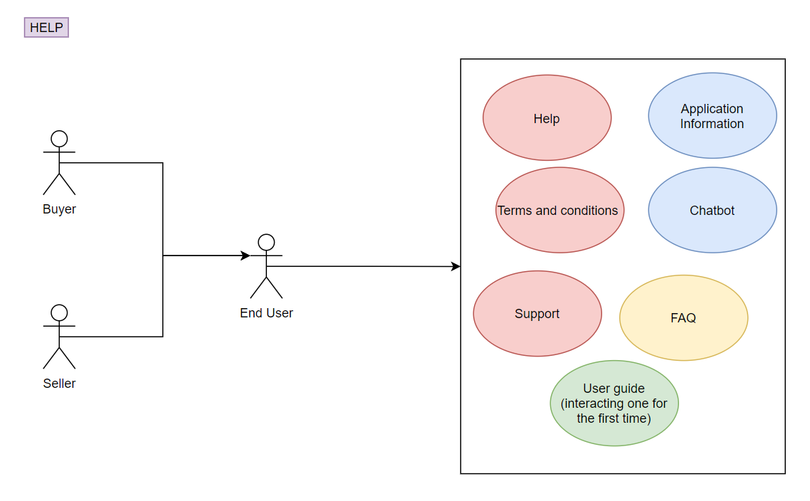

## 6.1. Accept Application Terms And Conditions (-)

|  |  |
| --- | --- |
| **Id** | UC_500 |
| **Name** | Accept Application Terms And Conditions |
| **Priority** | - |
| **Goal** | - |
| **Constraints** | - |
| **Scenario** | - |
| **Actors** | - |
| **Pre-conditions** | - |
| **Post-conditions** | - |
| **Trigger Event** | - |
| **Flow** | - |
| **Alternative Flow** | - |

## 6.2. Get Help (-)

|  |  |
| --- | --- |
| **Id** | UC_501 |
| **Name** | Get Help |
| **Priority** | - |
| **Goal** | - |
| **Constraints** | - |
| **Scenario** | - |
| **Actors** | - |
| **Pre-conditions** | - |
| **Post-conditions** | - |
| **Trigger Event** | - |
| **Flow** | - |
| **Alternative Flow** | - |

## 6.3. Interact With Chatbot (-)

|  |  |
| --- | --- |
| **Id** | UC_502 |
| **Name** | Interact With Chatbot |
| **Priority** | - |
| **Goal** | - |
| **Constraints** | - |
| **Scenario** | - |
| **Actors** | - |
| **Pre-conditions** | - |
| **Post-conditions** | - |
| **Trigger Event** | - |
| **Flow** | - |
| **Alternative Flow** | - |

## 6.4. See FAQ (-)

|  |  |
| --- | --- |
| **Id** | UC_503 |
| **Name** | See FAQ |
| **Priority** | - |
| **Goal** | - |
| **Constraints** | - |
| **Scenario** | - |
| **Actors** | - |
| **Pre-conditions** | - |
| **Post-conditions** | - |
| **Trigger Event** | - |
| **Flow** | - |
| **Alternative Flow** | - |

## 6.5. See Application User Guide (-)

|  |  |
| --- | --- |
| **Id** | UC_504 |
| **Name** | See Application User Guide |
| **Priority** | - |
| **Goal** | - |
| **Constraints** | - |
| **Scenario** | - |
| **Actors** | - |
| **Pre-conditions** | - |
| **Post-conditions** | - |
| **Trigger Event** | - |
| **Flow** | - |
| **Alternative Flow** | - |

# 7. FEEDBACK

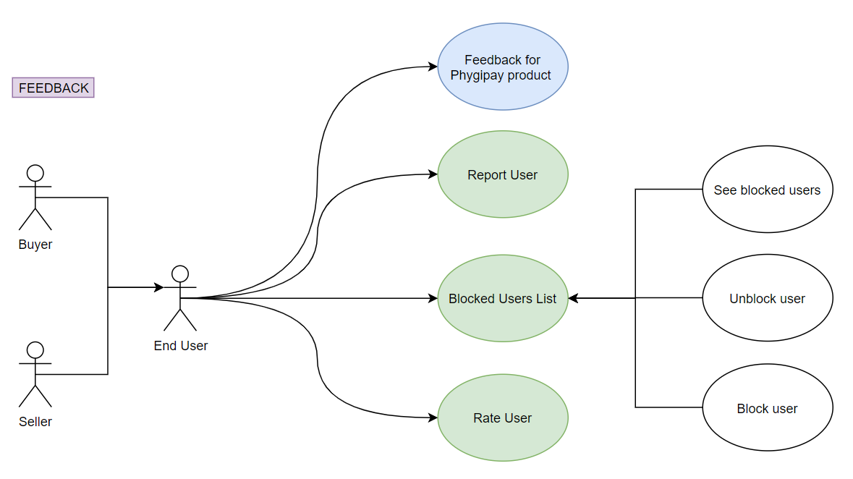

## 7.1. Rate Application (-)

|  |  |
| --- | --- |
| **Id** | UC_600 |
| **Name** | Rate Application |
| **Priority** | - |
| **Goal** | - |
| **Constraints** | - |
| **Scenario** | - |
| **Actors** | - |
| **Pre-conditions** | - |
| **Post-conditions** | - |
| **Trigger Event** | - |
| **Flow** | - |
| **Alternative Flow** | - |

## 7.2. Rate User (-)

|  |  |
| --- | --- |
| **Id** | UC_601 |
| **Name** | Rate User |
| **Priority** | - |
| **Goal** | - |
| **Constraints** | - |
| **Scenario** | - |
| **Actors** | - |
| **Pre-conditions** | - |
| **Post-conditions** | - |
| **Trigger Event** | - |
| **Flow** | - |
| **Alternative Flow** | - |

## 7.3. Report User (-)

|  |  |
| --- | --- |
| **Id** | UC_602 |
| **Name** | Report User |
| **Priority** | - |
| **Goal** | - |
| **Constraints** | - |
| **Scenario** | - |
| **Actors** | - |
| **Pre-conditions** | - |
| **Post-conditions** | - |
| **Trigger Event** | - |
| **Flow** | - |
| **Alternative Flow** | - |

## 7.4. See Blocked Users (-)

|  |  |
| --- | --- |
| **Id** | UC_603 |
| **Name** | See Blocked Users |
| **Priority** | - |
| **Goal** | - |
| **Constraints** | - |
| **Scenario** | - |
| **Actors** | - |
| **Pre-conditions** | - |
| **Post-conditions** | - |
| **Trigger Event** | - |
| **Flow** | - |
| **Alternative Flow** | - |

## 7.5. Block User (-)

|  |  |
| --- | --- |
| **Id** | UC_604 |
| **Name** | Block User |
| **Priority** | - |
| **Goal** | - |
| **Constraints** | - |
| **Scenario** | - |
| **Actors** | - |
| **Pre-conditions** | - |
| **Post-conditions** | - |
| **Trigger Event** | - |
| **Flow** | - |
| **Alternative Flow** | - |

# 8. COMMUNITY

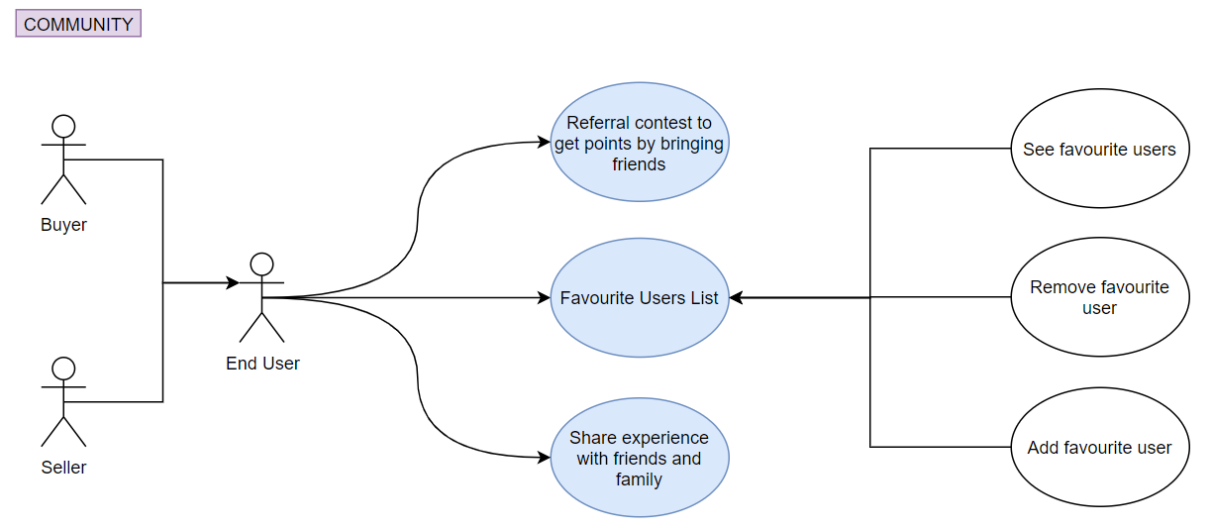

## 8.1. Invite New Users (-)

|  |  |
| --- | --- |
| **Id** | UC_700 |
| **Name** | Invite New Users |
| **Priority** | - |
| **Goal** | - |
| **Constraints** | - |
| **Scenario** | - |
| **Actors** | - |
| **Pre-conditions** | - |
| **Post-conditions** | - |
| **Trigger Event** | - |
| **Flow** | - |
| **Alternative Flow** | - |

## 8.2. See Favourite Users (-)

|  |  |
| --- | --- |
| **Id** | UC_701 |
| **Name** | See Favourite Users |
| **Priority** | - |
| **Goal** | - |
| **Constraints** | - |
| **Scenario** | - |
| **Actors** | - |
| **Pre-conditions** | - |
| **Post-conditions** | - |
| **Trigger Event** | - |
| **Flow** | - |
| **Alternative Flow** | - |

## 8.3. Remove User From Favourites (-)

|  |  |
| --- | --- |
| **Id** | UC_702 |
| **Name** | Remove User From Favourites |
| **Priority** | - |
| **Goal** | - |
| **Constraints** | - |
| **Scenario** | - |
| **Actors** | - |
| **Pre-conditions** | - |
| **Post-conditions** | - |
| **Trigger Event** | - |
| **Flow** | - |
| **Alternative Flow** | - |