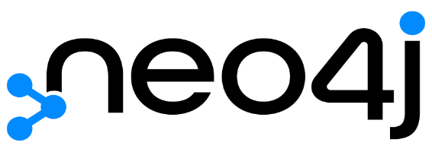



Neo4j MAIN WEAPONS

Graph DBMS

* Easy to represent connected data
* Supports fully ACID rules
* Simple and powerful data model
* Faster than MySQL
* It does not require JOINS to retrieve connected data
* The relationships already exist
* Highly performant read and write scalability
* Query language easy to learn
* Very interactive UI for analysis of datasets

Analysis of Data

* Rather than looking at row or column headers, graphs focus on data relationships.
* Neo4j Bloom is an easy and a very expressive tool to explore and interact with the graphs.

Matei Grosu

Alex Constantinescu

Data security

* Schema-based security restricts what data can be seen by different users.
* Role-based access control approach restricts the access at any level.
* With Neo4j is possible to data for a particular country`s citizens to be physically stored in that country as the GDPR require.

Purpose & Goal

* The purpose of Neo4j is to efficiently store, handle, read, write and query highly connected data. To the maximum speed and performance, while protecting the data integrity.
* The company goal is to bring graph technology into the mainstream by connecting the community, customers, partners and even competitors as they adopt graph best practices everywhere.
* Neo4j has some support for replication, but this is not one of the core objectives of it.

What is neo4j?

* A NoSQL, native graph database, meaning that it implements a true graph model all the way down to the storage level stored just as on the whiteboard.
* Organizes data using the concepts of nodes and relationships. Both being able to have properties.
* Fully ACID-compliant, offers the same guarantees as if you were working with a traditional relational database system.

Market

* Neo4j is the leader provider of scalable graph technology with more than 6,401 companies using it.
* The market share of neo4j is 0.67%

Limitations of Neo4J

* Has some upper bound limit for the graph size.
* It has a limitation of supporting number of nodes, properties, and relationships in a single graph.
* It does not support Sharding (method of distributing data across multiple machines).

Performance

* In comparation with MySQL Neo4j is much faster.
* Compared to other graph databases (OrientDB and GraphDB) Neo4J displayed the best performance.
* Neo4J has a robust structure and an architecture that gives to it a great performance, while the Cypher syntax, which Neo4J uses, minimizes the possibility of human error.

Problems

* eBay rely on Neo4j to drive recommendations, promotions, and streamline logistics.
* Airbus depends on it to connect and solve complex data problems.
* Volvo Cars or Toyota counts on it to drive innovative manufacturing solutions.
* Marriott uses Neo4j to manage complex and rapidly changing inventories.
* Orange or AT&T leans on Neo4j to manage networks, control access, and enable customer 360.

History

* The Neo Technology company located in San Francisco and Sweden, being available in a variety of licenses.
* The initial version of Neo4j was released in 2007. A stable release (4.4.6) was on 20th of April 2022.
* Written in Java and accessible from software written in other languages using the Cypher query language through a transactional HTTP endpoint, or through the binary “Bolt” protocol.

NEO4J