# Running

Application should start by executing the following commands in the Sisu folder:

*mvn install*

*mvn javafx:run*

## Uml-diagram

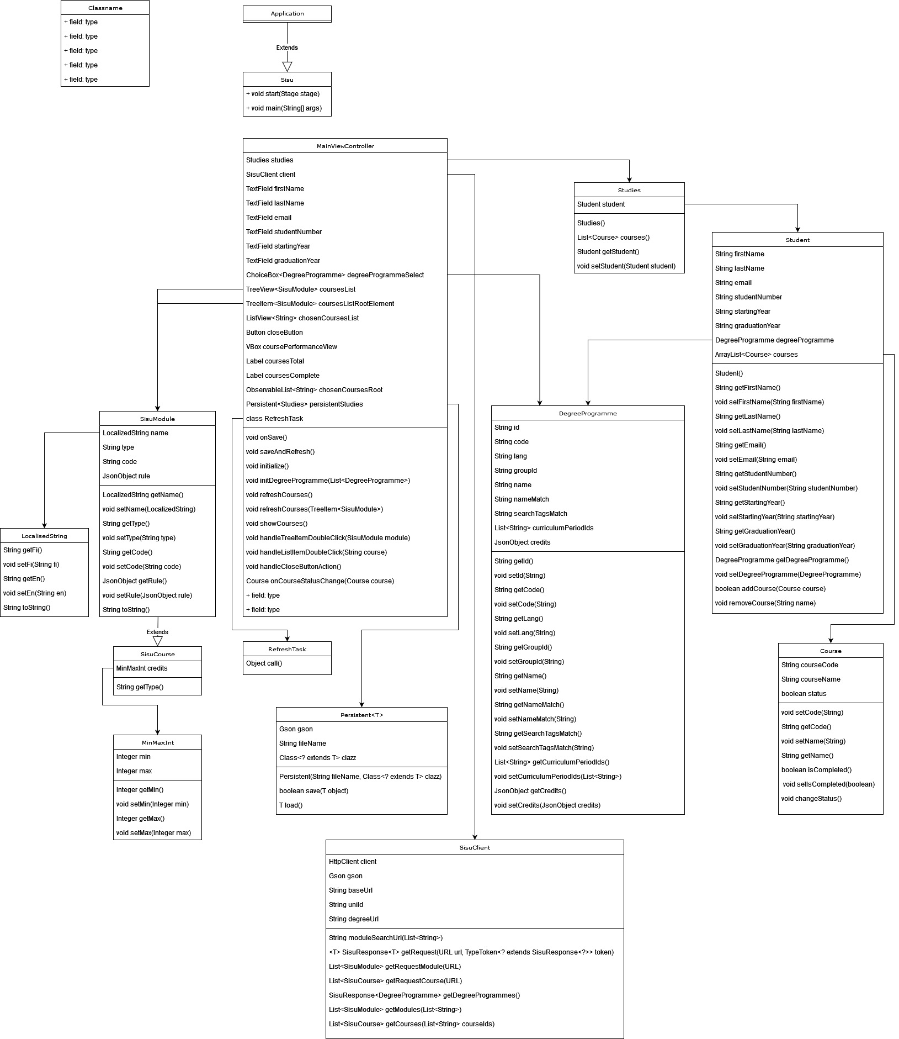

## Important classes

### MainViewController

* Handles the graphical interface.

### DegreeProgramme

* Contains all the required data for the degree program.

### Studies

* Contains the student.

### Student

* Contains information about student and their courses.
* Contains the degree program of the student.

### Course

* Contains information about a course.

### SisuModule

* Processes the data provided by sisu api.

### SisuClient

* Fetches data from the sisu api.

## Functionality

The program contains three tabs:

The first tab is where the user can input their student information and study program they are studying.

Second tab contains the structure of the study program and user can select courses they want to attend there. Courses can also be removed from the list and course information can then be saved to a file for later use.

Third tab shows all the selected courses and user can check or uncheck the course as completed. The program also shows how many courses has been selected and how many of them are completed.