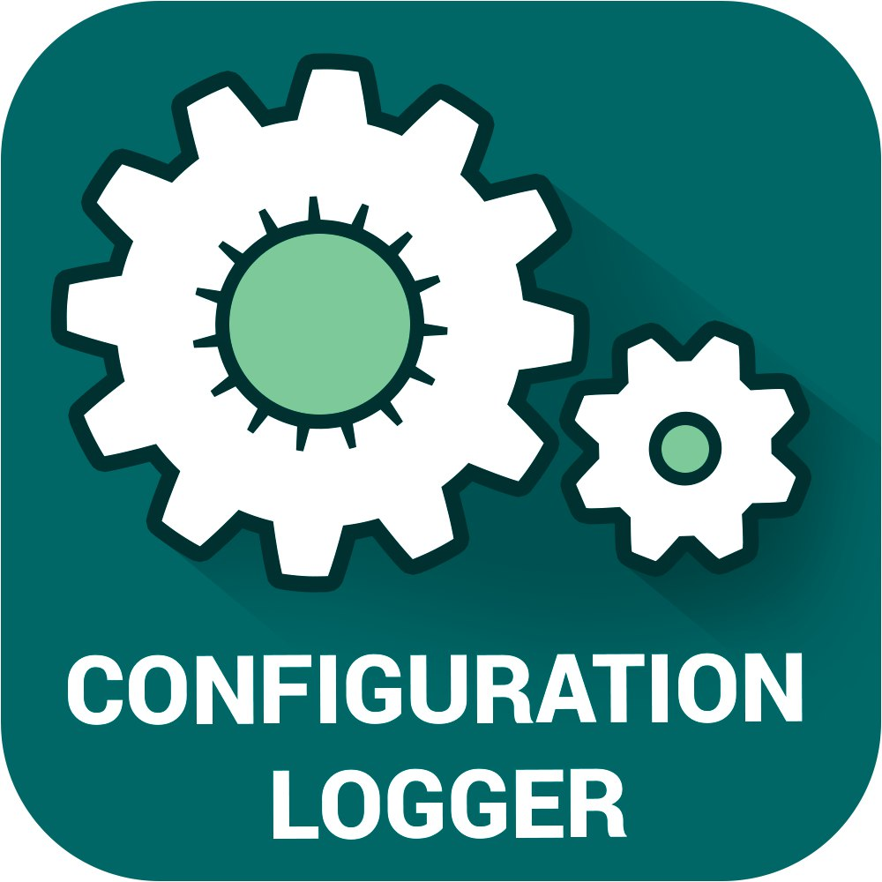

**Extension for Magento 2**

Testing on Magento 2.1 with Sample Data.

Version 1.0 (23.04.1)

**Configuration Logger**

Configuration Logger is a great extension for Magento 2, which records the actions performed in the configuration of your store. With this extension, as administrator, you can find out when, and what actions are performed in changing the configuration of your store. You can view detailed information about the history of data activity, ip-addresses and the amount of time spent. This extension also allows you to restore the previous configuration.

**Quick information:**

* Identification of the user logins, records IP-address;
* The storage time when changing the configuration;
* view all the previous configuration values;
* Ability to restore the configuration;
* It supports almost all types of configurations;
* easy installation.

**Installation:**

* Copy the folder with the module at the root of your site;
* run the following command:

php bin/magento setup:upgrade

php bin/magento setup:di:compile

php bin/magento setup:static-content:deploy

php bin/magento cache:clean

* after they are completed, you should see in the app/etc/config.php this module.

**Use:**

Go to admin -> system -> configuration. In the configuration, you should see an icon in the form of a watch. After clicking on this icon you should see the following pop-up window:

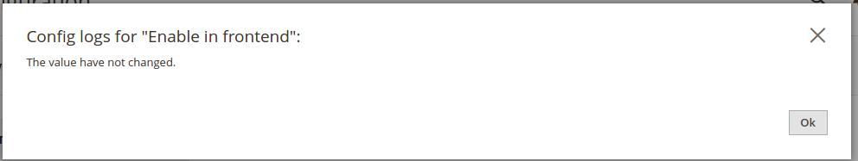

If the configuration of the field will have changed, you will see the following window:

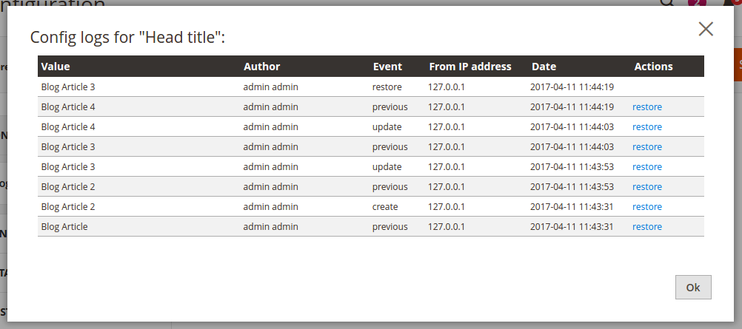

In this window, you can also restore the previous configuration.

Do not forget to clear the cache after each configuration change.

**Note: The extension can override the files that you already use. Make sure**

**that there are no conflicts with your modules before using this module. The**

**module has been tested on Magento 2.1 with Sample Data.**