# Brief

Your challenge is to build out Home page and get it looking as close to the design as possible.  
You can use any tools you like to help you complete the challenge.

The design is based on 12-column system.

Your users should be able to:

* View the optimal layout for the site depending on their device's screen size
* See hover states for all interactive elements on the page. Feel free to use your own styling for hover state colors.

# Elements analysis

## Header

The header is following the user window and sticks to top. After certain amount of pixels (ex. 200px ) the header changes styling. See **Header Sticky** group.

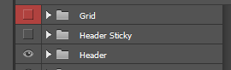

For mobile menu layout check the hidden group **Header opened menu.**  
  
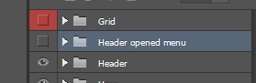

## Hero

The height of the hero section on large screens must be equal as window height.

When user clicks the arrow at the bottom the window must scroll to next section.

## Rooms Slider

You must create a carousel. You can use any JavaScript library to achieve that.

## Animations (**optional** task)

Feel free to use any JavaScript library or custom effects. We like fadeInUp effect when elements entering view of the window but you can use any other you prefer.