**Project:** NetSave

**Description:** NetSave provides a platform to local community members with peace of mind when shopping and interacting online. People list their new and used products and share with the other members. People can create multiple group which help others to find products according to their need.

**Tech Stack:** AWS services (Amplify, cognito, lambda, API gateway), ReactJS, NodeJS, Mysql

**Role:** Full Stack developer

1. Product post: This function is used to add product into the database. After validating the input data, store data in database.

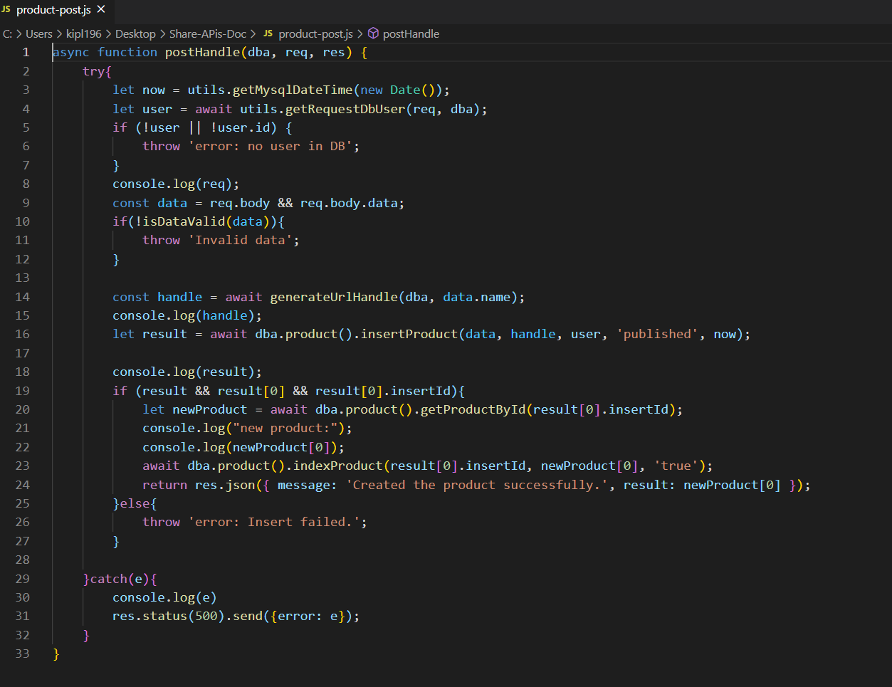

1. User update: This function is used to update the user profile.

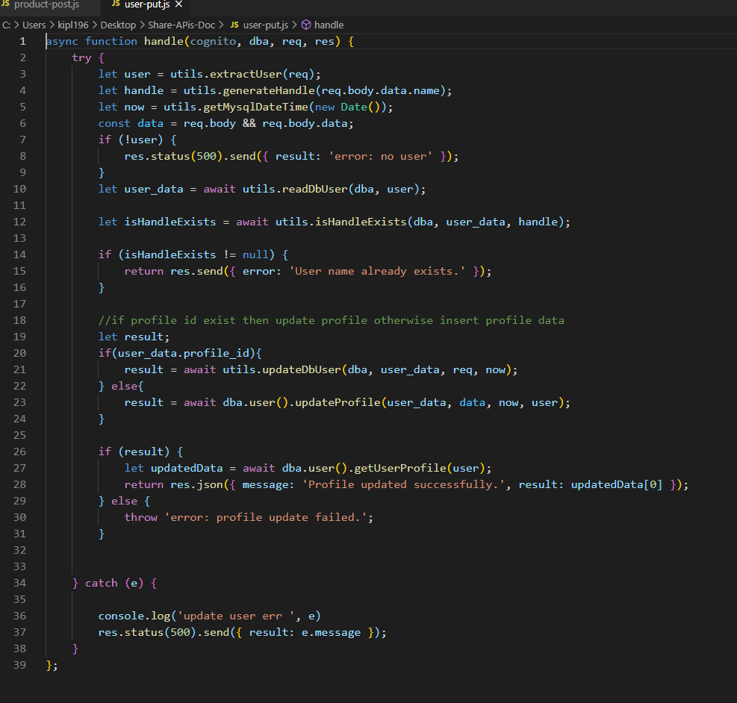

**Project:** Tern Water

**Description:** Ultrasonic Water Meter is integrated which emits the water data to Machineq gateway server. I have integrated IOT solutions provided by Machineq.

**I have used NodeJS throughtout the project but some part (Machineq APIs) was implemented in python.**

**Tech Stack:** AWS services (IOT, lambda, Quicksight), Pyhton, NodeJS, MySQL

**Role:**

1. Machineq device integration with AWS IOT(NodeJS)
2. Integrate MachineQ APIs (Python)
3. AWS quicksight Dashboard
4. Decoder: Machineq server send hexadecimal string to AWS IOT which call the lambda function. Incoming hexadecimal string contain information of the water flow. Lambda function decode the hexadecimal string and save the data to MySQL database.

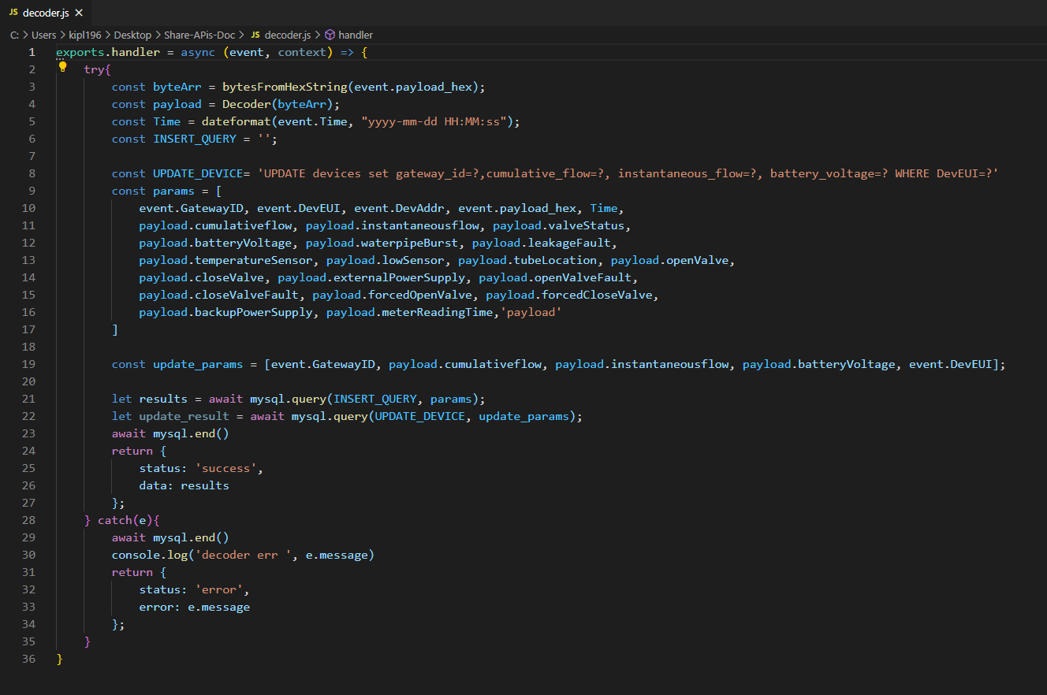

1. Machineq APIs: In this function I have integrated Machineq Rest APIs
2. Gateway APIs
3. Device APIs

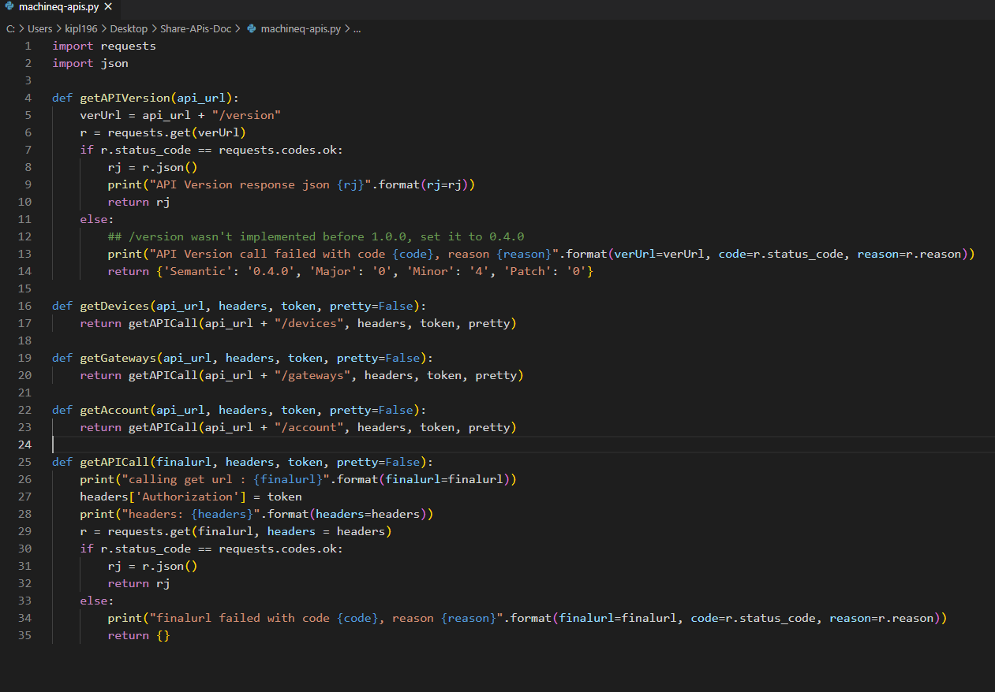

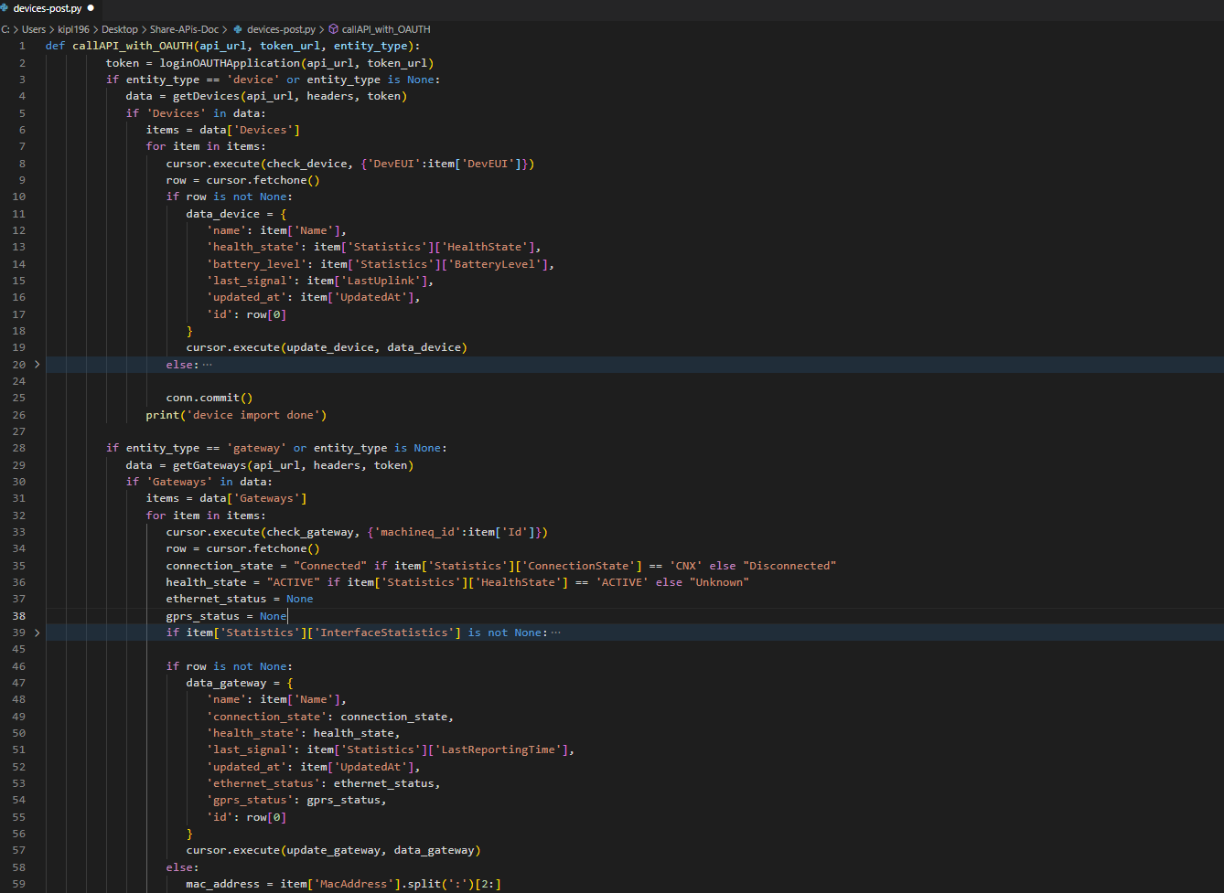

**Project:** Dokita

**Description:** A simple, fast and uncomplicated medical platform, that provides you affordable access to overseas medical practitioners from within Nigeria!

myDokita allows you to have either video, voice or chat consultations via your mobile phones/tablets over the Internet with our overseas based medical practitioners. We also have a list of accredited top-grade clinics/hospitals across the country for easier in-country referrals.

**Tech Stack:** NodeJS, Mongodb, Twilio, SendGrid, PayStack, AWS services

**Role:** API development from Pilot

1. Initiate Transaction: This function is used to recharge user wallet. We use Paystack payment gateway to deduct amount from his saved card.

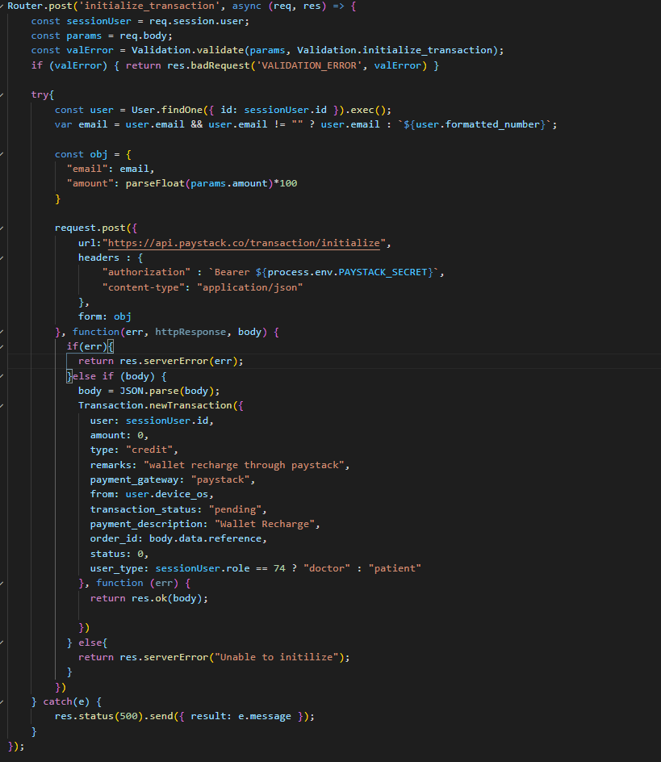

1. Twilio Token: Generate an Access Token for Twilio Video, and Voice using Twilio Functions.

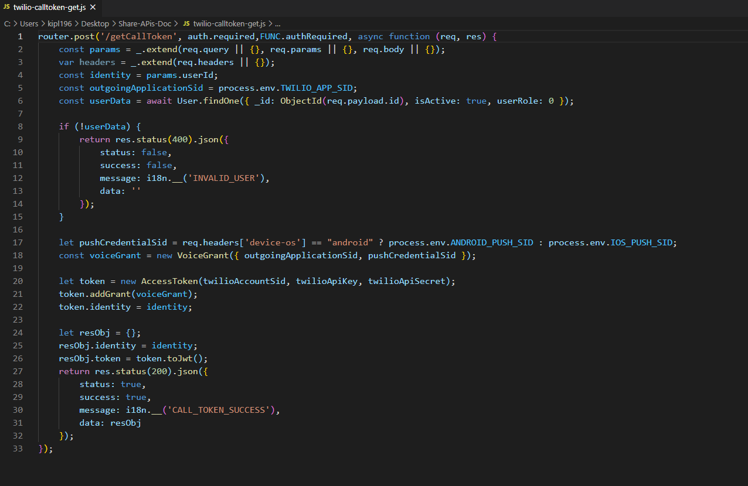

**Project:** yoortime

**Description:** yoortime enables users to view their clash of clan app profile progress into yoortime. Players can create group and chat with other players.

**Tech Stack:** NodeJS, MongoDB, AWS services

**Role:** Integrate Clash of clan APIs

1. Insert/Update Player profile: This function used to update the player profile. For this i use COC player API and update the database.

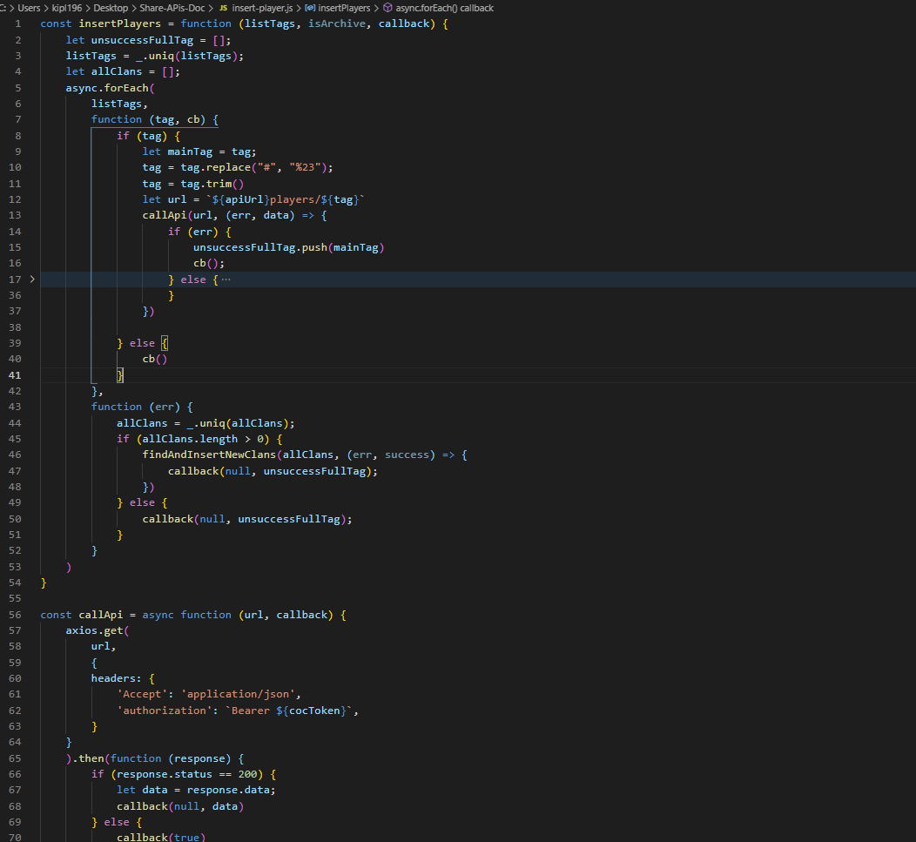

1. Get clans: In this function I pull Clan information form COC clan API and update the database on daily basis with cron job.

