**Project:** K-Bus

**Description:** K-bus app has two modules each for bus drivers and bus passengers. It shows the location of the passengers that pinged the driver and are currently waiting on the bus in the Cayman Islands. K-BUS saves time and effort waiting on the bus by tracking the real time location of Public Buses in the Cayman Islands. A display of bus routes will assist you in taking the correct bus to get to your destination. Passengers can ping the drivers on specific routes so that drivers can see their location for a faster and more efficient service.

**Tech Stack:** Node JS, Mongo DB (Microservice Based), AWS Lambda

**Role:** Team Lead

**Function Description:** This function is used to image processing through Lambda function

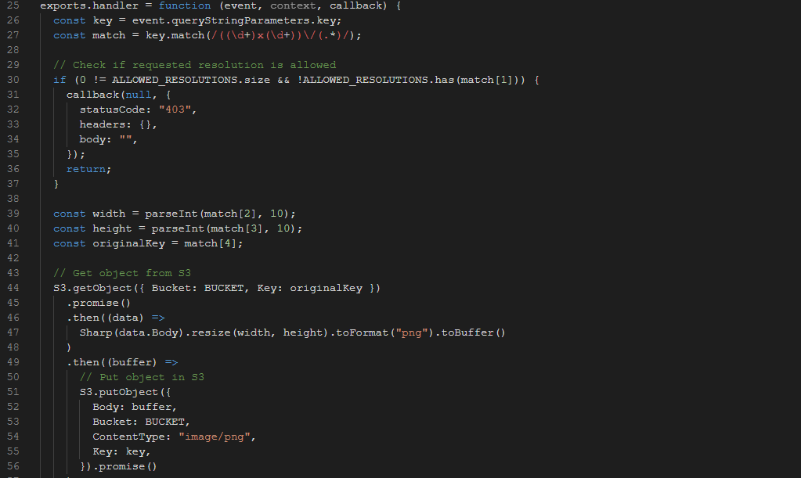

**Project Name:** Tripmood

**Description:** This project is a combination of Airbnb and Instagram. Create for Traveller and Business Person.

**Tech Stack:** Node JS, Mongo DB (Microservice Based), Axios

**Role:** Sr API Developer

**Function Explanation:** This function is used to calling other micro-service with the help of **axios** module

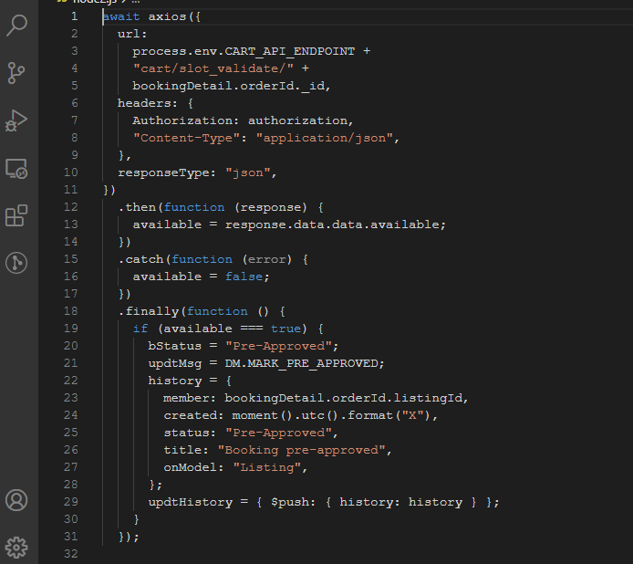

**Project Name:** Stripes

**Description:** It's a gaming application built in NodeJS and ionic 4 that allows people who wish to participate in online gaming to apply and make payment online. Push notifications help keep players posted about the latest updates of the game. Players can access games of their choice according to the location set by GPS.

**Tech Stack:** Node JS, Mongo DB, Stripe Payment Gateway REST API

**Role:** Team Lead

**Function Explanation:** This function is user to create a customer and subscription on Stripe payment gateway

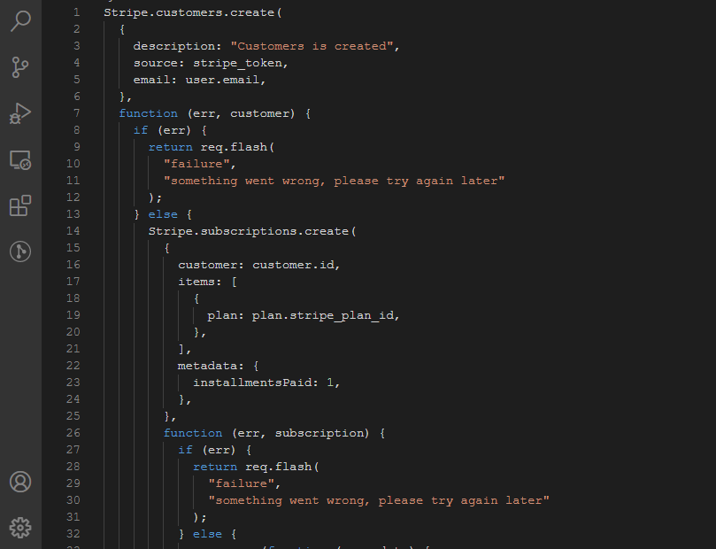

**Project Name:** Pacefunding

**Description:** Pace Funding is a finance company that offers financial support and expertise to residential properties for energy efficiency. The application is meant to be used by in-home sales representatives for all the on-site operations including assessment, approval and contracting. The application is integrated with ID verification, payment, a detailed dashboard to keep all the tasks secure and traceable.

**Tech Stack:** CakePHP (80%), MySQL, DocuSign, Node JS (20%), MongoDB, Microservice

**Role:** Team Lead  
**Function Explanation:** This function is used to create docusign e-signature documents & embedded documents

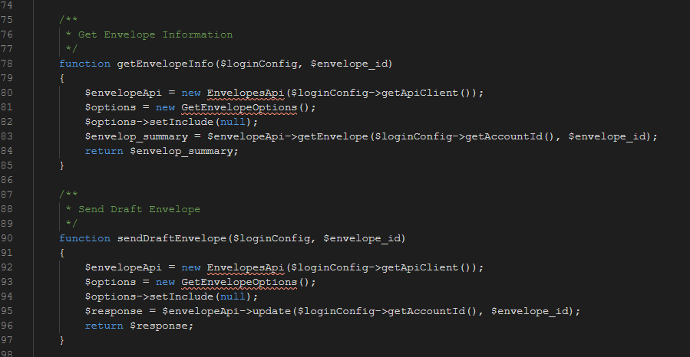

**Project Name:** Pacefunding

**Description:** Pace Funding is a finance company that offers financial support and expertise to residential properties for energy efficiency. The application is meant to be used by in-home sales representatives for all the on-site operations including assessment, approval and contracting. The application is integrated with ID verification, payment, a detailed dashboard to keep all the tasks secure and traceable.

**Tech Stack:** CakePHP (80%), MySQL, Node JS (20%), MongoDB, Microservice, Zillow API

**Role:** Team Lead  
**Function Explanation:** This function is used to get property evaluation from Zillow API

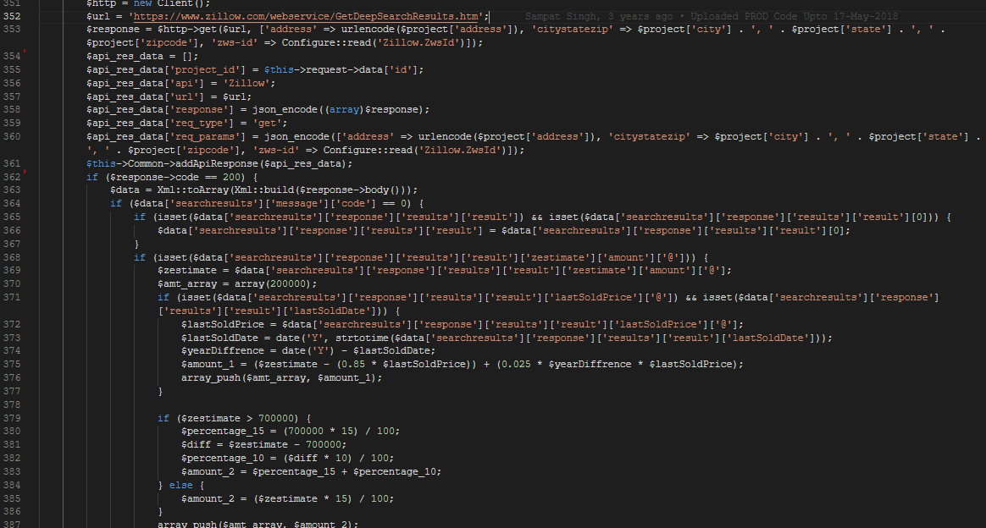

**Project Name:** Pacefunding

**Description:** Pace Funding is a finance company that offers financial support and expertise to residential properties for energy efficiency. The application is meant to be used by in-home sales representatives for all the on-site operations including assessment, approval and contracting. The application is integrated with ID verification, payment, a detailed dashboard to keep all the tasks secure and traceable.

**Tech Stack:** CakePHP (80%), MySQL, Node JS (20%), MongoDB, Microservice, Salesforce, SOAP

**Role:** Team Lead  
**Function Explanation:** This function is used to create new leads on Salesforce

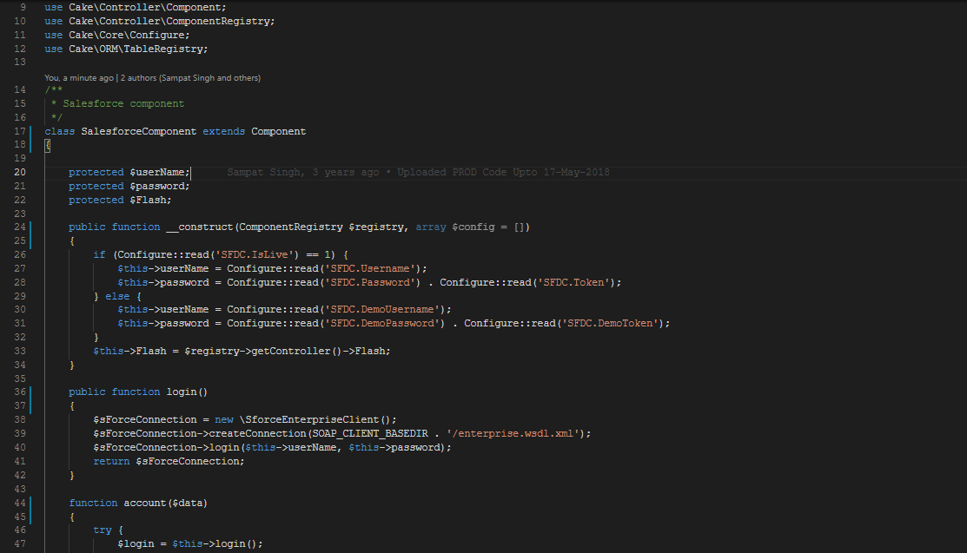

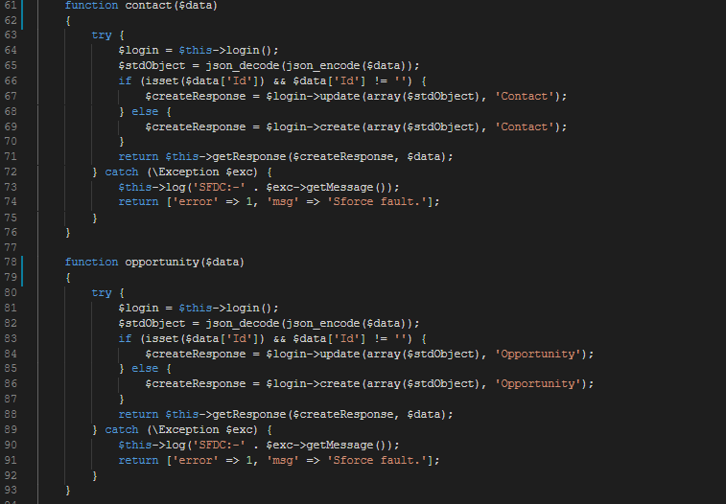

**Other API Swagger Links: (For Reference)**

<http://18.224.59.137:5000/docs>

<http://18.224.59.137:5001/docs/>

<http://18.224.59.137:5002/docs/>

<http://18.224.59.137:5004/docs/>