Emotion Classification using Machine Learning

By Kostantinos Telioglanides, Neofytos Petrou, Loucas Sialis

1. Introduction
This project focused on building and optimizing a machine learning model for emotion classification using 8,000 labeled text documents with no missing values across seven emotion classes. We preprocessed the data, tested various models, evaluated their performance, and developed a final classifier for predicting emotions in new, unlabeled text.

2. Preprocessing and Feature Engineering

2.1 Text Cleaning
Some preprocessing steps were crucial to reduce noise and enhance model performance:
- Lowercasing, punctuation removal, number removal
- Tokenization: Performed before vectorization
- Stopword Removal: Kept negation words (e.g., "not", "no") for semantic integrity
- Duplicate Handling: 13 duplicates were found, but retained due to their negligible impact (~0.16%)
- Misspellings: We tested PySpellChecker and SymSpell, but they often made incorrect corrections, like changing “doen” to “does” instead of “doesn’t.” Due to such issues and reduced performance, we decided against using automated spelling correction.
- Normalization: Common informal words (e.g., "gonna", "wanna") retained or transformed selectively
- Short tokens: Isolated letters or non-word tokens were removed
- Unbalanced emotion class: Neutral texts have ~120 words while other emotions have ~20 words. After preprocessing steps, we managed to have ~60 words for “neutral” and ~20 words for the other emotions.

2.2 Lemmatization and Stemming
We attempted stemming to reduce the feature space, but it was too aggressive—removing meaningful context (e.g., “loved” to “love”) and reducing accuracy. Despite a ~25% drop in vocabulary size, the performance loss led us to discard stemming and use only lemmatization.
Lemmatization was preferred. Applied to nouns, helped unify singular/plural forms without loss of meaning. Lemmatization was also used on verbs without an impact on the performance.

2.3 Feature Selection
To manage the size of the vocabulary and reduce dimensionality, we removed words that appeared in fewer than 2 documents (~10,000 features). We observed that keeping words with slightly higher document frequency helped strike a balance between retaining meaningful terms and eliminating noise.

3. Feature Representation
We evaluated two main feature extraction methods: Bag of Words (BoW) and TF-IDF. Both convert text into numeric matrices, with BoW counting word occurrences and TF-IDF weighting words based on their importance across the corpus.
BoW is faster and works well with models like Neural Networks, but can overfit due to common words dominating the representation. TF-IDF, by down-weighting frequent terms and highlighting more informative ones, proved more effective, especially with SVM and Logistic Regression—for capturing emotional nuances.
We also used bi-grams (1- and 2-grams) to retain context, particularly for negations (e.g., “not happy”), which are crucial in sentiment analysis. Both methods were tested using the same pipelines and evaluated using accuracy, precision, recall, and F1-score.

4. Model Experiments
We experimented with multiple classification algorithms, using Scikit-learn Pipelines and evaluation through 5-fold cross-validation and hold-out sets. Key models tested:
Classifier | Accuracy (BoW) | Accuracy (TF-IDF)
K-Nearest Neighbors | ~60.5% | ~83.0%
SVM | ~89% | ~91.0%
Logistic Regression | ~87.4% | ~91.0%
Random Forest | ~90.3% | ~88.6%
Naïve Bayes | ~81.55 | ~89.0%
Neural Networks | ~88.3% | ~87.2%

Error Analysis
Out of 1,600 test samples, there were 126 misclassifications. Happiness, neutral, and surprise had relatively few errors.
Fun was often misclassified as happiness, which is understandable. Hate and neutral were generally misclassified into related emotions. Hate was frequently confused with worry or sadness, which can make sense contextually, though a few were incorrectly labeled as fun.
Worry was mostly misclassified as surprise, often incorrectly—many of these texts included the word “overwhelmed”, common in surprise-labeled samples. Sadness had diverse misclassifications, mostly to fun, hate, or worry. While some hate predictions reflected real hate, others were inaccurate or emotionally mixed, making them hard to judge definitively.

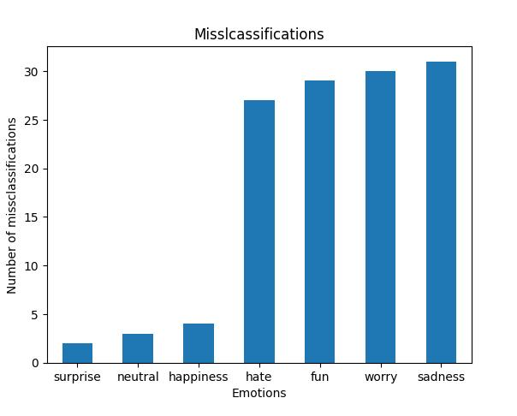

5. Final Model and Evaluation
For our final model, we used scikit-learn’s VotingClassifier, an ensemble method that combines predictions from multiple classifiers to improve performance. It trains each model on the same data and makes decisions by aggregating their outputs.
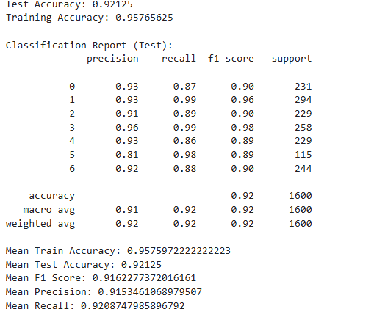

In our experiment, we observed that most individual models performed better with TF-IDF than with CountVectorizer. However, when we used a VotingClassifier to combine the models, the version using CountVectorizer outperformed the one using TF-IDF. This result was unexpected and got us curious about why the ensemble behaved differently.
The likely explanation is that ensemble performance depends not only on individual model accuracy but also on how diverse their errors are. TF-IDF may have caused the models to behave more similarly, leading to correlated errors that weakened the benefits of voting. In contrast, CountVectorizer preserved more variation in how each model interpreted the data, allowing the ensemble to better correct individual mistakes through majority voting.
We used hard voting, where the final prediction is the majority vote, as some models didn’t support soft voting (which averages predicted probabilities). This method leveraged the strengths of models like Random Forest, SVM, Logistic Regression, and Naive Bayes, assuming their errors are uncorrelated. When individual models perform well and don’t overfit, combining them often leads to better generalization and accuracy.
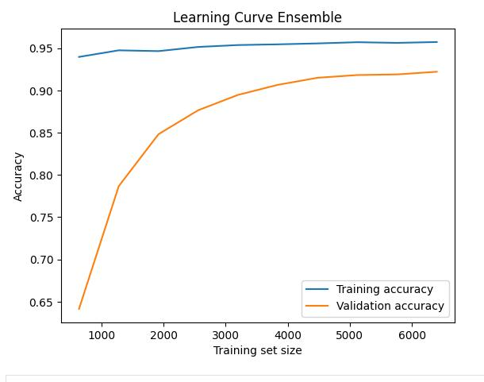
To assess overfitting, we compared the model’s performance on the training and test datasets. We performed a train/test split cross-validation, achieving 94% accuracy on the training set and 91% on the test set. This was a strong indication that our model was not overfitting. Even though the other models used individually have better robustness against overfitting, we chose the ensemble model because it achieves higher accuracy while still not overfitting.

