Sekwencja1: GATGCCTACACAGATTATCAAGG
F: TTCGGATGCCTACACAGATTATCA
R:AAACTGATAATCTGTGTAGGCAT
czy specyficzna:

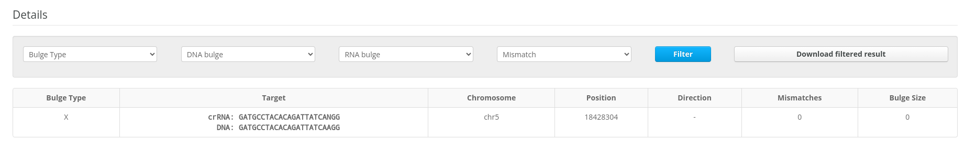
Sekwencja2: GAAGCGAATCCACCATACCAAGG
F:TTCGGAAGCGAATCCACCATACCA
R:AAACTGGTATGGTGGATTCGCTT
czy specyficzna:
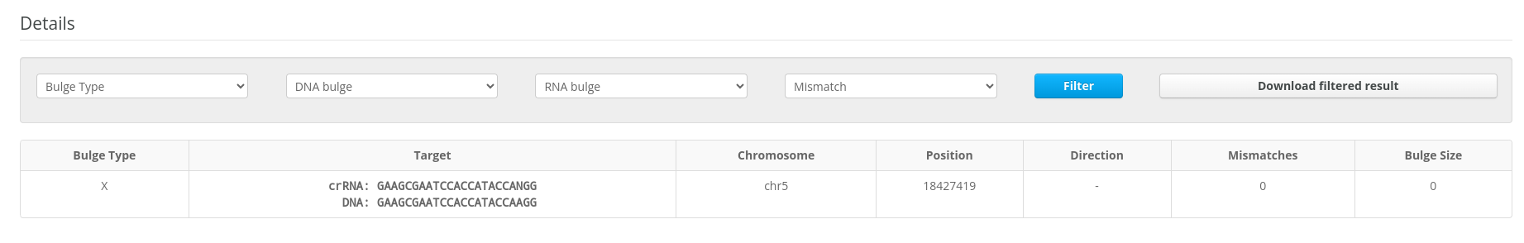

1 ccaaccagaa taattcaaac cttcacacac aacaaaaagc ctcaaaagca aaaaaactca
61 tagtaaaacc agaaaaagaa agaagtcaac ctctttagat gtatctgtgt tagatctcat
121 aaaccatcag ttcttgtctg tttcagcaaa tcagtttcaa gatggtgaac gcaatcccaa
181 agcctatcaa ggacatttgg gacgaatgga gcattcgaag taccttaatc ttcagtctca
241 gccttcaaac atttctcatt ttctttgcac ctcaaagaaa acgctcatcc agaaaagttt
301 tactctcttt catttggtca gcttaccttc ttgctgattg gtctgccaat ttcgccgccg
361 gacaaatctc agatagtcaa ggagatgatc cagaacccgg agaaccgaaa aagagcgccg
421 agttgtttgc tttctgggtt cctttcttgc tcttgcatct cggtggtcca gatacaatca
481 ctgcccttgc ccttgaagat aacgagctct ggctcaggca cttgttgggt cttttctttc
541 aatcagttgc aaccgtttac gtgcttttgc agtcgttacc caatgctctt tggaaaccta
601 ttttgctggt gtttgcgacc ggggtgatca agtatgtcga gaggacatta gctttgtacc
661 tggcgagtct tgacaagttc aaagattcca tgattcagcg gcctgatcct ggaccaaact
721 acgcaaagct catggaggaa tacgcagcca agaaagatat gaagatgcct acacagatta
781 tcaaggttgg cgagcctgag aaagatccaa gagacgatgc tccggtaaag cctcctgacg
841 ggttcactcc actcaatatt ctccagtacg cctacaagta ctttaatatc ttcaaaggtc
901 ttgtggttga tctcatcttt acatttcaac aacgagctga gagcaagaga ttctttgact
961 cgctgaaagc agaagaagct ttaagaatct tagaggttga gctcaacttt atctacgcag
1021 ctctatacac gaaagccgag atcttgcaca actggatagg attcctcttc aggttcattg
1081 ccctgggatg ccttgcagca gctctacgca tctttcaata caagagcaag aaagattata
1141 gtggatttga tgttggcctt acttacgcat tgctgttagg aggaatagct ctggattgca
1201 tcgctcttat catgttctgt gcatctgatt ggacgtttgt cagattgagg aagatgaagg
1261 acgaagtgga cgatccaccc acctggtccg acaacattct taactggatt cttgaaaaca
1321 ttctcggggt caggaaattg aaggtggagg agtatgatga atgctacaag aatacacagt
1381 ctcatgaagt gcccaacacg agtactaaga aaacaccatt tcttaaaagg attcttaaca
1441 ggattctcag ggtgagggag ttgaagacag agaagtctca tgaagttctc gacaagagta
1501 ccagcaaaat accaggtcag gaagtgcccg acaagagtgc caagacaata ccatgtcata
1561 aagtgctcga cacgagtttc atgtatcgcc ggtggtctga gtatgtacat gcacacaacc
1621 tgatcgaata ctgcctaggt ttaaaaccga agcgaatcca ccataccaag ggtttcatac
1681 acatcgcctt tgacaaggtt atcaacatac tttacattgg ccccgcattc acaaaacttg
1741 gaagtgtcat tgaatcctgt tttagagtca caaaacagag aattcatcag actttcaagt
1801 ggattgacgg taaagtaagt cgtttatgca agaaataccc gaagttgaat gaagagtaca
1861 ttaggtttag cttcttctgc atattttaca ttcctagtct acctggacgc tggataaaaa
1921 gttttatgga gttctttggc atccgagctc agctagatga ggtgatctac acatctagtg
1981 atcgtctcac cctggatatg tgggaacaca tattcggaga ggttaaagcc aaatcccgtt
2041 tcgctgacga ctctgaaagc gccatgaggg tatcttcagc aagaggtgac tggacactgc
2101 gcgacataca aggtgaccca gaaacagaaa aaaaacgtga gaaacttcta cgctatgtga
2161 tggaaatgga ttacgatcag agccttcttg tatggcatat agccactgag ctcttatacc
2221 agacaaaaaa aggcactaaa gcgaatcata gcgcccgtga gttcagtaaa atcctgtcag
2281 actacatgat gtatctccta atgatgcaac ccactctgat gtcagctgtt gtgggtattg
2341 gaaagataag attcagagac acgtgcgagg aggctcagag gttcttcgat aggaggcata
2401 tcatggggat atccgcaaag aaggcccctg atgcaaagga agccagcgtg gcaattttat
2461 cagtggcagt tccagcaaaa gctgagccca ttgacgtgaa aggagataga agcaaatccg
2521 tcctgtttga tggggccatg ctggcgaaag agcttaaggg tttaagaaag aataaggagg
2581 acgactcaga gatgtggaaa ataatgagcc aagtgtgggt tgagttgctt tcgtatgcag
2641 cgacaaagtg tggcgctata gaacacgcag ctcagctaag caaaggagga gaactcataa
2701 gctttgtttg gctattgatg gctcattttg gactaggaga ccaattccaa atcaaccaag
2761 gagatgccag agccaaactg attataggca agtgatcatc atccaataag caacgaaagt
2821 agcagcaatt gattagtttc cctcatttgc ttccattgtg ttttttttgt tttgtttcaa
2881 agagtagtct tcaactgttt gccagcaaaa caatctgttc ttgaatcatc tgcattgttg
2941 taactcatgt ccttcttctg tccctgataa attcatttat gtgagct

