1. Run following command in the command window:
   1. ng new event-hub
2. When asked to add routing choose yes.
3. When asked to choose styling approach choose CSS.
4. System will go on and scaffold the project for you and install all necessary packages.
5. Open the folder in Visual Studio Code.
6. Create a folder named as “images” in “assets” folder.
7. Clone or download the repo:
   1. <https://github.com/kontacthimanshu/angular-fundamentals>
8. Go to folder: event-hub\src\assets\images in the cloned or downloaded repo.
9. Copy all the files from this “images” folder and paste them to your application’s “assets/images” folder.
10. Installing bootstrap. Run the following command to install bootstrap:
    1. npm i bootstrap
11. Referring bootstrap CSS in your application.
12. Open the file “angular.json”. In this file look for section “styles” and add this path on top of the existing path: “node_modules/bootstrap/dist/css/bootstrap.min.css”.
13. Now lets refer bootstrap JS. Bootstrap JS helps to render components like modal window etc.
14. In the angular.json file look for section called “scripts” and add this path:
    1. “node_modules/bootstrap/dist/js/bootstrap.min.js”
15. Bootstrap also requires jQuery so lets install and refer jQuery also in the “scripts” array.
16. Run the following command: “npm i jquery”.
17. In the angular.json file, in the scripts section add following line on top of existing line.
    1. "node_modules/jquery/dist/jquery.min.js"

With this our application is ready for development. Run the application by running the command “ng serve”. Type in browser: <http://localhost:4200>. You should see something like below:

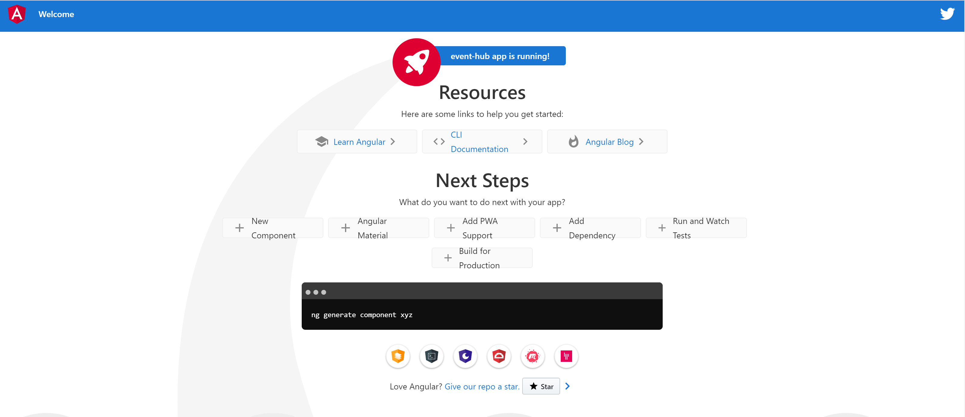

# Add some global styles

1. Open the cloned/downloaded Github repo and go to folder: “event-hub\src”.
2. Open the file “styles.css” and copy its content.
3. Go to VS Code and paste its content in the file called “styles.css”.
4. Apply “.container” class to <body> tag in “index.html” file like below:
5. 