1. Open events-list.component.ts.
2. Add following property to it:
   1. event = {
      1. id: 1,
      2. name: ‘Angular Connect’,
      3. date: ‘09/26/2036’,
      4. time: ’10:00 AM’,
      5. price: 599.99,
      6. imageUrl: ‘/assets/images/angularconnect-shield.png’,
      7. location: {
         1. address: ‘1057 DT’,
         2. city: ‘Pune’,
         3. country: ‘India’
      8. }
   2. }
3. Now update the template code and it should like the image below:
4. 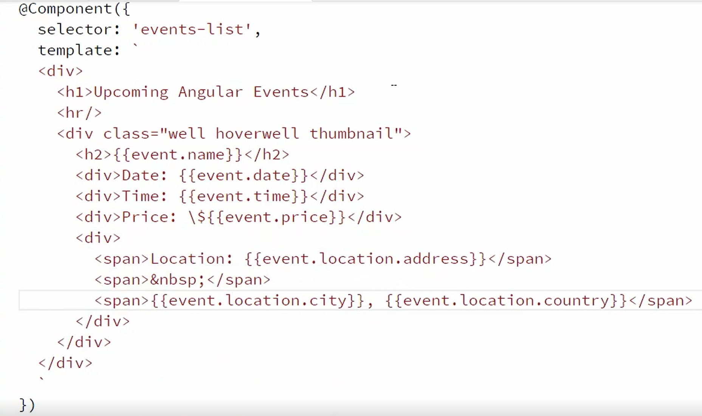
5. After entering the code above, run the application. Your application should look like below:
6. 