1. Right click on the “events” folder and click “New File”.
2. Name the file “events-list.component.html”.
3. Copy the inline HTML from the component decorator of ‘events-list.component.ts’ and paste it in the file create in step 2.
4. From line number 8 in events-list.component.html remove the backslash.
5. In the “events-list.component.ts” file change the “template” property to be “templateUrl” and sets its value to be “./events-list.component.html”.
6. Your code in “events-list.component.ts” file should like below:
7. 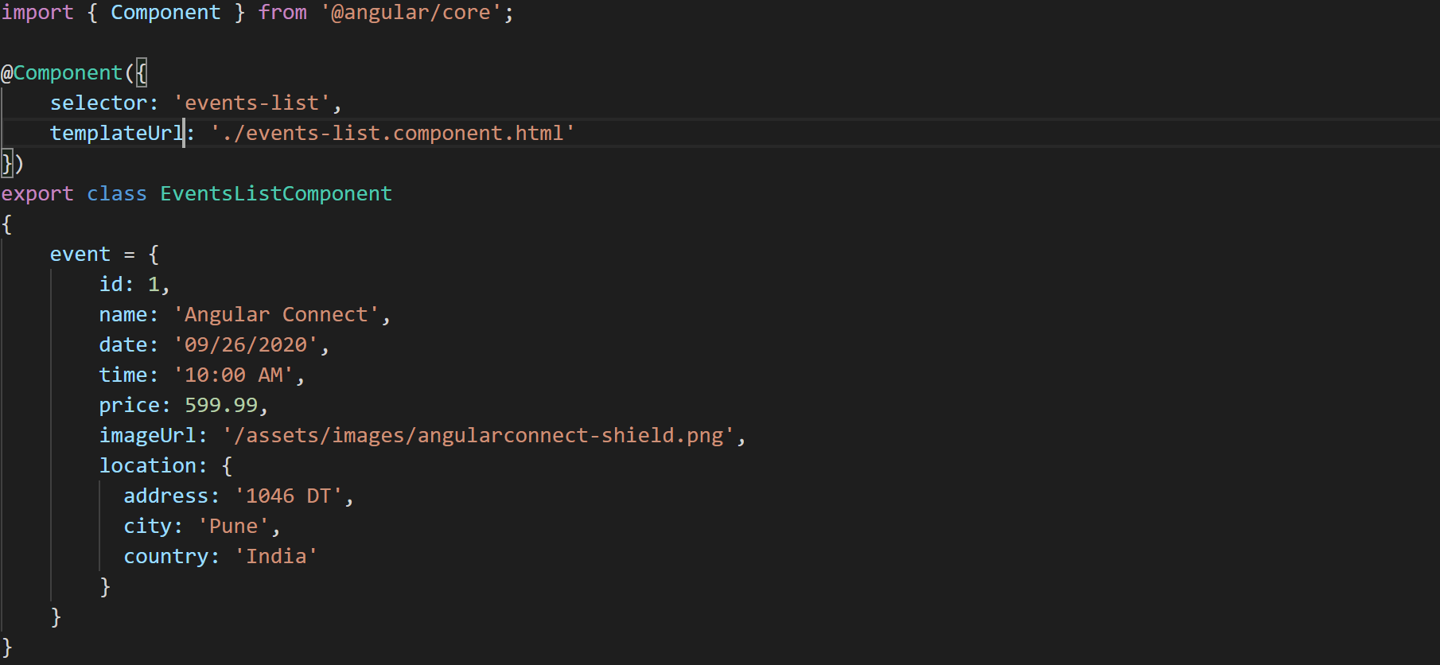
8. After this change the application should look same.
9. 