1. Right click on “events” folder and click “New File”.
2. Name the file “event-thumbnail.component.ts”. Add basic component code like below:
3. 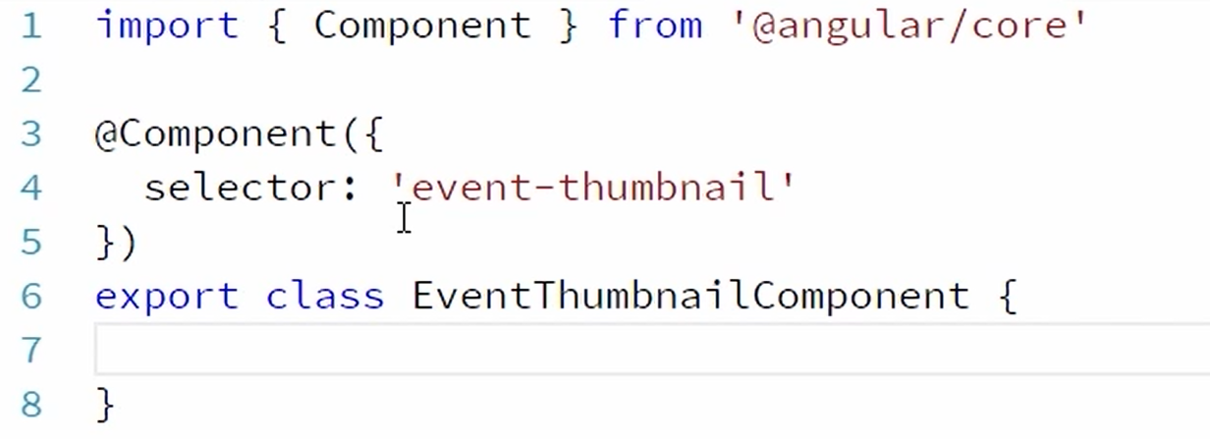
4. Right click the “events” folder and click “New File”.
5. Name the file “event-thumnail.component.html”. Copy following code from “events-list.component.html” and paste it in “events-thumbnail.component.html”.
6. 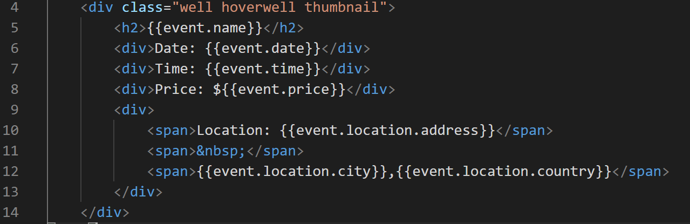
7. Create a property named “event” in “events-thumbnail.component.ts”.
8. In the import statement add “Input” decorator like below.
9. 
10. Decorate the “event” property in “event-thumbnail.component.ts” like below:
11. 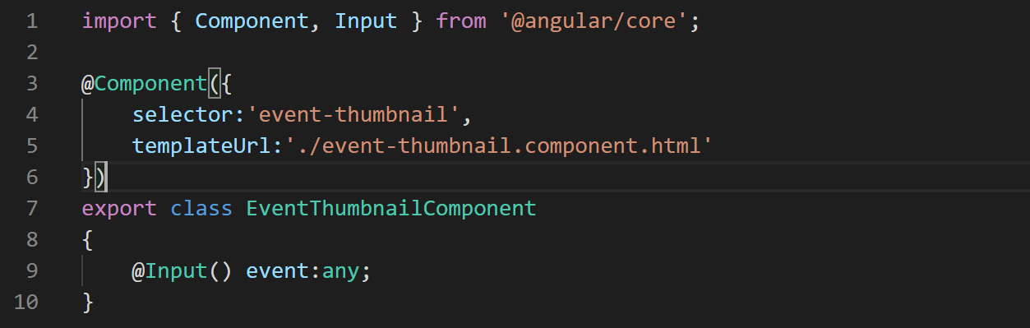
12. Now that we have event thumbnail component ready. Lets use it in “events-list” component. Open the file “events-list.component.html” and refer the “event-thumbnail”component like below:
13. 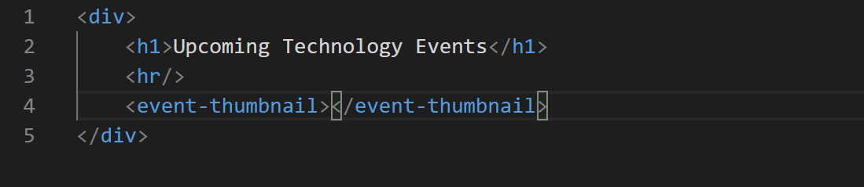
14. Now we are again getting an error in terminal which is depicting that “event-thumbnail” component should be part of a module. So lets add it in our “App” module. Open the file “app.module.ts”. And in the declarations array add the “event-thumbnail” component like below:
15. 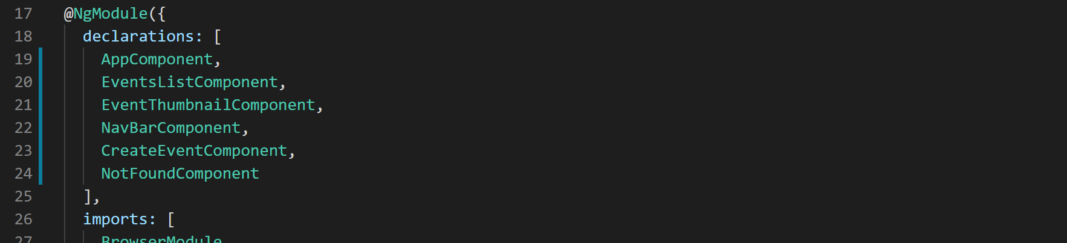
16. Now notice the error in terminal is gone.
17. Now lets pass in the data to the “event-thumbnail” component from “events-list” component like below:
18. 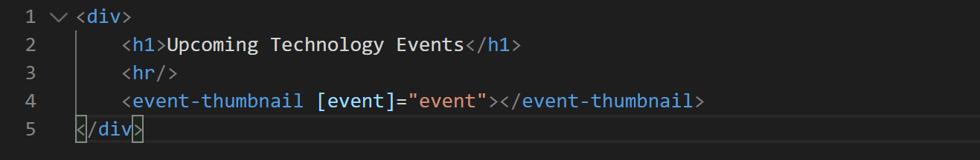
19. With this we have successfully connected both the component and application should still be rendering successfully.