1. Open the file “event-thumbnail.component.html” and add a button in it like below:
2. 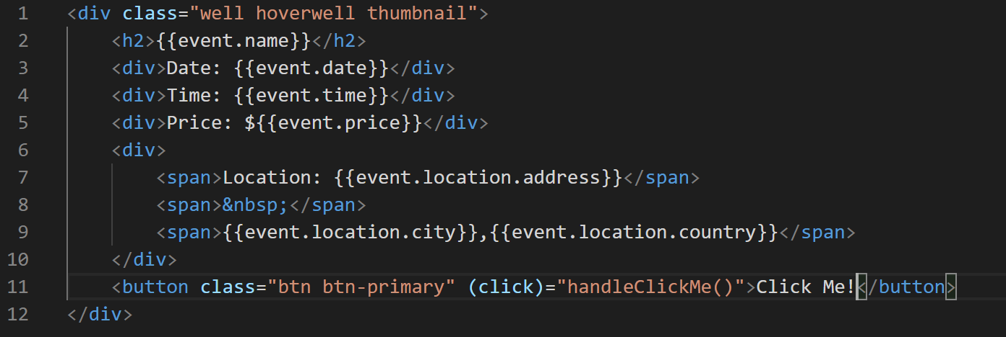
3. Now lets add the “handleClickMe()” method in “event-thumbnail.component.ts” file like below:
4. 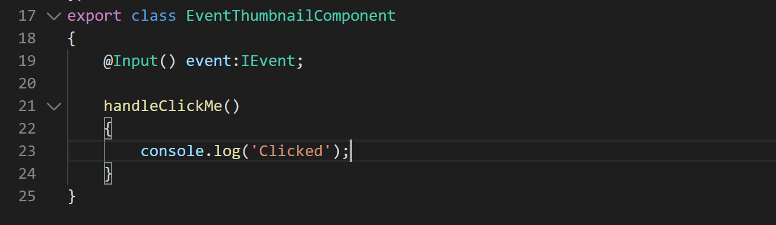
5. Now lets take a look at it in the browser and run the application if it is not running already. Your application should look like below:
6. 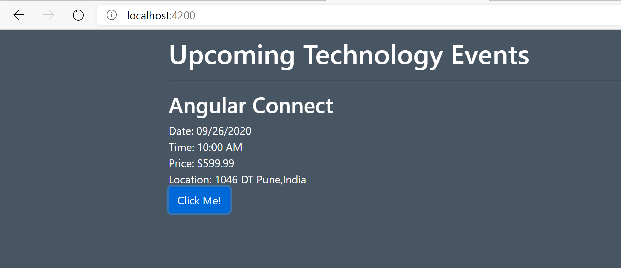
7. Open the Developer tool bar by pressing F12 in your browser and click the button. You should see something like below in your console.
8. 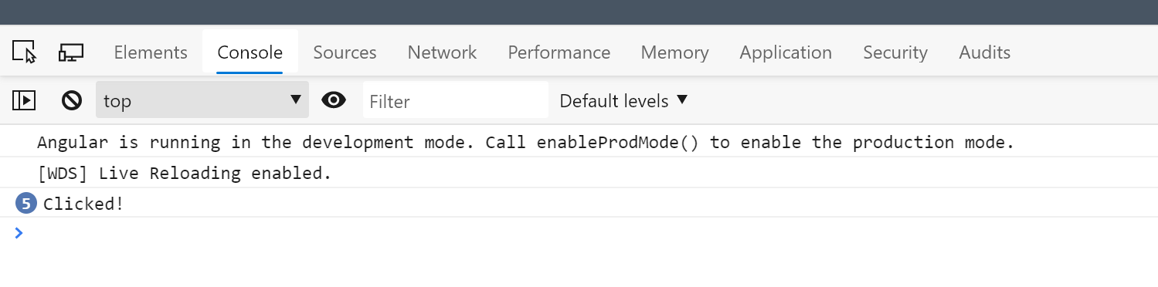
9. Now lets emit the event to parent component using the Output decorator like below in “event-thumbnail.component.ts”:
10. 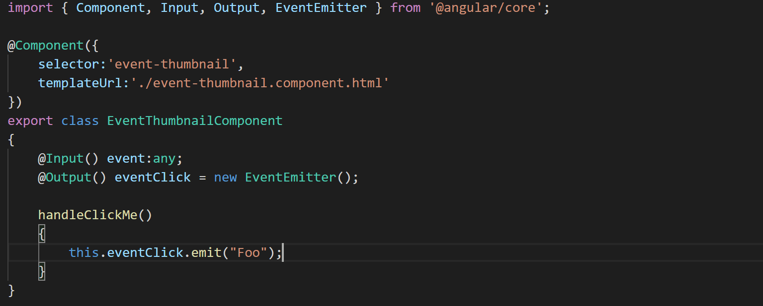
11. Now lets modify the “events-list” component to listen for the event that “event-thumbnail” component is firing. Modify the “events-list.component.html” file like below:
12. 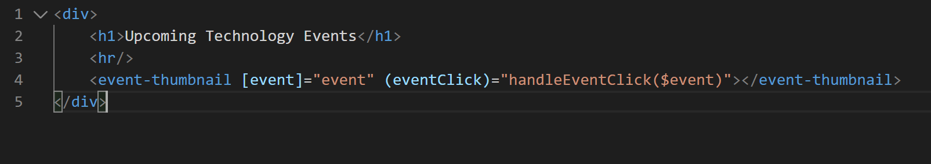
13. Now add the handle method in “events-list.component.ts” like below:
14. 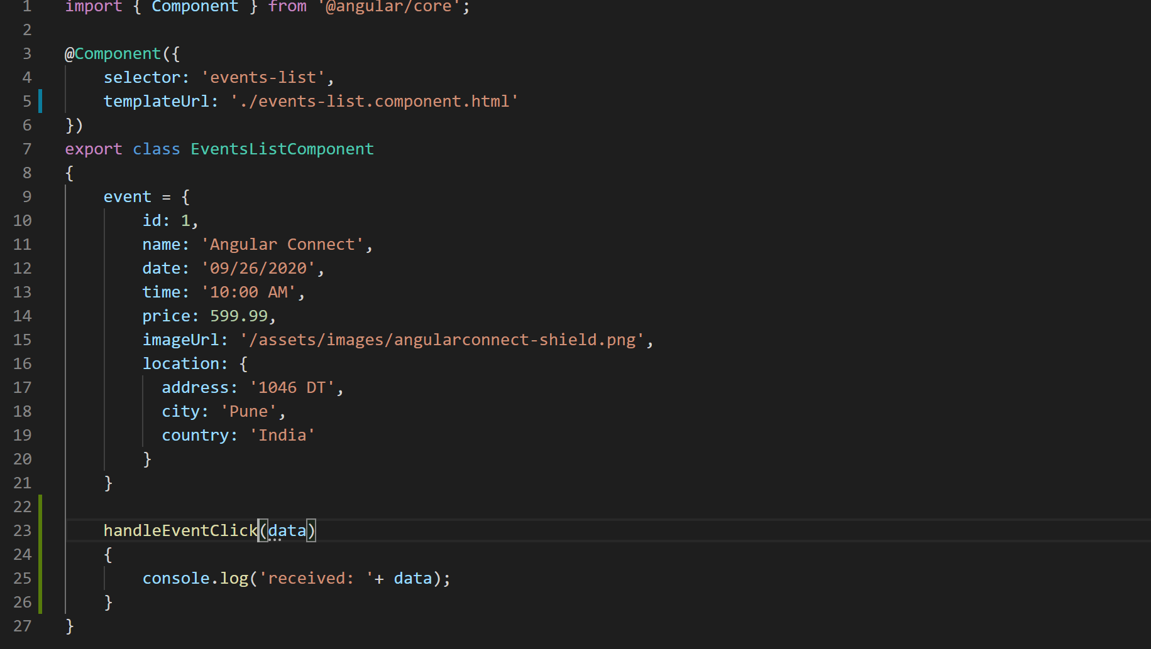
15. Now when you run application and open Developer tool bar after click the button you should see something like below:
16. 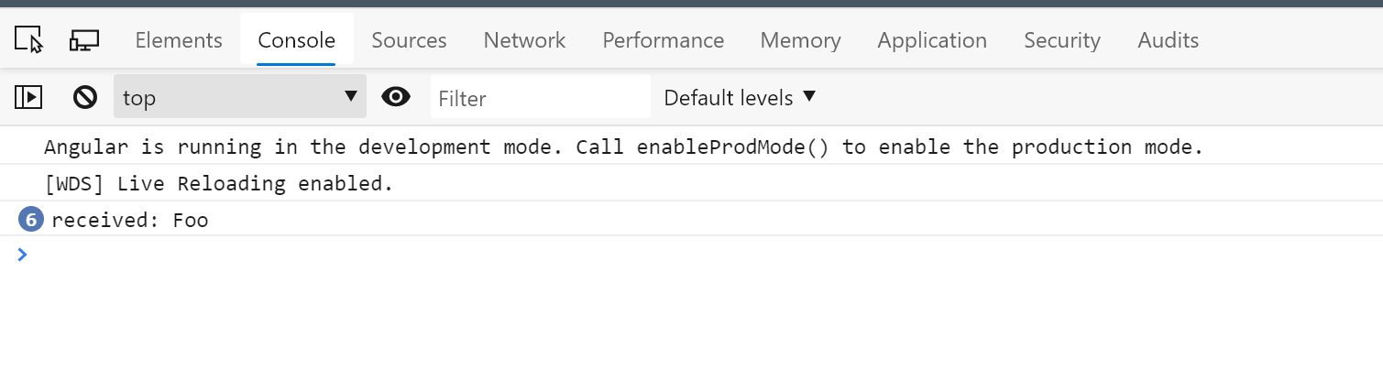
17. Now lets pass some real data from child component “event-thumbnail.component.ts” like below:
18. 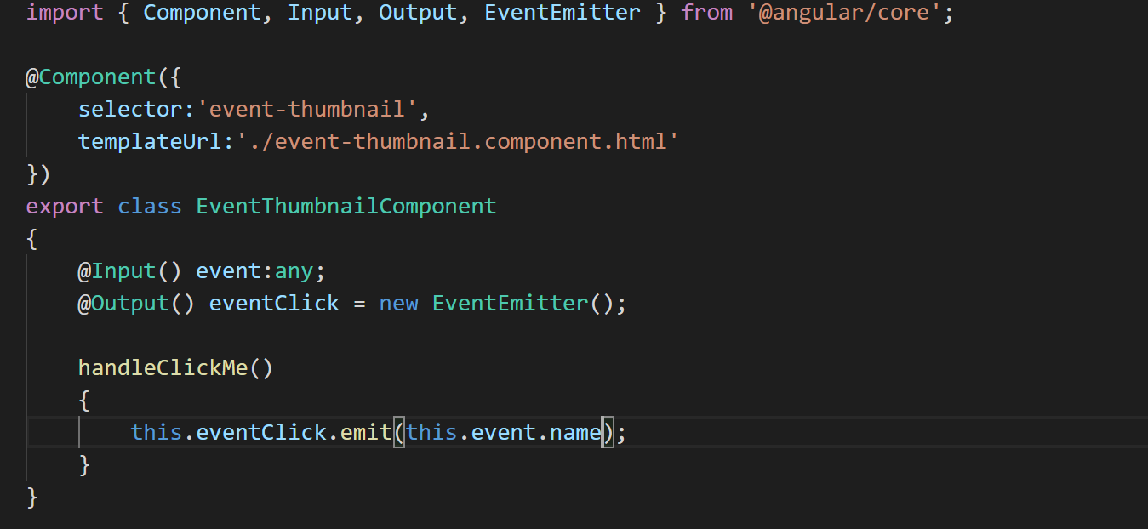
19. Now when you run the application you should something like below in Developer tool bar.
20. 