1. Open the file “events-list.component.html” and on the <event-thumbnail> element add a template reference variable named as “#thumbnail” like below:
2. 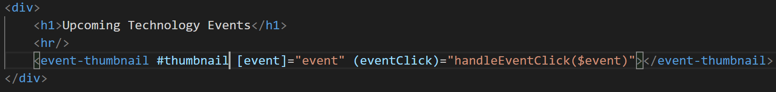
3. Now open the file “event-thumbnail.component.ts” and in this file add a method called “logFoo()” like below:
4. 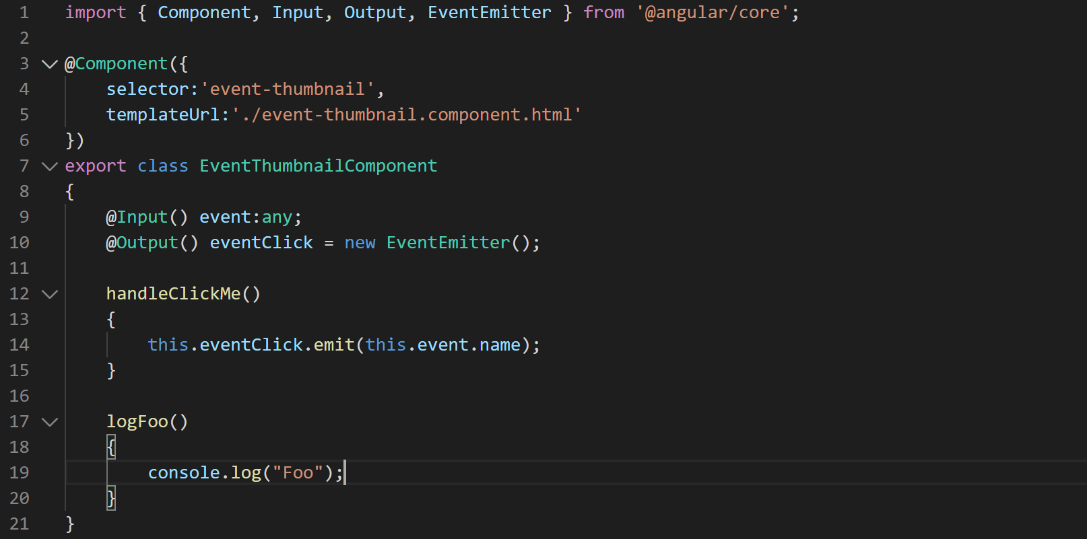
5. Now open the file “events-list.component.html” and in this file add a button to access the method you defined just above like below:
6. 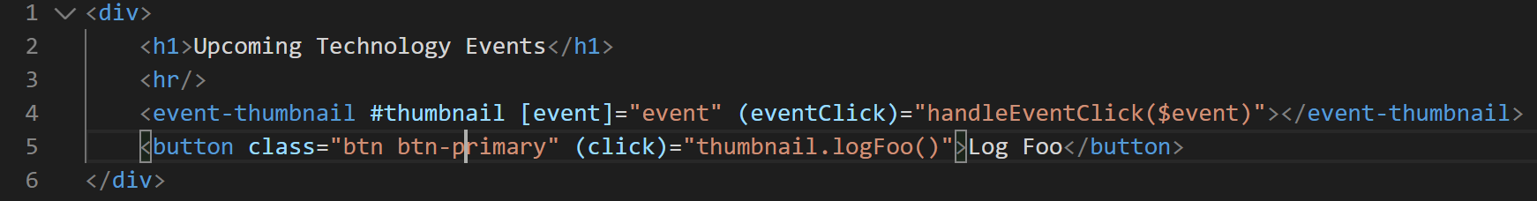
7. Now compile and run the site and your site should look like below:
8. 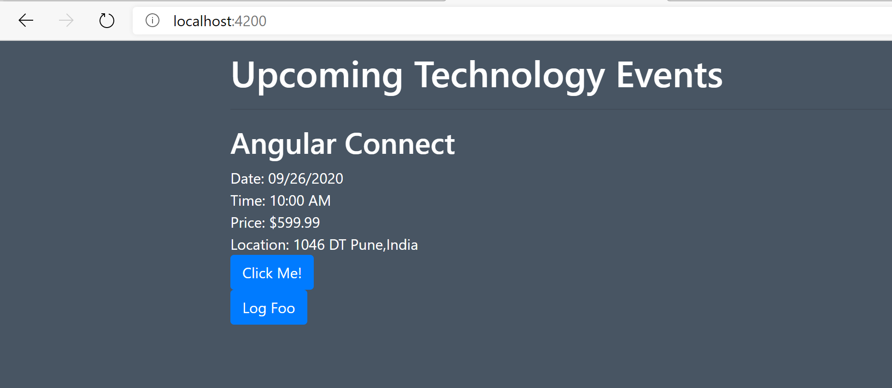
9. Open Developer tool bar and click the button “Log Foo” and you should see something like below in Developer tool bar:
10. 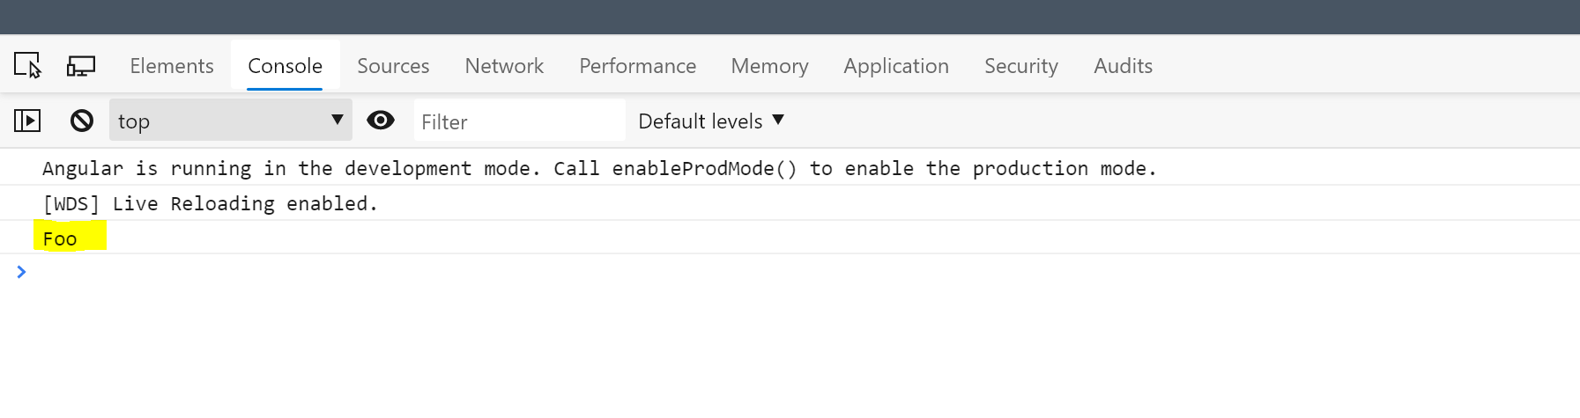
11. Now lets try to access a property on child component (event-thumbnail.component.ts) from parent component (events-list.component.ts). Open the “event-thumbnail.component.ts” file and define a property named as “someProperty” and set it to some random value like below:
12. 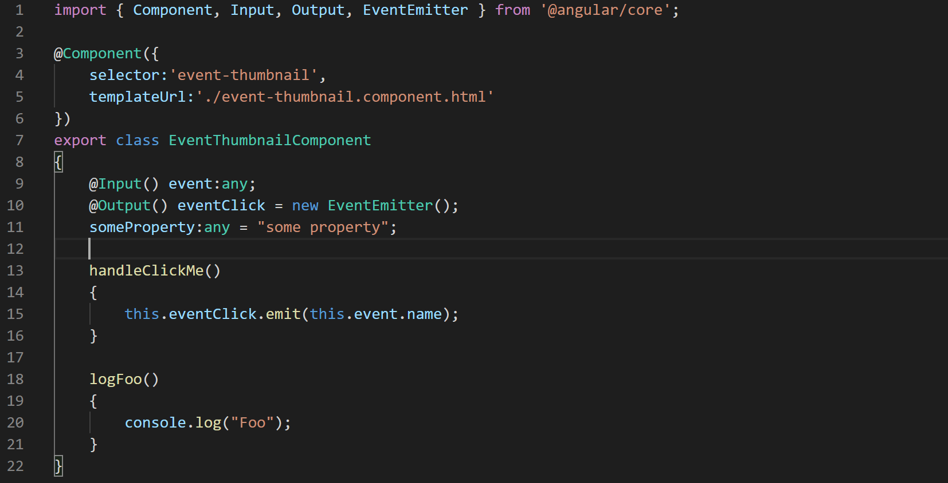
13. Now open the file “events-list.component.html” and try to access the property you defined just above by creating an “h1” element like below:
14. 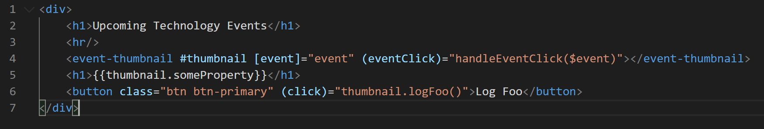
15. Now if you look at your application in browser it should look like something like below:
16. 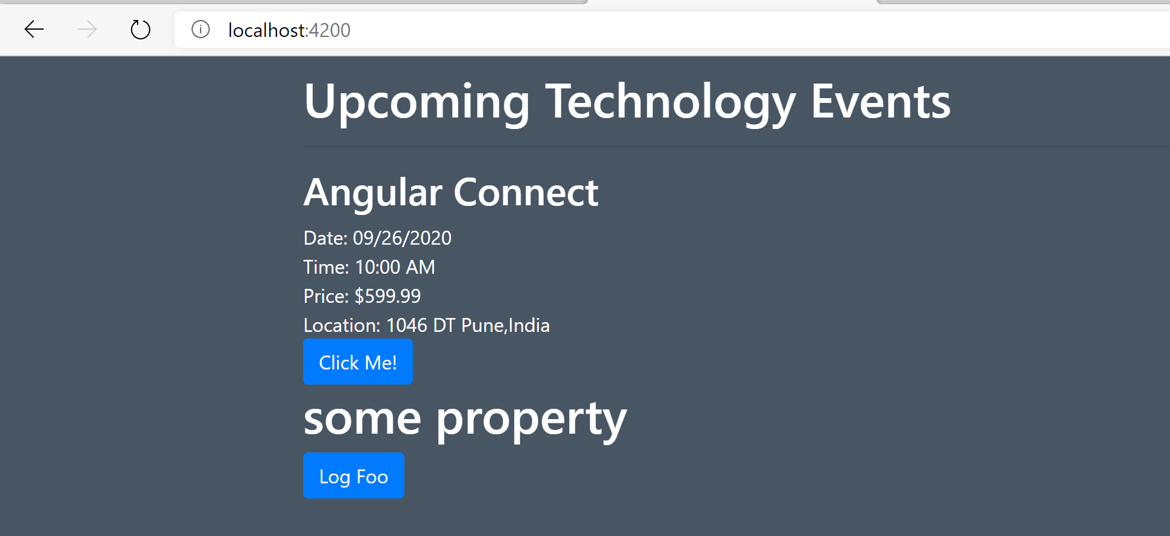
17. Since we are not going to need this template variable stuff in our application lets just clean all of it. So delete the following:
    1. From “events-list.component.html” delete the following:
       1. Button titled as “Log Foo”.
       2. “h1” element.
       3. Template variable on <event-thumbnail> element “#thumbnail”.
    2. From “event-thumbnail.component.ts” delete the following:
       1. Property named as “someProperty”.
       2. Method named as “logFoo()”.
18. After cleaning up you application should be back to looking like below:
19. 