1. Open the file “event-thumbnail.component.html”and delete the nonbreaking space like below:
2. 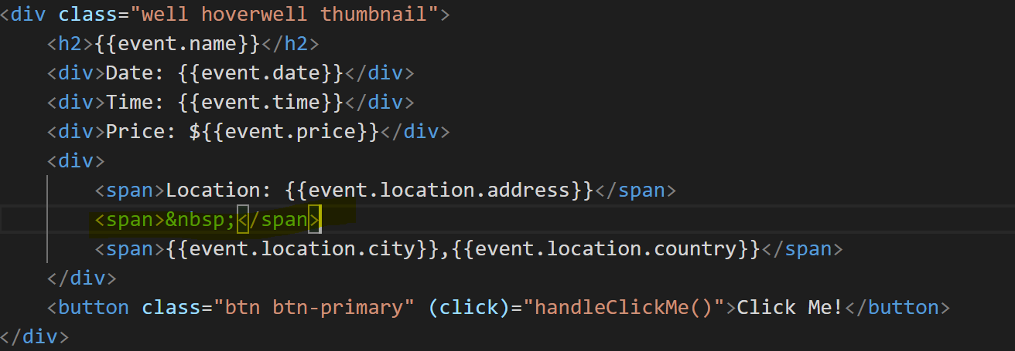
3. Now add a class pad-left to the span rendering the city and the country like below:
4. 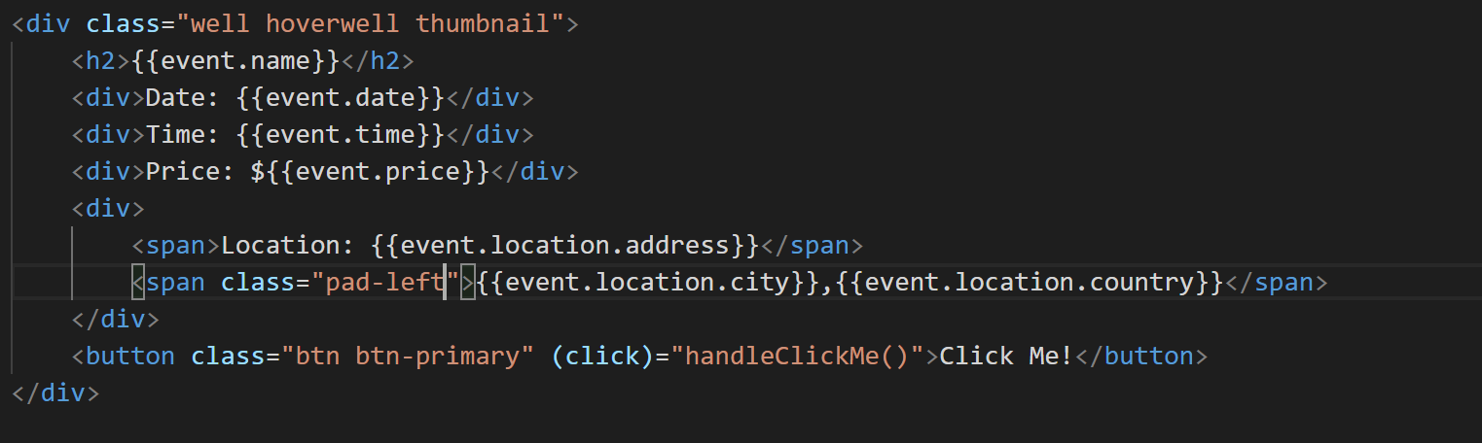
5. Now open the file “event-thumbnail.component.ts” and add styles array to the component decorator like below:
6. 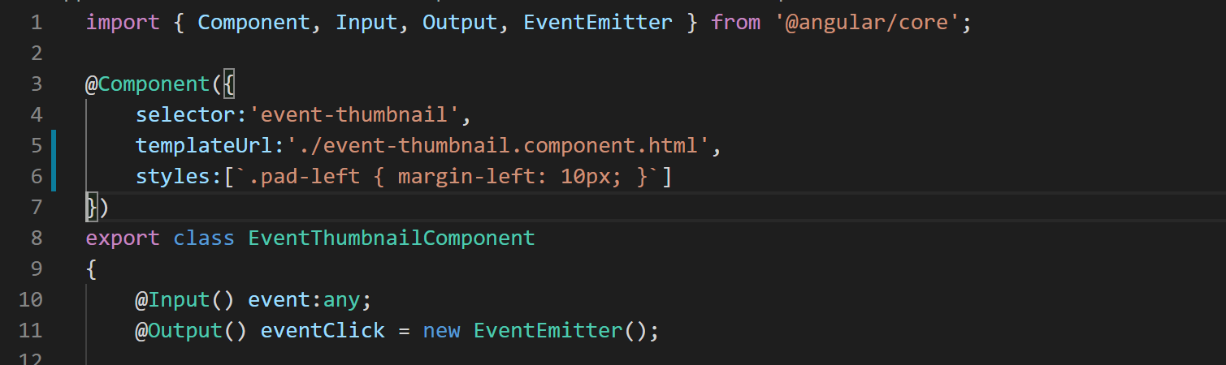
7. If you go to the application in browser now you will notice there is some space between address ender city without the non-breaking space.
8. Now let's add further styles to the style array to change the color of the event details like below:
9. Now go to the web application in the browser and notice the color of the event details is a little darker now.