1. Right click the “app” folder and click on new folder.
2. Name the folder “nav”.
3. Right click the “nav” folder and click on new file. Name the file as “navbar.component.ts”.
4. Add basic component code like below:
5. 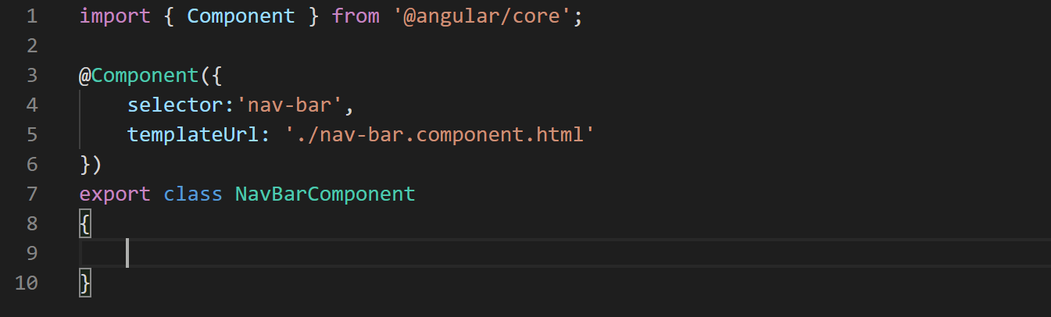
6. Right click the “nav” folder again and click on new file. Name the file “nav-bar.component.html”.
7. Copy and paste the code for “nav-bar.component.html” from the cloned or downloaded repository. In the cloned or downloaded repository look for the path: “event-hub\src\app\nav\ nav-bar.component.html”.
8. No this never component is ready to go. Let's add this component in the app component like below:
9. 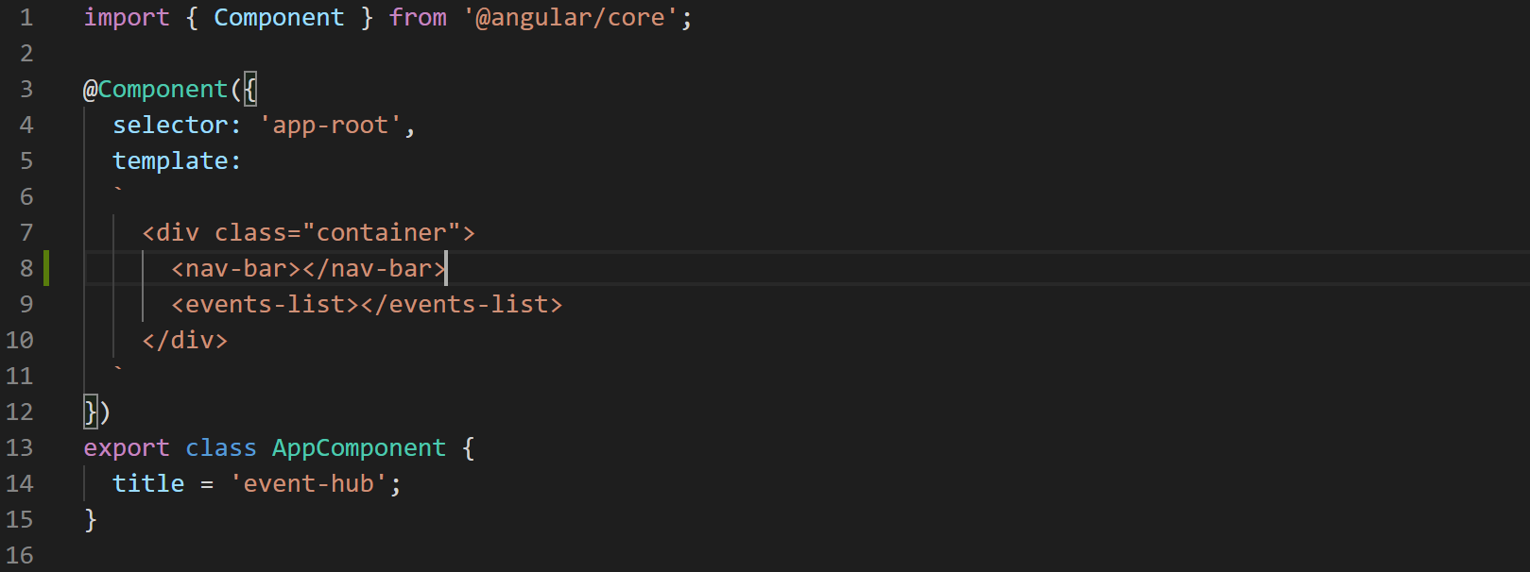
10. Now look at the terminal we are again getting the same error that we get when a component is not registered in the module. So let's add the “nav-bar” component in the app module like below:
11. 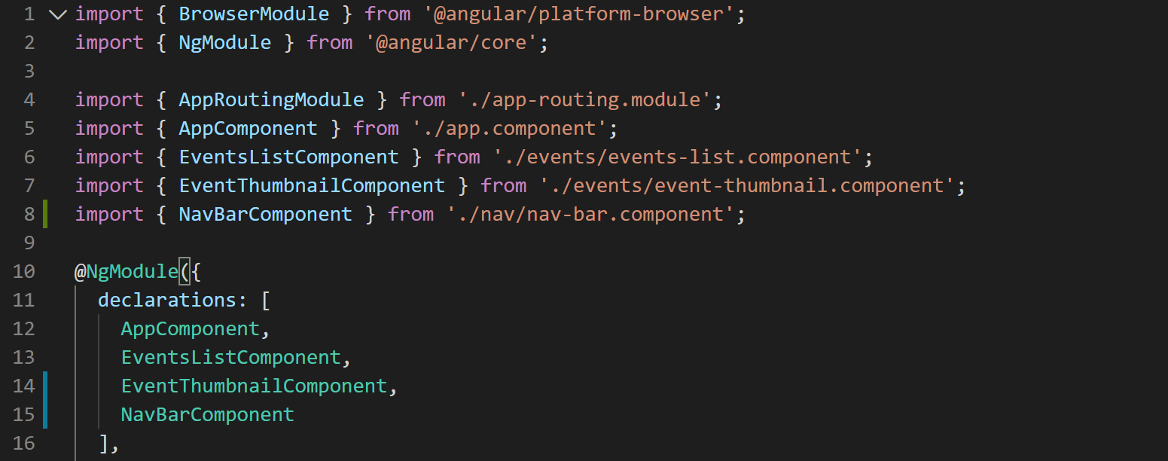
12. Now render the application in browser and your application should look like below:
13. 