1. Open the file “event-data.json” file from “misc” folder of cloned or downloaded repo and copy the events array from it.
2. Paste the events array in your “events-list.component.ts”.
3. Remove the event object that you have in your “events-list.component.ts”.
4. Open the file “events-list.component.html” and edit the “<event-thumbnail>” element like below to add “ngFor” in it:
5. 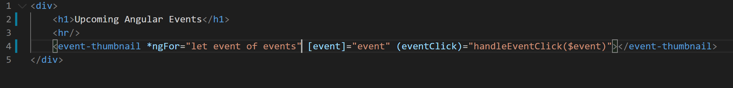
6. Let's remove the click me button we don't need it actually. so remove following code from these files:
   1. Remove “handleClickMe” method from “event-thumbnail.component.ts”.
   2. Remove “(eventClick)” event binding from “event-list.component.html”.
   3. Remove “handleEventClick()” method from “events-list.component.ts”.
   4. Remove “button” element from “event-thumbnail.component.ts”.
7. After doing the steps above your application should look below in the browser:
8. 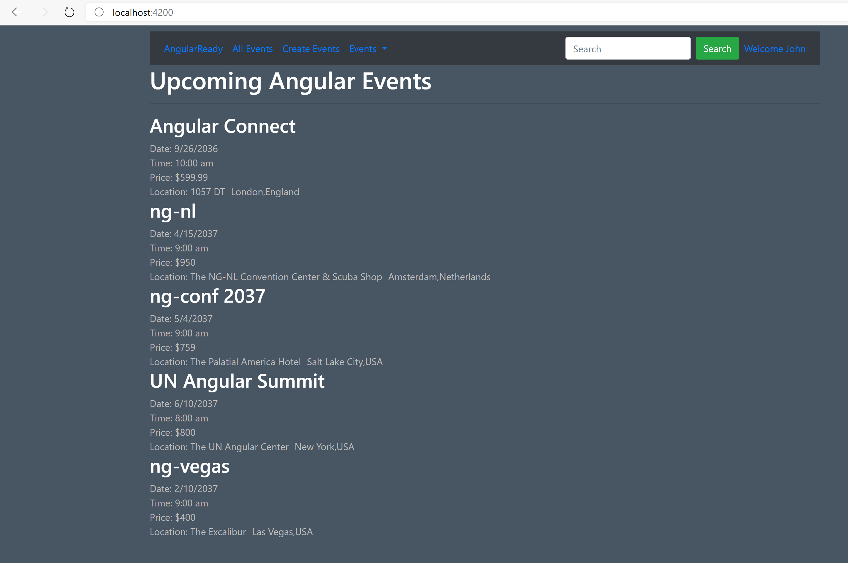
9. Notice the application is rendering multiple events now.
10. Now lets take advantage of Bootstrap’s grid system to render a grid of events rather than a large list of events like above. Modify code in “events-list.component.html” like below:
11. 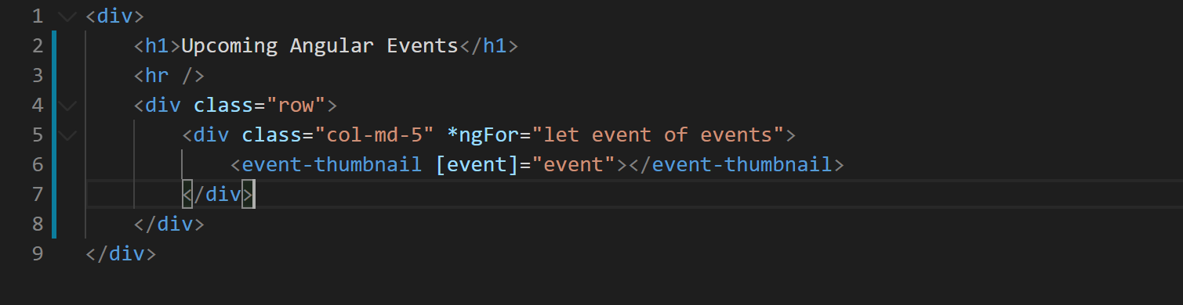
12. With this modification our application should look like below:
13. 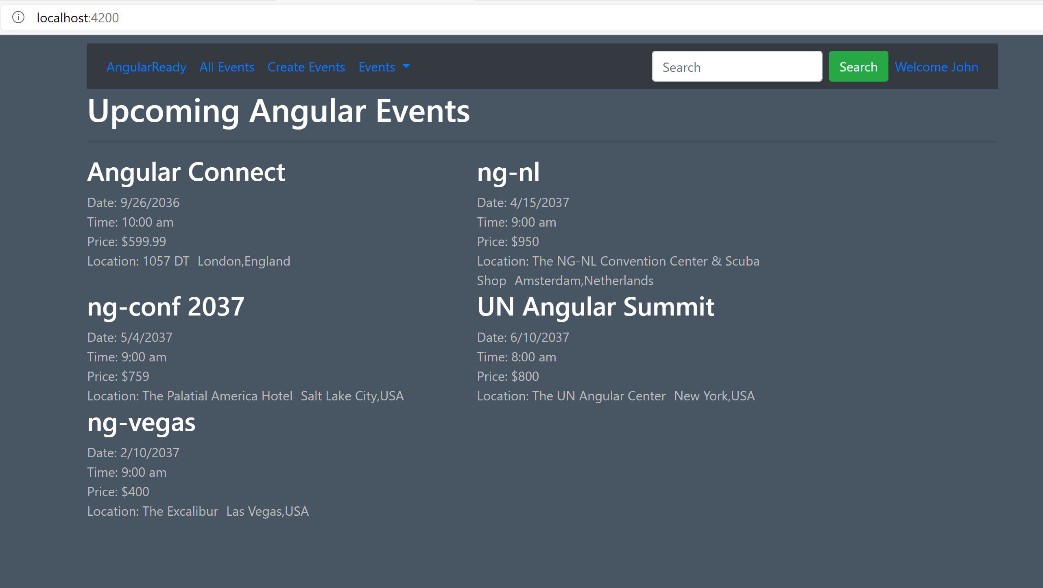
14. Lets add some styles to improve the rendering of each event.
15. In the component decorator of “event-thumbnail” component in file “event-thumbnail.component.ts” modify style array like below. Ignore if you already added the styles.
16. 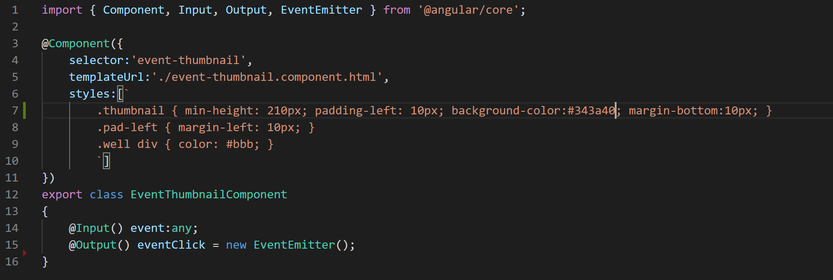
17. After this modification your site should look like below:
18. 