1. Open the file “events-list.component.html” and remove the value of “event” property like below:
2. 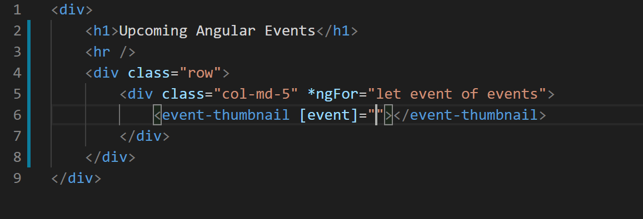
3. Now if you browse the application it would look like below:
4. 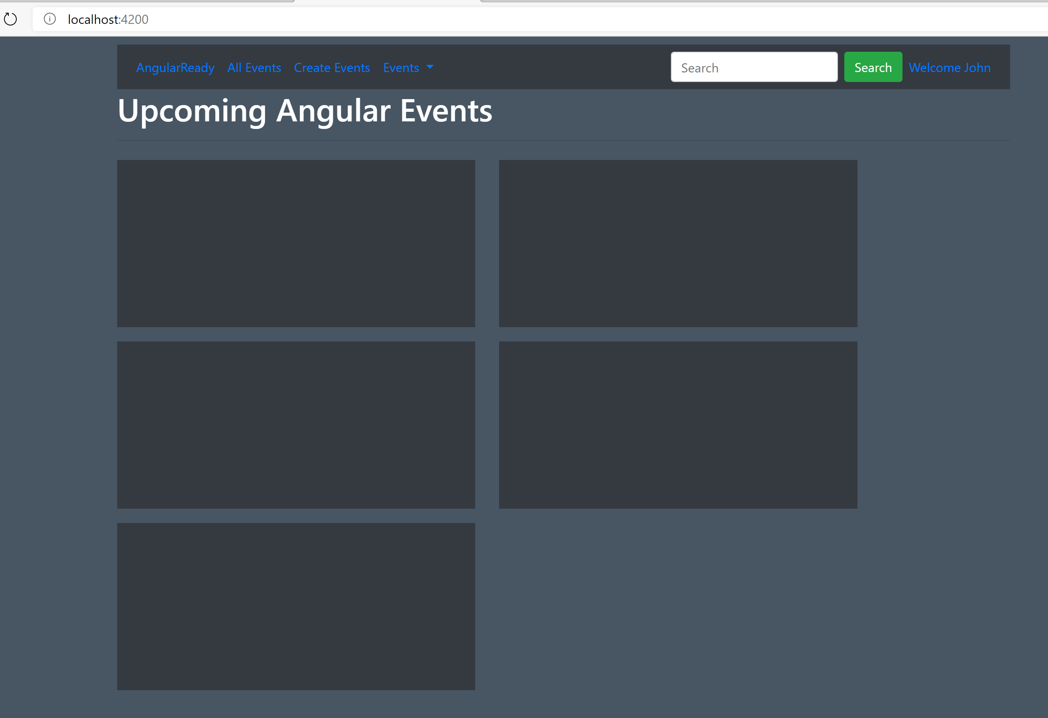
5. It looks like that application is rendering fine without any error but if you open the Developer tool bar you will notice error like below:
6. 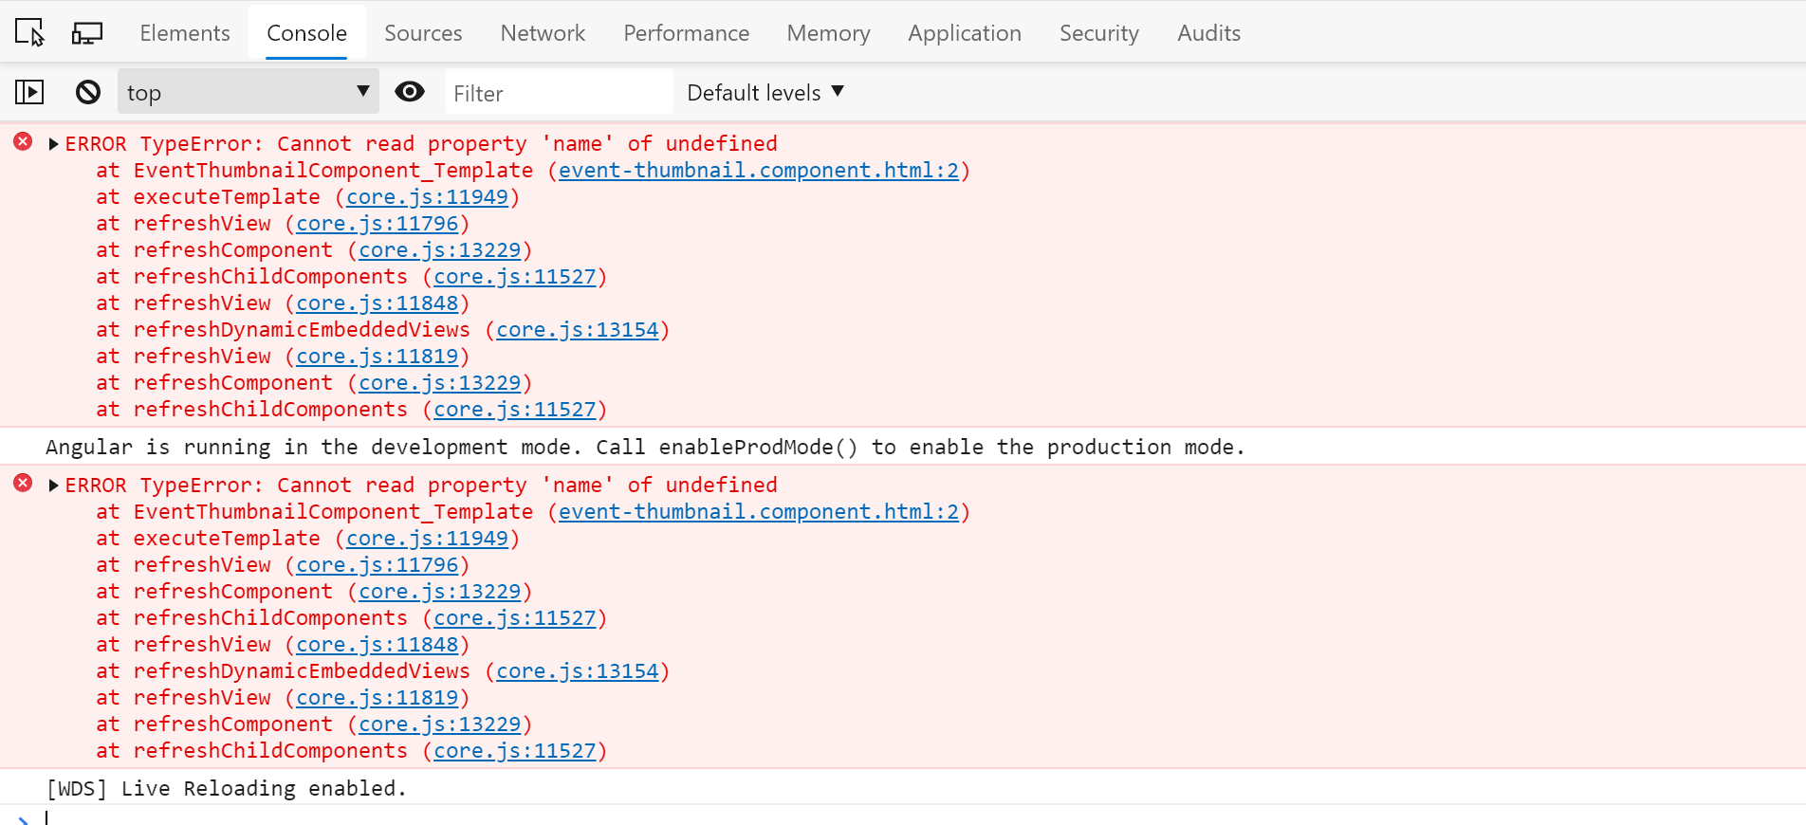
7. This is because the event we are binding to is undefined. To fix this all we need to do is add a “?” to all interpolations in “event-thumbnail.component.ts” like below:
8. 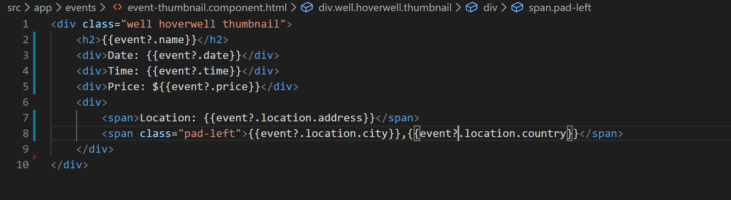
9. With this the error in Developer tool bar will be gone and our interpolations will start working.
10. Now if you notice application will look like below:
11. 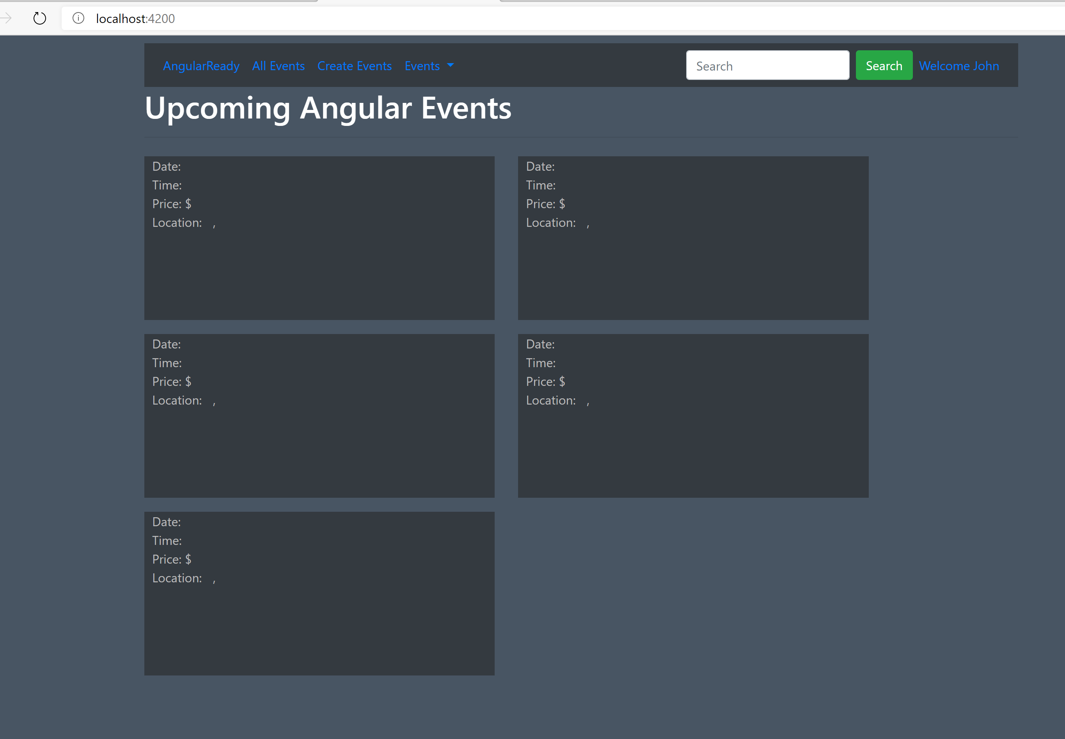
12. Now lets put the property value back in “events-list.component.html” like below:
13. 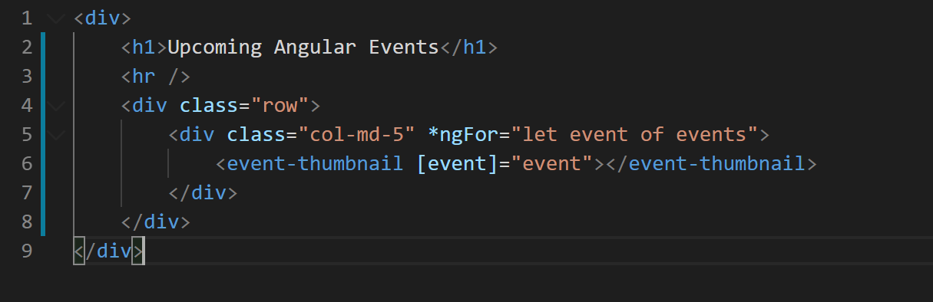
14. Now we handled the nullability of top level object but child objects can also be null or undefined. For example: “event.location” can be null or undefined.
15. To mimic that go to “events-list.component.ts” file and for one event remove the “location” object and add a property called “onlineUrl: <https://bit.ly/angnetherlands>” like below:
16. 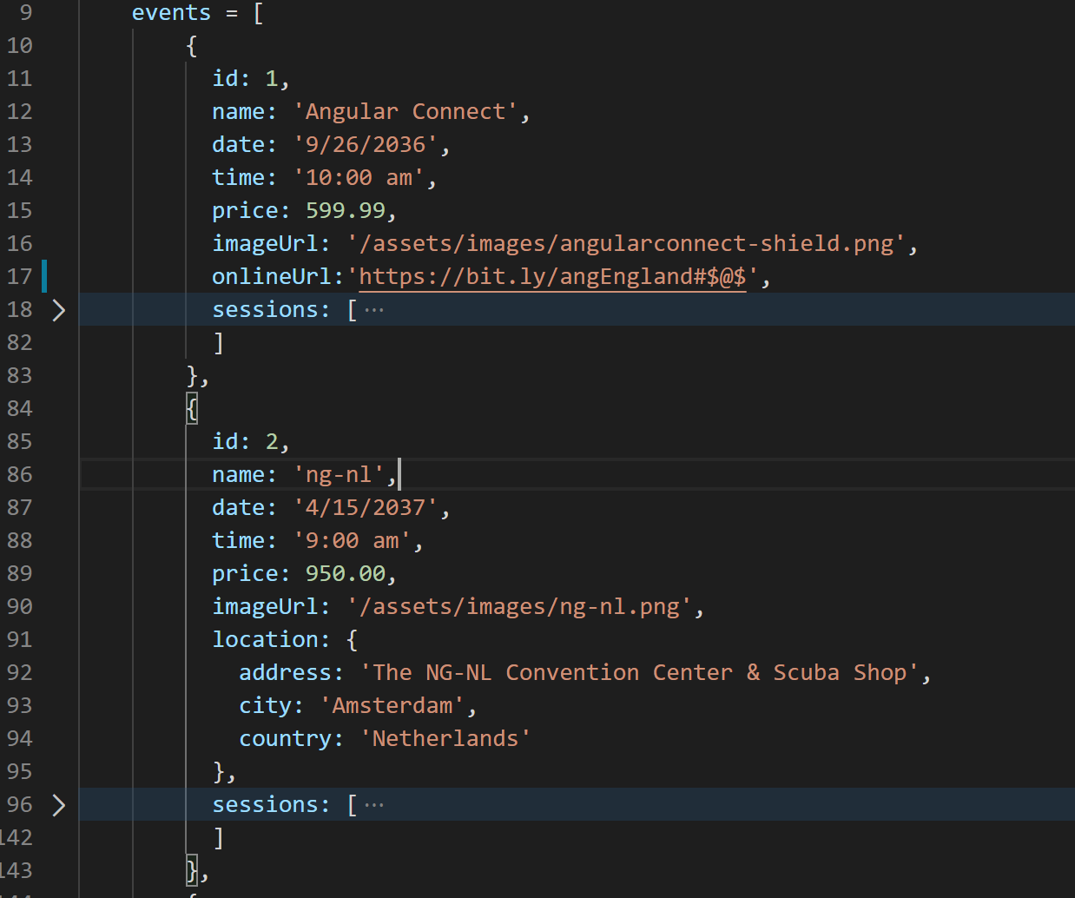
17. Now notice the application is broken again and we are getting same error in Developer tool bar. So to fix this lets add “?” to “location” binding as well like below:
18. 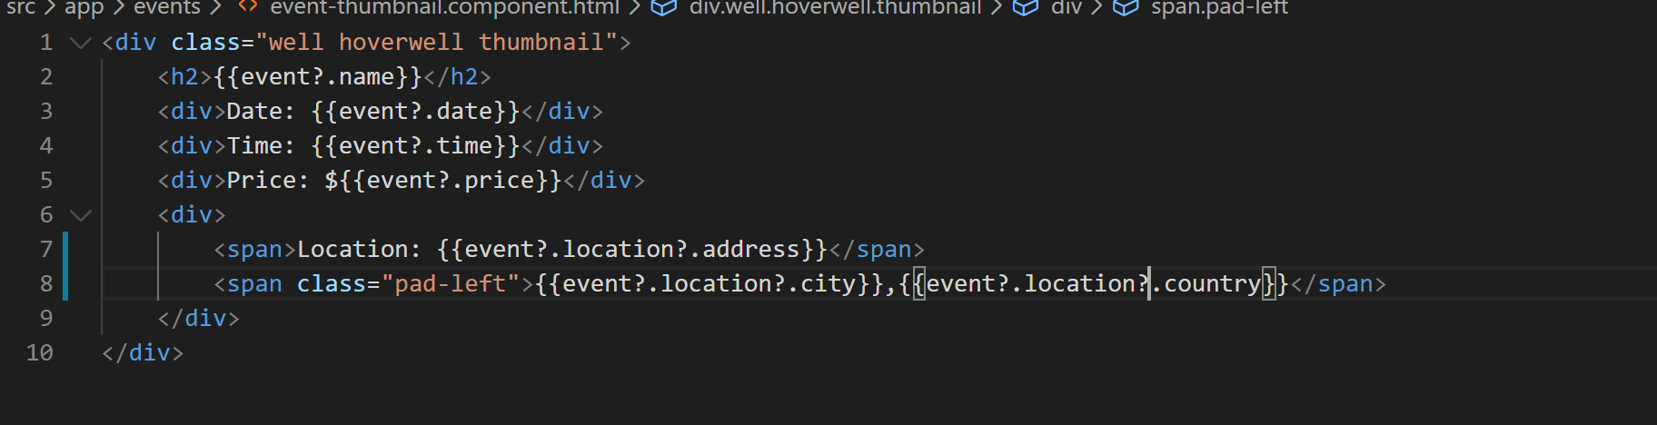
19. Since the England event is online only lets add binding for it to display it like below:
20. 