1. Open the file “event-thumbnail.component.ts” and add “ngIf” to “div” like below:
2. 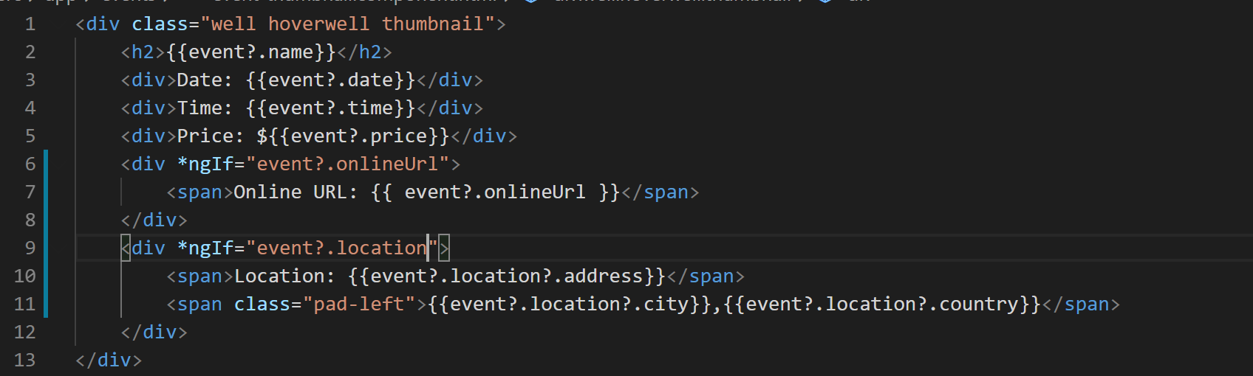
3. Now go to the browser and notice that objects which have location are not rendering empty “onlineUrl” element and objects which have “onlineUrl” are not rendering empty “location” element.
4. 