1. Open the file “event-thumbnail.component.ts” and add following HTML just below “div” displaying Time:
2. 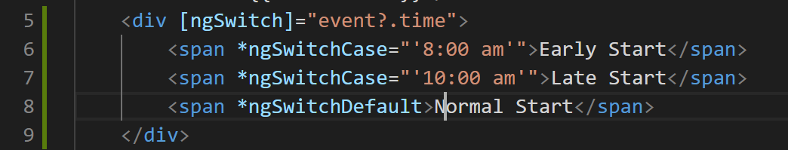
3. Modified HTML should look like below:
4. 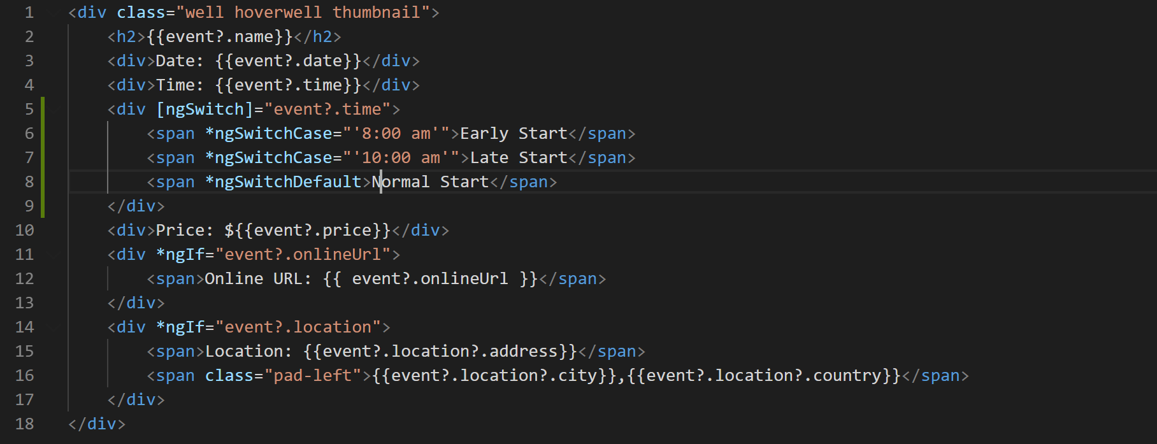
5. Now if you go to browser and look at the application, notice it is rendering another label according the time of the event.
6. 