1. Open “event-thumbnail.component.html” and on “div” having “ngSwitch” statement add following class binding like below:
2. 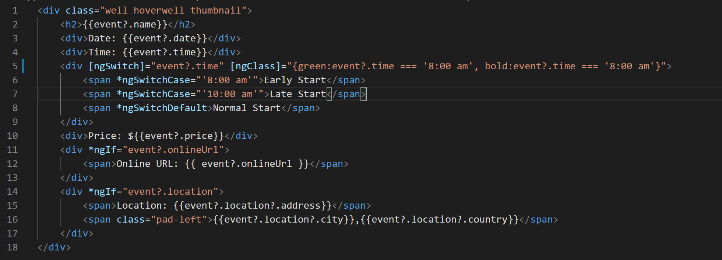
3. Add following CSS classes to “event-thumbnail.component.ts” styles array:
4. 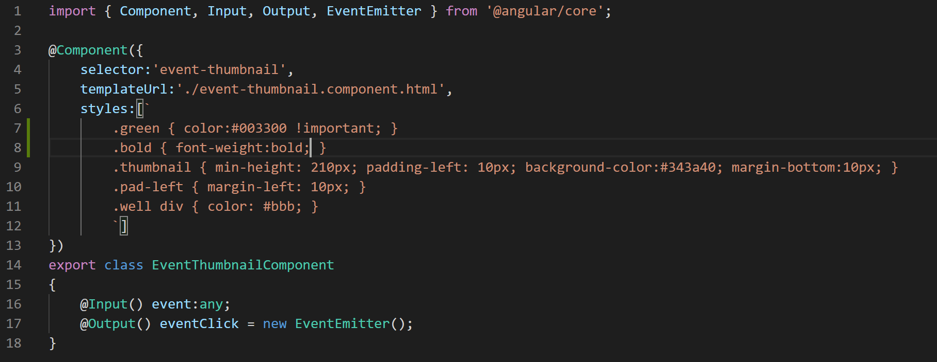
5. Once you save and render the application in browser it will look like below:
6. 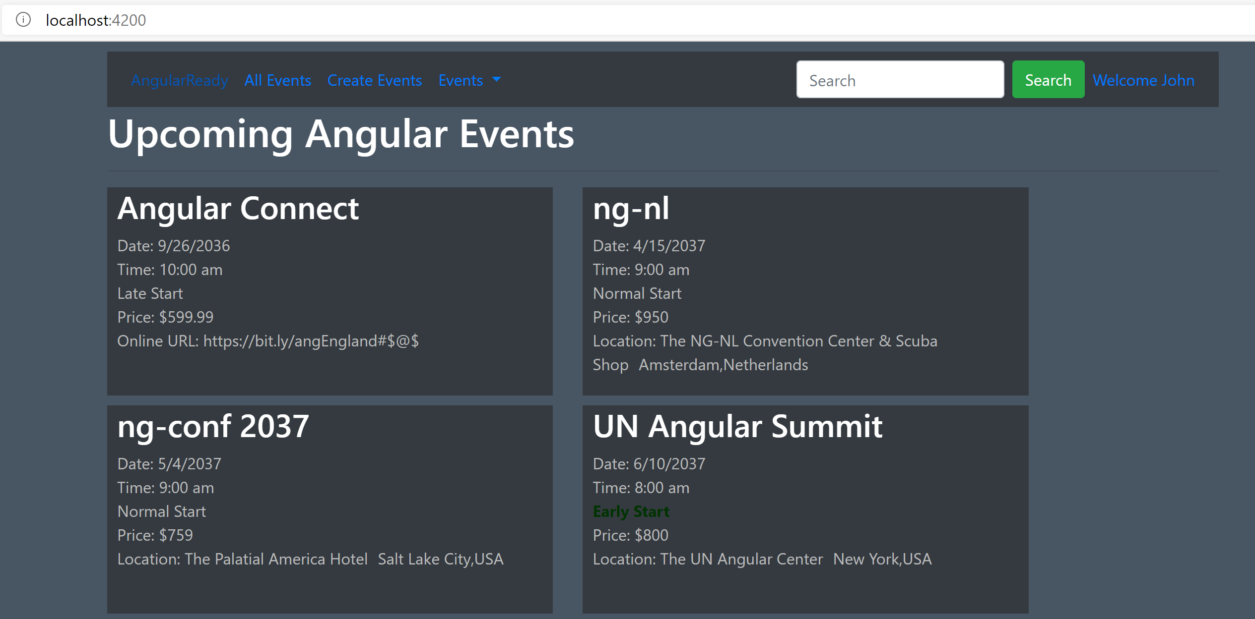
7. Notice the early start element for “UN Angular Summit” event is in green and bold.
8. If you notice that's a lot of code that we have written in the ngClass expression. So what we can do is we can move this into a function in our type script class and call that function rather.
9. So open “event-thumbnail.component.ts” and add a function like below:
10. 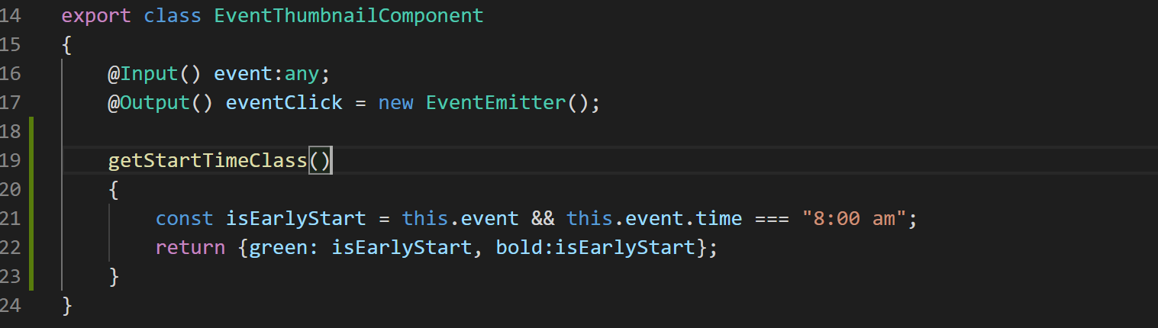
11. Now let's call this function in the ngClass expression in our template like below:
12. 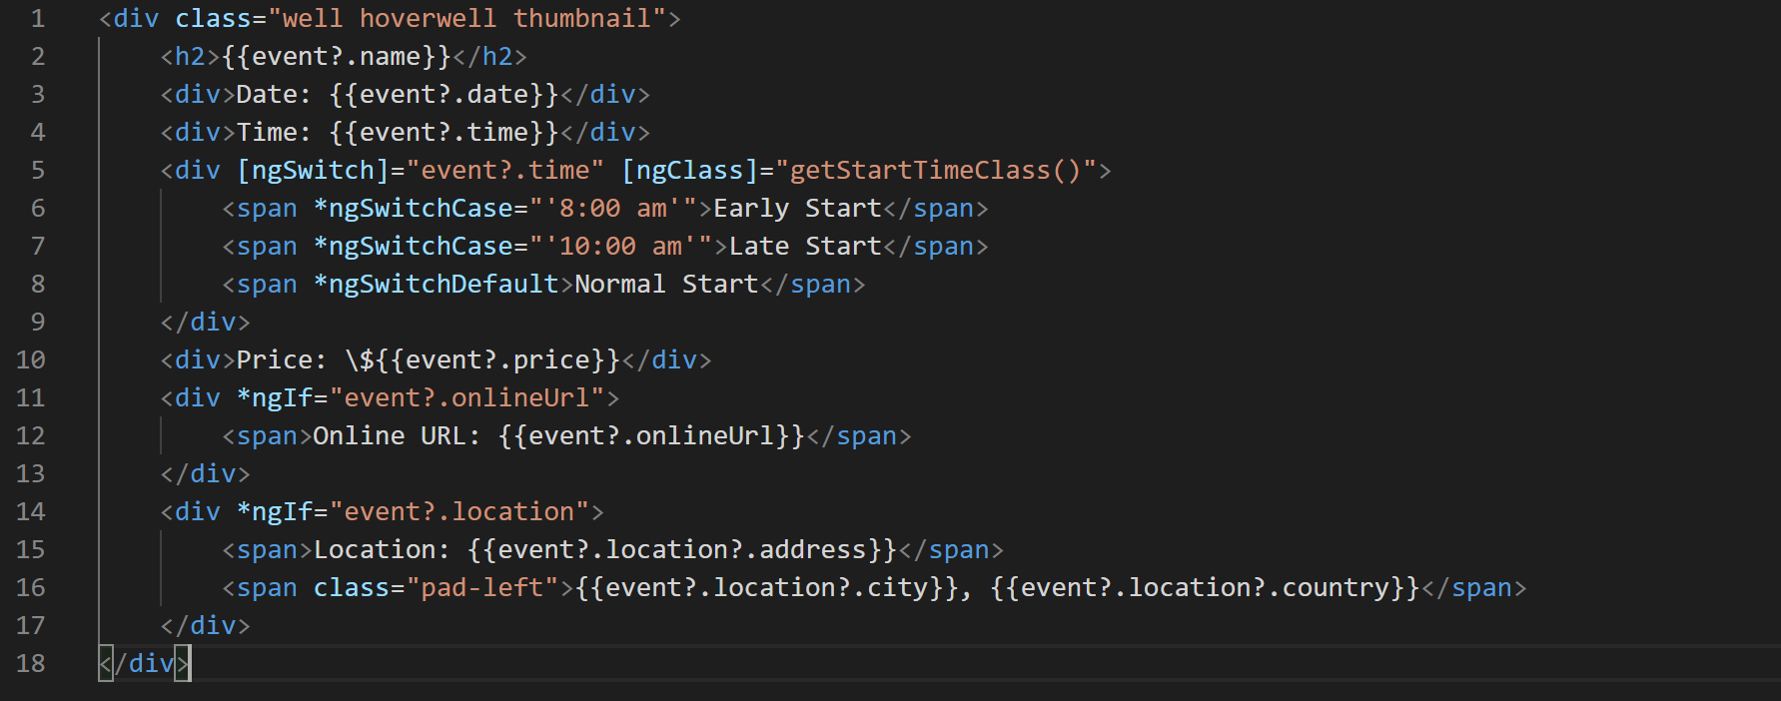
13. After this change notice our application is still working the same.