1. Right click the “events” folder and click on “New Folder”.
2. Name the new folder “shared”
3. Right click the “shared” folder click on “New File” and name the file as “event.service.ts”.
4. In this file export a class like below:
5. 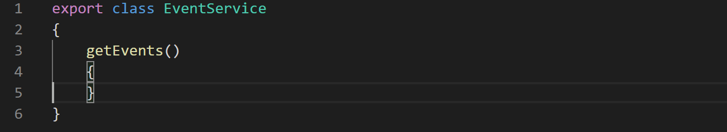
6. Now copy the “events” array from the “events-list.component.ts” class and paste it in the “event.service.ts” file like below
7. 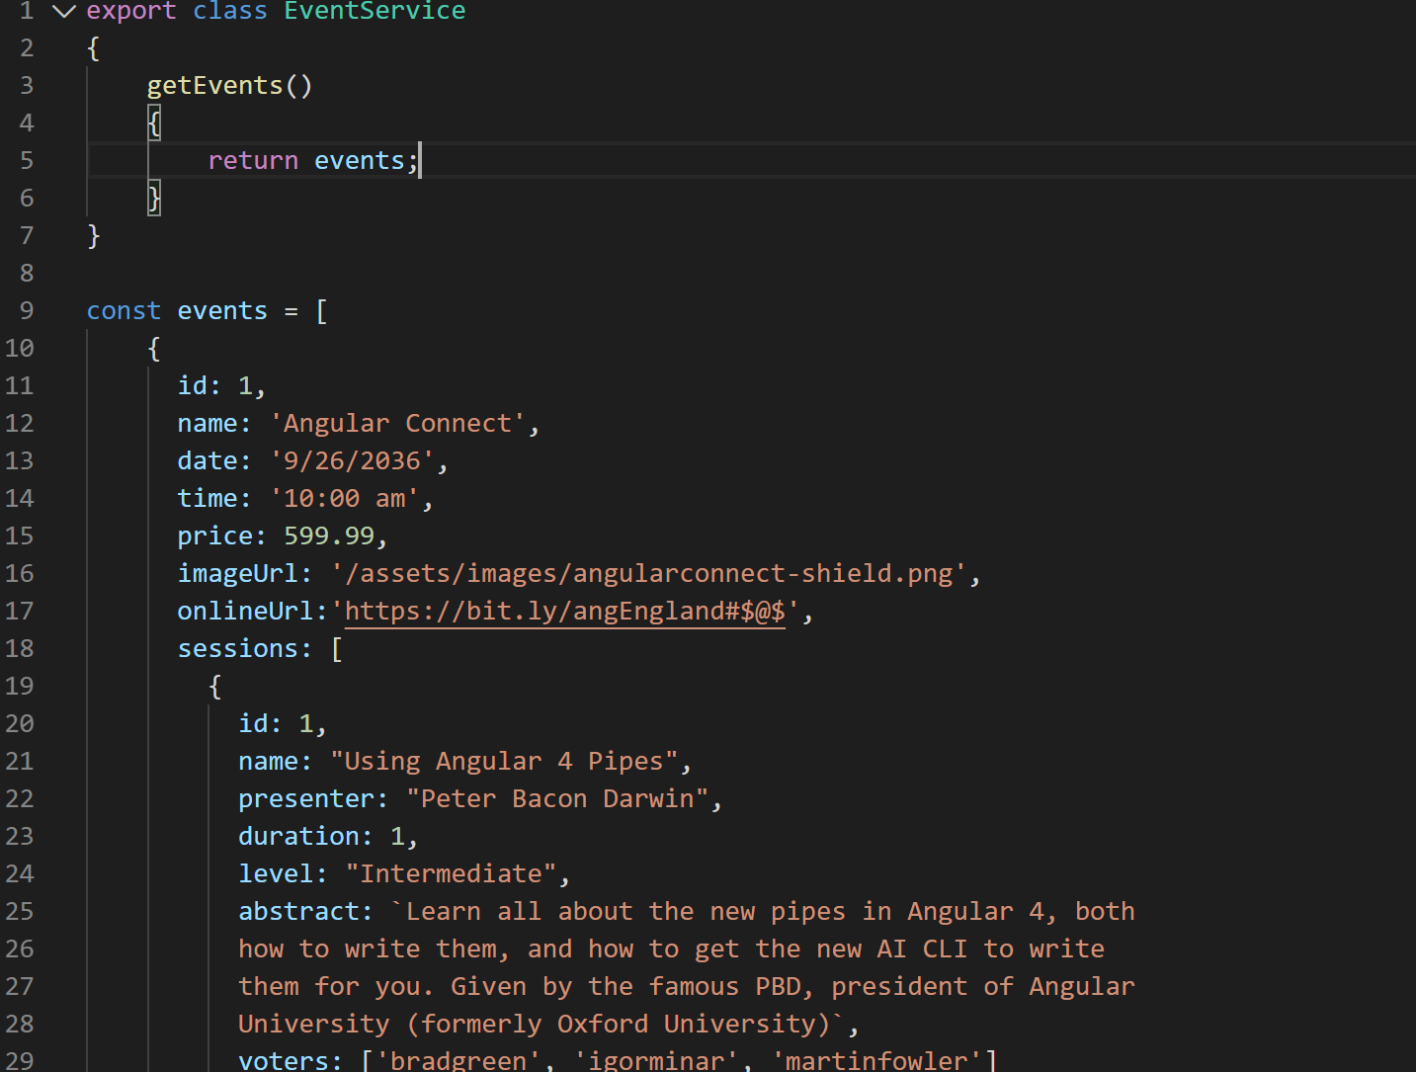
8. Also return the “events” constant from the “getEvents()” method.
9. Now as a best practice let's decorate the service with “Injectable” decorator. That will ensure that in future if we inject any other service in this service we will not get an error. It is an easy thing to forget.
10. 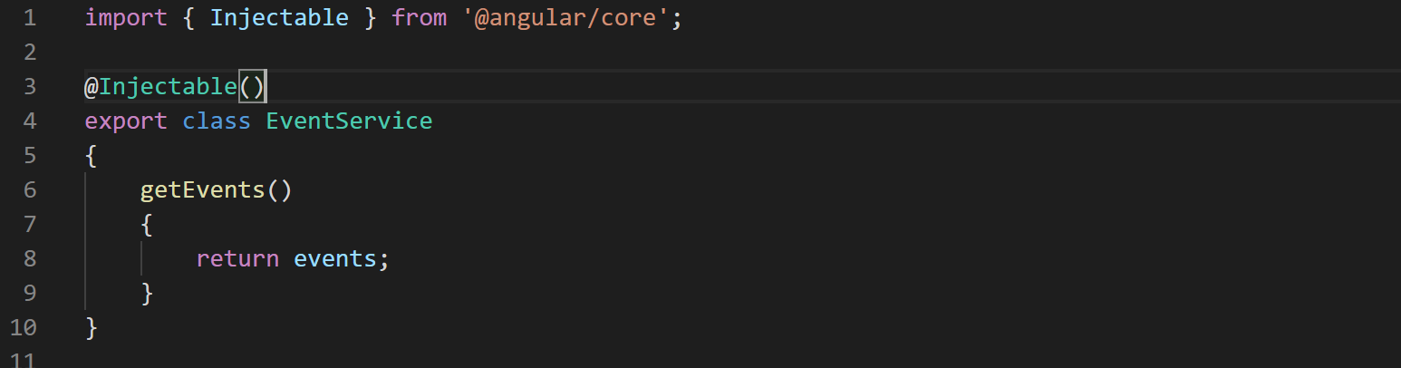
11. Now that our service code is complete let's register this service as a provider in the app module.
12. Open the file “app.module.ts” and look for the array “providers” which is empty right now. In this array type the class name of our service which is “EventService”.
13. Once you type the class name “EventService” and press enter Visual Studio code will automatically add the import statement on top of the class. And your modified code will look like below:
14. 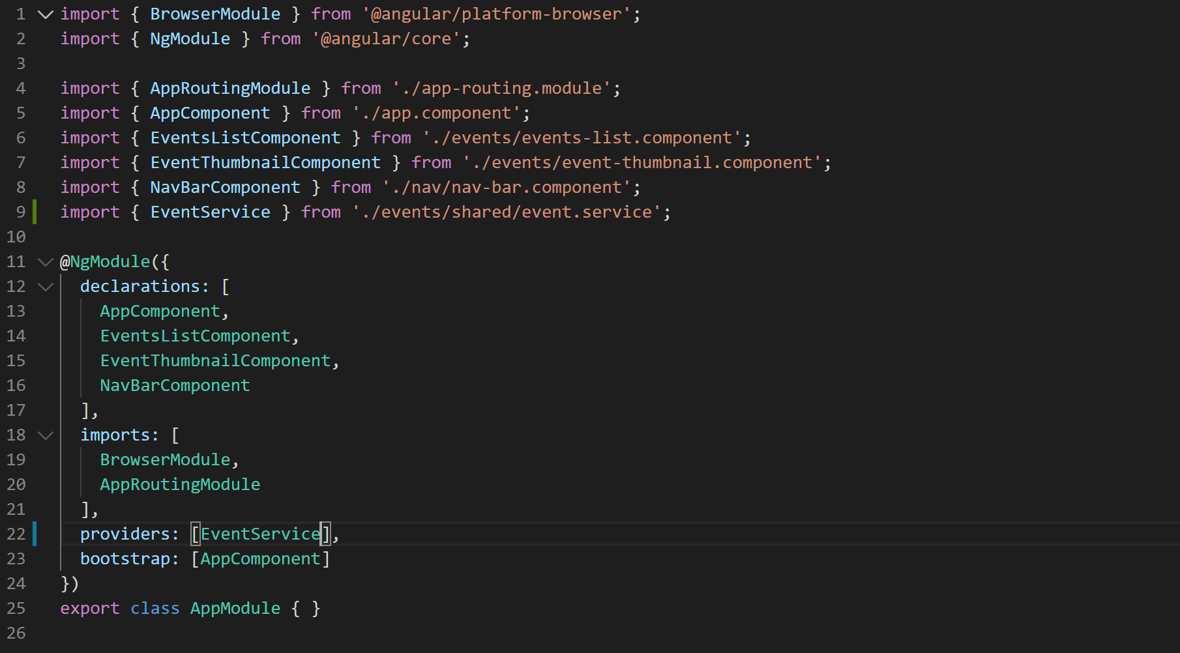
15. Now we're ready to inject this service in our events list component. So go to the events list component and add a constructor like below:
16. 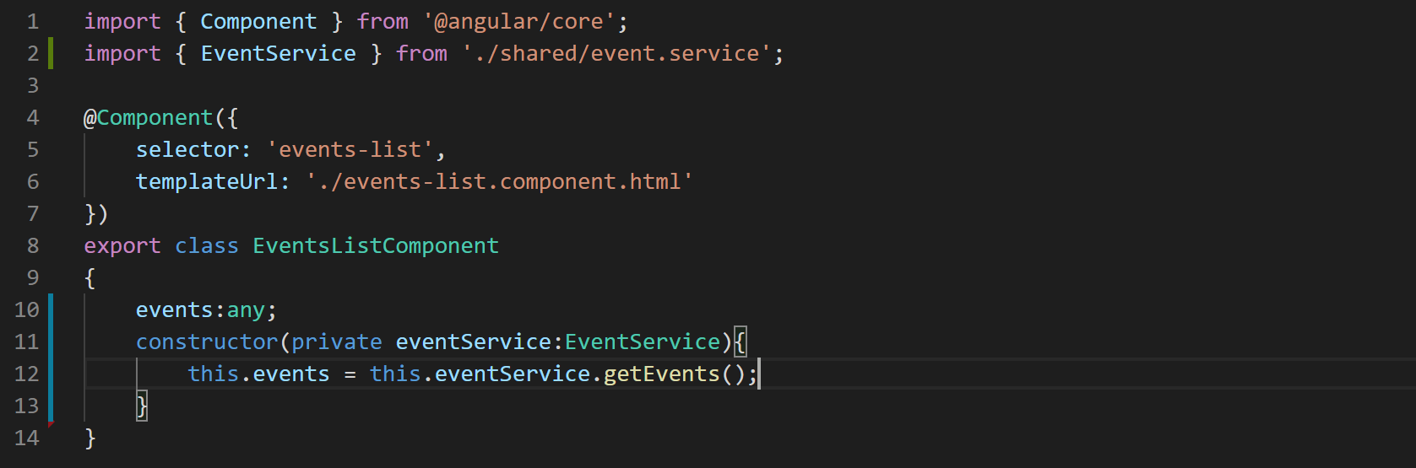
17. Notice we have defined “events” property and in the constructor we have called the “getEvents” method to initialize the “events” property with the array that “getEvents” method is returning.
18. Now if you notice our event list component is quite clean and the functionality is still working. if you go to the browser and browse the application it is still rendering the event successfully.
19. Since it's not a good idea to make long running calls in the constructor let's move the service call from constructor to one of the lifecycle hooks called “ngOnIniit” like below:
20. 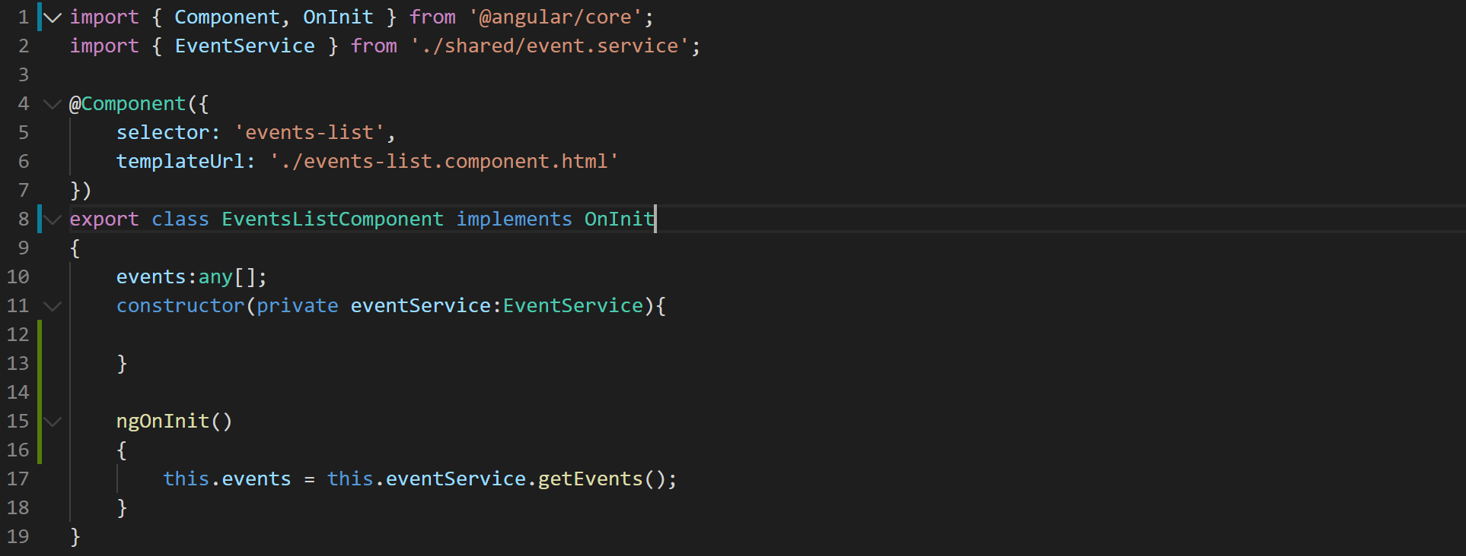
21. This change will ensure that our constructor will not have to wait for Ajax call to finish.