1. Open “nav-bar.component.ts” and on the links add “routerLinkActive=”active”” directive like below:
2. 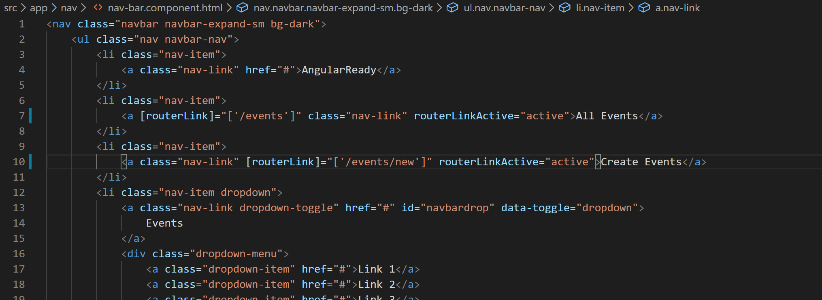
3. Now lets add the CSS class “active” in the styles array in class “nav-bar.component.ts”:
4. “li > a.active { color: #F97924 }”
5. Now if you go to your application in browser you will notice that the link you click gets highlighted in orange but more than one link are getting highlighted in orange. That is because of partial match of URL by “routerLinkActive” directive. To fix that we need to set one more property called “[routerLinkActiveOptions]=”{exact:true}” like below:
6. 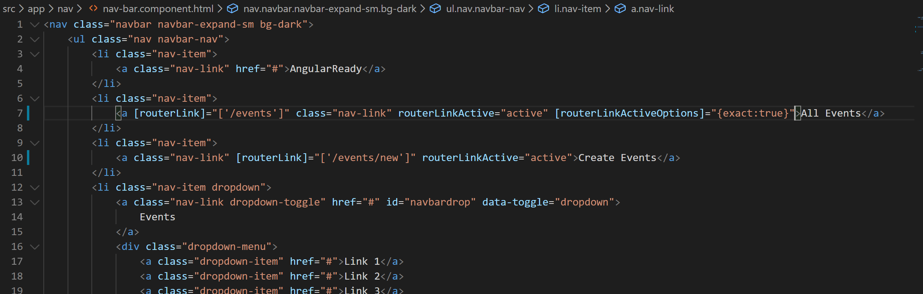
7. Now only one link which completely matches will be highlighted.