1. For performance benefits an Angular should be broken into multiple feature modules and such feature modules should be loaded only when they are really needed by the user. For example when user clicks on a link requiring loading of feature module.
2. One such module in our demo application can be user module through which we will manage user creation/modification and user profiles. So lets start creating such a module.
3. We will start with creating the profile component.
4. Right click the “app” folder and create a folder named as “user”.
5. Right click the “user” folder and create a file named as “profle.component.ts”.
6. Lets copy and paste the code for this profile component from “misc” folder of our cloned or downloaded repository.
7. Now lets create the user module. Right click the “user” folder and create a new file named as “user.module.ts”.
8. Lets export the “UserModule” class and decorate it with “NgModule” decorator like below:
9. 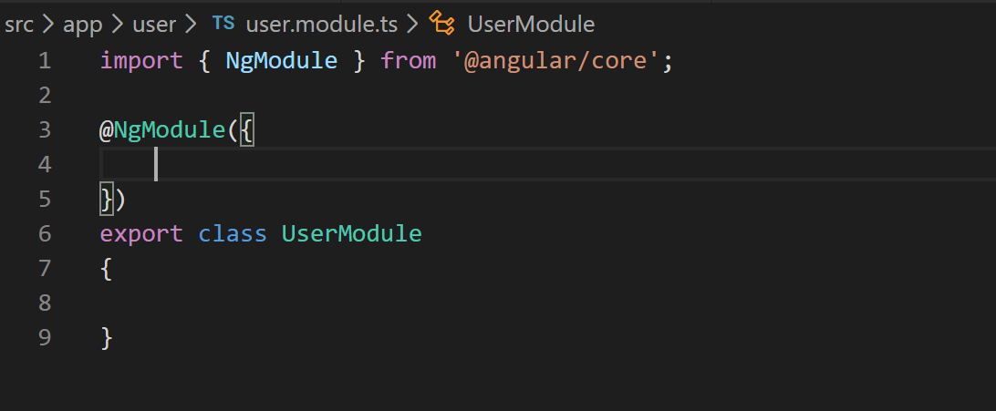
10. An NgModule decorator has three arrays namely “imports”, “declarations” and “providers”. So lets add these arrays to decorator like below:
11. 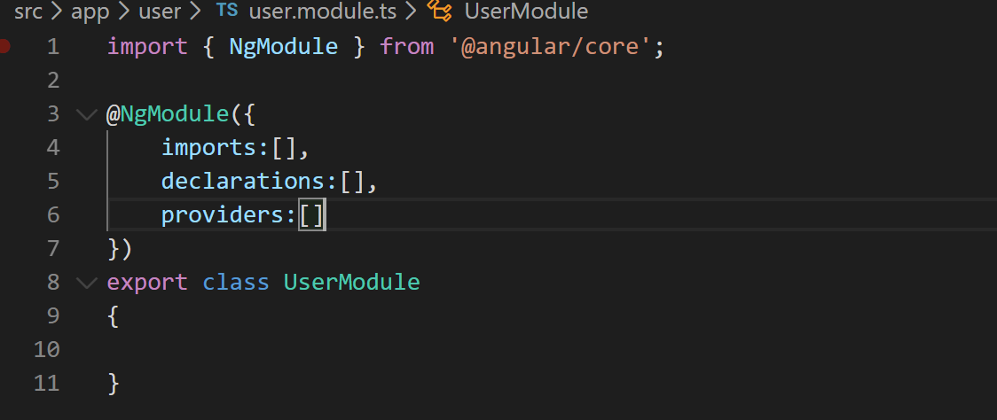
12. Now lets import Angular’s “Common and Router” modules in “imports” array like below. Also lets declare constant for user module’s routes.
13. 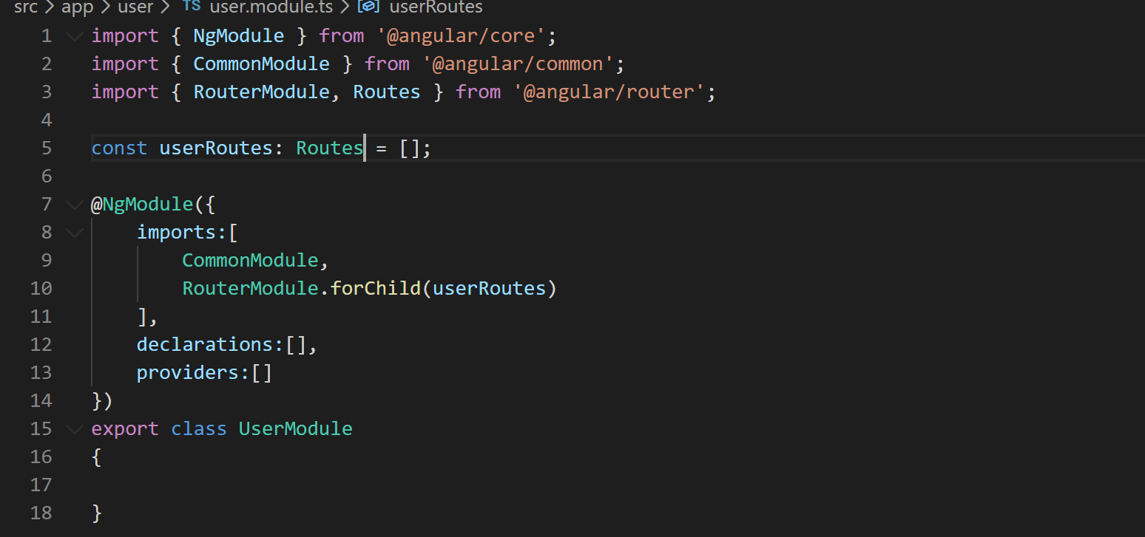
14. Now lets add “ProfileComponent” to declarations array like below:
15. 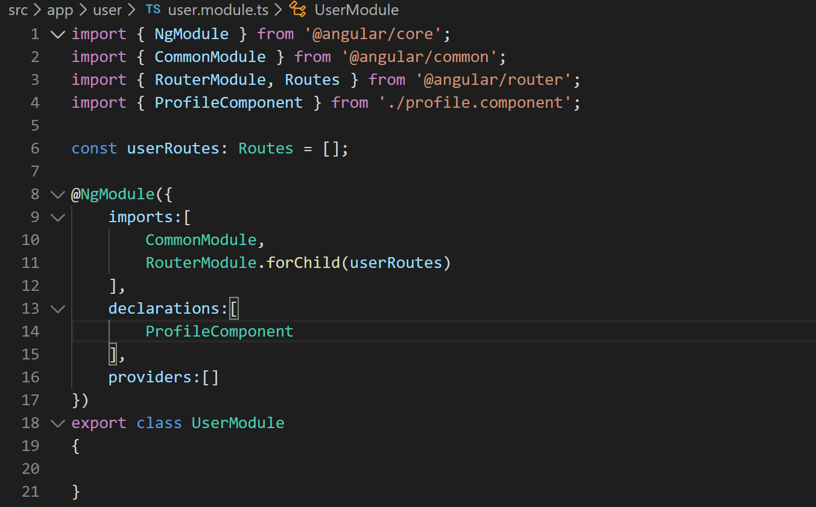
16. Now we are ready to add our route to userRoutes constant. Lets add it like below:
17. 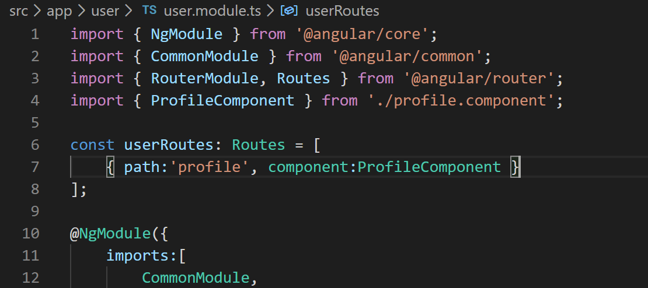
18. Lets now lazily load this module in our app module. That happens through a route in the route config. So we will define a route that will point to this module like below. Open “app-routing.module.ts” and define a new route like below:
19. 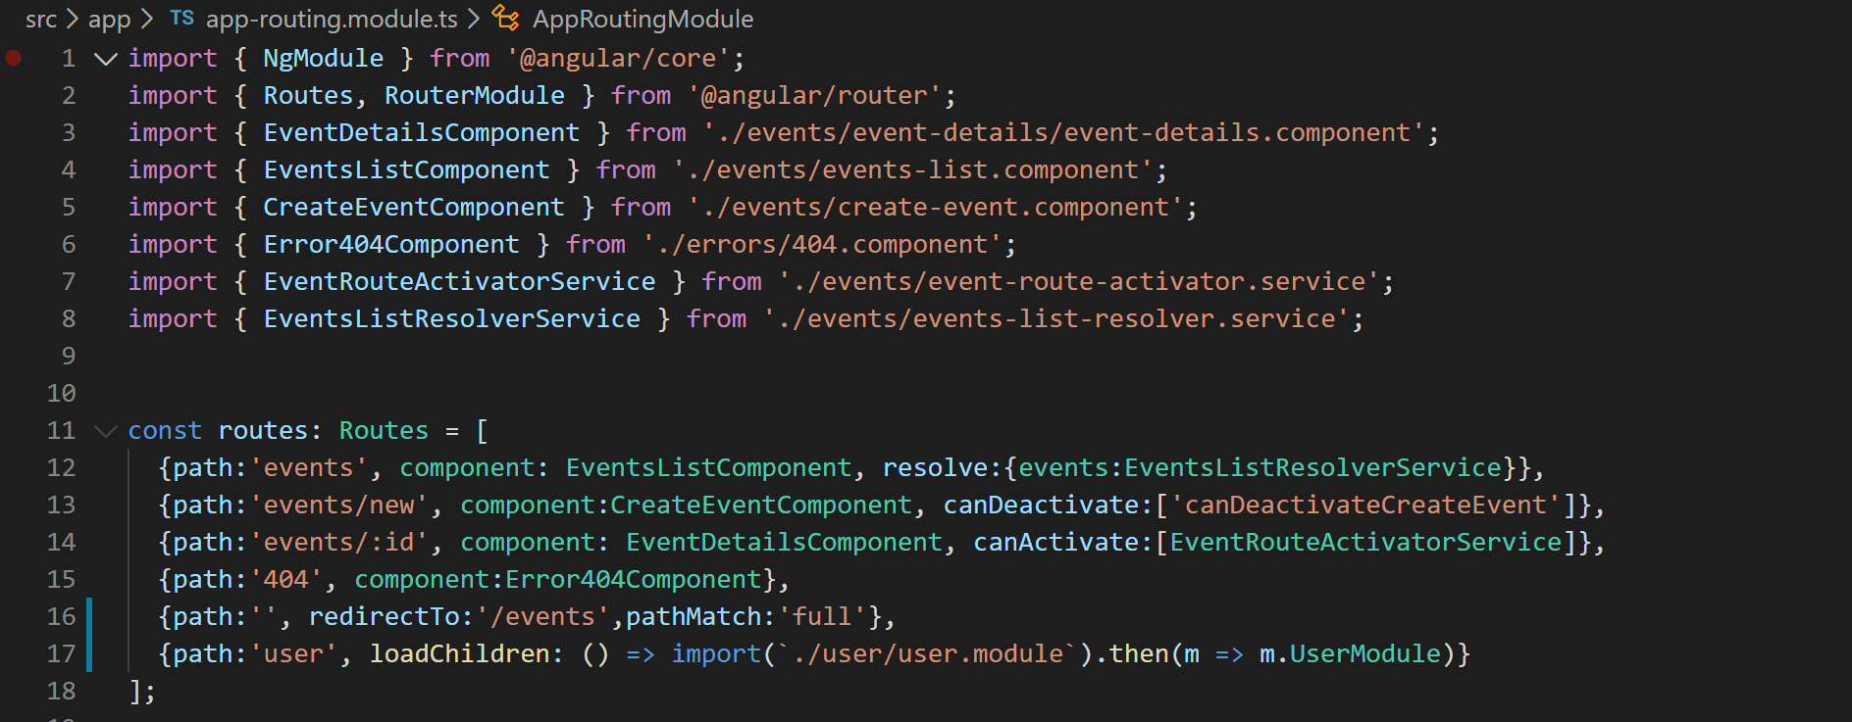
20. Lets now wire the user profile link in the nav-bar. So open “nav-bar.component.html” and add a router link like below:
21. 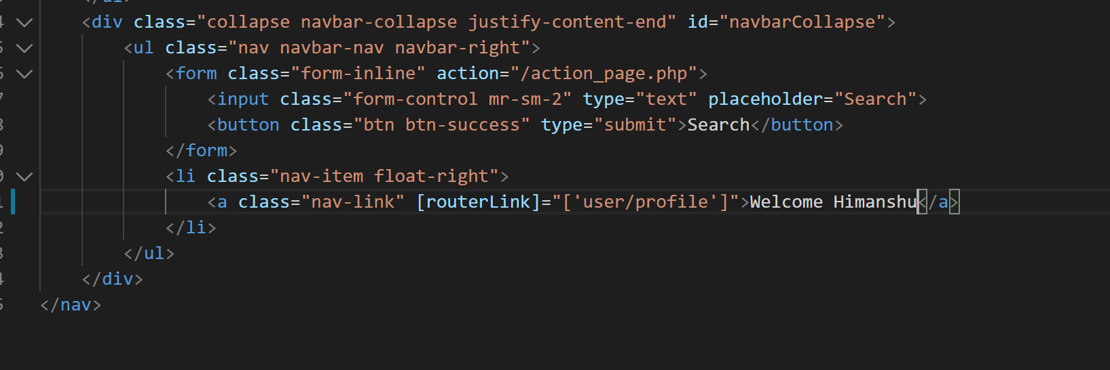
22. Now if you go to your application in browser and click on the link “Welcome Himanshu”. System will render this page like below:
23. 