1. We are now Ready to add validation code to our template. so open “login.template.html” file.
2. Before we write Angular specific validation code lets disable HTML 5 default validation on our form by appending “novalidate” attribute like below:
3. 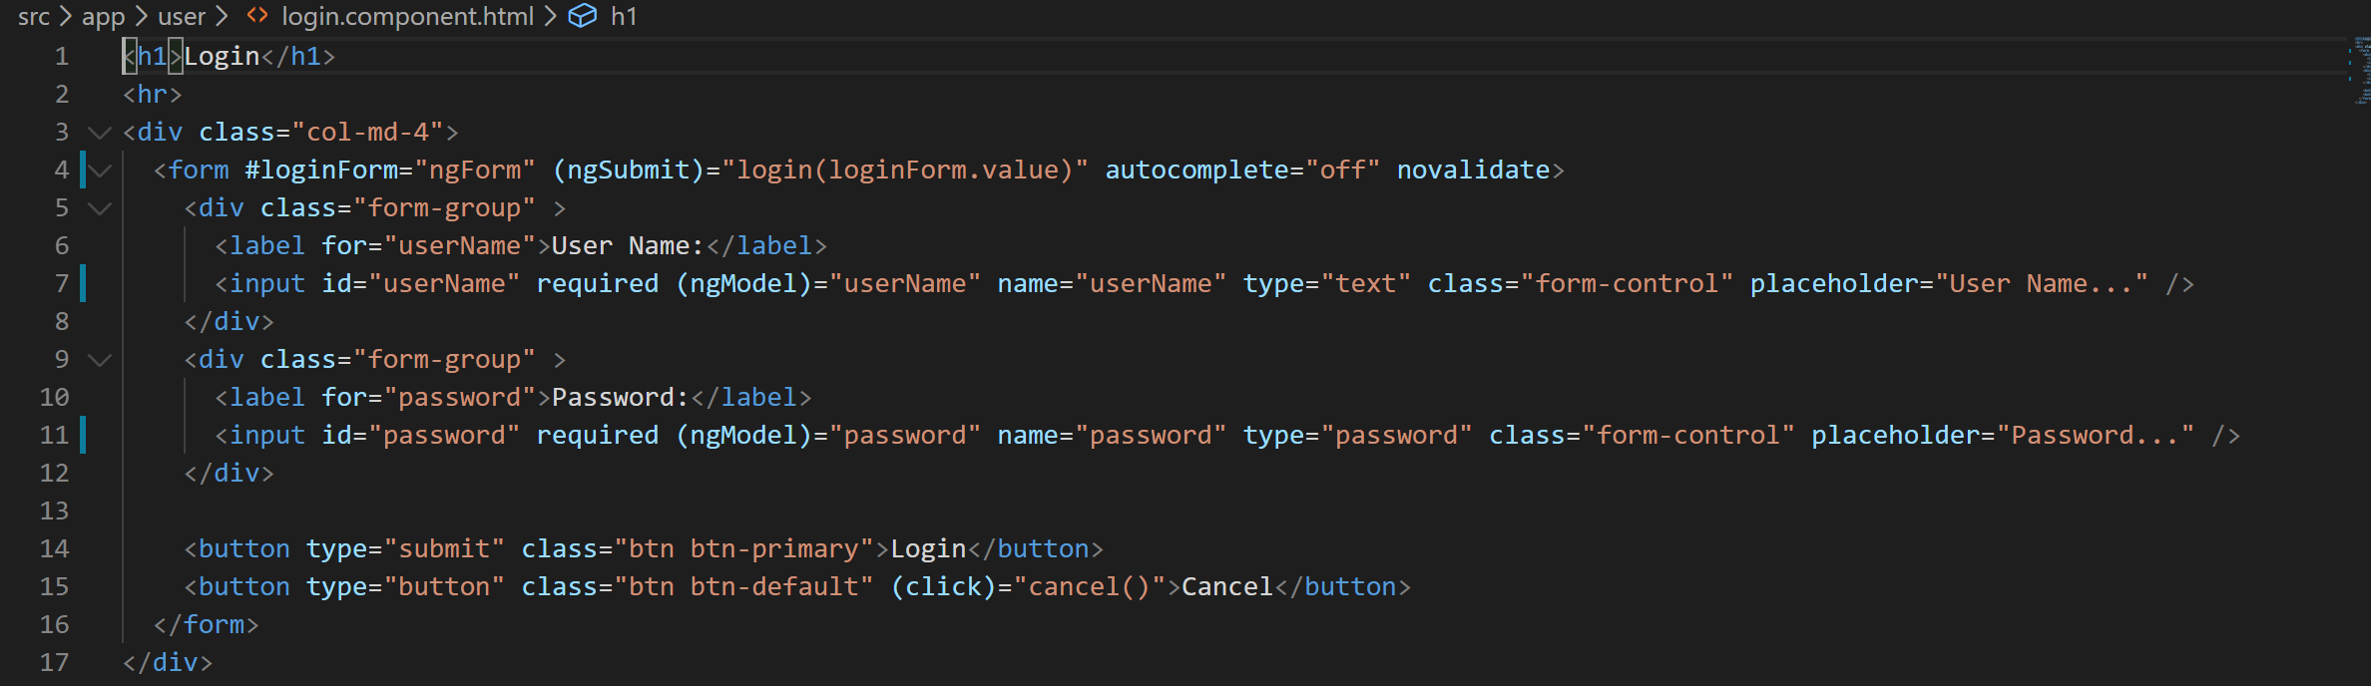
4. Now lets disable the submit button when the form is invalid using forms “invalid” property like below:
5. 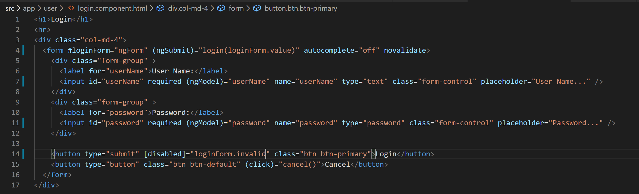
6. Now if you go to the application in the browser and try to click the login button you won't be able to click the button.
7. But if you notice we're not showing the user that why the submit button is disabled so let's show a label to the user depicting what's wrong with the form and why the button is disabled like below:
8. 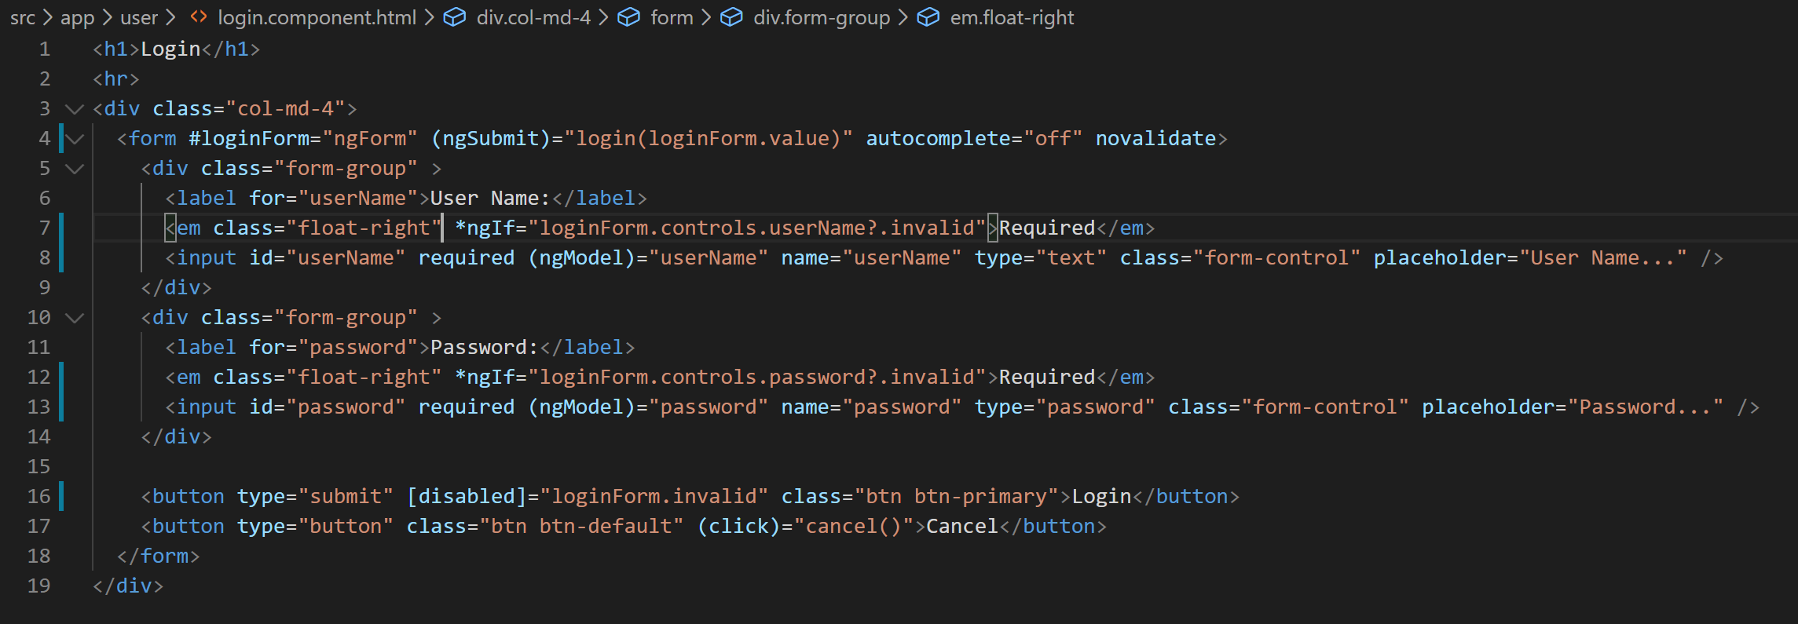
9. Now if you Go to the application and look at the form you will notice her small reqd label pleased to the right of each field like below:
10. 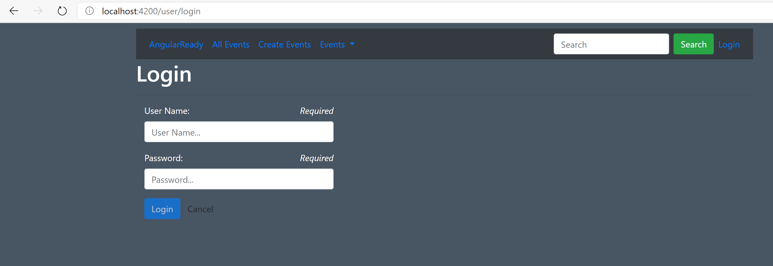
11. Now if you notice it's a little annoying to show validation message even before the user has tried to do anything with the form. This would look very odd if there were so many fields. So let's try to show these messages only when user has touched the fields like below:
12. 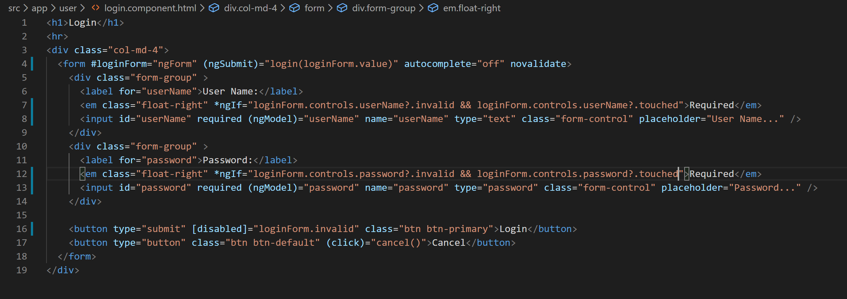
13. If you go to the application now and browse the form you will notice that the required validation message is not there now. But if you click on the field and tab out the message appears.
14. Now if you think our form is still not very informative to the user at the very start. We're not telling the user what's wrong with the form again. So let's try to show a message to the user when the user tries to hover over there login button. You can be creative and do various things with your real application but for now we will do just this.
15. To do this will have to handle the mouse over and mouse leave events on the button but since our button is disabled in the initial state and disabled controls don't raise events will have to wrap the buttons in a span like below:
16. 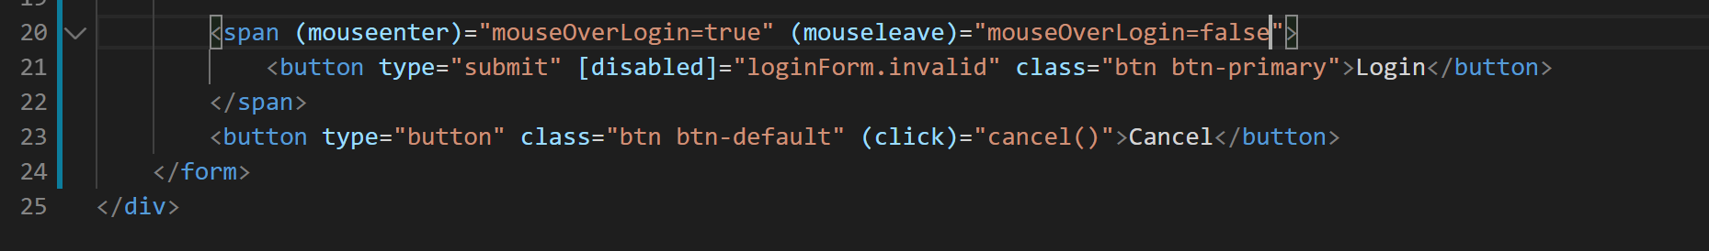
17. Now lets modify the expression on “em” elements to show the message when either the input control is touched or “mouseOverLogin” property is true like below:
18. 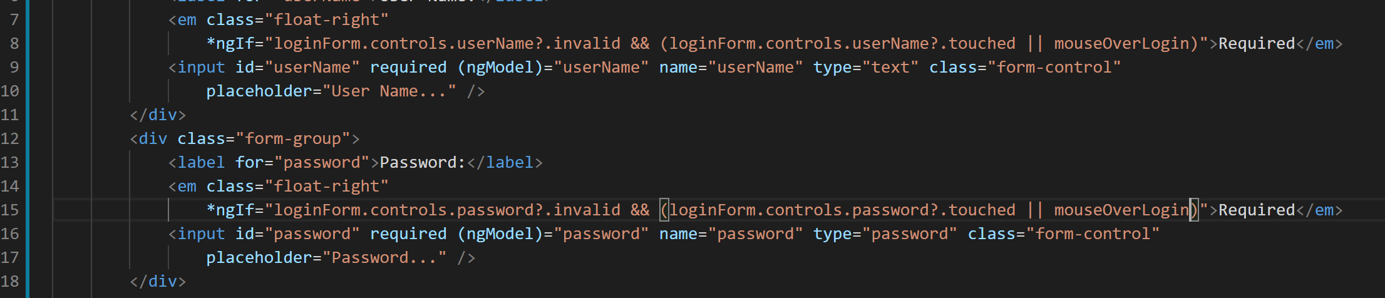
19. Now VS Code is complaining that “mouseOverLogin” property is not defined so lets define that. Go to “login.component.ts” and add a property “mouseOverLogin”.
20. Now if you go to the application and hover your mouse over the login button you will notice that the required message appears and goes away as soon as you remove the mouse from the login button.