1. Adding validators is very easy in reactive forms. Just pass in the validator as a second argument to FormControl constructor like below:
2. 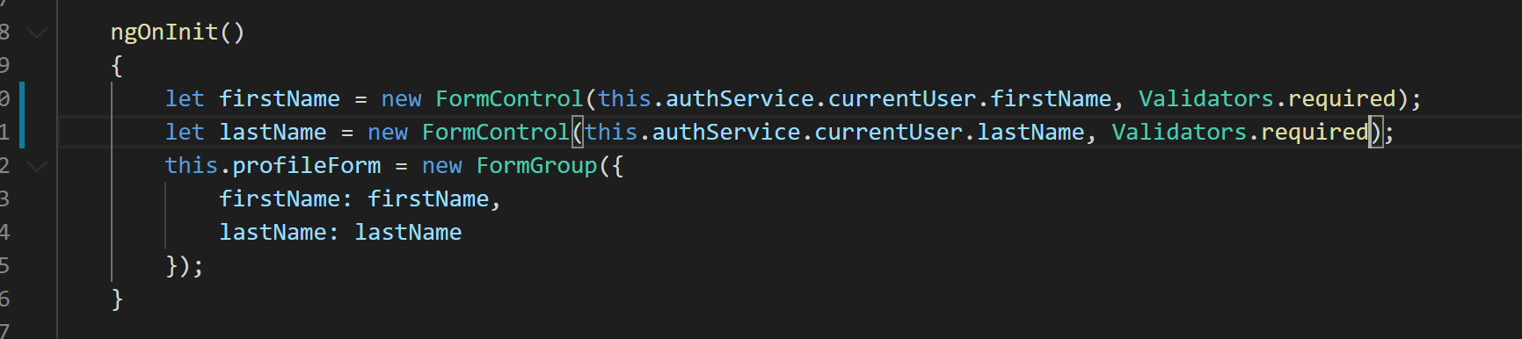
3. Now lets modify the save profile method to save profile only when the form is valid like below:
4. 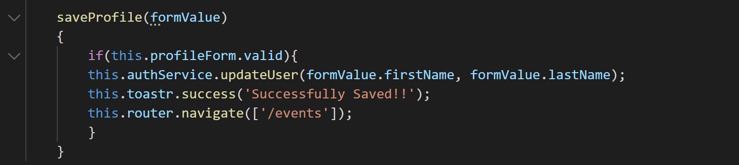
5. To test this change you can go to your application and browse the edit profile form. On the edit profile form remove the prepopulated values from input boxes and try to click save button.
6. You will notice you won’t be redirected to events page. But if you provide some value and click on Submit button you will get redirected successfully.
7. Now lets work on the template to show validation error messages to the user. Before that lets add some CSS classes to our styles array in profile.component.ts like below:
8. 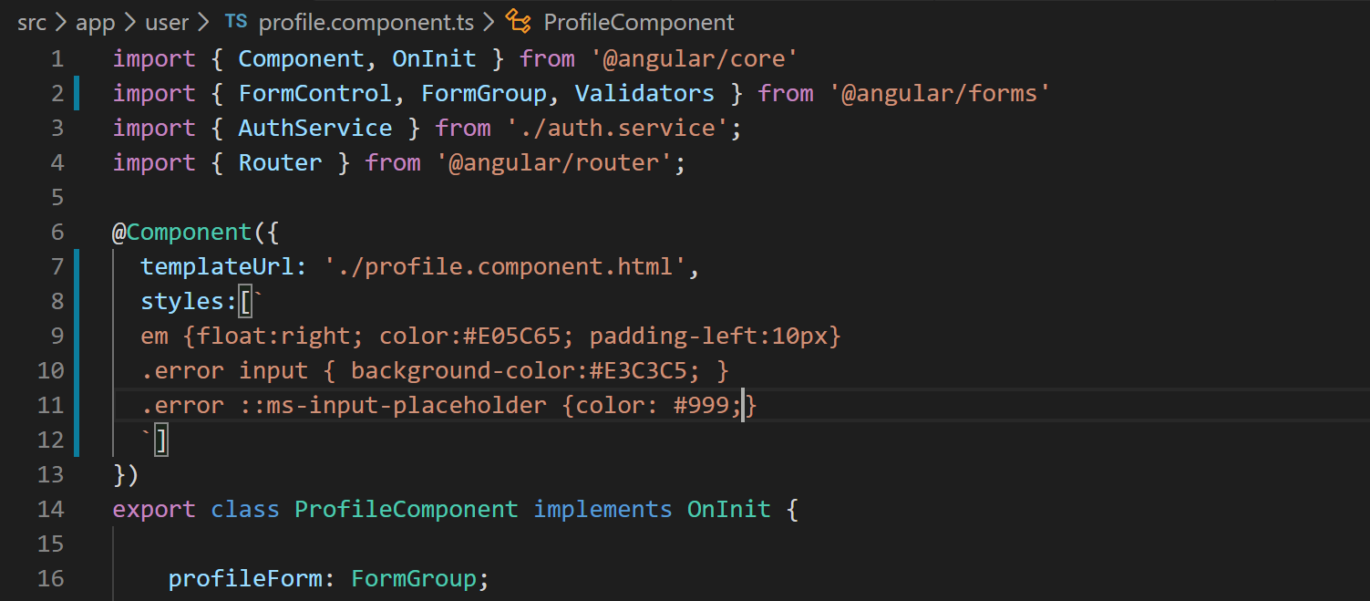
9. Now lets modify the template to use these classes in case of error like below:
10. 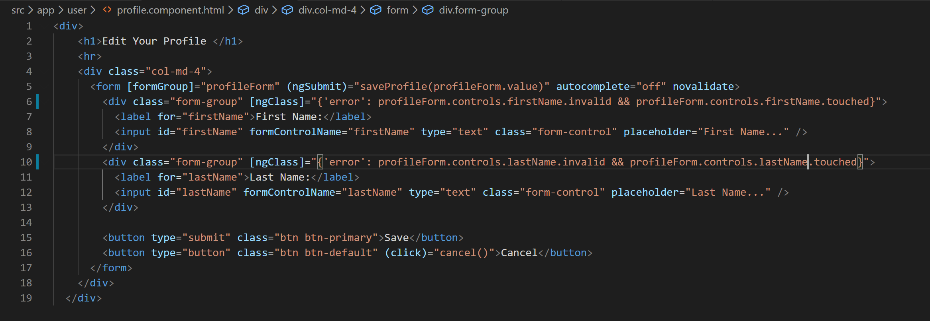
11. With above change if you go to edit profile page and make the fields invalid by removing the prepopulated values you will notice the fields become red like below:
12. 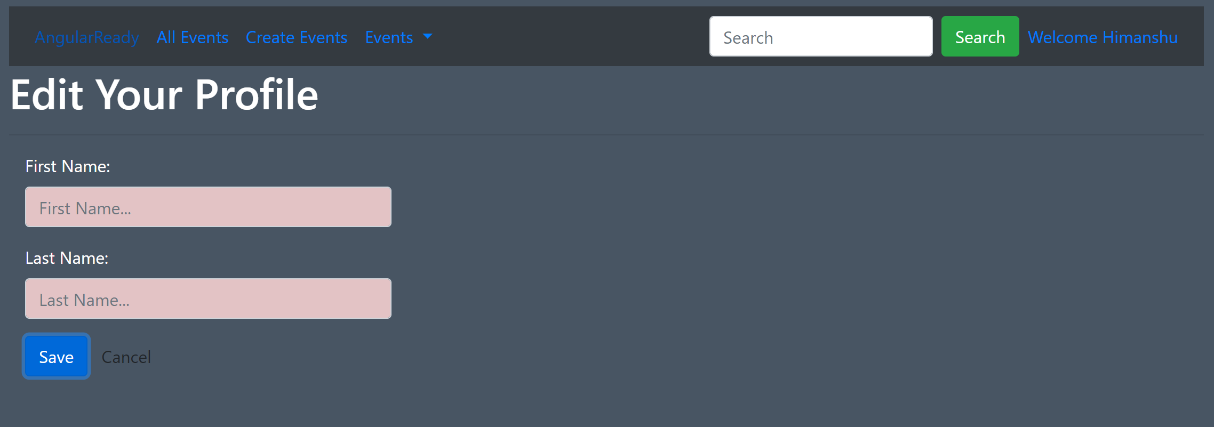
13. Now lets show Required error message to user also. This will be similar to what we did it in login form like below:
14. 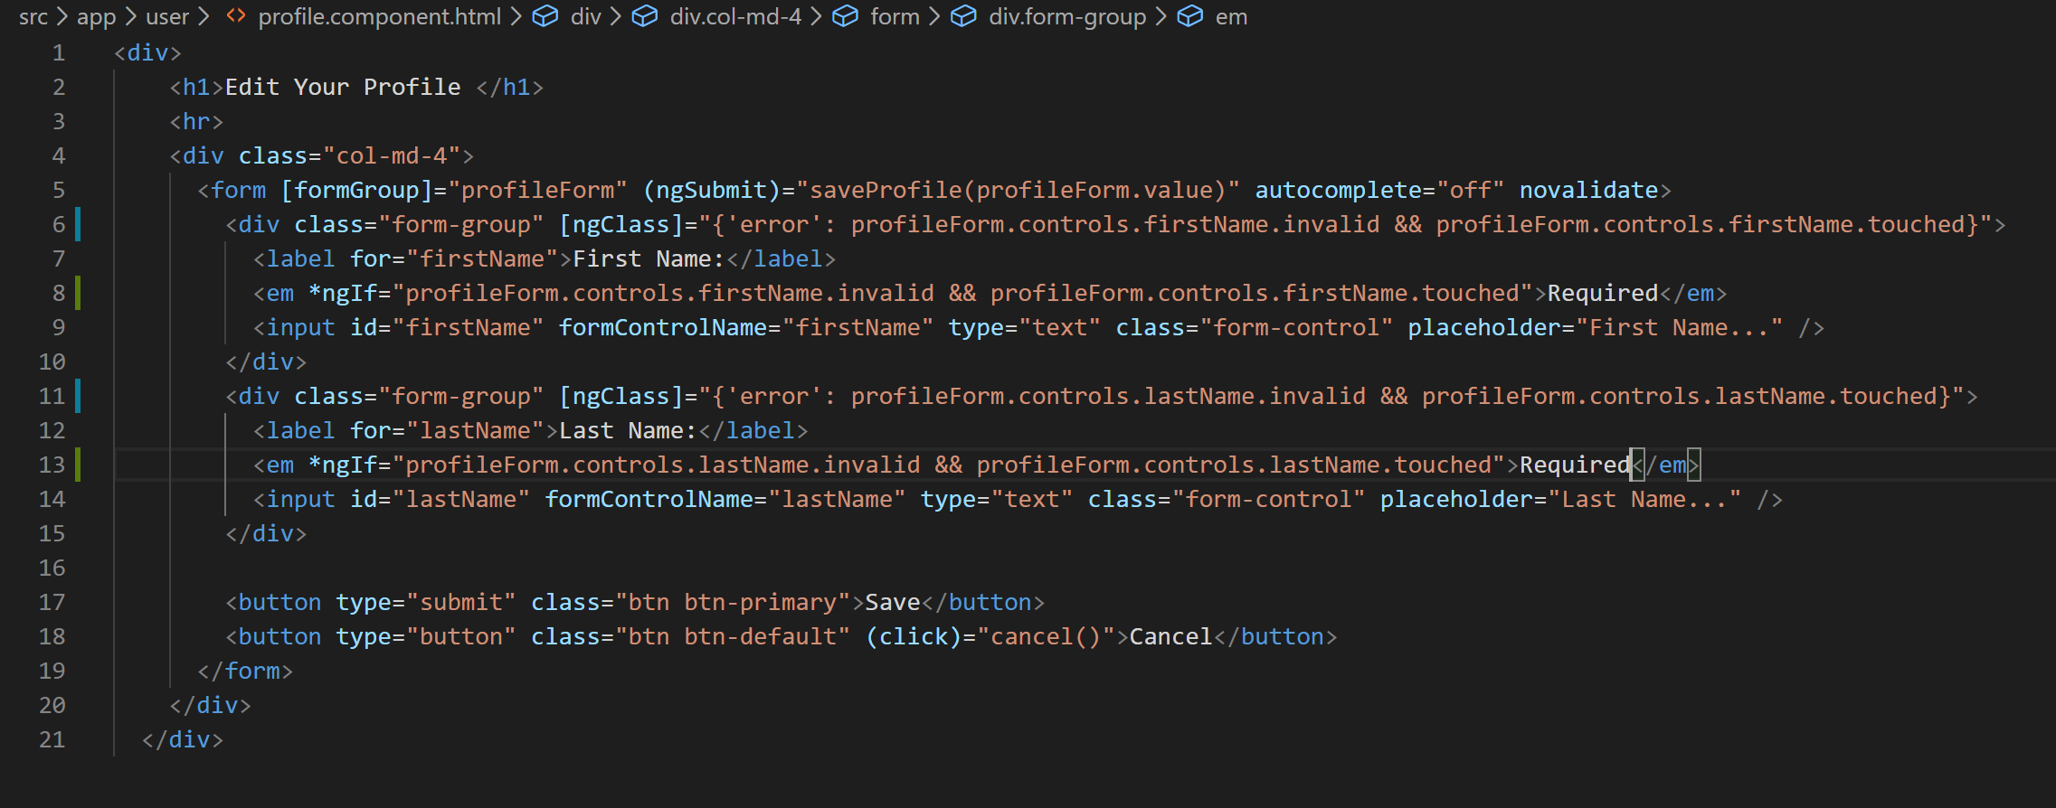
15. Now if you invalidate the fields again on edit profile page you will see error messages also like below:
16. 