1. Adding multiple validations in reactive forms is very easy just add the another validator in the validators array like below:
2. 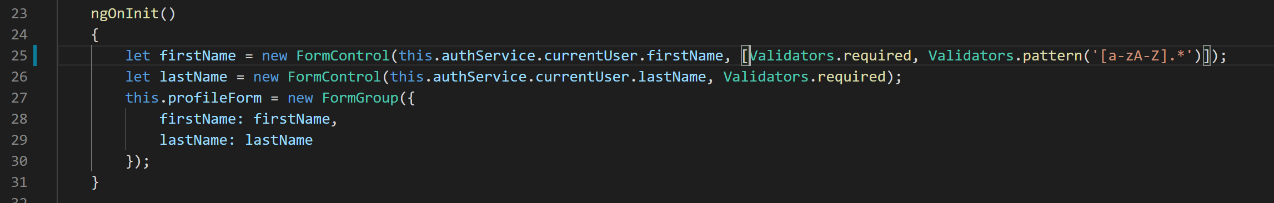
3. Now if you go to edit profile form and try to type in a numeric value in the first name field it will become invalid like below:
4. 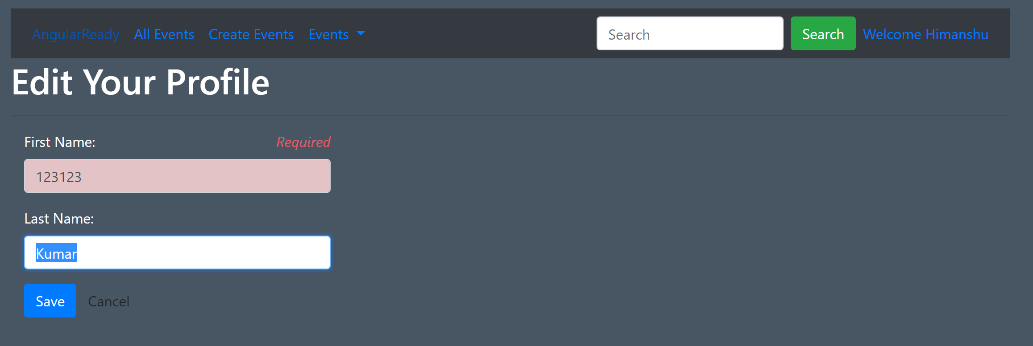
5. You can notice that even though the error message is displayed it's not very relevant. The error message should depict that the field is having invalid pattern rather than just showing Required as error message. So to do that we will have to add one “em” tag for pattern related error message like below:
6. 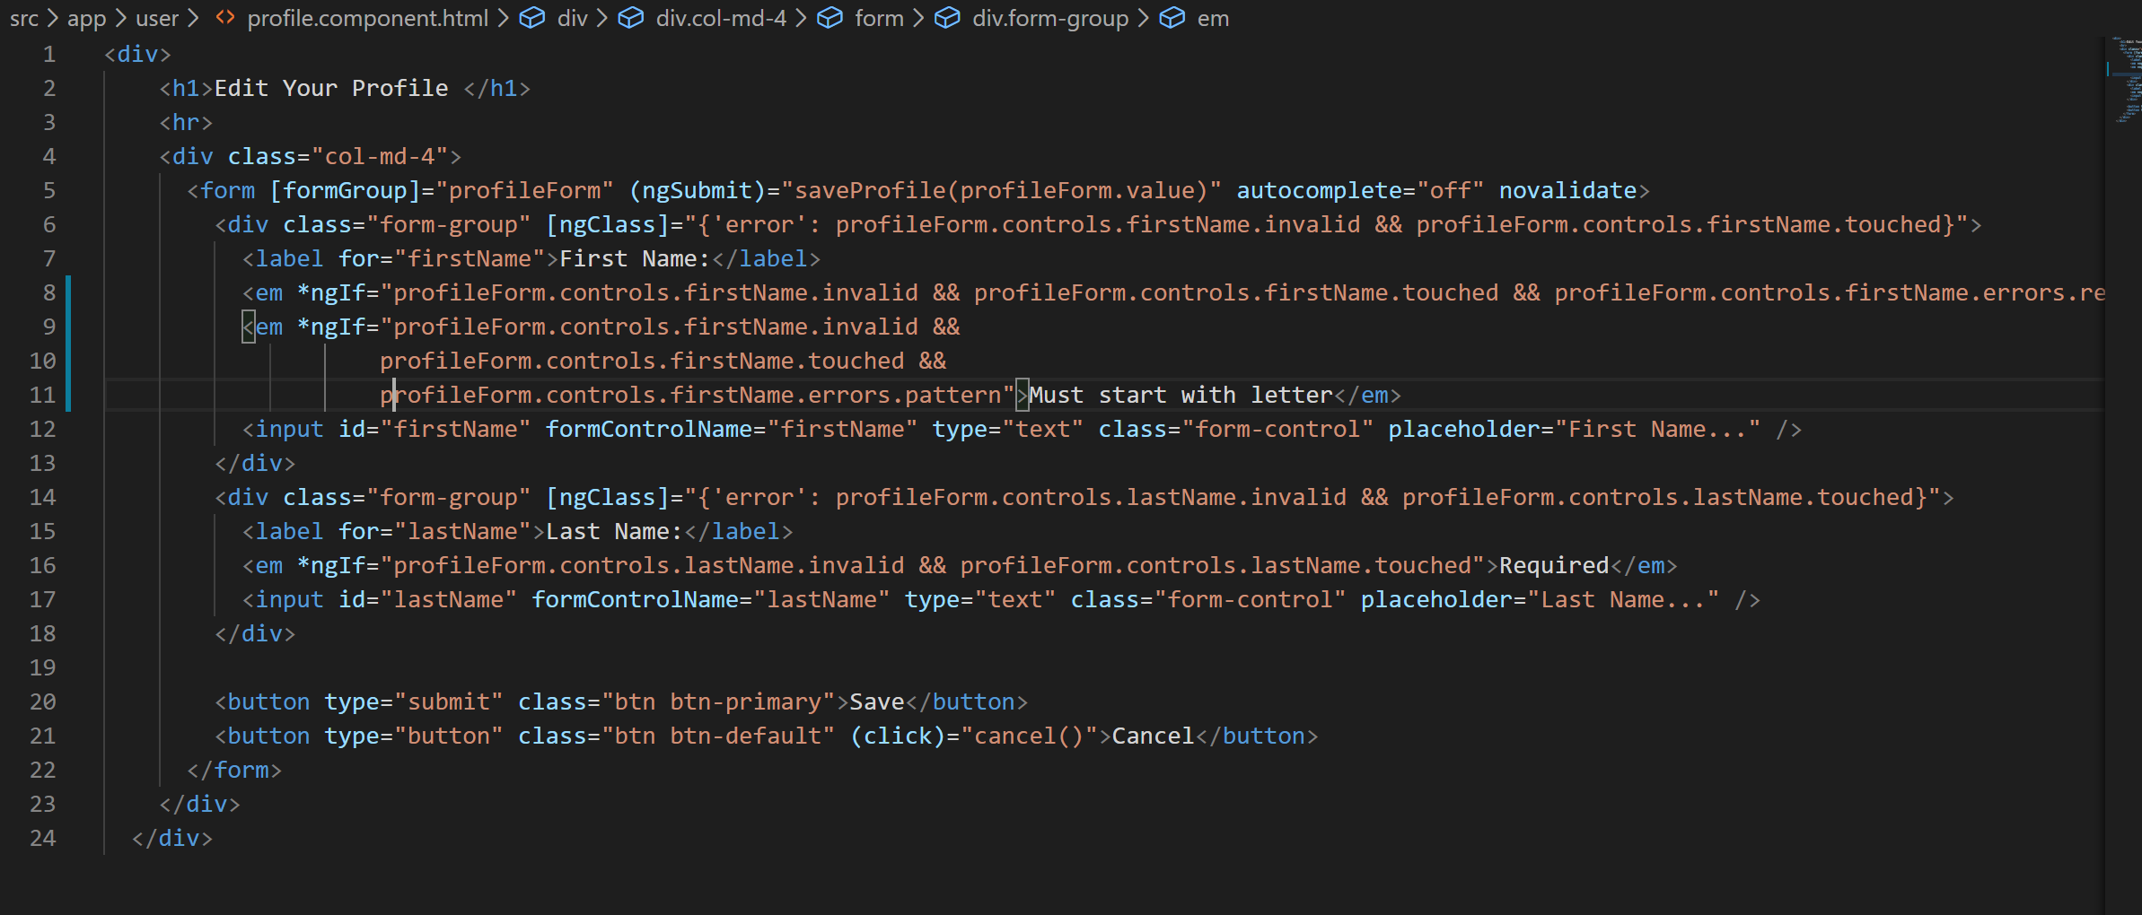
7. Now if you try to type in a numeric value in first name of edit profile page you will see an error message like below:
8. 