1. Custom validators help you do validations which are not possible to do using out of the box validations. For example cross field validation where in you need to validate one field based on value of another field. Lets try to create one such custom validator for our reactive form.
2. A custom validation is just a function which returns null if the control is valid or an error object if the control is invalid. We will create a validator which will restrict users from typing some words in an input field.
3. So lets create the validator function in our “create-session.component.ts” like below:
4. 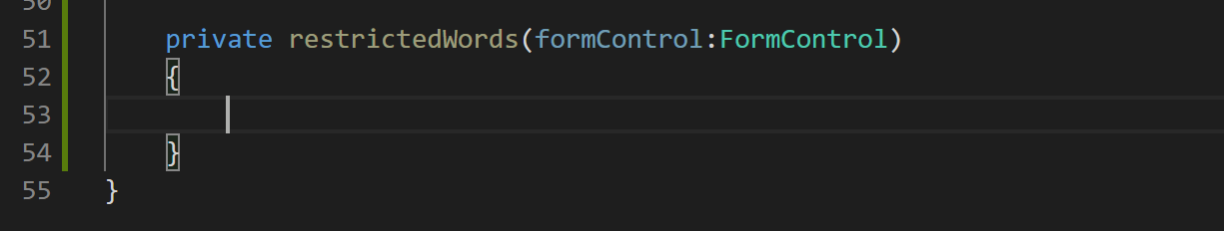
5. Now let us specify the return type for the function like below. Ignore the typescript error the VS Code terminal is giving.
6. Lets implement the function like below:
7. 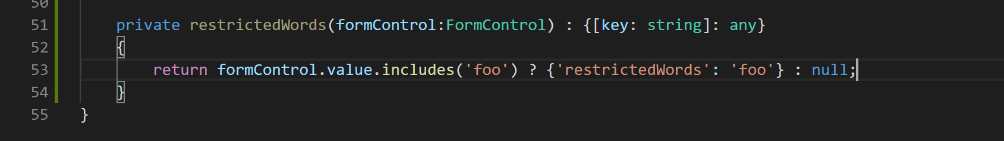
8. Now lets add this validator to our abstract form control’s validator array like below:
9. 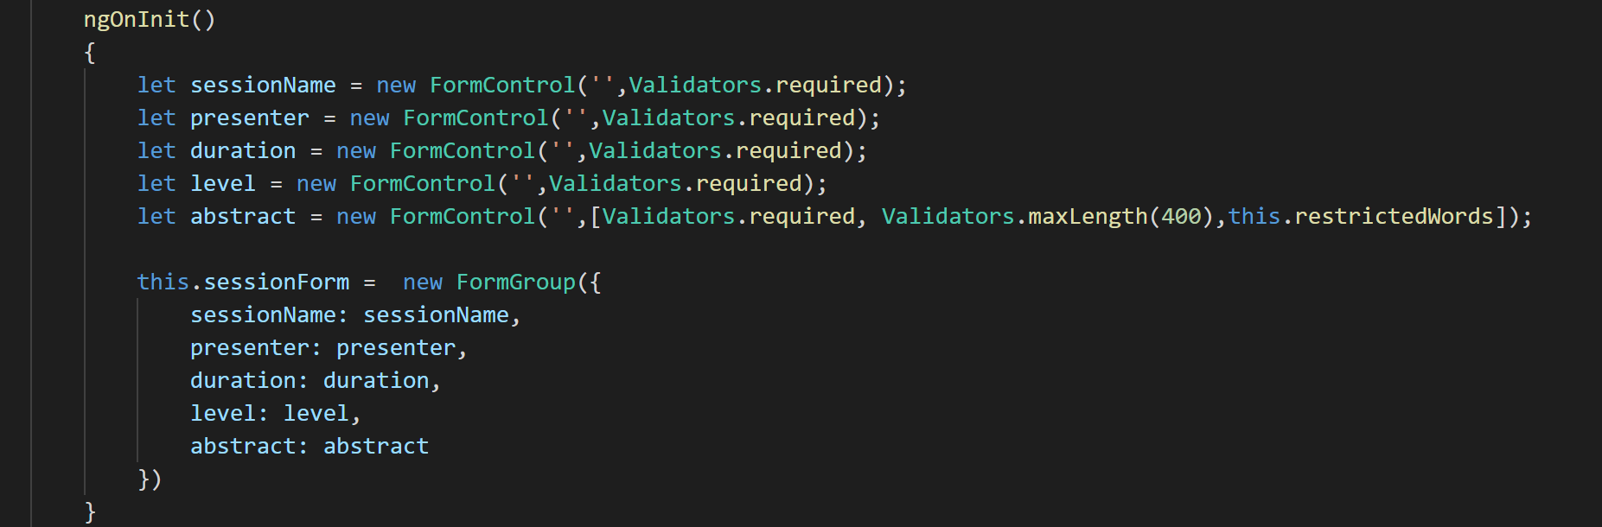
10. Now if you go to create session form and in the abstract field if you type word fluent about you will see it will become red. but we are still missing an error message describing what really happened. So let's add the error message like below:
11. 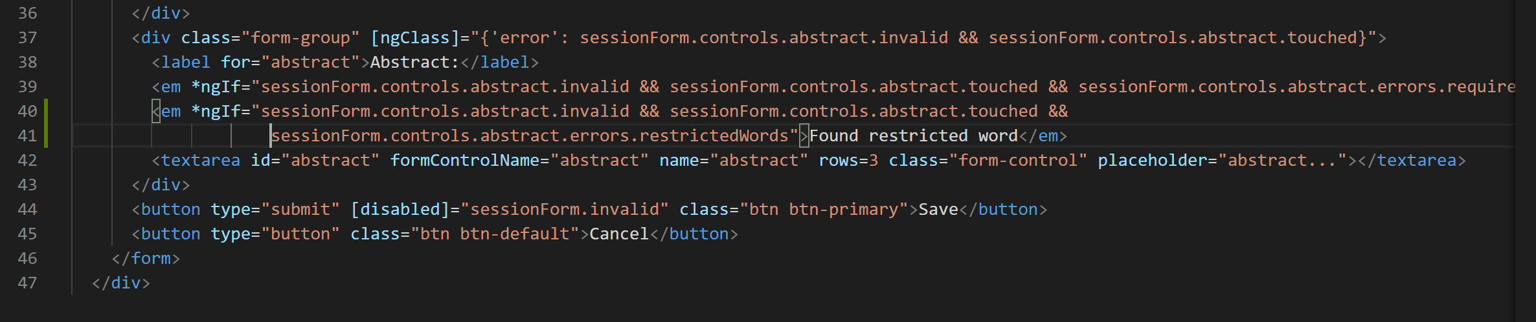
12. Now if you type foo in abstract field the error will show up like below:
13. 