1. If you look at our event details page you will notice it is displaying basic event details but not the sessions that events have so let's modify the event details page so it starts displaying the sessions also .
2. Lets modify the “event-details.component.html” like below:
3. 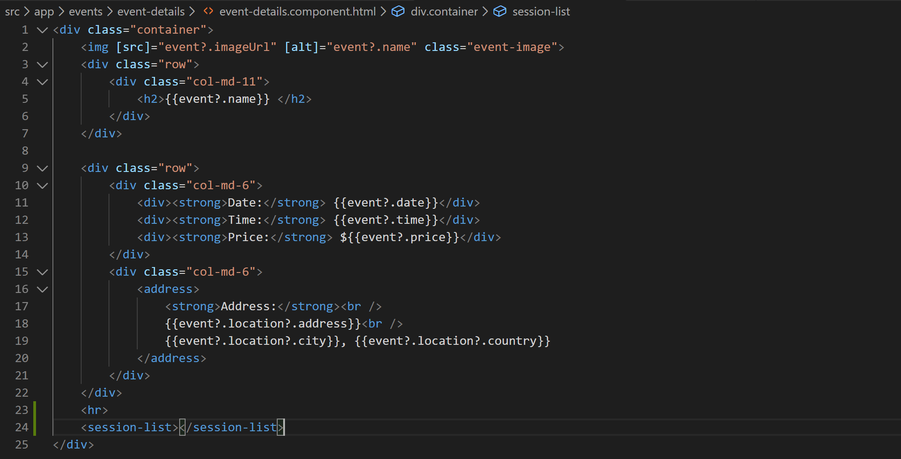
4. Now you as you can see we have specified an element named “session-list” so lets go create the corresponding session-list component.
5. Right click the “event-details” folder and create following two files:
   1. session-list.component.ts
   2. session-list.component.html
6. Add basic component shell in the “session-list.component.ts” like below:
7. Register the component in declarations array in app module like below:
8. 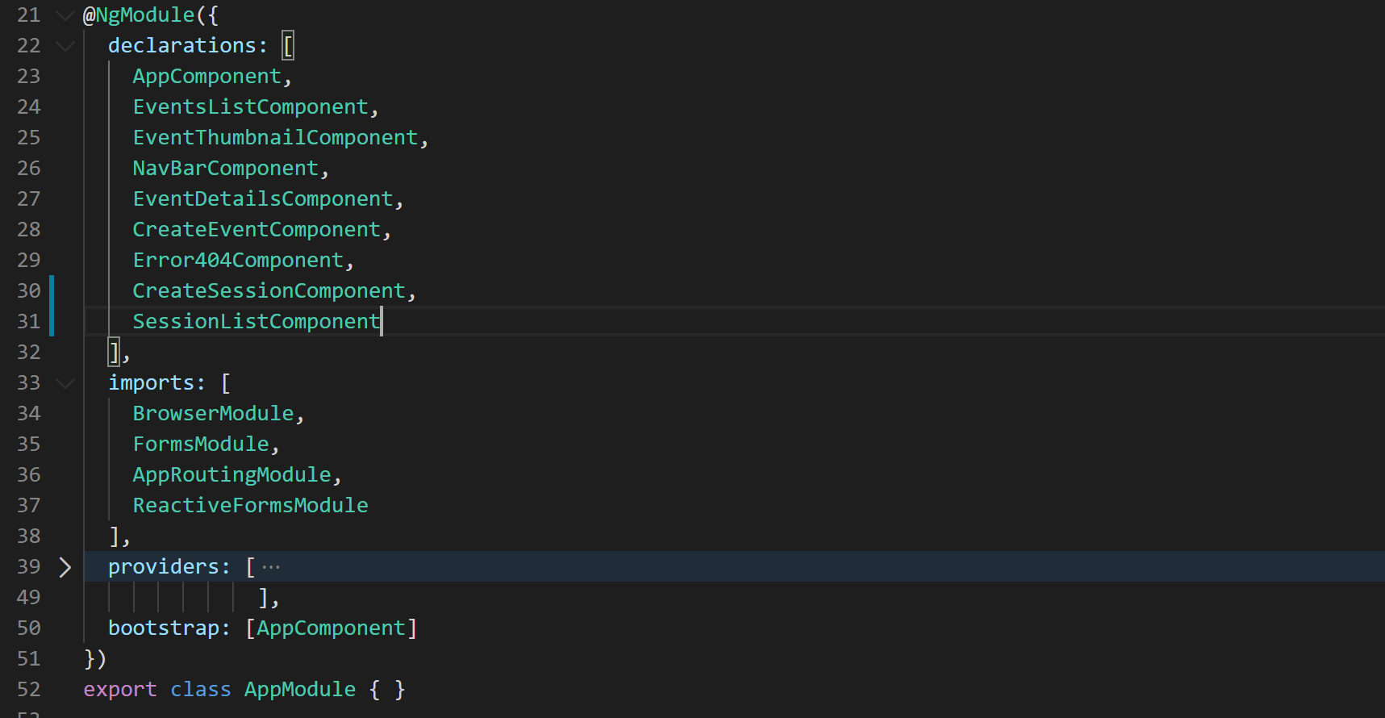
9. Now lets pass the session object from “event-details.component.html” template to session-list component like below:
10. 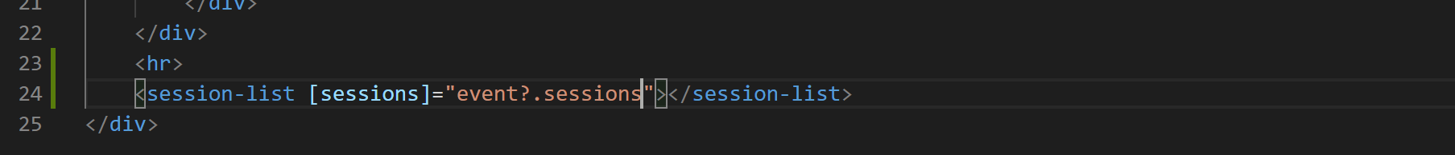
11. Lets create the “sessions” property on “session-list.component.ts”:
12. 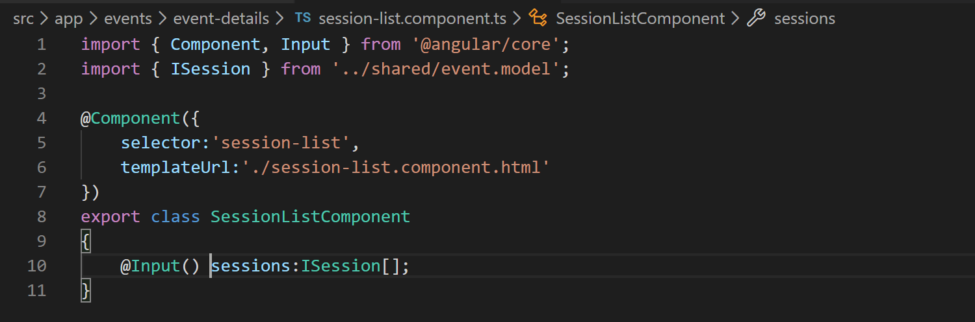
13. Now lets grab the HTML for session-list.component.html from “misc” folder of cloned or downloaded library.
14. Now lets add some styles to style array in component “session-list.component.ts” like below:
15. 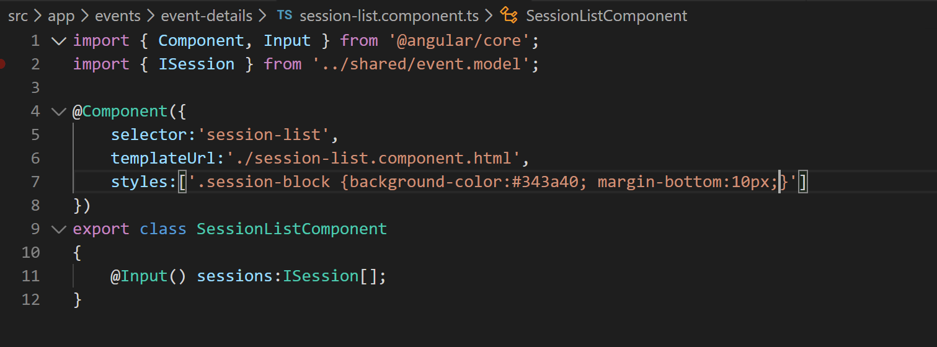
16. Now lets apply the “session-block” class to our top div in “session-list.component.html” file like below:
17. 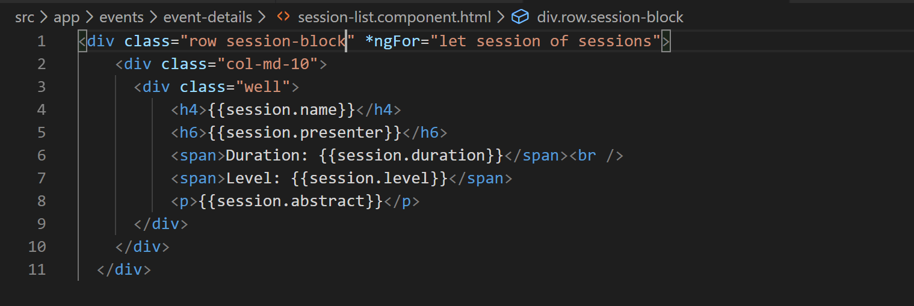
18. Now if look at the application and go to event details page you will see all the sessions listed like below:
19. 