1. Content projection let's you change the content of a component based on the need of the application. In our application An event details page we show all the sessions that are there in that event. What we want is that the session boxes should be collapsible so that we only show the title of the session and if the user really wants to see the details of the session user should be able to click the title of the session and that should expand automatically to show all the details of the session.
2. Let's start by modifying the HTML of the “session-list.component.html” like below:
3. 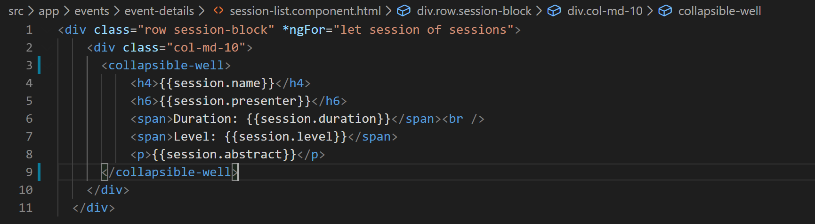
4. So if you notice image above we have defined a new component called “collapsible-well”. So lets go create the component files in “common” folder:
   1. collapsible-well.component.ts
   2. collapsible-well.component.html
5. Lets define the component shell in “TS” file and define a property also called “title” like below:
6. 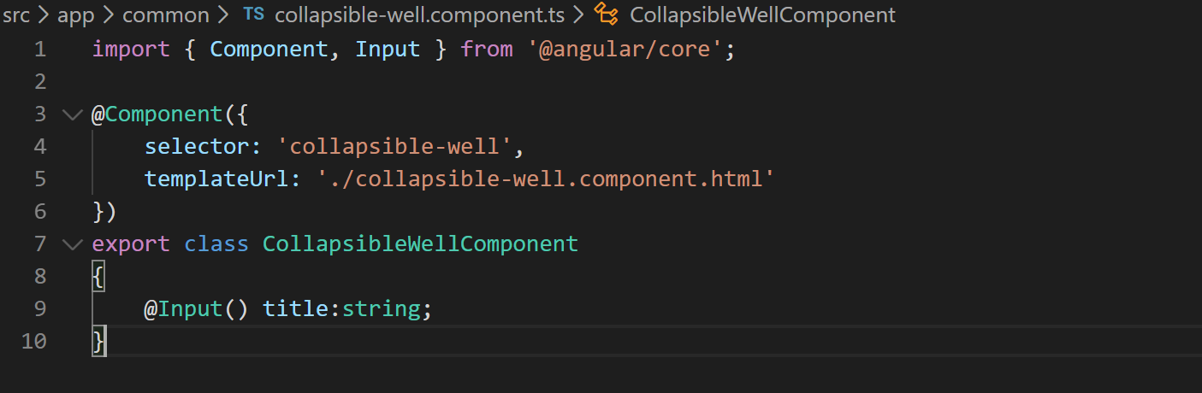
7. Lets bind the title property on session-list.component.html like below:
8. 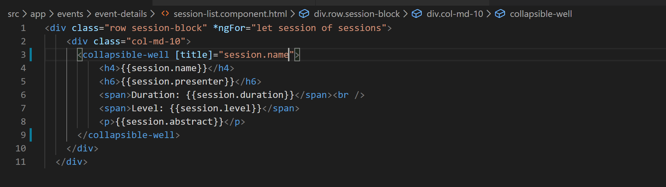
9. Now lets define the HTML for the collapsible-well.component.html file like below:
10. 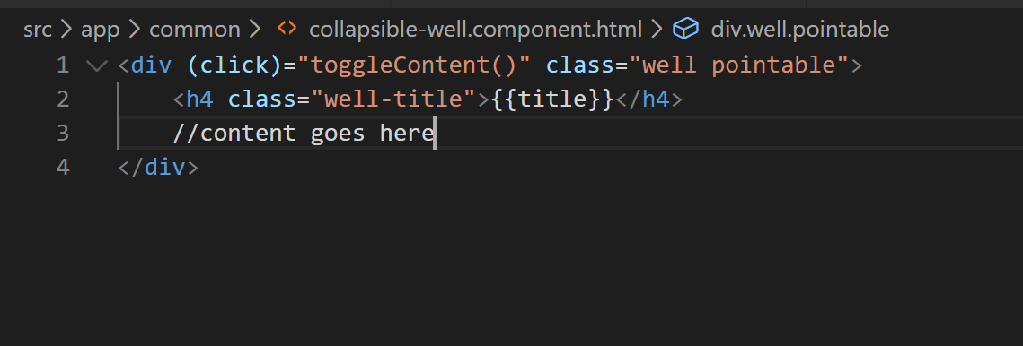
11. Now lets define the “toggleContent” method in “collapsible-well.component.ts” file like below:
12. 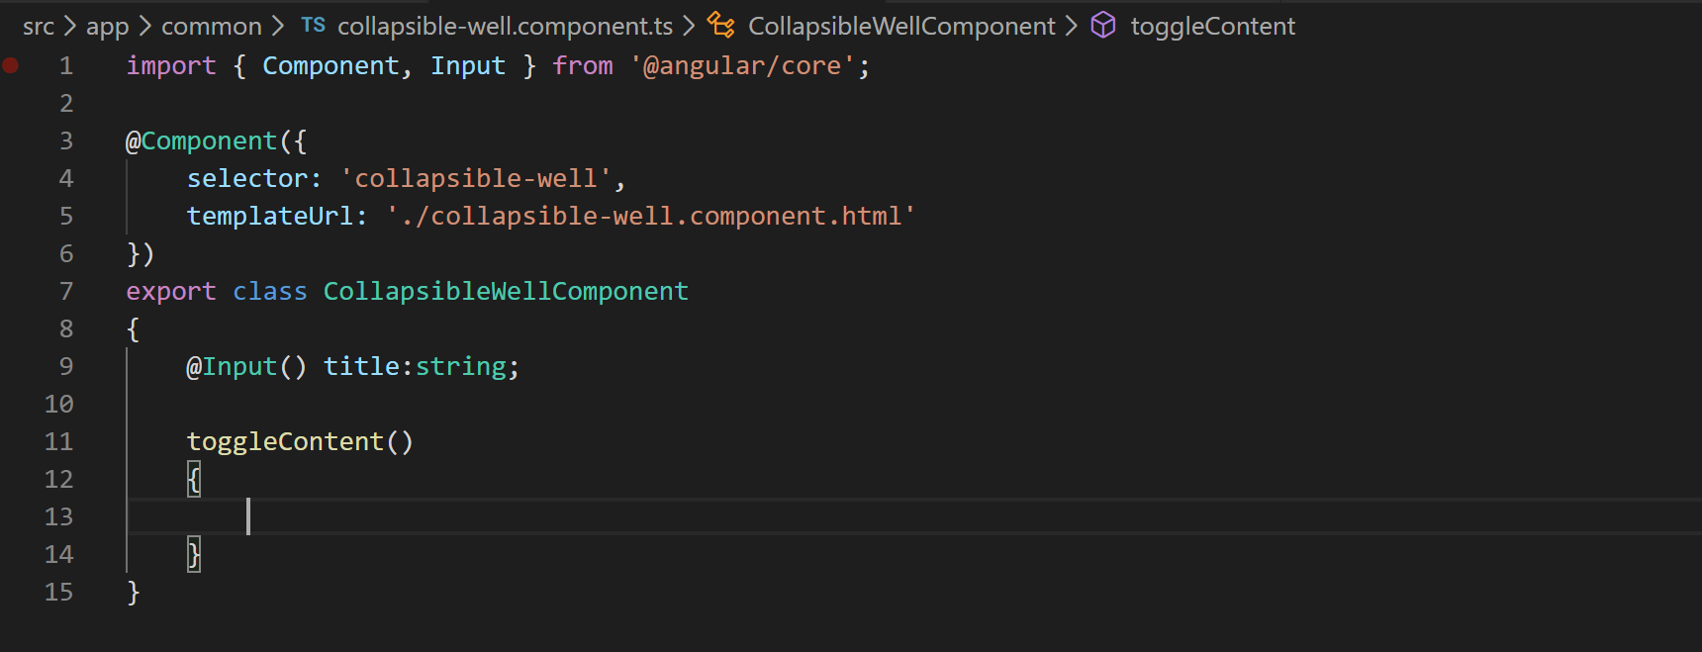
13. Now if you notice VS Code terminal we are getting the same error which says that component should be part of a module so lets add the component in declarations array of app module like below:
14. 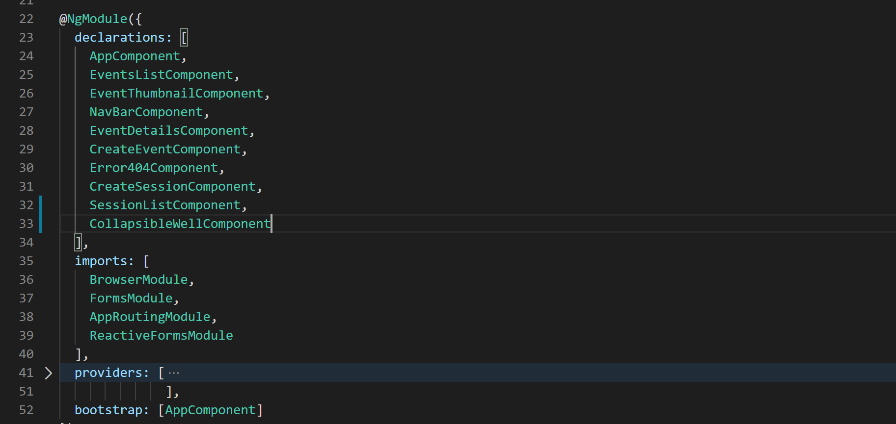
15. Since through the “toggleContent” method we want to toggle visibility of content so lets control that visibility using a property called “visible” and toggle it in the method like below:
16. 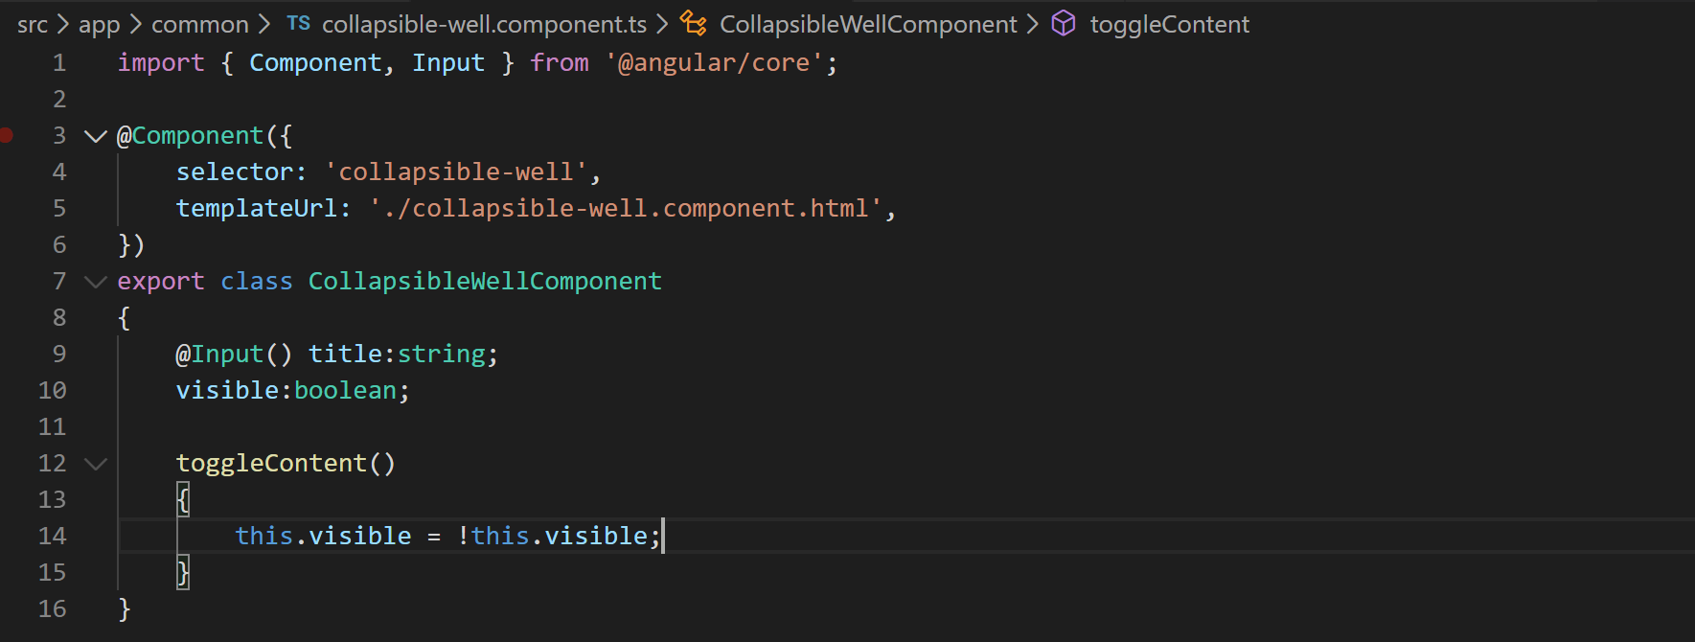
17. Now lets use the <ng-content> tag to project the content like below:
18. 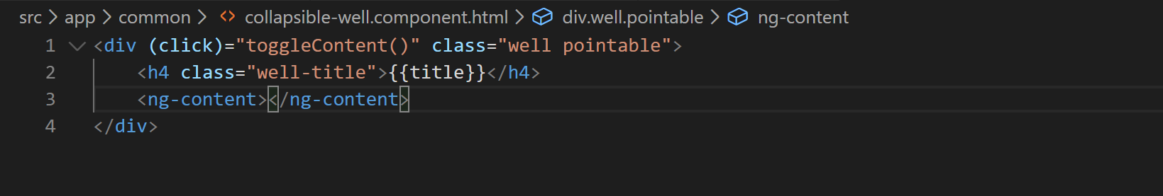
19. Now lets toggle the visibility of ng-content element using ngIf and visible property we just created like below:
20. 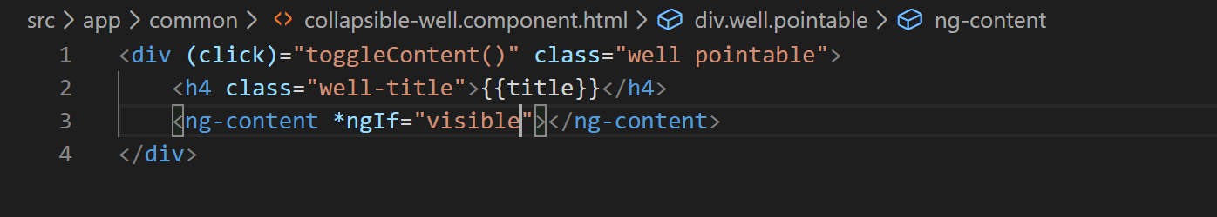
21. Now if you go to the application all the sessions should look collapsed by default like below:
22. 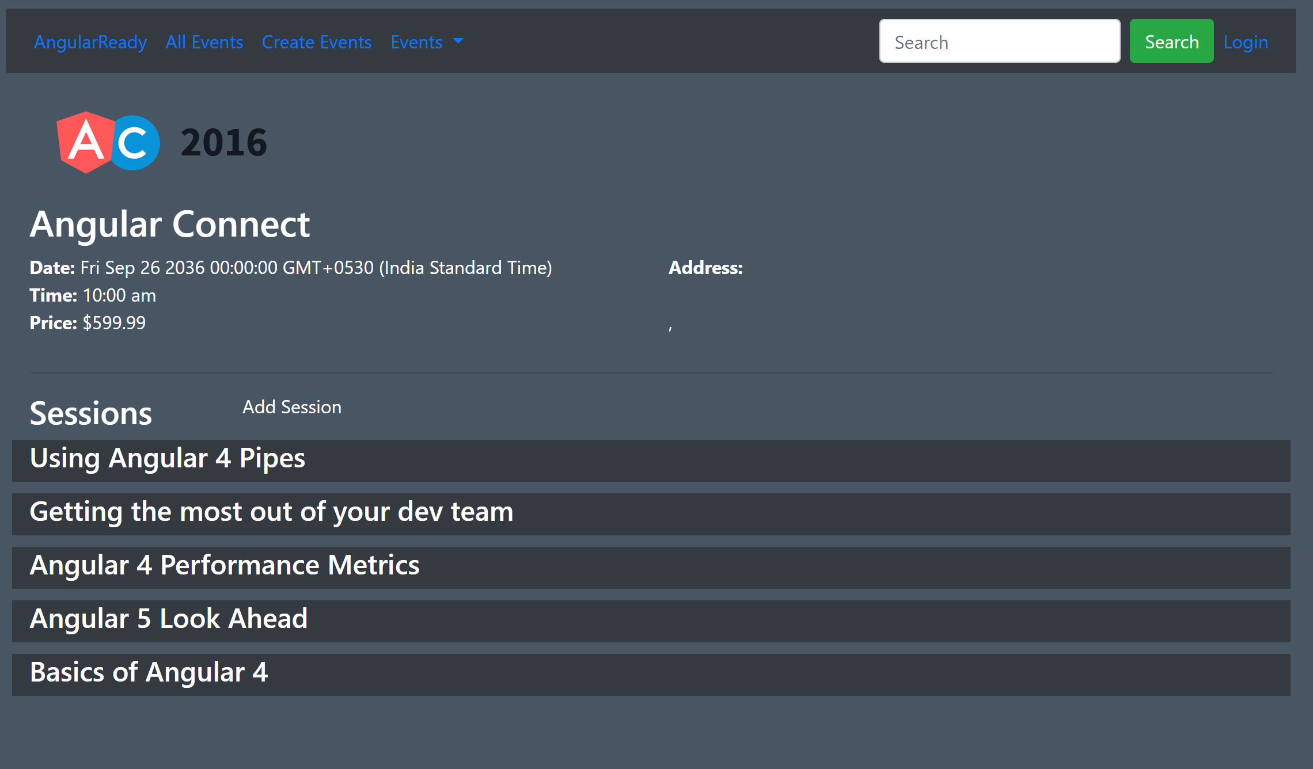
23. Now when you click on the title the content will expand and show all the details. But if you notice the title is appearing twice that’s because we forgot to remove the title from sessions-list component so go remove that.