1. Wrapping a JavaScript library is in an Angular service is practical as long as the library is not too big like jQuery. For libraries as big as jQuery you need a different mechanism to inject that library in our components. That mechanism is injection token. Lets use that to inject “toastr” library in our components.
2. So lets first remove the wrapper code that we wrote. Go to file “toastr.service.ts” and remove the class ToastrService.
3. Now import “InjectionToken” from “@angular/core” like below:
4. 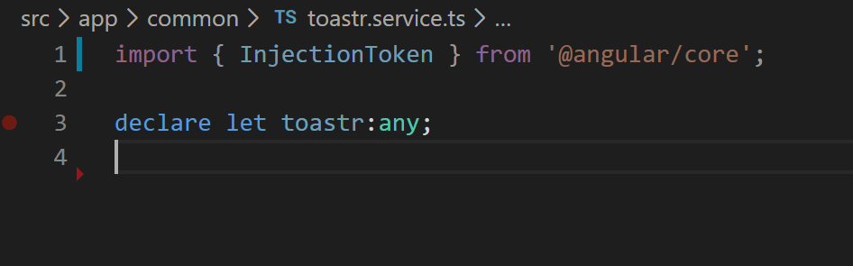
5. Now create an InjectionToken object like below. Injection token is just a keyword that will be mapped to an instance of an object that we want to inject in our component. In order for DI framework to be able to inject it in our components we need to register this mapping in our “providers” array in app module.
6. 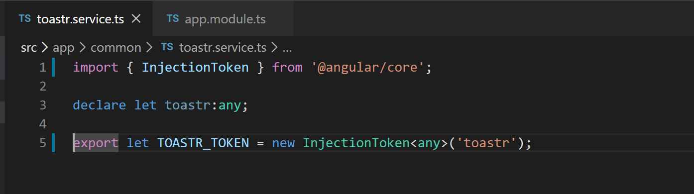
7. Now lets go to app.module.ts and register the injection token like below. First lets import the token object.
8. 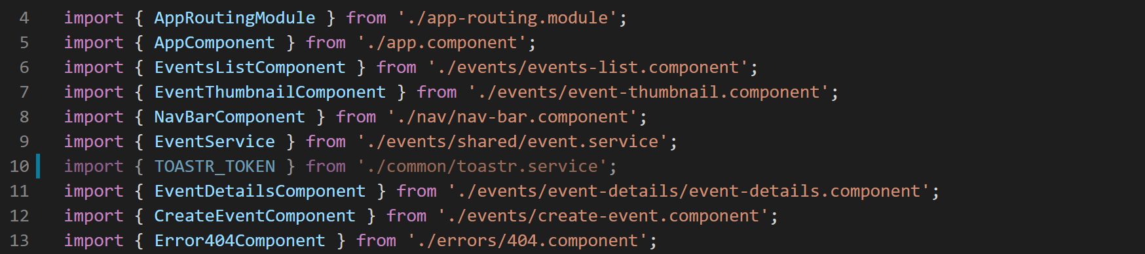
9. Then lets bring in the global ‘toastr’ object from ‘toastr.service.ts” and declare it in app module so that we can use it in the provider registry mapping.
10. 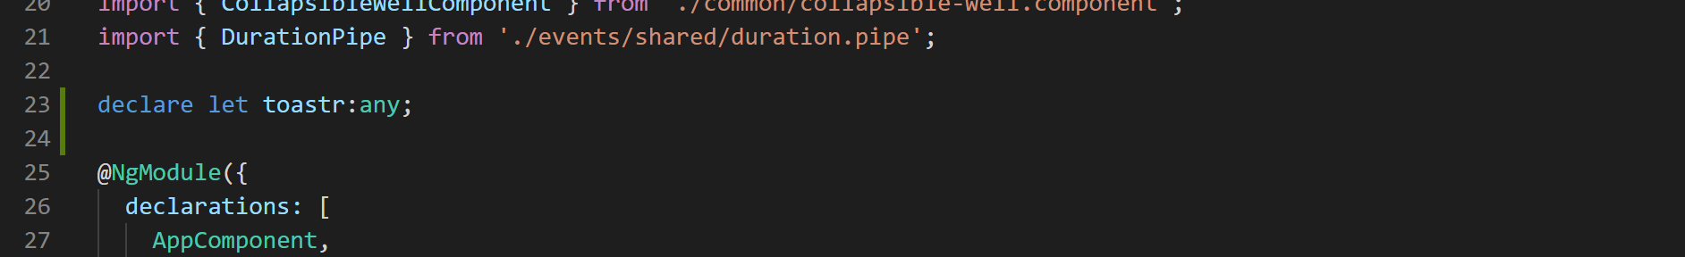
11. Now lets create the mapping like below:
12. 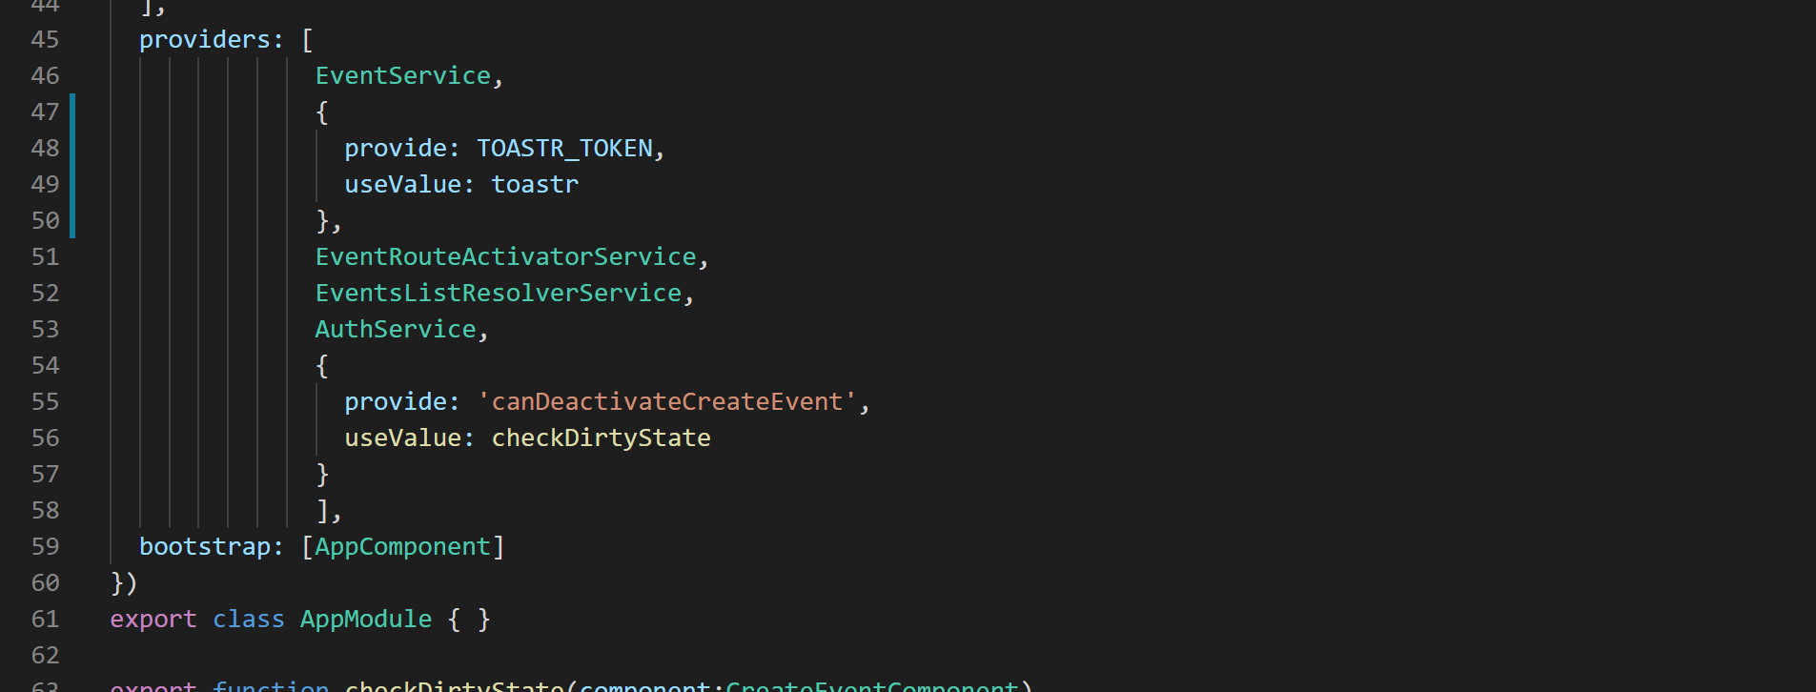
13. We are now ready to clean up traces of old ToastrService and use the new injection token so from event-details component remove following code:
    1. From events-list.component.html remove the (click) event binding from <event-thumbnail> component.
    2. From events-list.component.ts remove the click handler method and remove the Toastr service injection from the constructor.
14. Now lets use new the toastr injection token in edit profile form like below:
15. 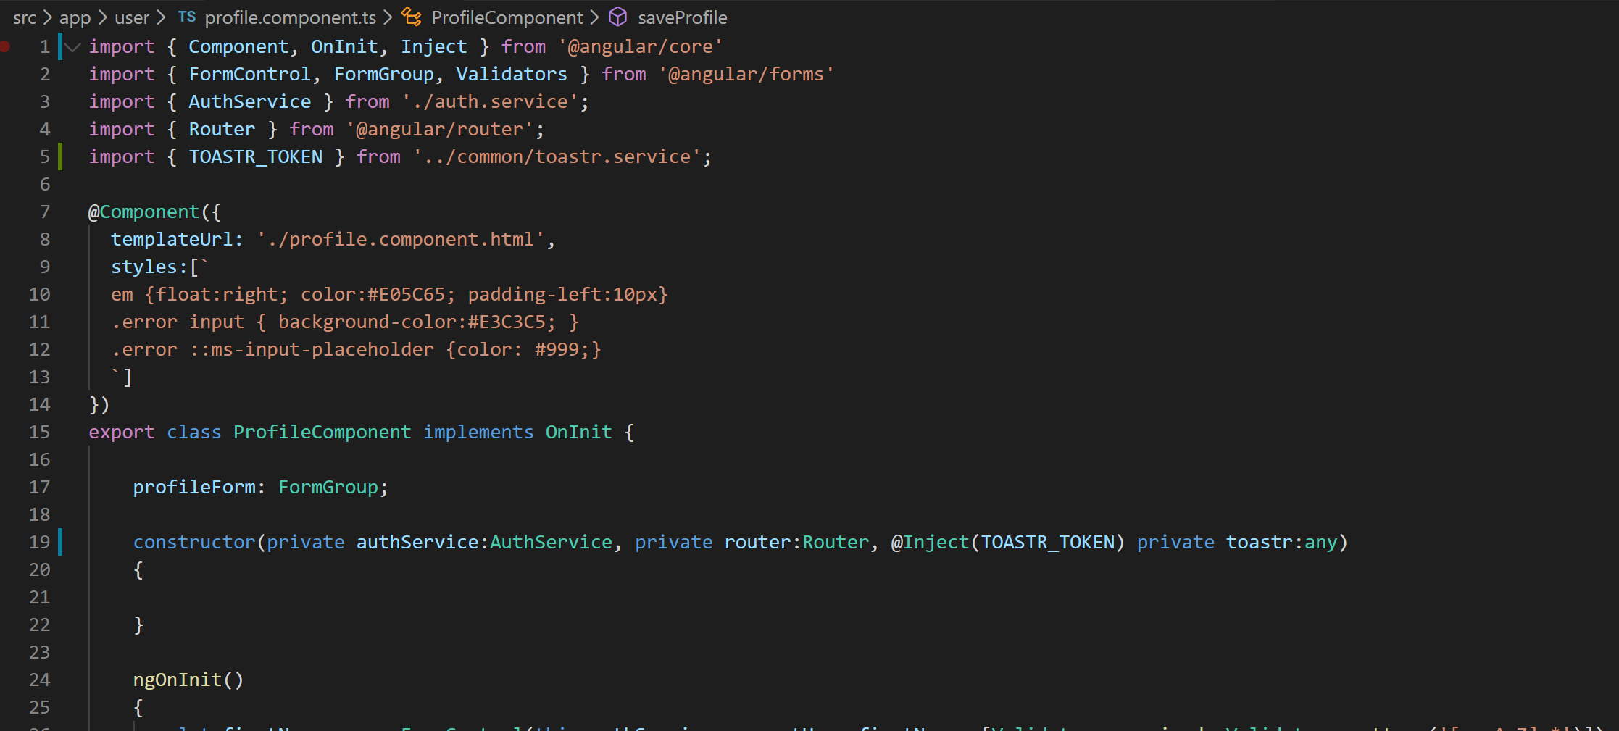
16. 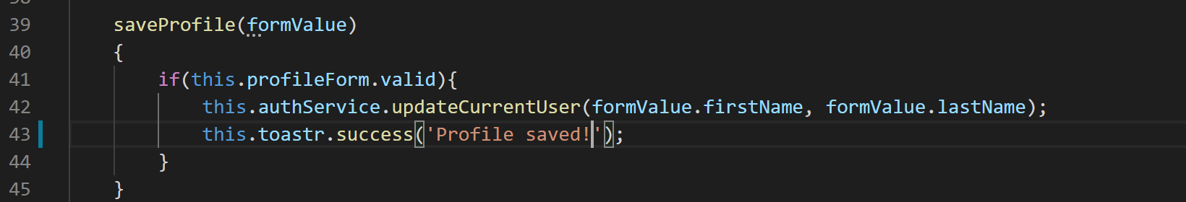
17. Now if you go edit the profile you will see a toast once you click save method and profile is successfully saved.