1. If you notice that redirection from search results modal is working only once. You get redirected to the desired events page once but after that if you click on a search result link which belongs to a different event the redirection does not happen. The reason is the way Angular’s route snapshot is implemented. The route’s snapshot property is not an observable and we do not get to know if it got updated or not.
2. So lets try to fix this issue in event-details.component.ts like below. What we need to do is we need to subscribe to the “params” property which is an observable.
3. 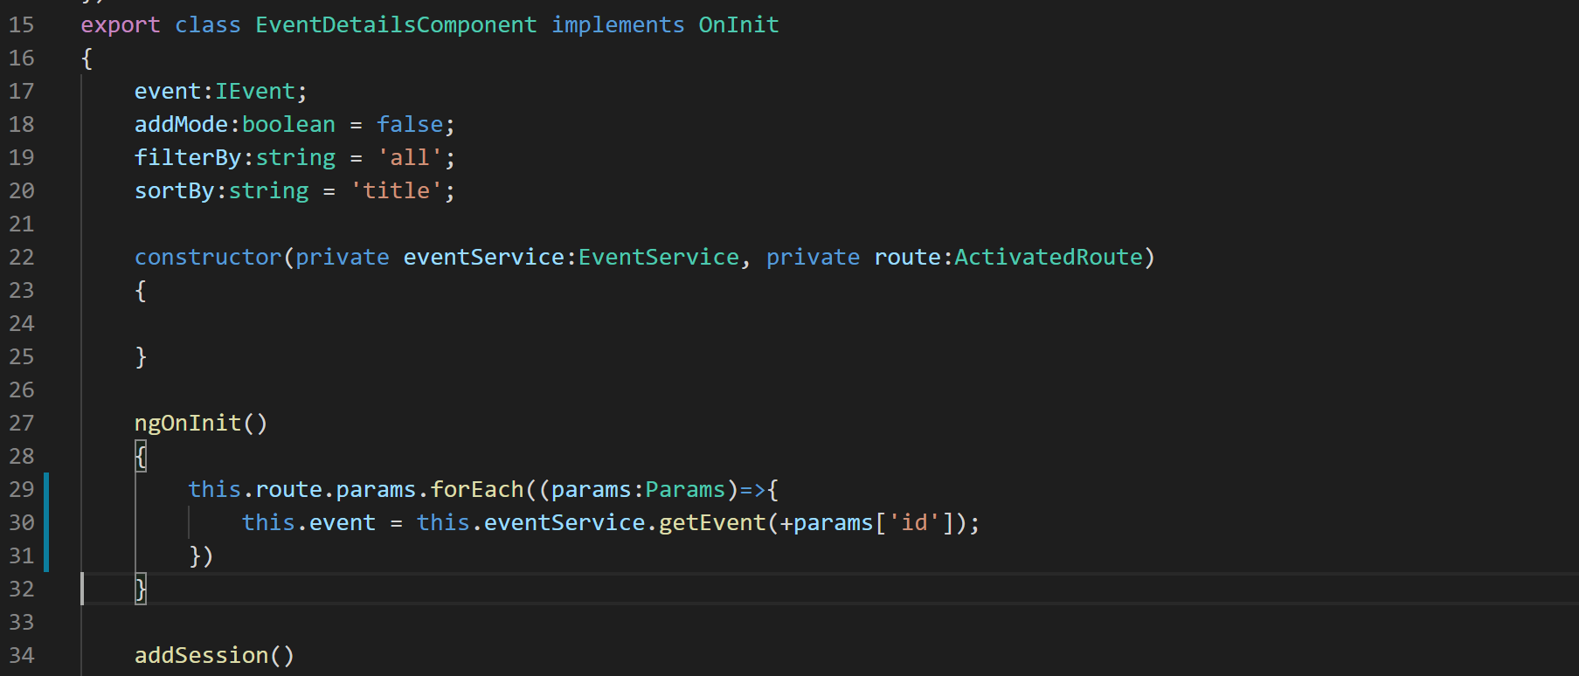
4. Now if you go to the application and search the word ‘Angular’, you will get results from multiple events and you will be able to navigate to all such events.