1. Another issue you would have noticed by now is that when we click any link on the modal it is doing the redirection on parent page but its not closing the modal in the end.
2. So lets fix it. We can do it using the same approach we followed in the directive we created but there is another approach available using the ViewChild decorator. So lets implement that.
3. Open the file “simple-modal.component.ts” and in this files’ HTML template define a template ref variable like below:
4. 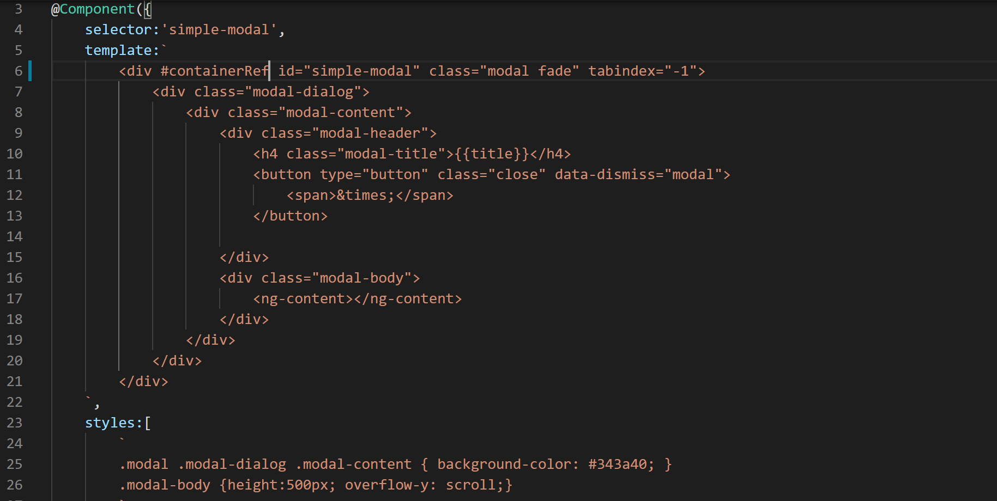
5. This template variable will let us access the “div” using the ViewChild decorator like below:
6. 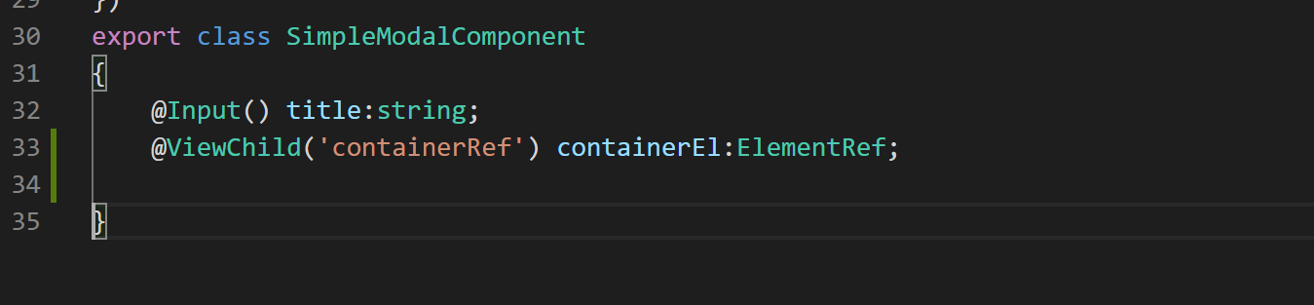
7. Now we need to define a click event handler on the “div” which has the class “modal-body” like below:
8. 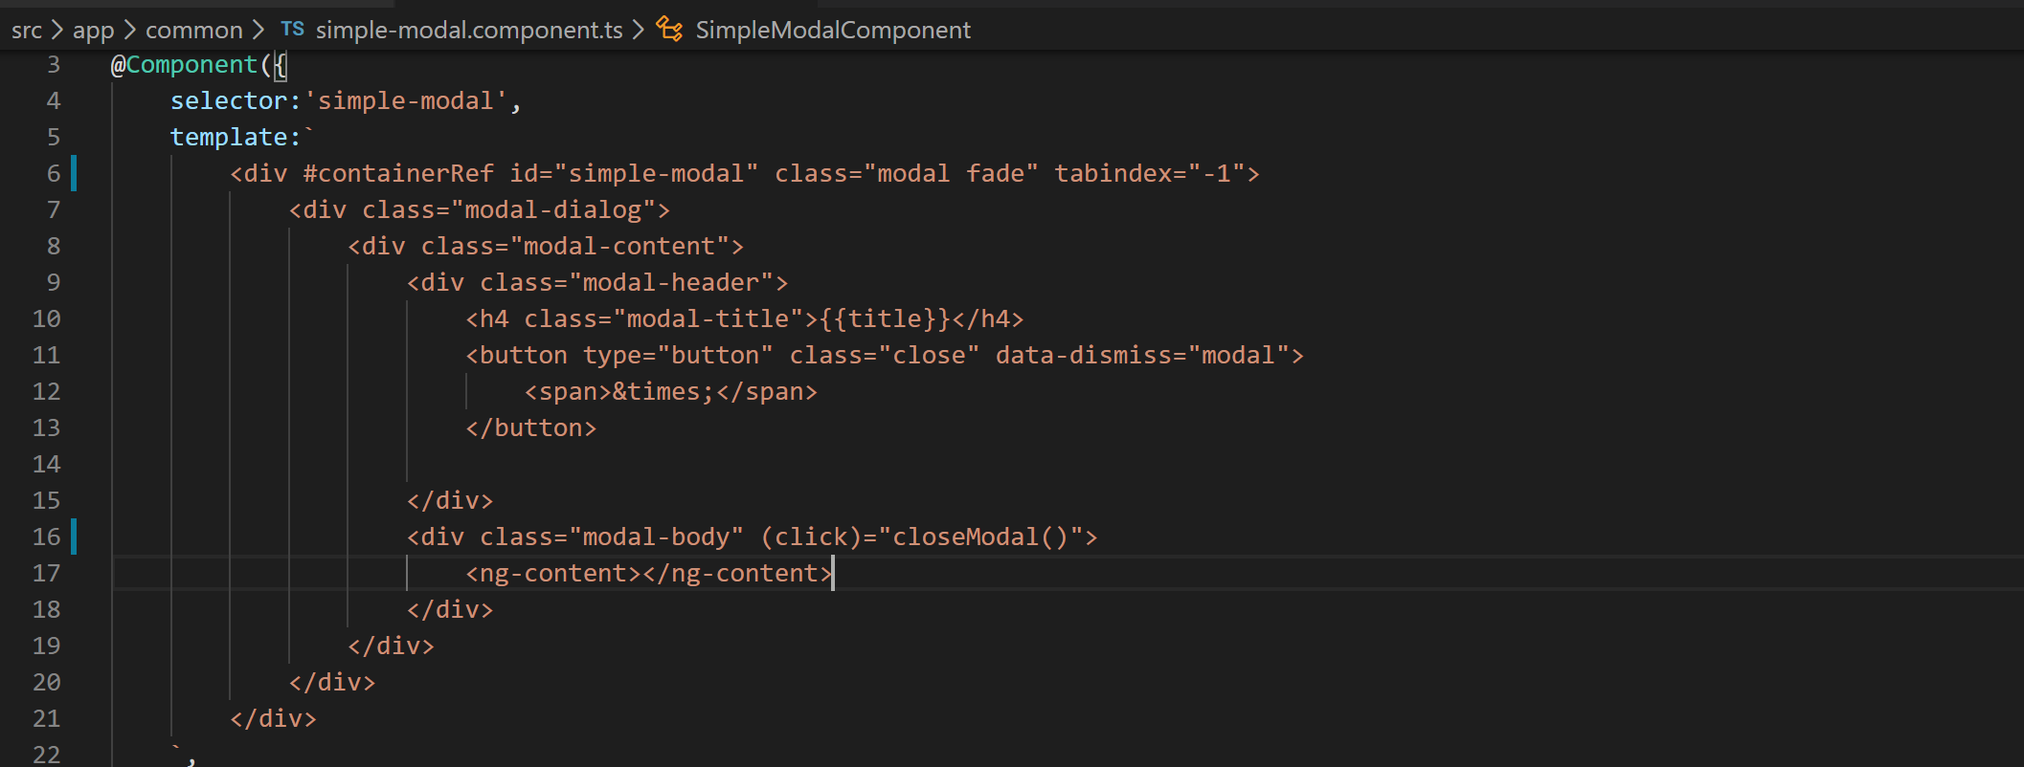
9. Now lets define the closeModal() function and close the modal using jQuery. So before that lets inject JQ_TOKEN like below:
10. 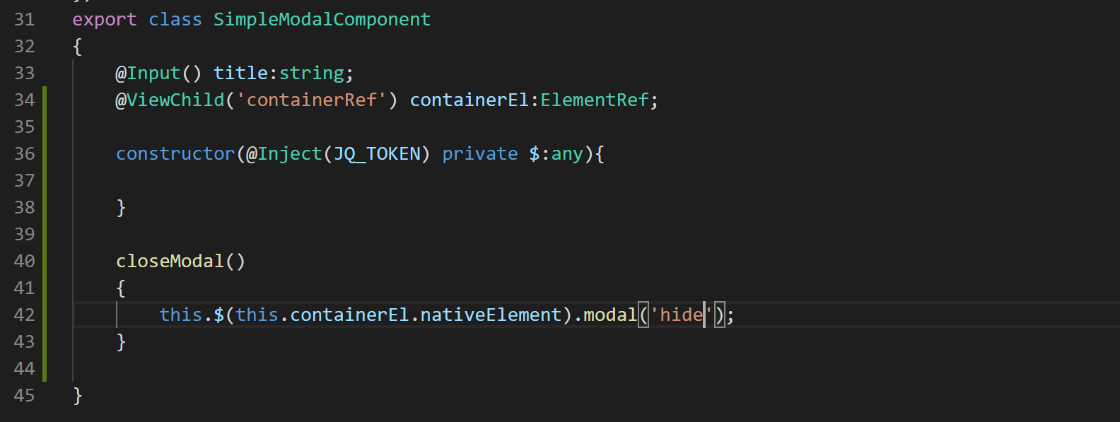
11. Alright now if you go to the modal dialog and click on any link. It will not only redirect to event details page but also close the modal.