1. If you remember our create event form. We have two sets of field in it wherein we ask the user to supply address of the location where event will happen or online URL if the event is online event. We expect user to supply either of the fields. Currently there is no validation on these fields that will do that. So lets add a directive that will do that.
2. So right click the “shared” folder and create a file called “location-validator.directive.ts”.
3. Now lets add the basic shell like below:
4. 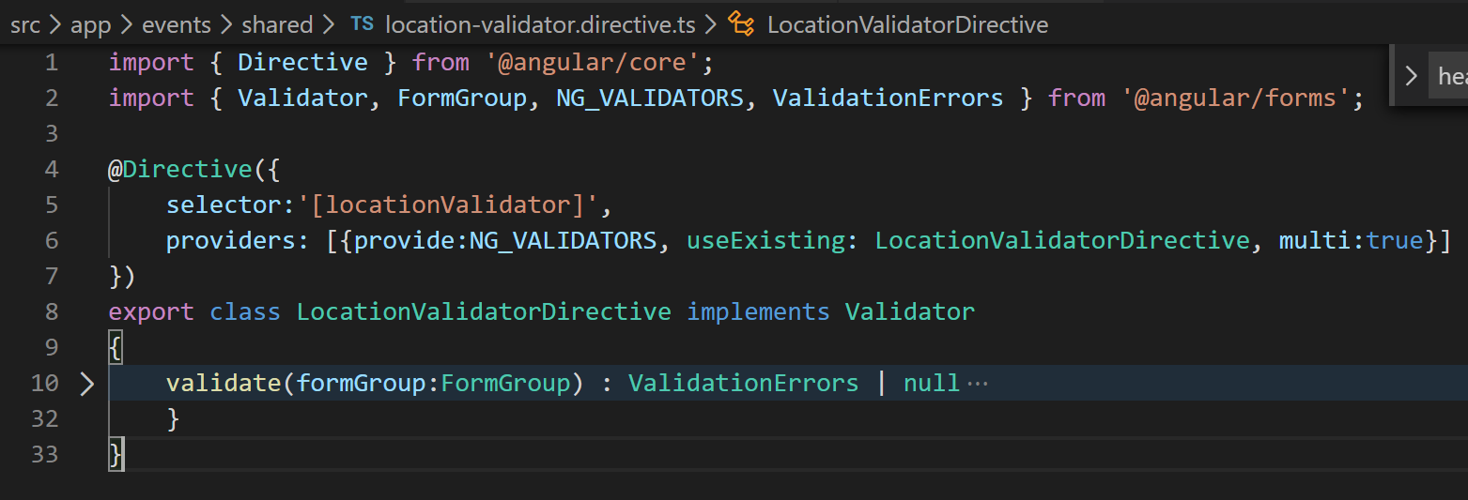
5. Ok now lets implement the Validator interface of angular/forms like below:
6. 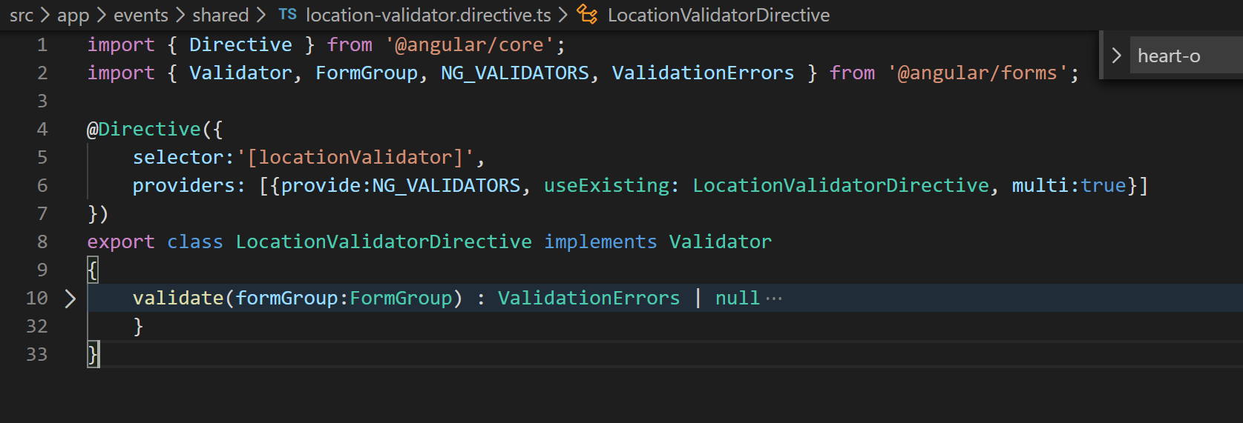
7. Alright now we are ready to access controls of the form group and check their values to return an object depicting the error or no error scenario like below:
8. 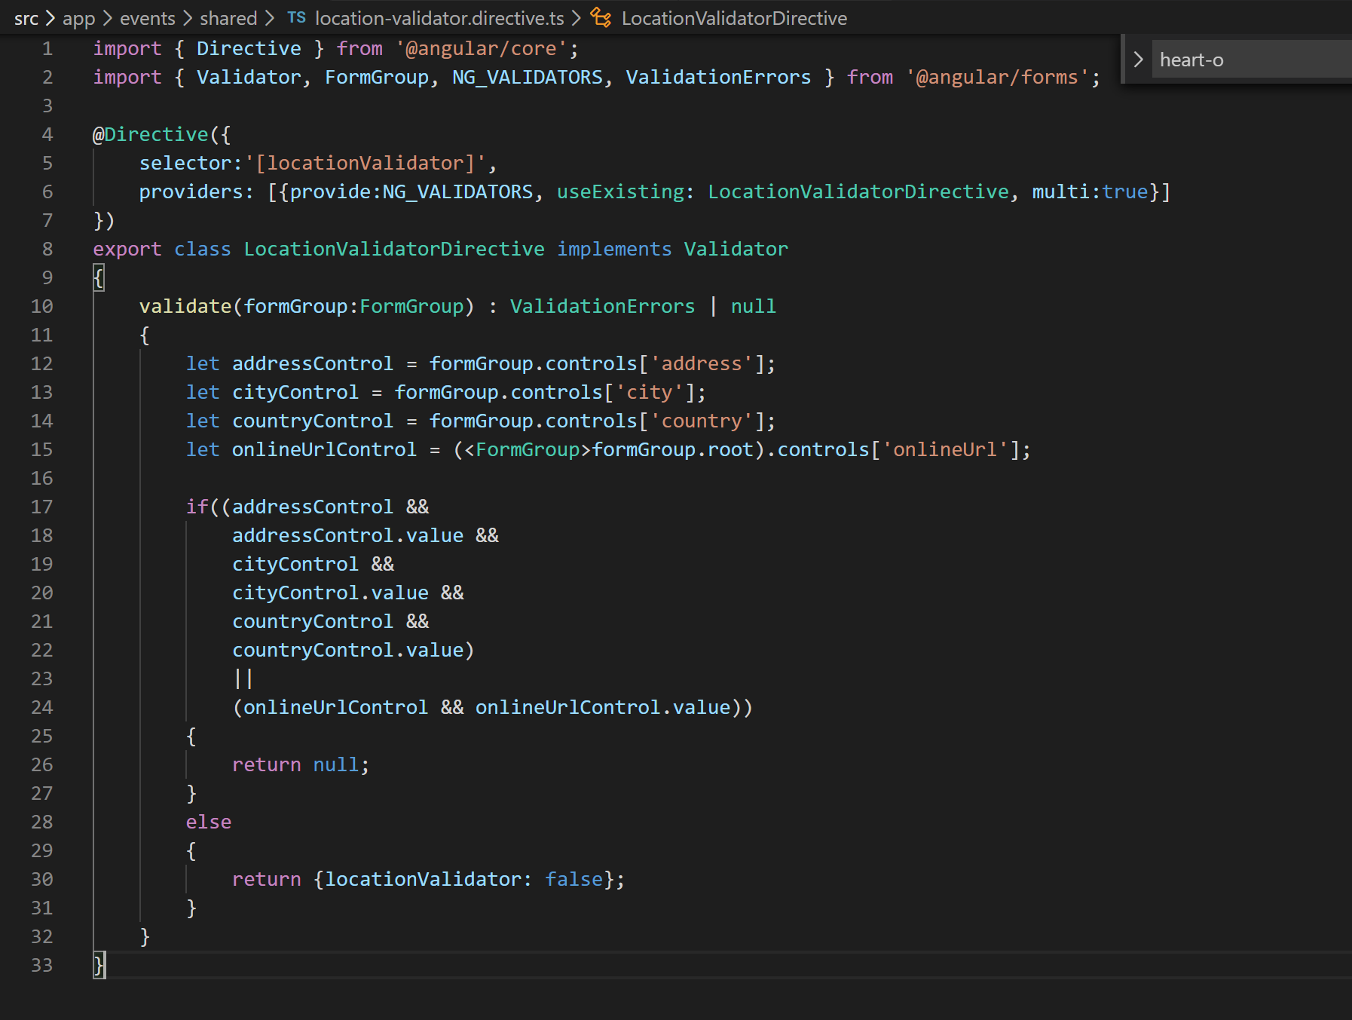
9. Now lets add this directive in declarations array in app module.
10. Now we need to add this validator to NG_VALIDATOR service for angular to be able to fire this.
11. 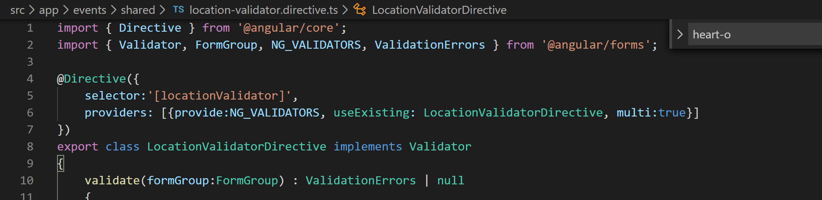
12. Now lets apply the selector to the create event form HTML template like below:
13. 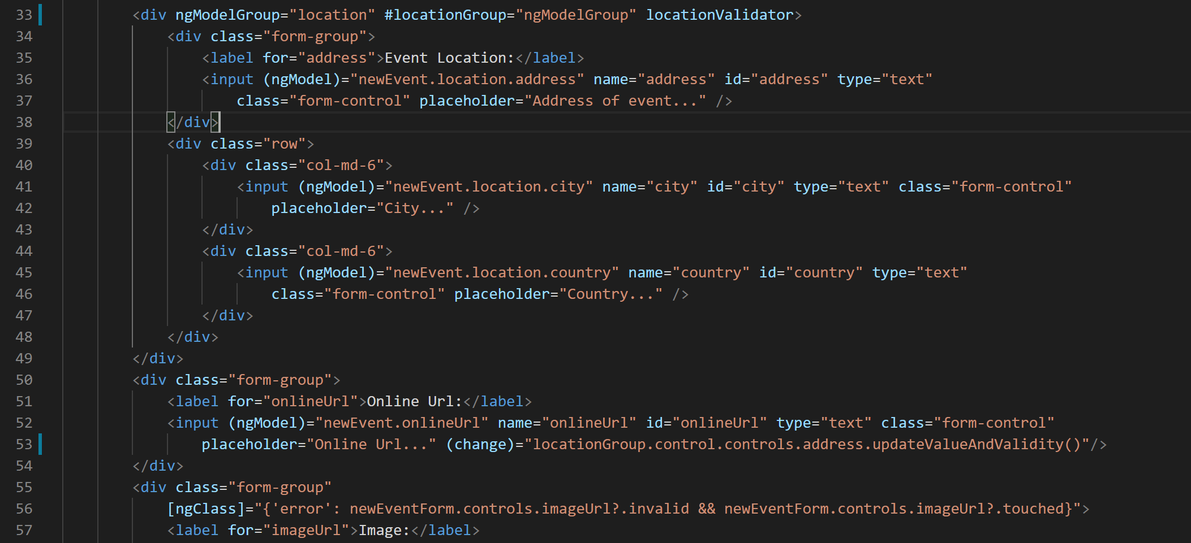
14. Now if you go to the create event form you will not be able to save the event without passing in either location address or online url.
15. Now lets show an error message also that has been missing:
16. 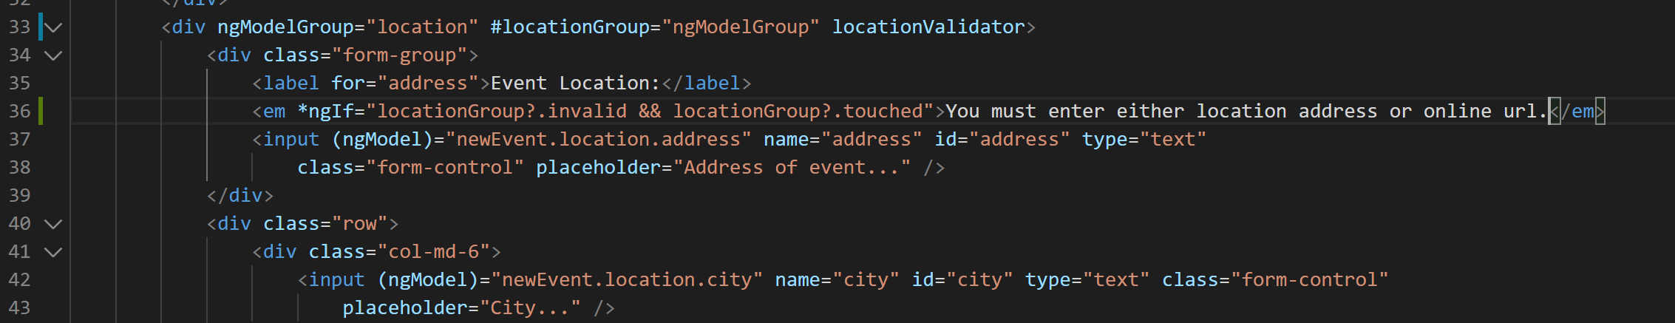
17. Now the error message will show up like below:
18. 