ACKNOWLEDGEMENT: -

I take this opportunity to humbly express our thankfulness to all those concerned with my project.

First of all, I am thankful to LDRP ITR for undertaking this project. I am sincerely indebted to Prof. Shivangi Surti for giving me the opportunity to work on this project. Her continuous guidance and help have proved to be a key to my success in overcoming the challenges that I have faced during my project work. Her support made the project a pleasantly memorable one. Without her help at all stages in spite of her own work load, the completion of the project would not have been possible.
There are so many persons without whose help I would never have conceived and learnt, to whom I would like to express my gratitude – my friends, colleagues, and of course CE & IT Department of LDRP ITR.

Last but not least I am thankful to almighty GOD and my PARENTS for giving me such a good atmosphere to work hard and to succeed.

With regards,
-- -- -- -- -- -- -- -- -- -- -- -- -- -- -- -- -- --

ABSTRACT

Cloud Storage is a service where data is remotely maintained, managed, and backed up. The service allows the users to store files online, so that they can access them from any location via the Internet. According to a recent survey conducted with more than 800 business decision makers and users worldwide, the number of organizations gaining competitive advantage through high cloud adoption has almost doubled in the last few years and by 2017, the public cloud services market is predicted to exceed $244 billion.

Our cloud storage service also provides managing the file operations and other numerous operations with is useful for users to manage that files easily or migrate that files or data to another remote location with easily on simple click events of the selected data. We also connected to the some third party cloud service providers so that user can
also manage and view files by simple giving us some access. We also give you some file data storage information which can help you to how many space you already occupied
and give also some validation features about that so we can save your unnecessary data
upload and downloads rates and if your device is not capable of supporting for current advance APIS we also provide convenience to you by providing server side management
services.

TABLE OF CONTENTS:

Acknowledgement i
Abstract ii
Table of Contents iii
List of Figures iv
List of Tables v
1 Introduction
1.1 Introduction 2
1.2 Scope 2
1.3 Project summary and Purpose 3
1.4 Overview of the project 3
1.5 Problem definition 4
2 Technology and Literature Review
2.1 About Tools and Technology
2.2 Brief History of Work Done
3 System Requirements Study
3.1 User Characteristics
3.2 Hardware and Software Requirements
3.3 Constraints
3.3.1 Regulatory Policies
3.3.2 Hardware Limitations
3.3.3 Interfaces to Other Applications
3.3.4 Parallel Operations
3.3.5 Higher Order Language Requirements
3.3.6 Reliability Requirements
3.3.7 Criticality of the Application
3.3.8 Safety and Security Consideration
3.4 Assumptions and Dependencies
4 System Analysis
  - Study of Current System

4.2 Problem and Weaknesses of Current System
4.3 Requirements of New System
4.3.1 User Requirements
4.3.2 System Requirements
4.4 Feasibility Study
4.4.1 Does the system contribute to the overall objectives of the organization?
4.4.2 Can the system be implemented using the current technology and within the given cost and schedule constraints?
    - Can the system be integrated with other system which are already in place?
4.5 Requirements Validation(is concerned with showing that the requirements actually define the system which the customer wants)
4.6 Activity/Process In New System(Use event table)
4.7 Features Of New System
4.8 Class Diagram
4.9 System Activity(Use case and/or scenario diagram)
4.10 Object Interaction
4.11 Sequence and Collaboration Diagram
5 System Design
5.1 System Application Design
5.1.1 Method Pseudo code
5.2 Database Design/Data Structure Design
5.2.1 Table and Relationship
5.2.2 Logical Description Of Data
5.3 Input/Output and Interface Design
5.3.1 State Transition/UML Diagram
5.3.2 Samples Of Forms, Reports and Interface
6 System Testing
Test cases
7 Conclusion
8 Bibliography

LIST OF FIGURES

LIST OF TABLES

1 Introduction:

1.1 Introduction:

Cloud Storage is a service which helps you to manage your files or data on remote data server and access your data anywhere with the power of the Internet and we also provides you some convenience of some other file related operations and also connects you to third party service providers for your data or files and its related operations.

1.2 Scope:

1.2.1 Current Scope:

In Cloud Storage user can sign up via web application's own sign up portal or other third party who is same service provider its login portal through. User can currently upload and download files or data to the our storage server and also manage perform manage operations like view , rename , delete data or files. User can also see its storage status through the graph and also get results as per that data. Currently user can also connect to one third party service provider which means our application gives convient platform for our user to manage that data to both the service provider with give us some access.user can also makes his/her data public with generate public URLs with our function and share it to other persons so that it will be helpful for others and other users also download or view that files. For some size of files we also give us “Get In Email” functional service which means our server can mail you that files in your registered email so that you have to no worry if you share that file to others in mail. Our system can manage that operations and we also save your data bandwith and time for that operation. We also provide backup service for your data as per our saftey and your saftey purposes.

    - Future Scope:
In future we will provide interface API so that any application wants to connect with us can easily connect and we will also increase the third party same service provider connection so that user can manage that data with the single platform and some numerous click operations. We will provide you online editor so that user can change that file or data online without download and upload procedures and maybe we add some designing to look the application better.

1.3 Project Summary and purpose:

    - Project Summary:

- You can create your storage account via system register module or third party login service.
- You can perform operatons like upload and download for any type of files or data.
- You can also perform some file operations like rename,delete and share that file or data to other third party service storage also.
- You can have also some functional operations like “Get In Email” which means your file or data can be send to your register email by the system for limited size only.
- We also provide you another functional operation which is “Get Public” which helps you to share your file with the register users with just help of the URL the user can only perform view and download operations to it.
- We also provide your storage statistics which show your how much space remaining for you to perform upload operations and also prevents your data bandwidth for unnecessary uploads.
- We also provide data backup service so that data will be recover if some unnecessary operations done by you or us.

    - Purpose:
This website will help you to manage your files or data remotely so that you can view or manage that data or files anywhere via accessing this application. This application also provides you interface so that you can connect same service providers with the help of this website interface and manage your files or data also via giving us some access and you can also connect multiple third party accounts via your register account on our website sequentially not parallel.

1.4 Overview of the project
Cloud Storage provides functionalities about manage the files or data remotely and other same service providers storage devices.

1.5 Problem definition
The problem definition of the current Cloud Storage website is such that the user can manage the files or data remotely with the help of Internet and web-browser and provides some functionalities with the help of some simple click events.

1.4 Objective:

There are objectives that specify how the system should work for fulfilling the purpose of developing it. Below are the objectives for Cloud Storage:
- The system should provide easily manageable remote file operations .
- This system should minimize complexity and should provide efficiency.
- The application should consume less memory space and should fit in any device without taking much time for loading.
- This system should provide security as we are dealing with the databases.

2 Technology and Literature Review

2.1 About Tools and Technology:

Python is a dynamic, interpreted , bytecode-complied language. In python we wrote the code 1/4 times compare to other languages and python provides the gateways to connect other languages.
In python the application will be easy to made.

Flask is a web framework. This means flask provides you with tools, libraries and technologies that allow you to build a web application. This web application can be some web pages, a blog, a wiki or go as big as a web-based calendar application or a commercial website.

Flask is part of the categories of the micro-framework. Micro-framework are normally framework with little to no dependencies to external libraries. This has pros and cons. Pros would be that the framework is light, there are little dependency to update and watch for security bugs, cons is that some time you will have to do more work by yourself or increase yourself the list of dependencies by adding plugins. In the case of Flask, its dependencies are Werkzeug a WSGI utility library and jinja2 which is its template engine.

Redis is an open source, advanced key-value store and an apt solution for building high performance, scalable web applications. Redis has three main peculiarities that sets it apart. Redis holds its database entirely in the memory, using the disk only for persistence. Redis has a relatively rich set of data types when compared to many key-value data stores. Redis can replicate data to any number of slaves.

Html5 is used for displaying web pages at client side web browser so that client can interact with the server and perform operations. JavaScript is used for validation purposes and jinja2 template engine is used for generate the webpage for client when the client requests for the webpage at the server side. Werkzeug library is used for redirect the webpage and custom operations with the parameters.

Third party login ibraries are also used and also used storage apis of third party so that user can manage and perform all operations with the simple interaction within simple website.

At the server side for backup purpose we used smtp protocol to connect to the fault tolerance server and also used python smtplib library for send or receive files to the server.

2.2 Brief History of Work Done

The Cloud Storage system is builded. User can signup and login in the system and manage or view their files or datas and also perform other functionalities. The third party modules of some providers are completed so that user can also login and manage or view data or files with their third party account also. Added backup code and other third party modules.

3 System Requirement Study

3.1 User Characteristics

Analysing user characteristics is an important aspect of any project. It allows us to clearly define and focus on who the end users are for the project. Also, it allows checking the progress of the project to ensure that we are still developing the system for the end users. The user must have following characteristics:

- User must have basic knowledge of how to access websites
- User must have basic understanding about file structure.
- User must have knowlege about files or data operations .
- User must know the terms like email, data storage limit, space occupied,
upload, download, public share.
- User should be also being aware about the running process of the system.

3.2 Software and Hardware Requirements

Software and Hardware Requirements are used to describe the minimum hardware and software requirements to run the Software. These requirements are described below.

3.2.1 Software Requirements

- Client:

- Operating System: Any operating system is used which have
web-browsers that understand html,css,
javascript,TextFormates and
allows network communications.

- Server:

- Operating System: Any operating system with server confgration
- Database Server: Redis
- Technologies: Python , Flask , HTML5, CSS , JavaScript

3.2.2 Hardware Requirements

  - Client:

- Any Operating System
- 256 MB RAM
- Internet Connection
- Storage Space or Files or Data (For Download or Upload)
- Web Browsers which understand (HTML, CSS, JavaScript, TextFormat)

  - Server:

    - 1.6 GHZ CPU
    - 1 GB of RAM
    - Internet Connection
    - Console Oriented or GUI Oreiented
    - Python Supported

3.2.3 Functional Requirements

The basic features available in the system are as follows:

- Admin sets the application credentials, update it and also fix it.
- Users can upload files or data to server storage.
- User can download files or data to his/her system.
- User can manage his/her data or files on the server storage.
- User show its storage statistics.
- We provide security with authentication for system login and register
- We also provide data reliability with the user data backups
- This system should remain accessible 24x7. At least 100 users should be able to access the system altogether at any given time.
- Internet connection for the nodes with the web-server is ensured and hence the application will be available any time for access.
The developed website is portable as it can be accessed from any operation system have web browsers with understand HTML, CSS, JavaScript and various text formats provided they have a facility to access Internet.
- Some third party service providers are connected to that storage so that user
can easily manage that data to various data storage sites

3.2.4 Non-Functional Requirements

Following is a list of non-functional requirements:

- User can also get files or data in his/her registered emails after selected
- User can also share his/her data or files to the other registered users
- Users can also manage his/her data in the third party storage services
with the help of simple click events via the convenience interface

3.3 Constraints

3.3.1 Parallel Operations

The project is on basis of multi-user. This is used for carrying out updating as well as entry by preventing the redundancy of the data.

3.3.2 Reliability Requirements
Reliability requirements of the system are one of the prime ones in the list. The system is needed to be highly reliable in terms of performance and capable of delivering robust performance. If the requested results are generated within 5 seconds then the system is said to be reliable.

3.3.3 Criticality of the Application
The system can working slowly on device with very low internet connection. Other than that there won’t be any issues. Apart from these the system should be able to make updates at regular time intervals. And it is also depend on the third party responses for some functionalities.

3.3.4 Safety and Security Consideration
Safety and security too are other major concerns of any system. It is necessary to provide safety and security as the system is web application and might be intrude by security threats from the internet. Thus, the data needs to be encrypted and any transaction needs to be done securely.
Which we will provide by our encryption and decryption algorithm for data transfer which we will introduce in the future version. And also scripts and browsers code are sent through stateless
protocol and through communication via https protocol.

3.3.5 Hardware Limitations
Hardware Limitations are other constraint of the system. Hardware Limitations should be overcome for better performance of the system. This can be achieved by using minimum and only necessary hardware.

3.3.6 Regulatory Policies

Regulatory policies about achieving organization’s objectives through the use of regulations, laws, and other instruments to deliver better economic and social outcomes and thus enhance the life of business. Thus, the system should be developed by using these regulations to provide better outcome to the company. we are not responsible for what data user should upload and what type of data it will be .we are also not responsible for what you will upload through third party storage service via our interface.

3.3.7 General Constraints
The service provided by consultants of Team Spotter is 24*7 to its client companies. Hence the redis database server as well as the website needs to be up 24*7. Internet availability is the major requirement for all the end users to successfully access the application. As well as being a live application security enforcement needs to be tight else there are chances of hacking or intrusion.

3.4 Assumptions and Dependencies

3.4.1 Assumptions:

- Database transactions are assumed to be secure and reliable.
- User is the person having enough knowledge for the their own websites operation.
- User can upload valid files or data on the server.
- User can also provide valid email address so that user get more benefits from
the services.
- While on third party transactions we assume that user give us access to our website
- browsers should be understand HTML , CSS and JavaScript.

3.4.2 Dependencies:

• The system is dependent upon the user’s valid credentials. If user inputs wrong
username or password, he/she will not be allowed to login to the system.
• This application depends on the server and internet as all the information is collected and then stored in the server through secure internet connection.

• All the users of the system will be assigned a specific role. According to these roles
each and every user will be allowed to access predefined set of features.
• The server have python installed and also support the libraries of flask so that it will
be work as same as expected.
• The server have redis database installed so that database can work properly and data
will store at the server will be persistence as per redis application.
• The server also connected to the fault tolerance server so that script will be
executed properly and data backup process will be executed and user data
will be persistence.

4.System Analysis

4.1 Study of current system

- In the world of Internet we also provide file management and file operations on the Internet
- Our system can provide easily usable interface so that user can upload , download and also perform file operations through remote connection
- We also provide functionalities like public share so that user can share that data or files to other register users and user can also get files or data in direct registered email but size validation is also applicable.
- We also provide some third party connection to other same service providers so that user can manage operations through our website and also connect to his/her data which is stored at our data server. So that user can manage multiple services through one platform.
- We also provide data backup service which take user data or files backup periodically and provides fault tolerance and prevent to data lose.
- Our system also handles some cases when the browser does not support some javascript apis or validation with the help of only one node can be set up perfectally and it handles all.
- In future we also provide provide editor so that user can also update their file or data contents online without go in the download-update-upload cycle. And we also provide some styling to our interface. And we also connect other service providers to ours so that user can take more advantage of it.In future we also provide functionalities like data may be compressed.

4.2 Problems

- Third party can update their connection apis as per changes in the services. So that site maintaince cost is some extra or we discontinue to give that service.
- The language is also in updating phase so that we also take away our virtual environment in which our application works.
- We will provide functionalities like you can upload any kind of data so that user may be upload an unappropriate content which may be break down our policy.
- Data will be compressed at the client side so that process time will be some more but data upload time will be less.
4.3 Requirements of New System
4.3.1 User Requirements
  - Upgraded Browsers.
4.3.2 System Requirements
  - The tool is easy to use, and a simple graphical user interface.
  - An encryption which takes less time to generate output
  - For provide fast result and provide great processing powe
  - To store more user data and files

4.4 Feasibility Study

4.4.1 Does the system contribute to the overall objectives of the organization?
Yes, this application serves the overall objective to be made less time, work and resource management and it satisfies a lot of data storage systems requirements at a very good extend.

4.4.2 Can the system be implemented using the current technology and within the given cost and schedule constraints?
Yes, the system can be implemented using current technology, with low cost and very less work.

4.4.3 Can the system be integrated with other systems which are already in place?
Yes, it can be integrated with right now system. It can run on any software and mostly on all hardware and it can run on any operating system.

  - Modules and functionality of proposed system

- You can create your own profile.
- You can create your own events and also join other’s.
- If you are at an unknown place and you want to play any sport then you just have to mention the details of the sport, timing and the location in the application.
- The application will notify the interested and available peoples at the scheduled time of the event.
- It also shows the peoples, who doesn’t lives in that area but they are interested and available in that area to play, that which events of their interests are scheduled.
- You can also share the event to your friend who doesn’t lives in that area.

3.3 Feasibility Study

An important outcome of the preliminary investigation is the determination that the system requested is feasible. The feasibility study is carried out to examine the likelihood that the system will be useful to the organization.
There are four aspects in the feasibility study namely.
- Operational Feasibility
- Technical Feasibility
- Economic Feasibility

3.3.1 Technical Feasibility:
The main purpose of checking Technical Feasibility is to examine whether the current technology is sufficient for the development of the system.
The outcomes of the technical feasibility are as follows:
- Application uses Android based on the JAVA.
- The application developed in JAVA can run on any of the Android devices which has version higher than 4.0.
- Back end we can use Oracle Database for database connection.
- It provides faster response to the user.
So, this application is Technically Feasible.
3.3.2 Operational Feasibility:
The main purpose of checking Operational Feasibility is to find out whether the system will be functional after its development and installation or not.
The outcomes of the operational feasibility are as follows:
- This application provides all the data of all sports which has players across the provided area.
- They can be administered from remote locations using application, or telephone.
- So, it is supposed to improve the working efficiency of user.

So, this application is operationally feasible.
3.3.3 Economic Feasibility:
The main purpose of checking Economical Feasibility is to examine whether the financial investment in the system will meet the user’s requirements or not.
The outcomes of the technical feasibility are as follows:
- Proposed System is developed as mobile application which is freely available on Google Play Store.
- It uses Android as a front end that is also freely available.
- The advantages of the system nullify its development cost as the scope and effect of the system are very large.
So, this application is economically feasible.
3.4 Requirements Validation

The Basic validation from user side is to detect wrong information or blank information:
- When the user has entered correct username and password, then he/she is allowed to enter information or to see the information either into the database or from the database.
- If anyone field from username or password remains blank, then user will not be allowed to enter the system.
- If a player leaves some fields blank in details log form then he/she does not allow submitting his/her information.
- If user has entered wrong data then accordingly message will generate automatically.
3.5 Class Diagram

A class diagram is a graph of classified elements connected by their various static relationships. It is shown here for Client Support System. This includes the System and the End-users as its main classes. Here are three different fields: Class, Attributes, and Operations.
Class shows the class name, i.e., Admin, Player, Location, Sport, Team Generator, Team. They relate to each other through links and their relationship with each other is shown through the numbers represented on the link; here * indicates zero or more multiplicity. Attributes provide the details of the Class while Operations show all possible operations respective class can do in the system.

Fig: 3.5.1 Class Diagram of Team Spotter App
3.6 Usecase Diagram

A use case diagram shows the relationship among actors and use cases within a system. Hence it provides the characteristics of the actors whose behavior and relationships can be well understood using the diagrams elaborated here.
An user can perform various tasks on the application; he may search for new team or player. On the other hand, the system would respond to the operations done by the user. It would display the appropriate matches of player/team to the user. Also, it would provide a message whenever needed for confirmation.
Here the rectangle indicates system boundary, out of which there are actors found who perform various operations on the system which are the end-user and the system here. An elliptical shape shows the use-case while the connecting links between an actor and a use case are said to be communicates.

Fig: 3.6.1 Use-case Diagram of Team Spotter.

3.6.1 Use Case Scenarios For System:
- Login
Use to provide way to enter through User_id and Password.
- Provide Details
Use to provide details by the users.
- Create Team
Use to create team by the user.
- Search for team/player
Use to search teams or players for the user.
- Join Team
Player can join the appropriate team.
- Feedback
- User gives feedback.
- Admin receives feedback.
- Contact
Use to contact teams or players by the user
- Logout
Use to logout.

Fig: 3.6.2 Use-case Diagram of Admin.
3.6.2 Use Case Scenarios For Admin:
- Login
Use to provide facility to enter through username and password for admin.
- Manage Database
Use to manage different databases by admin.
- Manage User
Use to manage different users by admin.
- Send Suggestions
Use to send suggestions to the users by admin.
- Receive Feedback
Use to receive feedback from the users by admin.
- Logout
Use to sign out from the session.

Fig: 3.6.3 Use-case Diagram of Team Generator.
3.6.3 Use Case Scenarios For User:Team Generator:
- Login
Use to provide way to enter through User_id and Password
- Provide Details
Use to provide details by the users
- Create Team
Use to create team by the user
- Search Player
Use to search player by the team.
- Send Request
Use to send request to the player by the team.
- Accept/Decline Request
Use to accept/decline requests of the players.
- Contact Player
Use to contact players by the team.
- Send Feedback
Use to send feedback by the team generator.
- Logout
Use to sign out from the session.

Fig: 3.6.4 Use-case Diagram of Player.
3.6.4 Use Case Scenarios For User:Player:
- Login
Use to provide way to enter through User_id and Password
- Provide Details
Use to provide details by the users.
- Search Team
Use to search team by the palyer.
- Join Team
Use to join team by the palyer.
- Send Request
Use to send request to the team.
- Accept/Decline Request
Use to accept/decline request from the team.
- Contact Team
Use to contact team by the palyer.
- Send Feedback
Use to send feedback by the palyer.
- Logout
Use to sign out from the session.

4. Project Planning and Estimation

4.1 Technologies Required for System

4.1.1 Android:

Android is an open source and Linux-based operating system for mobile devices such as smartphones and tablet computers. Android was developed by the Open Handset Alliance, led by Google, and other companies. This tutorial will teach you basic Android programming and will also take you through some advance concepts related to Android application development.

4.1.2 Oracle Database:

The Oracle Database (commonly referred to as Oracle RDBMS or simply as Oracle) is an object-relational database management system produced and marketed by Oracle Corporation.
An Oracle database system—identified by an alphanumeric system identifier or SIDcomprises at least one instance of the application, along with data storage. An instance identified persistently by an instantiation number comprises a set of operating system processes and memory-structures that interact with the storage. (Typical processes include PMON (the process monitor) and SMON (the system monitor).) Oracle documentation can refer to an active database instance as a "shared memory realm".
Users of Oracle databases refer to the server-side memory-structure as the SGA (System Global Area). The SGA typically holds cache information such as data-buffers, SQL commands, and user information. In addition to storage, the database consists of online redo logs (or logs), which hold transactional history. Processes can in turn archive the online redo logs into archive logs (offline redo logs), which provide the basis (if necessary) for data recovery and for the physical-standby forms of data replication using Oracle Data Guard.

4.2 Project Planning
4.2.1 Project Development Approach:
The model that is referred for the development of the project is INCREMENTAL model. It combines elements of the waterfall model applied in an iterative fashion. In this process the phases are same as waterfall but the advantage is that when first phase is done it is incremented and then the other phases are carried with the same cycle. Here in this add ons on each phase can be added according to the need of the client and the project.

Phases are as follows:
1. Communication
2. Planning
3 .Modeling: Includes Designing
4. Construction
5. Deployment: Feedback, Delivery

Each phases are iteratively carried out. Main reason for using this then any other is waterfall has the drawback of iterations, if there is any other requirement added later on then this is not possible to add up in it, Spiral model has disadvantage that it need more manpower and even it is for multiple transactions or multiple tasks handling projects and so does the time consumption is more in it for those projects.
Planning is essential cause multiple software teams works in parallel on different system functions. Scalability should be obtained in any of the project selected but it is not available in waterfall cause of few drawbacks.

4.2.2 Milestones and Deliverables

- Month1:- Milestones & Deliverables
Milestones | Deliverables
Study about our web application requirement, planning | Analysis Report
Understand a project definitions and basic terms and logic for Parameter Evaluation. | Analysis Report
Gathering the requirements of the project using different fact finding techniques. | Analysis Report
Still Continue with Requirement’s study. | Analysis Report

- Month 2-4: -Milestones & Deliverables
Milestones | Deliverables
System Analysis | Analysis Report
System Design including various diagrams | SRS

- Month 5 to 7 : -Milestones & Deliverables
Milestones | Deliverables
Integrating techniques of Android and oracle | Designing/Coding
Database creation and Procedures | Designing/Coding
Admin Module of Team Spotter | Designing/Coding
Team Generator Module of Team Spotter | Designing/Coding
Player Module of Team Spotter | Designing/Coding
Team Module of Team Spotter | Designing/Coding
Location Module of Team Spotter | Designing/Coding
Sports Module of Team Spotter | Designing/Coding

- Month 8 : -Milestones & Deliverables
Milestones | Deliverables
App Testing | Testing
Required changes after testing | Designing/Coding

4.2.3 Group Dependencies

The team structure depends on the management style of the organization, number of people in the team, their skill levels and the problem difficulty. Our team organization is democratic decentralized which doesn’t have a team leader. Decision is made by all of us and the problems were discussed and solved by all of us after consulting and discussing with our external guide and project guides.

4.3 Project Scheduling

Project scheduling involves separating the total work in a project into separate activities and judging the time required to complete these activities. Usually, some of these activities are carried out in parallel.

- Work Breakdown Structure
Work Breakdown Structure is used to decompose a given task set recursively into small activity [Fig (4.1)].

- Activity Network Representation
An activity network shows the different activities making of a project, their estimated duration and interdependencies [Fig (4.2)].

- Gantt Chart
Gantt chart is mainly used to allocate resources to activities. Gantt Charts are useful for resource planning [Fig (4.3)]

  - Work Breakdown Structure

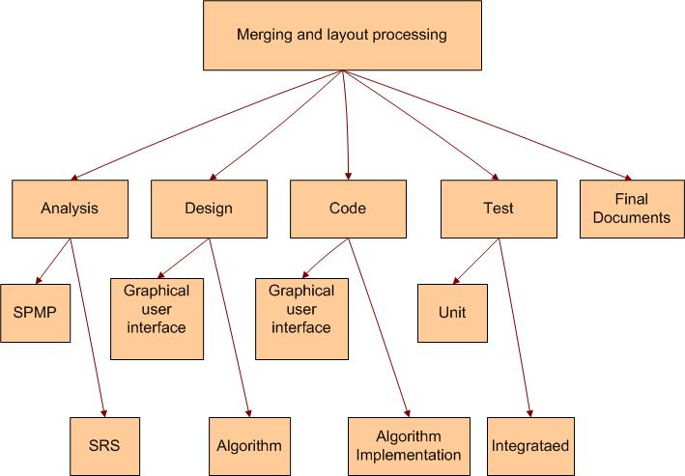
Fig 4.1 Work Breakdown Structure
(b)Activity Network Representation
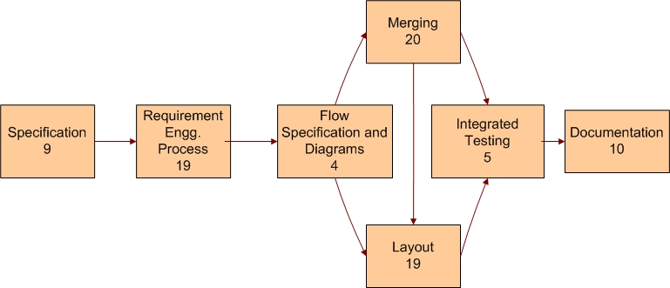
Fig 4.2 Activity Network Representation
(c)Gantt chart
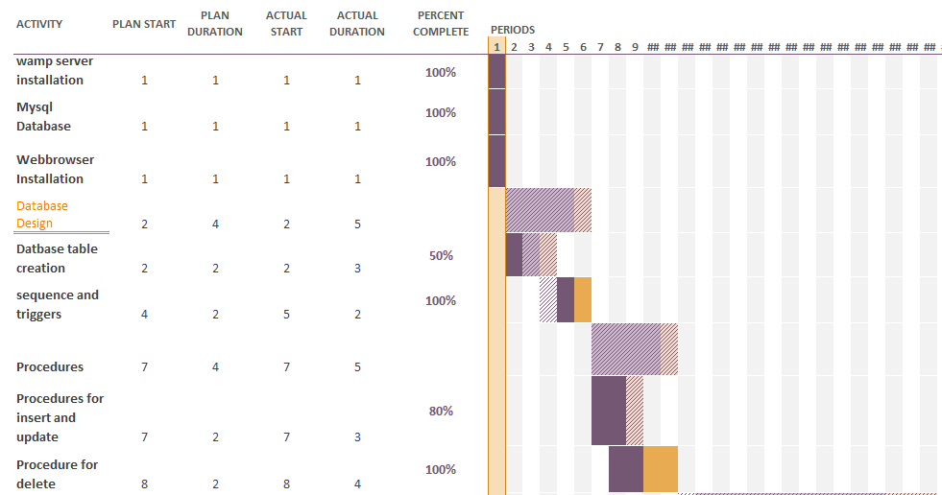
Fig 4.3 Gantt chart 1
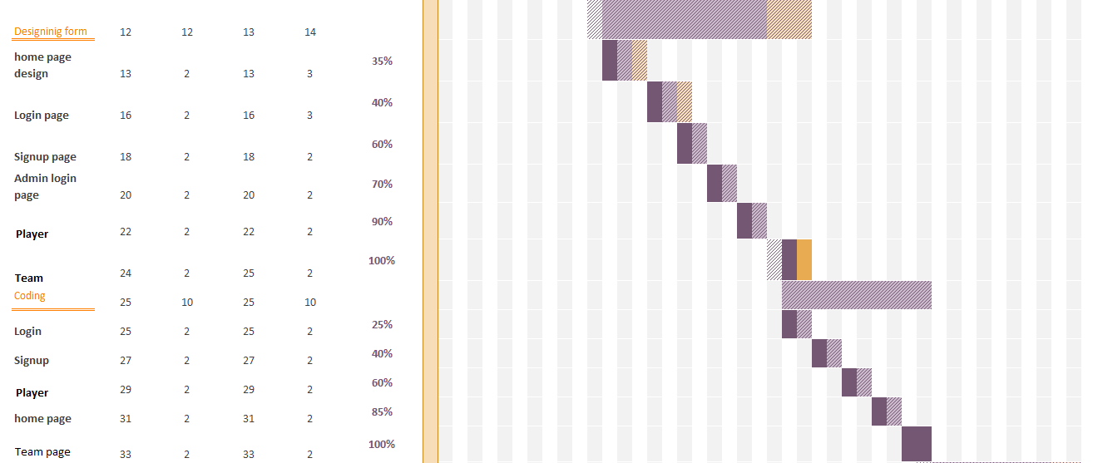
Fig: 4.4 Gantt Chart 2
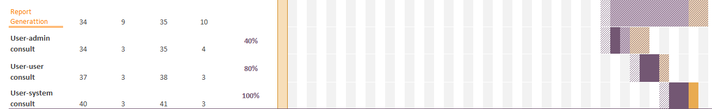

4.4 Estimation
4.4.1 Effort Estimation
Effort Estimation includes the time required i.e. the dedication for developing the project successfully. Gantt chart includes that each phases or each modules divided so that is according to the plan.
Even effort estimation includes the labor power included in it. But that is not in Client Support System as man power does not include the cost.
4.4.2 Cost Estimation
There are two types of models that have been used to estimate cost: cost models and constraint models. Cost models provide direct estimates of effort. These models typically have a primary cost factor such as size and the number of secondary adjustment factors or cost drivers. Cost drivers are characteristics of the project, process, products, or resources that influence effort. Cost drivers are used to adjust the preliminary estimate provided by the primary cost factor.
COCOMO (Constructive Cost estimation Model) is a Heuristic Technique which can be used for our project.
Software project can be classified in one of the three categories based on the project complexity.
- ORGANIC
- SEMI DETACHED
- EMBEDDED

Since we are unfamiliar with some aspects of the system like image processing etc. our project falls under the category of semidetached type.
Final step is to select complexity of software project.

Software project | a_{b} | b_{b} | c_{b} | d_{b} | Select
Organic | 2.4 | 1.05 | 2.5 | 0.38
Semi detached | 3.0 | 1.12 | 2.5 | 0.35
Embedded | 3.6 | 1.20 | 2.5 | 0.32
Effort = a1*(KLOC) ^a2 PM
Tdev = b1*(Effort) ^b2 Months
Initial COCOMO estimate without cost drivers:
Effort = 3.0*(8.500) ^1.12
= 32.96 PM approx
Tdev = 2.5*(32.96) ^0.35
= 8.49 Months approx
- This doesn’t mean that in 8.49 Months 1 person completes the project nor does it indicate the reverse.
- Cost drivers have not been taken into consideration.
- If it take an estimate of cost incurred:
Consider, per month the developer gets 10,000 Rupees as a trainee. Then the total cost will be
8.49*10,000 = 84,900 Rupees for developing the software.
- Transportation, hardware and other cost have not been included.

COCOMO model can be used to estimate the effort, development time and the cost for developing the software. Staffing is very important after these estimates. In this project, there are only three team members and the work is done by all equally in all the phases of development.
Using COCOMO Model
Effort=a*(KLOC)^{b}_{PM}
_{Tdev=2.4*(Effort)}^{c}_{Months}
- _{For Effort:-}
a=2.1
b=1.0
c=0.30
Effort=a*(KLOC)^{b}_{PM}
_{=2.1(10)}^{1.0}_{PM}
=21 PM(Approx)
- _{For Tdev:-}
_{Tdev =2.5(Effort)}^{c}_{Months}
_{=2.5(21)}^{0.30}_{Months}
_{=5.98(Approx)}

5. System Design
5.1 Data Dictionary
5.1.1 User Table
Table Name: User_Tab
Primary Key: User_ID
Description: Stores information about user

Sr No | Column Name | Data Type | Size | Constraint | Description
1 | User_ID | Int | 5 | Primary Key | Store user unique number
2 | Name | Nvarchar | 30 | Not Null | Store user name
3 | Ph_no | Int | 10 | Not Null | Store user contact no.
4 | Address | Nvarchar | 30 | Not Null | Store user address
5 | Team_ID | Int | 5 | Foreign Key | Store team_ID from Team_tab
6 | Type | Nvarchar | 20 | Not Null | Store type of user (Generator or player)

5.1.2 Team Table
Table Name: Team_Tab
Primary Key: Team_ID
Description: Stores information about Team

Sr No | Column Name | Data Type | Size | Constraint | Description
1 | Team_ID | Int | 5 | Primary Key | Store unique number for team
2 | Name | Nvarchar | 30 | Not Null | Store team name
3 | Location_ID | Int | 5 | Foreign Key | Store user location_ID from Location_Tab
4 | Address | Nvarchar | 30 | Not Null | Store exact location in area define by location_id
5 | Sport_ID | Int | 5 | Foreign Key | Store Sport_ID from Sport_tab
6 | Player_Needed | Int | 3 | Not Null | Store Players required to complete team
7 | Day_and_Time | Date | - | Not Null | Store day and time of team want to play

5.1.3 Sport Table
Table Name: Sport_Tab
Primary Key: Sport_ID
Description: Stores information about Sport to be play by users

Sr No | Column Name | Data Type | Size | Constraint | Description
1 | Sport_ID | Int | 5 | Primary Key | Store unique number for sport
2 | Name | Nvarchar | 30 | Not Null | Store name of sport
3 | Total_Player | Int | 3 | Not Null | Store total no of player needed for sport

5.1.4 Admin Table
Table Name: Admin_User
Primary Key: Admin_ID
Description: Stores information about Admin

Sr No | Column Name | Data Type | Size | Constraint | Description
1 | Name | Nvarchar | 30 | Not Null | Admin name
2 | Admin_ID | Nvarchar | 25 | Not Null | Admin id

5.1.5 Location Table
Table Name: Location_Tab
Primary Key: Location_Id
Description: Stores information about Location

Sr No | Column Name | Data Type | Size | Constraint | Description
1 | Location_ID | Int | 5 | Primary Key | Store unique no. for each team
2 | Area | Nvarchar | 30 | Not Null | Store area where sport will be organised

5.1.6 Feedback Table
Table Name: Feedback
Description: Stores the feedback given by user to System.

Sr No | Column Name | Data Type | Size | Constraint | Description
1 | User_ID | Nvarchar | 30 | Foreign Key | Store user_id who had submit feedback
2 | Message_Text | Nvarchar | 30 | - | Store message submited by User

5.2 Entity Relationship Diagram

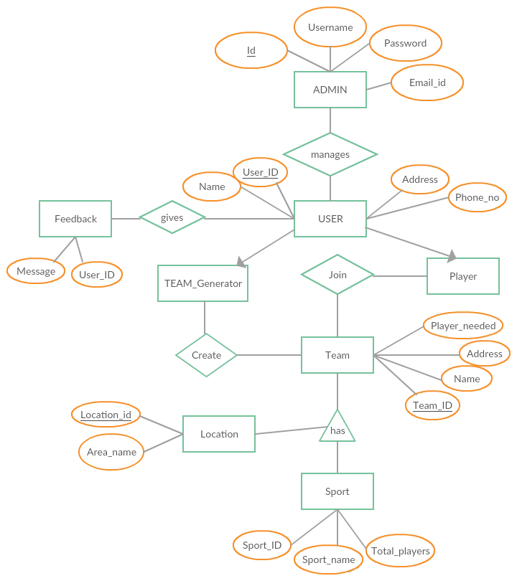
Fig: 5.2 ER Diagram for Online song website

5.3 Data Flow Diagram

5.3.1 Context Level DFD

Fig: 5.3.1 Context Diagram of online song website

5.3.2 First Level DFD of Admin

Fig: 5.3.2 First Level DFD
5.3.3 Second Level DFD of Admin

Fig: 5.3.3 Second Level DFD

5.3.4 First Level DFD of Team Generator

Fig: 5.3.4 Third Level DFD

5.3.5 First Level DFD of Player

Fig: 5.3.4 Forth Level DFD

5.4 Activity Diagram

An activity diagram is a special case of a state diagram in which all (or at least most) of the states are action states and in which all (or at least most) of the transitions are triggered by completion of the actions in the source states.
Below are the activity diagrams for the actions performed by the end-user and the response of the system.

5.4.1 Activity Diagram for Admin

Fig: 5.4.1 Activity Diagram for Admin
5.4.2 Activity Diagram for Player

Fig: 5.4.2 Activity Diagram for Player
5.4.3 Activity Diagram for Team Generator

Fig: 5.4.3 Activity Diagram for Team Generator
5.5 Sequence Diagram

A sequence diagram represents an Interaction, which is a set of messages exchanged among objects within collaboration to affect a desired operation or result. Here are the sequence diagrams for various interactions among the user, system and the data storage. It must be noted that the rectangle box on the top of the diagram indicates the object or actor and dashed lines beneath to it shows an object’s lifeline. Another rectangle following and followed by the dashed lines in a vertical manner show the activation period of the object or actor when it performs some actions. A solid arrow conveys a message while the dashed arrow gives return message. These message names are written along with their respective arrows as shown further in the diagram.

5.5.1 Sequence Diagram for Admin

Fig: 5.5.1 Sequence Diagram for Admin
5.5.1 Sequence Diagram for Player

Fig-5.5.2 Sequence Diagram for Player

5.5.1 Sequence Diagram for Team Generator

Fig-5.5.3 Sequence Diagram for Team Generator

5.6 Statechart Diagram

5.6.1 Statechart Diagram for Admin

Fig-5.6.1 Statechart Diagram for Admin

5.6.2 Statechart Diagram for Player

Fig-5.6.2 Statechart Diagram for Player

5.6.3 Statechart Diagram for Team Generator

Fig-5.6.3 Statechart Diagram for Team Generator

5.7 Snapshots of Wired Frame

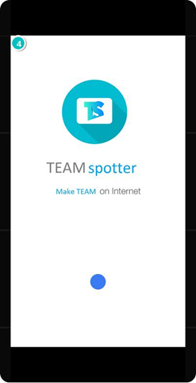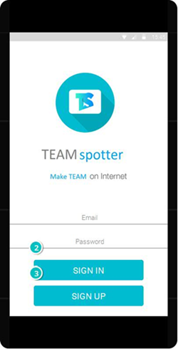

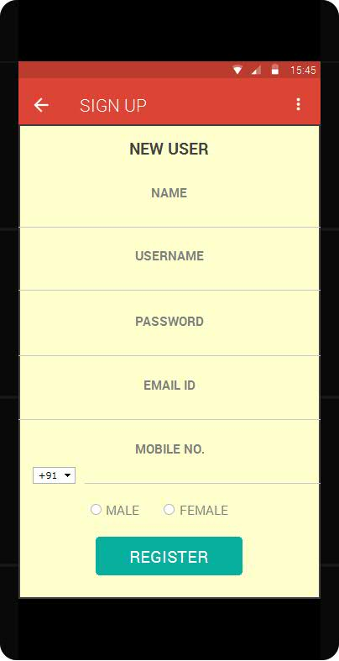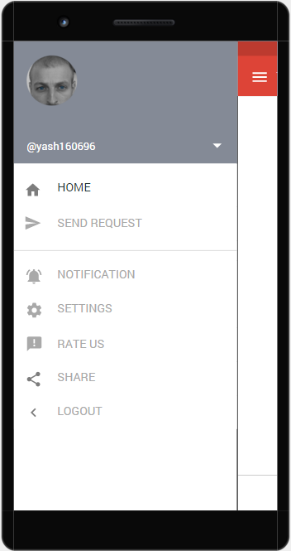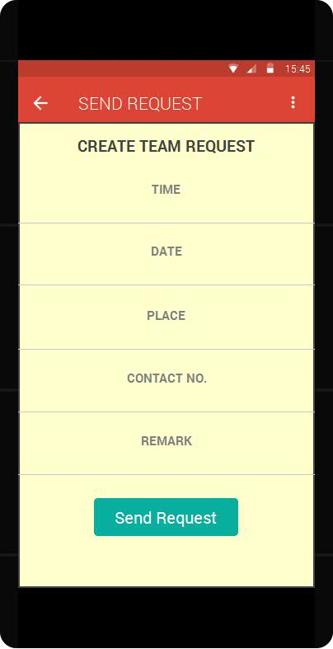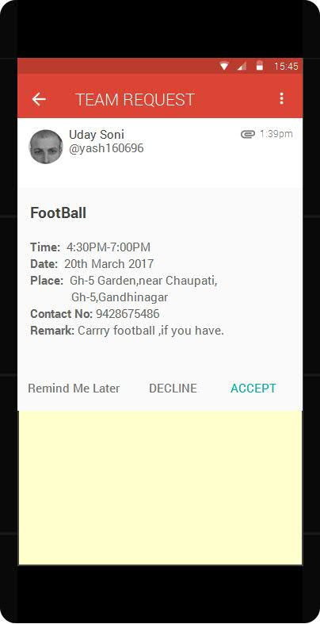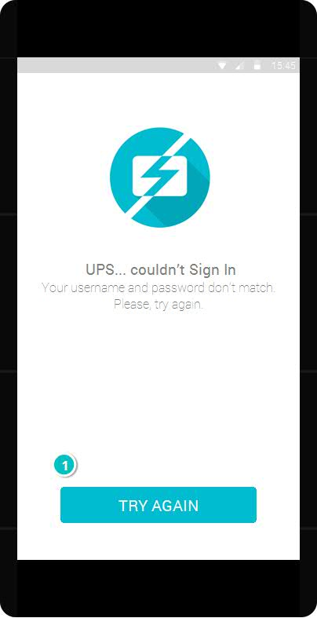

- Testing

6.1 Test Cases

6.1.1 Test Case for Registration
TEST CASE ID: TC001 |  | NAME: Registration
Purpose | When the user fill any form that data inserted into the database.
Input | Inserting new data through form
Expected Output | Add new data of user in the database
Steps: -
1.Open the registration form
2.Fill data and click submit it to add to the database.
This should be reflected in database tables.

6.1.2 Test Case for Log in
TEST CASE ID: TC002 |  | NAME: Log in
Purpose | When the user login it enters user-id and Password
Input | User-id and Password
Expected Output | Authentication of System
Steps: -
1.Enter the User-id, Password.
2.User authenticate of this system.

6.1.3 Test Case for Creating Team
TEST CASE ID: TC003 |  | NAME: Create Team
Purpose | When user wants his own team.
Input | Team name/Player name/Sports name/Location
Expected output | Created Team.
Steps: -
1.Enter the Team name/Player name/Sports name/Location name in Search bar.
2.Press Add to Team button.

6.1.4 Test Case for Request Player/Team
TEST CASE ID: TC004 |  | NAME: Request team/player
Purpose | When wants to request player/team in his system
Input | Requirement Criteria
Expected output | If match available then it will be displayed as output
Steps: -
1. Provide requirement details
2. press / click request button.

- Experience, Limitations and Future Enhancement

7.1 Experience during project development
During the project development, we learn some new technologies and also explored variety of things and also learn various aspects of software development.

7.2 Limitations
Following are the limitations of Online song website: -
- There needs to be an internet connectivity to access the application without internet connectivity the application cannot be accessed.
- User must login in order to download song or create playlist.
7.3 Future Enhancement
In future, we can add more categories of locations. We can add more sports and provide more functionality like donation of sports equipments and also provide details of sports infrastructure of the area. Another enhancement that can be done to the application is the addition of a personalised space for every user that can upload his own personal achievements and ratting, on application.

8 BIBLIOGRAPHY

8.1 Conclusion

So basically we are going to help society with our development in different aspects. This application will help various people to engage on the ground again. This will surely going to help them physically as well as mentally as sports plays the key role in increasing people’s health in both ways i.e., physically and mentally. By this application users may get chance to interact with the experts of various games that will lead to the personal growth of the user and which will lead to the growth of the institution or organization to which user belongs. So we are looking forward to help various members of the society with our development.

8.2 Bibliography

Web Resources
- www.justinmind.com
- www.creately.com
- www.android.com
‎
Books
- Object Oriented Modelling and Design with UML (second edition)
by Michael Blaha and James Rambaugh
- Software Engineering by Roger S. Pressman
- Software Engineering by K.K. Agrawal

