Assignment-2

Name: Sai Yashwanth Reddy Kontham

Student Id: 700744498

- A) def fullname(first_name, last_name): return f"{first_name} {last_name}"

# Taking user input

first_name = input("Enter your first name: ")

last_name = input("Enter your last name: ")

# Calling the fullname function

full_name = fullname(first_name, last_name)

- Displaying the result print("Full Name:", full_name)
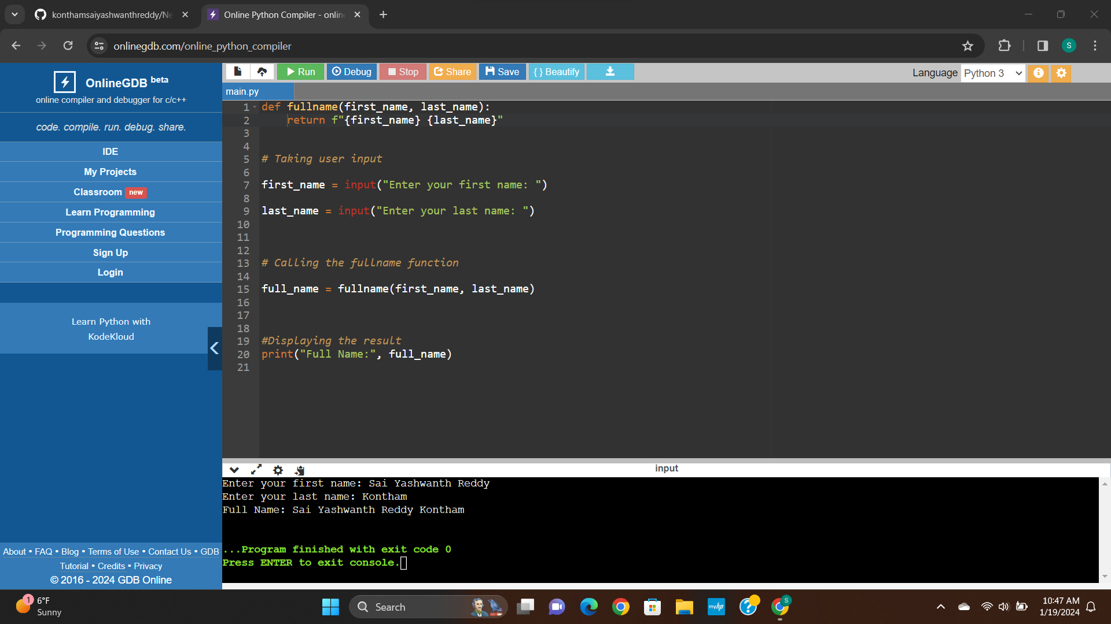

1.b)

def string_alternative(full_name):

return full_name[::2]

- Example usage with the provided string "Good evening" example_str = "Good Evening"

result = string_alternative(example_str)

- Displaying the result

print("Original String:", example_str)

print("Every Other Character:",result)

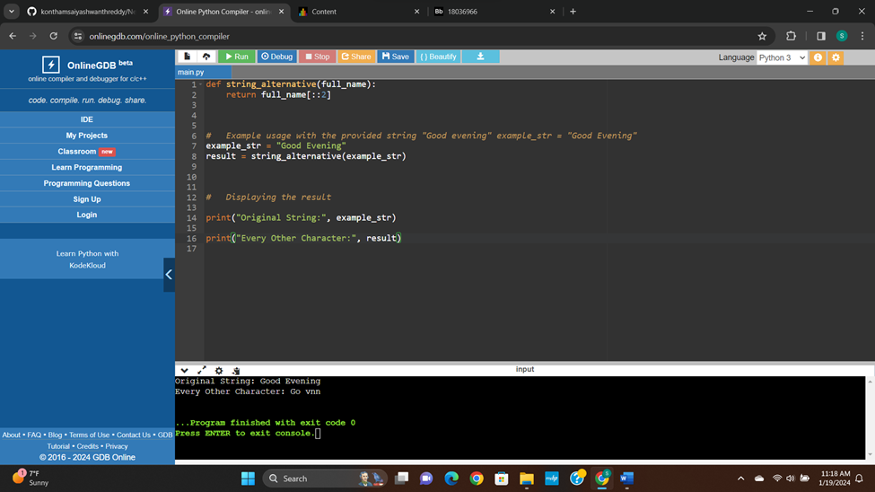

- Write a python program to find the wordcount in a file (input.txt) for each line and then print the output.

def wordCount():

file1=open("input.txt","r")

file2=open("output.txt","w")

count={}

for line in file1:

w=line.strip().split(" ")

for i in w:

if(i in count):

count[i]=count[i]+1

else:

count[i]=1

for i in count:

file2.write(i+ ": "+str (count[i]));

file2.write("\n")
print(count)

wordCount()
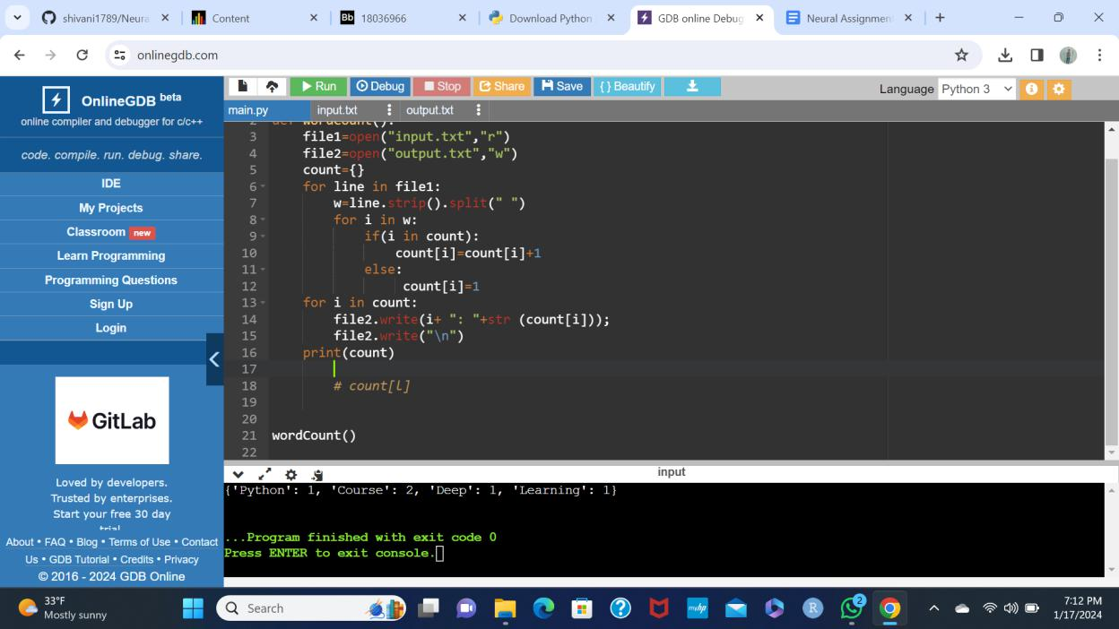
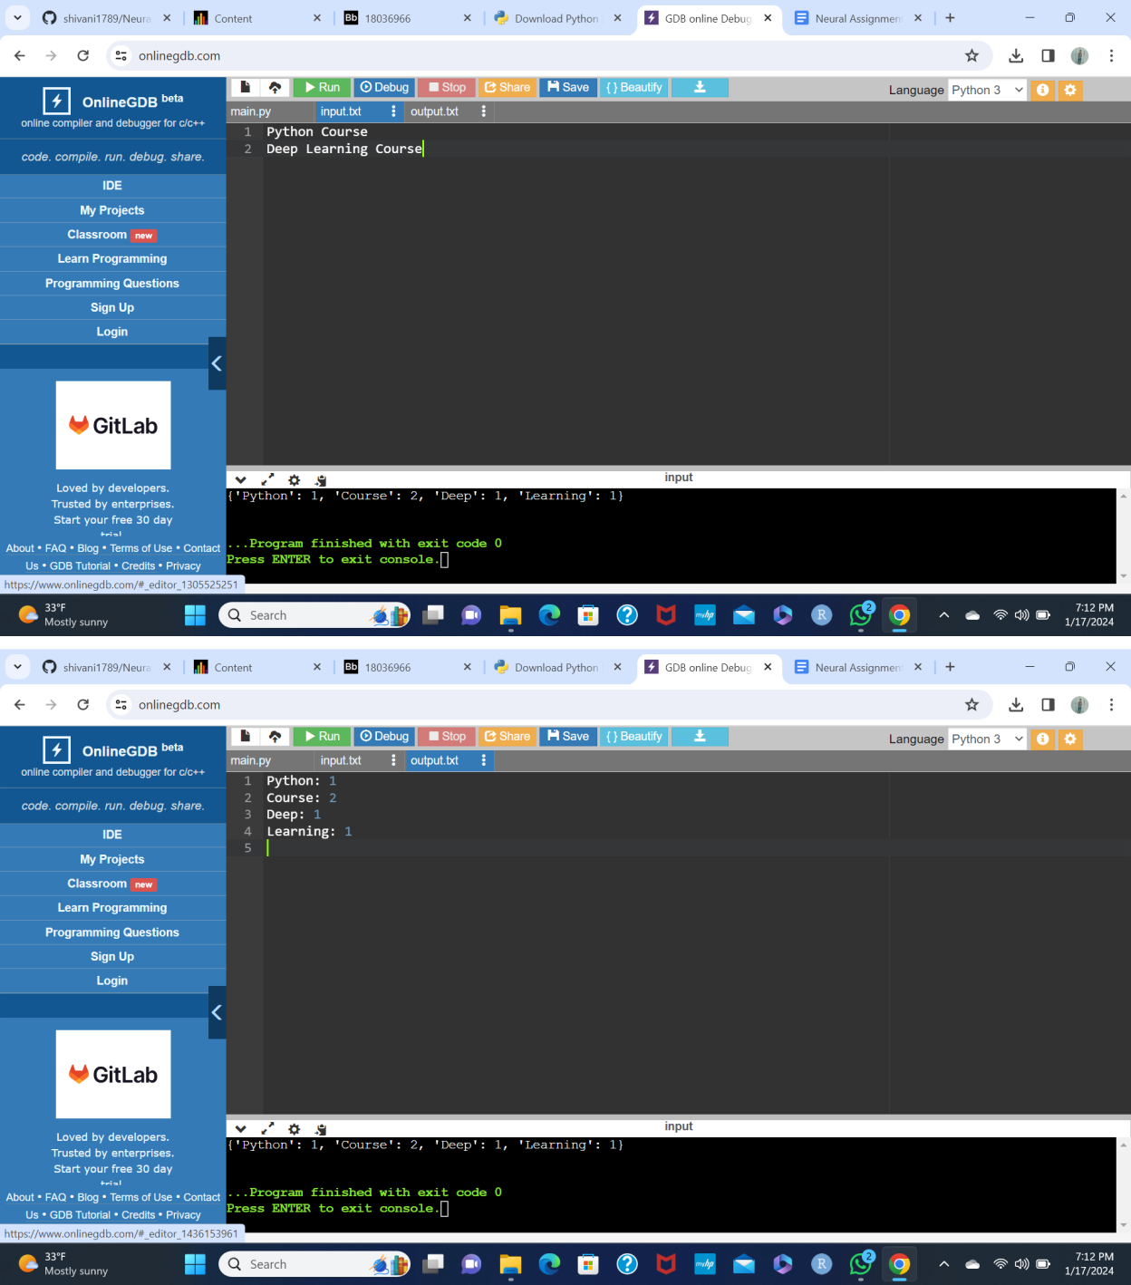
3.

- Function to convert inches to centimeters def inches_to_centimeters(height_in_inches):

return height_in_inches * 2.54

- Using Nested Interactive Loop

def convert_heights_nested_loop():

num_customers = int(input("Enter the number of customers: "))

heights_inches = []

# Input heights in inches

for i in range(num_customers):

height = float(input(f"Enter height (in inches) for customer {i + 1}: "))

heights_inches.append(height)

- Convert heights to centimeters using nested loop heights_centimeters = []

for height_in_inches in heights_inches:

height_in_cm = inches_to_centimeters(height_in_inches) heights_centimeters.append(height_in_cm)

return heights_centimeters

# Using List Comprehensions

def convert_heights_list_comprehension():

num_customers = int(input("Enter the number of customers: "))

# Input heights in inches using list comprehension

heights_inches = [float(input(f"Enter height (in inches) for customer {i + 1}: ")) for i in range(num_customers)]

# Convert heights to centimeters using list comprehension

heights_centimeters = [inches_to_centimeters(height_in_inches) for height_in_inches in heights_inches]

return heights_centimeters

- Example using Nested Interactive Loop print("Using Nested Interactive Loop:") heights_nested_loop = convert_heights_nested_loop() print("Heights in Centimeters:", heights_nested_loop)

- Example using List Comprehensions

print("\nUsing List Comprehensions:")

heights_list_comprehension = convert_heights_list_comprehension()

print("Heights in Centimeters:", heights_list_
comprehension)
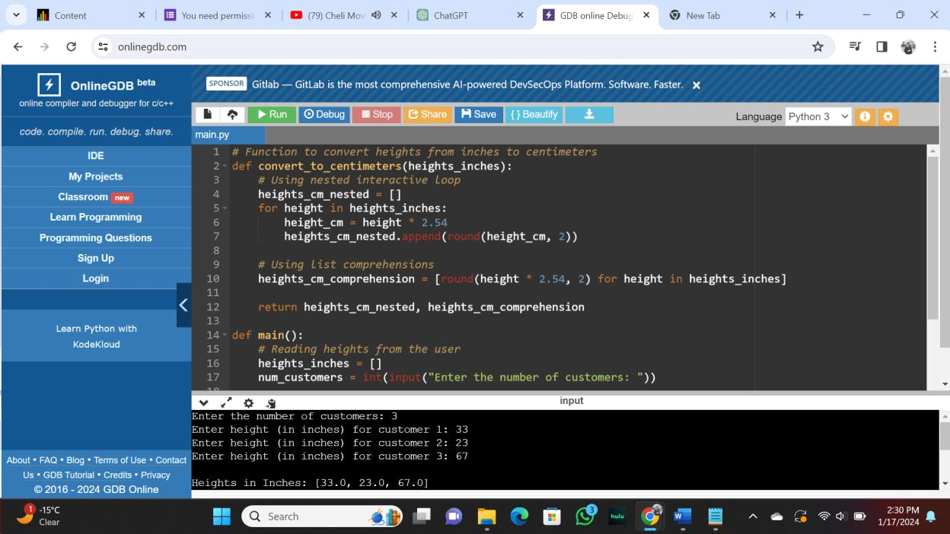

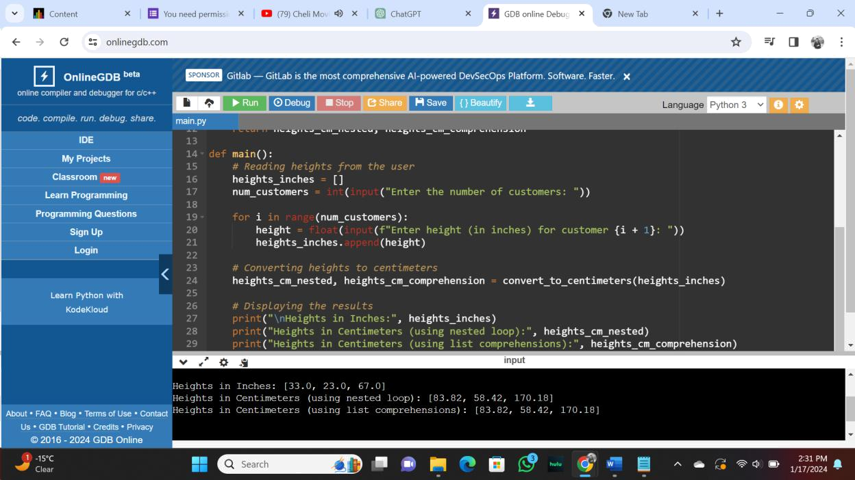

Git Link:

https://github.com/konthamsaiyashwanthreddy/Neural_AT2

Video Link:

https://github.com/konthamsaiyashwanthreddy/Neural_AT2/blob/master/assgn2%20video.mp4

