**Assignment-3**

**Name: Sai Yashwanth Reddy Kontham**

**Student Id: 700744498**

**Q1:** Create a class Employee and then do the following

• Create a data member to count the number of Employees

• Create a constructor to initialize name, family, salary, department

• Create a function to average salary

• Create a Fulltime Employee class and it should inherit the properties of Employee class

• Create the instances of Fulltime Employee class and Employee class and call their member functions.

**Code:**

class Employee:

numOfEmployee=0

def __init__(self,name,family,salary,department):

self.name=name;

self.family=family;

self.salary=salary

self.department=department

Employee.numOfEmployee+=1

def avgSal(self):

return self.salary/self.numOfEmployee;

class FullTime(Employee):

def __init__(self,name,family,salary,department):

super().__init__(name,family,salary,department)

f=Employee("yashwanth","male",200,"cse")

e= FullTime("tarun","male",300,"cse");

print(e.avgSal())

print(f.avgSal())

**Output:**

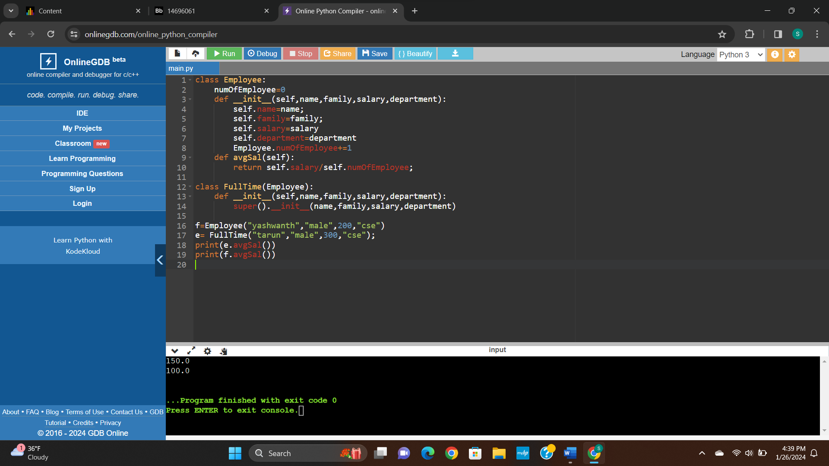

**Q2:** Numpy

Using NumPy create random vector of size 20 having only float in the range 1-20.

Then reshape the array to 4 by 5

Then replace the max in each row by 0 (axis=1)

(you can NOT implement it via for loop)

**Code:**

import numpy as np

random_vector = np.random.uniform(1, 20, 20)

# print(random_vector)

reshaped_array = random_vector.reshape(4, 5)

reshaped_array[np.arange(reshaped_array.shape[0]), reshaped_array.argmax(axis=1)] = 0

print(reshaped_array)

**Output:**

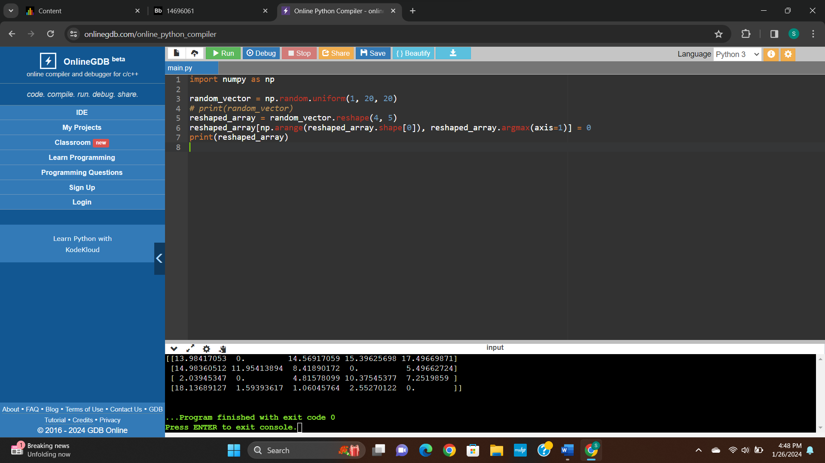

**Git Link:**