**Assignment-4**

**Name:Sai Yashwanth Reddy Kontham**

**Student ID: 700744498**

Q.1

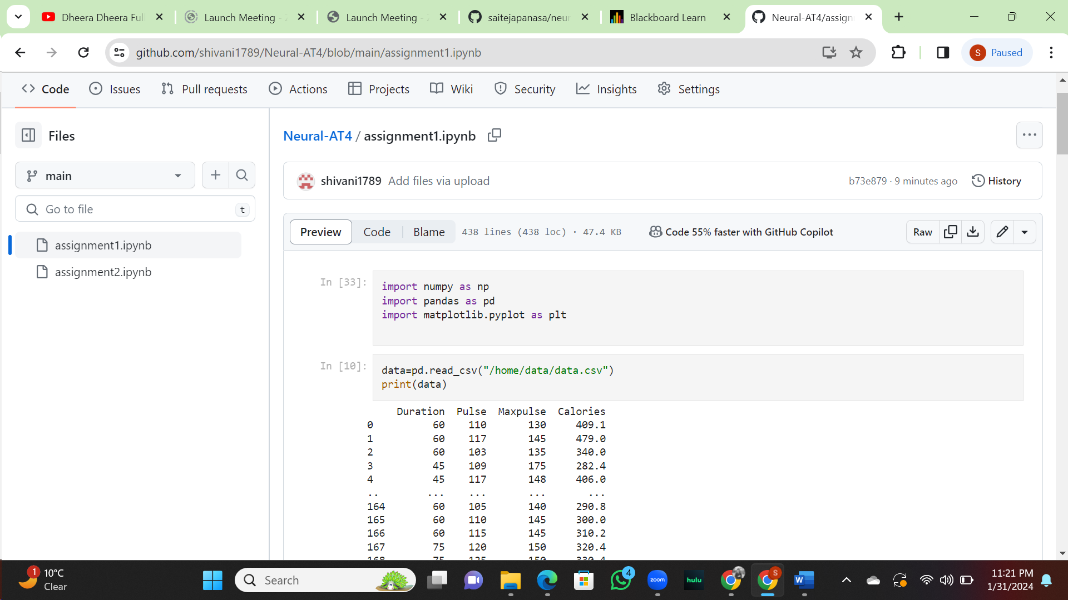

Q.2

Git Hub link:

<https://github.com/konthamsaiyashwanthreddy/Neural_AT4>