PERSONAL DATA

|  |  |
| --- | --- |
| **Name:** | Andrei Smirnov |
| **Date of Birth:** | 19/08/1985 |
| **Location:** | Russia, Samara region, Togliatti |
| **Mobile:** | +79179708254 |
| **E-mail:** | konung00@gmail.com |
| **Skype:** | andreysmirnov10 |
| **LinkedIn:** | [**www.linkedin.com/in/andrei-smirnov-ru**](https://www.linkedin.com/in/andrei-smirnov-ru/) |

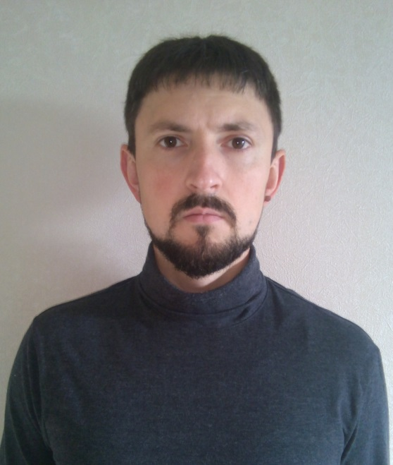

OBJECTIVE

|  |  |
| --- | --- |
| **Desired Position:** | Business Analyst / System Analyst |

SUMMARY OF QUALIFICATION

|  |
| --- |
| I have worked as business analyst since **August of 2013**.  I have a wide expertise in telecom business in scope of OSS stack namely resource inventory as well as service provisioning. I applied my technical background being involved in various solution delivery projects as an analyst or SME. Moreover I have got experience in data migration and working with databases.  I prefer to work along the agilemethodologies however I have experience in the waterfall. |

TECHNICAL SKILLS

* Telecom: transport network (SDH/SONET), Carrier Ethernet services (EPL, EVPL), various vendors (Cisco, Accedian).
* Business analysis: UML, BPMN, data modeling (Sparx systems Enterprise Architect)
* Data migration: database management system (Oracle, MySQL), SQL scripting (essential level)
* Documentation and task management: Atlassian Jira, Atlassian Confluence, MS office, Sparx systems Enterprise Architect
* IDE: Visual Studio Code, IntelliJ IDEA, PL/SQL developer

RELEVANT EXPERIENCE

* Communication with the customer
* Clarification of business requirements
* Projects and features development
* Code review and reverse engineering
* Tasks review and estimations

LANGUAGES

* English – Intermediate (B1)
* Russian – Native Speaker

EDUCATION

* 2007 – 2011 /Volzhsky University named after V.N. Tatischev, Faculty of informatics and telecommunication / Computing machines, complexes and networks (Engineer) / Togliatti, Russia
* 2000 – 2004 / Social – economic college, Faculty of engineering / Software of computing systems (developer) / Togliatti, Russia

SEVERAL FACTS ABOUT ME

|  |
| --- |
| I am interested in history (re-enacting), the natural sciences and sci-fi literature. In addition I study java and python in free time.  I am free of the bad habits.  I can find the optimal way from difficult situation by myself in short time period.  I have an experience in teaching other people by telecom skills.  I have an experience in public speaking (up to 20 audiences). |

PROFESSIOANL EXPERIENCE

|  |  |
| --- | --- |
| **“Altice migration project”** | |
| **Company:** | Netcracker technology |
| **Customer:** | Altice USA, Inc. |
| **Project Location:** | USA, NY, Bethpage |
| **Duration:** | 03/2019 – 07/2019 |
| **Description:** | We fulfilled data migration from several data sources to consolidate those in a one system. In additional we provided consulting to groom current business processes. |
| **Position:** | Business analyst, data migration lead |
| **Overall Team Size:** | 2 project managers, 1 technical manager, 1 data migration lead, 3 business analysts, 2 software engineers, 4 QA engineers |
| **Responsibilities:** | * Consulting in current business process adjustment * Preparing a data migration strategy and a migration plan * Data source analysis and environment estimation * Preparing a data model and design specifications * Establishing workshops with the customer |

|  |  |
| --- | --- |
| **“SoftBank migration project”** | |
| **Company:** | Netcracker technology |
| **Customer:** | SoftBank Group Corp. |
| **Project Location:** | Japan, Tokyo |
| **Duration:** | 10/2018 – 03/2019 |
| **Description:** | As a subcontractor of NEC we supported customer passing to a new solution. Part of this support was data migration fulfillment. |
| **Position:** | Business analyst |
| **Stream Team Size:** | 1 business analyst, 2 software engineers, 1 QA engineer |
| **Responsibilities:** | * Consulting NEC in common data migration approach * Preparing data migration strategy and migration plan * Preparing data models and design specifications * Establishing workshops with the NEC |

|  |  |
| --- | --- |
| **“COX retirement project”** | |
| **Company:** | Netcracker technology |
| **Customer:** | Cox Communications |
| **Project Location:** | USA, GA, Atlanta |
| **Duration:** | 01/2018 – 07/2018 |
| **Description:** | Since a third party was in charge of overall data migration process we provided consulting to main contractor. We closely worked with Accenture team as Netcracker system SMEs. |
| **Position:** | Business analyst, SME |
| **Overall Team Size:** | 1 project manager, 2 business analyst / SME, 2 software engineers, 2 QA engineer |
| **Responsibilities:** | * Consulting Accenture in common data migration approach * Attending in preparation of data migration strategy and migration plan * Attending in preparation of data model and design specifications * Attending in sessions with business users |

|  |  |
| --- | --- |
| **“Claro DOM project”** | |
| **Company:** | Netcracker technology |
| **Customer:** | Claro República Dominicana |
| **Project Location:** | Dominican Republic, Santo Domingo |
| **Duration:** | 09/2017 – 12/2017 |
| **Description:** | A huge project with complicated delivered solution. I was passed to enhance Claro development team as SME. |
| **Position:** | Business analyst, SME |
| **Stream Team Size:** | 1 scrum master, 1 business analyst / SME, 1 lead software engineer, 5 software engineers. |
| **Responsibilities:** | * Consulting the Claro team members in Netcracker system * Attending in a backlog preparation * Attending in sprints planning, task estimation * Attending in sessions with business users |

|  |  |
| --- | --- |
| **“Level 3 migration project”** | |
| **Company:** | Netcracker technology |
| **Customer:** | Level 3 Communications |
| **Project Location:** | USA, FL, Orlando |
| **Duration:** | 02/2017 – 09/2017 |
| **Description:** | For the aim to passing from a Netcracker system to a new solution (Amdocs) we fulfilled migration and transformation customer data and handed over those to further load to the new system. |
| **Position:** | Business analyst |
| **Overall Team Size:** | 2 project manager, 1 technical manager, 2 business analyst, 1 lead business analyst, 5 software engineers, 3 QA engineers |
| **Responsibilities:** | * Data source analysis * Attending in preparation of data migration strategy and migration plan * Attending in preparation of data model and design specifications * Attending in sessions with business users |

|  |  |
| --- | --- |
| **“Colt Ph1 project”** | |
| **Company:** | Netcracker technology |
| **Customer:** | Colt Technology Services Group Limited |
| **Project Location:** | Russia, Togliatti |
| **Duration:** | 09/2016 – 12/2016 |
| **Description:** | A big “green field” project. At service activation stream I attended as an activation business analyst and Accedian vendor SME. I had to describe service activation scenarios and provide consulting to BA team at parallel streams. |
| **Position:** | Business analyst, SME |
| **Stream Team Size:** | 1 lead business analyst, 2 business analysts, 1 lead software engineer, 2 software engineers, 2 QA engineers. |
| **Responsibilities:** | * Business requirements gathering in the service activation view * Preparing design specifications * Consulting development and QA team |

|  |  |
| --- | --- |
| **“Optus project”** | |
| **Company:** | Netcracker technology |
| **Customer:** | Singtel Optus Pty Limited |
| **Project Location:** | Russia, Togliatti |
| **Duration:** | 05/2016 – 09/2016 |
| **Description:** | An enormous-sized project with a lot of various streams. I attended as a business analyst in a circuit design tool team what was a part of service provisioning stream. |
| **Position:** | Business analyst |
| **Stream Team Size:** | 1 lead business analyst, 3 business analysts, 1 lead software engineer, 2 software engineers, 2 QA engineers. |
| **Responsibilities:** | * Preparing design specifications * Consulting development and QA team |

|  |  |
| --- | --- |
| **“Industry Solution project”** | |
| **Company:** | Netcracker technology |
| **Customer:** | Netcracker technology |
| **Project Location:** | Russia, Togliatti |
| **Duration:** | 10/2015 – 05/2016 |
| **Description:** | Netcracker’s internal project with aims to adjust part of the product solution and decrease time to delivery. I was involved in the project as a business analyst who had to describe B2B service provisioning use cases. |
| **Position:** | Business analyst |
| **Stream Team Size:** | 1 lead business analyst, 2 business analysts, 1 lead software engineer, 2 software engineers, 3 QA engineers. |
| **Responsibilities:** | * Preparing design specifications * Consulting development and QA team |

|  |  |
| --- | --- |
| **“Singtel NISA project”** | |
| **Company:** | Netcracker technology |
| **Customer:** | Singapore Telecommunications Limited |
| **Project Location:** | Russia, Togliatti |
| **Duration:** | 11/2014 – 10/2015 |
| **Description:** | One of the biggest projects in Netcracker technology. I described process of integration with a replicated database (RDB component) and implemented it |
| **Position:** | Business analyst, software engineer |
| **Stream Team Size:** | 1 business analyst, 1 software engineer, 1 QA engineers. |
| **Responsibilities:** | * Preparing design specifications * Implementation based on design * Consulting QA team |

|  |  |
| --- | --- |
| **“WOW RI project”** | |
| **Company:** | Netcracker technology |
| **Customer:** | Wide Open West |
| **Project Location:** | Russia, Togliatti |
| **Duration:** | 12/2013 – 09/2014 |
| **Description:** | A small resource inventory project which could be considered as “green field”. |
| **Position:** | Business analyst |
| **Overall Team Size:** | 1 project manager, 1 technical manager, 1 lead business analyst, 2 business analysts, 5 software engineers, 4 QA engineers. |
| **Responsibilities:** | * Attending in requirements gathering * Preparing design specifications and a traceability matrix * Consulting development and QA team |

|  |  |
| --- | --- |
| **“KDDI drive project”** | |
| **Company:** | Netcracker technology |
| **Customer:** | KDDI Corporation |
| **Project Location:** | Russia, Togliatti |
| **Duration:** | 08/2013 – 12/2013 |
| **Description:** | It was my fist project in Netcracker. I worked at localization stream as a software engineer. I had to communicate with main contractor (NEC) to figure out localization gap. |
| **Position:** | Software engineer |
| **Stream Team Size:** | 1 lead software engineer, 1 software engineer |
| **Responsibilities:** | * Attending in customer communications * Issue investigating and troubleshooting in localization |