(IR) INFRARED TECHNOLOGY

Introduction:

Technically known as "infrared radiation", infrared light is part of the electromagnetic spectrum located just below the red portion of normal visible light – the opposite end to ultraviolet. Although invisible, infrared follows the same principles as regular light and can be reflected or pass through transparent objects, such as glass. Infrared remote controls use this invisible light as a form of communications between themselves and home theater equipment, all of which have infrared receivers positioned on the front. Essentially, each time you press a button on a remote, a small infrared diode at the front of the remote beams out pulses of light at high speed to all of your equipment. When the equipment recognizes the signal as its own, it responds to the command.
But much like a flashlight, infrared light can be focused or diffused, weak or strong. The type and number of emitters can affect the possible angles and range your remote control can be used from. Better remotes can be used up to thirty feet away and from almost any angle, while poorer remotes must be aimed carefully at the device being controlled.
The light our eyes see is but a small part of a broad spectrum of electromagnetic radiation. On the immediate high energy side of the visible spectrum lies the ultraviolet, and on the low energy side is the infrared. The portion of the infrared region most useful for analysis of organic compounds is not immediately adjacent to the visible spectrum, but is that having a wavelength range from 2,500 to 16,000 nm, with a corresponding frequency range from 1.9*10¹³ to 1.2*10¹⁴ Hz.( From http://hyperphysics.phy-astr.gsu.edu/hbase/ems3.html : the frequency of infrared ranges from 0.003 - 4 x 10¹⁴ Hz or about 300 gigahertz to 400 terahertz.).
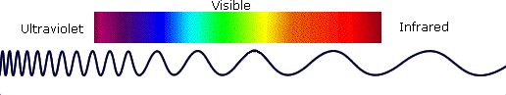
Infrared imaging is used extensively for both military and civilian purposes. Military applications include target acquisition, surveillance, night vision, homing and tracking. Non-military uses include thermal efficiency analysis, remote temperature sensing, short-ranged wireless communication, spectroscopy, and weather forecasting. Infrared astronomy uses sensor-equipped telescopes to penetrate dusty regions of space, such as molecular clouds; detect cool objects such as planets, and to view highly red-shifted objects from the early days of the universe
IR LED QED234:

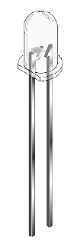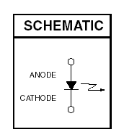

FEATURES:
• Wave length is 940 nm
• Chip material =GaAs with AlGaAs window
• Package type: T-1 3/4 (5mm lens diameter)
• Matched Photo sensor: QSD122/123/124
• Medium Emission Angle, 40°
• High Output Power
• Package material and color: Clear, untainted, plastic
• Ideal for remote control applications

Emitter/Detector Alignment:
Good alignment of the emitter and detector is important for good operation, especially if the gap is large. This can be done with a piece of string stretched between and in line with LED and phototransistor. A length of dowel or stiff wire could be used to set the alignment. Another method that can be used for longer distances is a laser pointer shone through one of the mounting holes.
For best results the height of the "beam" should be at coupler height and at an angle across the tracks. The emitter could also be mounted above the track with the phototransistor placed between the rails in locations such as hidden yards. Placing the emitter and detector at an angle would again be helpful.

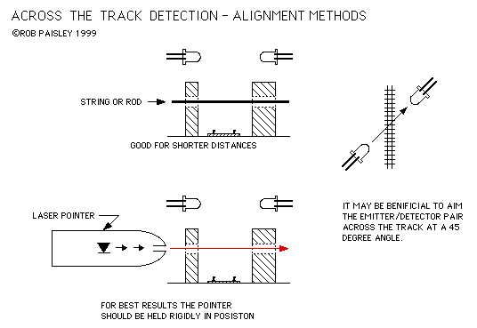

Emitter/Detector Alignment Methods

A sample infrared remote controle setup:

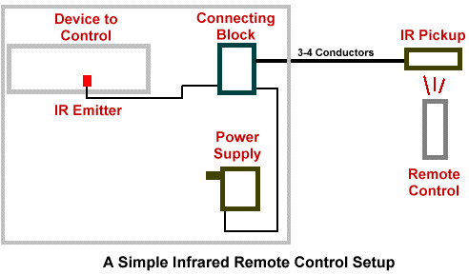

Infrared Receiver (Pickup)
This device picks up the infrared signal from your remote control just like a TV or VCR. It encodes the infrared signal into a signal suitable for transmission. Receivers must be located in the room you wish to use the remote control. The wire from the receiver to the connecting block needs at least three available conductors and can be several hundred feet long. Both quad wire and category 5wire work fine. See our IR receivers here.

Connecting Block
This is simply a place for all the parts to plug in or connect to. Connecting blocks are usually classified based on the number of outputs (how many IR emitters can connect to the block) Amplified connecting blocks can generally support more outputs. All connecting blocks can support many IR receivers wired in parallel. Connecting blocks are usually located near the equipment that is to be controlled, along with the power supply and emitters. See our connecting blocks here.

Infrared Emitters
IR Emitters generally "stick" onto the front of the device you want to control. Therefore you need one emitter for each device. "Dual" emitters have two emitters and one plug, so they only take up one jack of the connecting block. "Blink" emitters blink visibly as well as infrared, so they are easier to troubleshoot. All emitters come with long cords and extra double-stick tape. "Blast" style emitters, where one emitter blinks into several devices, are usually less reliable but can be used when the environment is tightly controlled and

Applications:

Infrared Filters

Night vision

Thermography

Other imaging

Tracking

Heating

Communications

Spectroscopy

Meteorology

Climatology

Astronomy

Art history

Biological systems

Photobiomodulation

Health hazard

