LCD (Liquid Cristal Display)

Introduction:

A liquid crystal display (LCD) is a thin, flat display device made up of any number of color or monochrome pixels arrayed in front of a light source or reflector. Each pixel consists of a column of liquid crystal molecules suspended between two transparent electrodes, and two polarizing filters, the axes of polarity of which are perpendicular to each other. Without the liquid crystals between them, light passing through one would be blocked by the other. The liquid crystal twists the polarization of light entering one filter to allow it to pass through the other.

A program must interact with the outside world using input and output devices that communicate directly with a human being. One of the most common devices attached to an controller is an LCD display. Some of the most common LCDs connected to the contollers are 16X1, 16x2 and 20x2 displays. This means 16 characters per line by 1 line 16 characters per line by 2 lines and 20 characters per line by 2 lines, respectively.
Shapes and S
available. Line lengths of 8, 16, 20, 24, 32 and 40 characters are all standard, in one, two

Many microcontroller devices use 'smart LCD' displays to output visual information. LCD displays designed around LCD NT-C1611 module, are inexpensive, easy to use, and it is even possible to produce a readout using the 5X7 dots plus cursor of the display. They have a standard ASCII set of characters and mathematical symbols. For an 8-bit data bus, the display requires a +5V supply plus 10 I/O lines (RS RW D7 D6 D5 D4 D3 D2 D1 D0). For a 4-bit data bus it only requires the supply lines plus 6 extra lines(RS RW D7 D6 D5 D4). When the LCD display is not enabled, data lines are tri-state and they do not interfere with the operation of the microcontroller.

Features:

(1) Interface with either 4-bit or 8-bit microprocessor.
 (2) Display data RAM
(3) 80x 8 bits (80 characters).
 (4) Character generator ROM
(5). 160 different 5  7 dot-matrix character patterns.
(6).  Character generator RAM
(7)  8 different user programmed 5  7 dot-matrix patterns.
(8).Display data RAM and character generator RAM may be
Accessed by the microprocessor.
 (9) Numerous instructions
 (10) .Clear Display, Cursor Home, Display ON/OFF, Cursor ON/OFF,
Blink Character, Cursor Shift, Display Shift.
 (11). Built-in reset circuit is triggered at power ON.
 (12). Built-in oscillator.

Data can be placed at any location on the LCD. For 16×1 LCD, the address locations are:

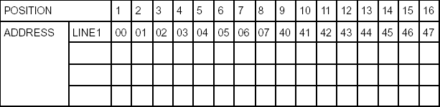

Fig : Address locations for a 1x16 line LCD

Shapes and sizes:
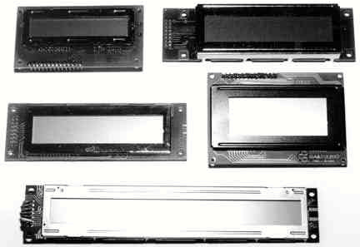

Even limited to character based modules,there is still a wide variety of shapes and sizes available. Line lenghs of 8,16,20,24,32 and 40 charecters are all standard, in one, two and four line versions.

Several different LC technologies exists. “supertwist” types, for example, offer Improved contrast and viewing angle over the older “twisted nematic” types. Some modules are available with back lighting, so so that they can be viewed in dimly-lit conditions. The back lighting may be either “electro-luminescent”, requiring a high voltage inverter circuit, or simple LED illumination.

Electrical blockdiagram:

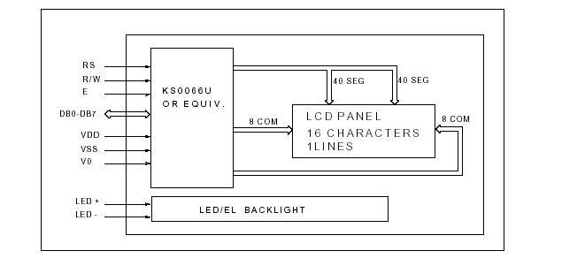

Power supply for lcd driving:
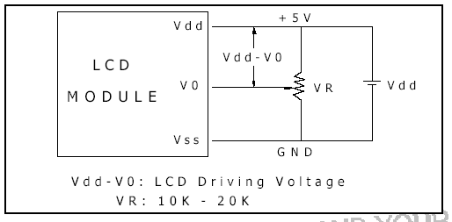

PIN DESCRIPTION:

Most LCDs with 1 controller has 14 Pins and LCDs with 2 controller has 16 Pins (two pins are extra in both for back-light LED connections).

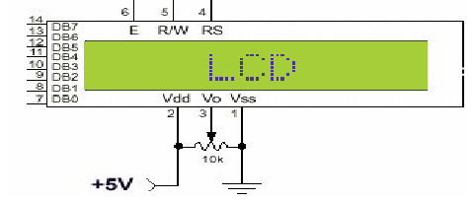
Fig: pin diagram of 1x16 lines lcd

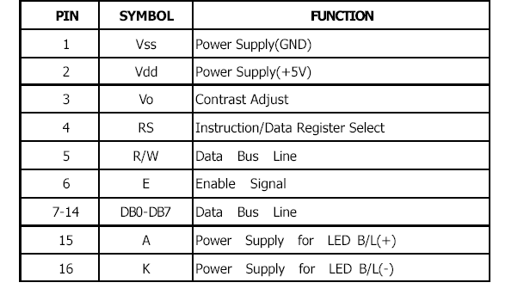

CONTROL LINES:
EN:
Line is called "Enable." This control line is used to tell the LCD that you are sending it data. To send data to the LCD, your program should make sure this line is low (0) and then set the other two control lines and/or put data on the data bus. When the other lines are completely ready, bring EN high (1) and wait for the minimum amount of time required by the LCD datasheet (this varies from LCD to LCD), and end by bringing it low (0) again.
RS:
Line is the "Register Select" line. When RS is low (0), the data is to be treated as a command or special instruction (such as clear screen, position cursor, etc.). When RS is high (1), the data being sent is text data which sould be displayed on the screen. For example, to display the letter "T" on the screen you would set RS high.
RW:
Line is the "Read/Write" control line. When RW is low (0), the information on the data bus is being written to the LCD. When RW is high (1), the program is effectively querying (or reading) the LCD. Only one instruction ("Get LCD status") is a read command. All others are write commands, so RW will almost always be low.
Finally, the data bus consists of 4 or 8 lines (depending on the mode of operation selected by the user). In the case of an 8-bit data bus, the lines are referred to as DB0, DB1, DB2, DB3, DB4, DB5, DB6, and DB7.
Logic status on control lines:
• E - 0 Access to LCD disabled
- 1 Access to LCD enabled
• R/W - 0 Writing data to LCD
- 1 Reading data from LCD
• RS - 0 Instructions
- 1 Character

Writing data to the LCD:
1) Set R/W bit to low
2) Set RS bit to logic 0 or 1 (instruction or character)
3) Set data to data lines (if it is writing)
4) Set E line to high
5) Set E line to low

Read data from data lines (if it is reading)on LCD:

1) Set R/W bit to high
2) Set RS bit to logic 0 or 1 (instruction or character)
3) Set data to data lines (if it is writing)
4) Set E line to high
5) Set E line to low

Entering Text:

First, a little tip: it is manually a lot easier to enter characters and commands in hexadecimal rather than binary (although, of course, you will need to translate commands from binary couple of sub-miniature hexadecimal rotary switches is a simple matter, although a little bit into hex so that you know which bits you are setting). Replacing the d.i.l. switch pack with a of re-wiring is necessary.
The switches must be the type where On = 0, so that when they are turned to the zero position, all four outputs are shorted to the common pin, and in position “F”, all four outputs are open circuit.
All the available characters that are built into the module are shown in Table 3. Studying the table, you will see that codes associated with the characters are quoted in binary and hexadecimal, most significant bits (“left-hand” four bits) across the top, and least significant bits (“right-hand” four bits) down the left.
Most of the characters conform to the ASCII standard, although the Japanese and Greek characters (and a few other things) are obvious exceptions. Since these intelligent modules were designed in the “Land of the Rising Sun,” it seems only fair that their Katakana phonetic symbols should also be incorporated. The more extensive Kanji character set, which the Japanese share with the Chinese, consisting of several thousand different characters, is not included!
Using the switches, of whatever type, and referring to Table 3, enter a few characters onto the display, both letters and numbers. The RS switch (S10) must be “up” (logic 1) when sending the characters, and switch E (S9) must be pressed for each of them. Thus the operational order is: set RS high, enter character, trigger E, leave RS high, enter another character, trigger E, and so on.
The first 16 codes in Table 3, 00000000 to 00001111, ($00 to $0F) refer to the CGRAM. This is the Character Generator RAM (random access memory), which can be used to hold user-defined graphics characters. This is where these modules really start to show their potential, offering such capabilities as bar graphs, flashing symbols, even animated characters. Before the user-defined characters are set up, these codes will just bring up strange looking symbols.

Codes 00010000 to 00011111 ($10 to $1F) are not used and just display blank characters. ASCII codes “proper” start at 00100000 ($20) and end with 01111111 ($7F). Codes 10000000 to 10011111 ($80 to $9F) are not used, and 10100000 to 11011111 ($A0 to $DF) are the Japanese characters.

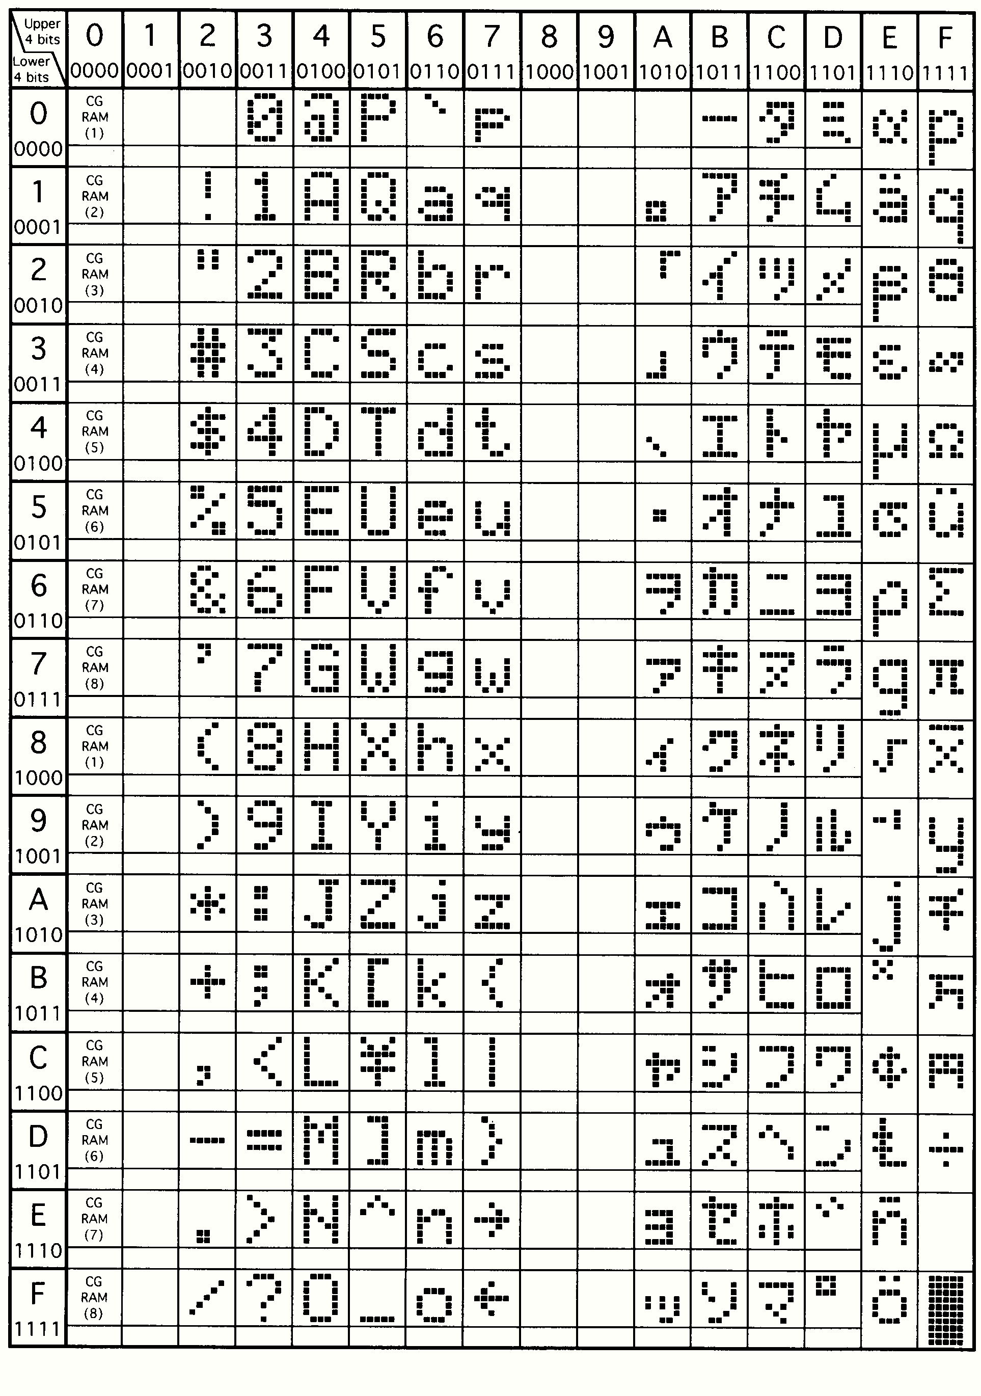
Initialization by Instructions:

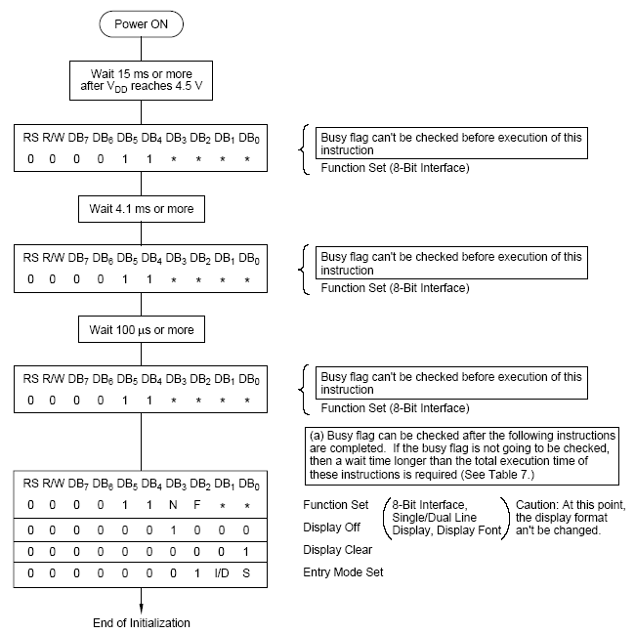

If the power conditions for the normal operation of the internal reset circuit are not satisfied, then executing a series of instructions must initialize LCD unit. The procedure for this initialization process is as above show.

